MID TERM 1 YR 2021
AGRICULTURE FOUR QUESTIONS
- State any two tests that should be carried out to determine the quality of fresh eggs. (1mk)

- List four factors that should be considered when grading eggs for marketing. (2mks)

- What is candling? (1mk)

- Describe how to candle an egg (3mks)

- Name any four main poultry rearing systems (2mks)

- The diagram below is an illustration of an egg. Study it carefully and answer the questions that follow

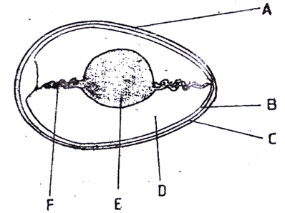

(a) Name the parts labelled B, C, D and F
B (½ mk)

C (½ mk)

D (½ mk)

F (½ mk)
- State four Signs of Broodiness in Poultry (2mks)

- Give four disadvantages of Natural Incubation (2mks)

- State four observations on the behavior of chicks which would indicate that the temperature of a brooder is too high.(4mks)

10.The diagram below shows a type of a farm gate. Study the diagram and answer the questions that follow.
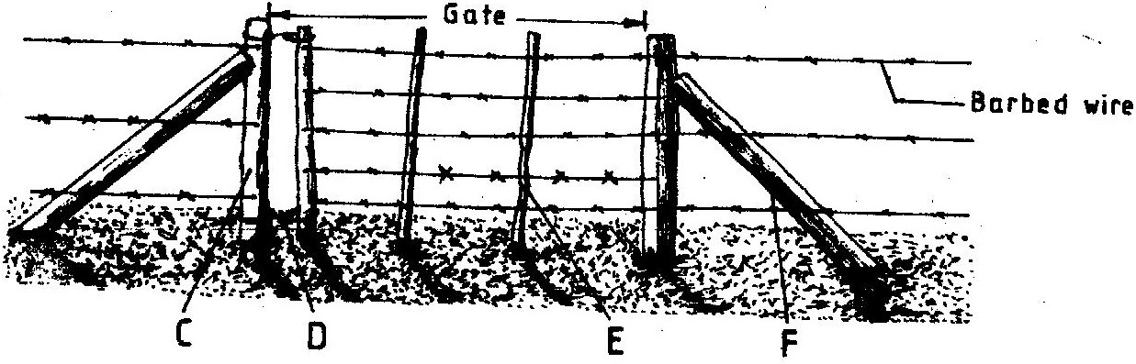

a) Identify the type of gate shown (1 mk)

b) Name the parts labeled C, D and E. (3 mks)
C -
D –
E–
c) I) State one function of the part labeled F. (1mk)

ii) State two functions of the gate illustrated above. (2mks)

11. Give three reasons why honey harvesting at night is not encouraged. (1¹/₂mks)

- Highlight five ways through which can pests be controlled on the farm (2 ¹/₂mks)

- State five uses of a crush (2 ¹/₂mks

15. Name
a) Diseases of bees. (2mks)

b) Give four examples of pests that affect bees (2mks)

16. What is hybrid vigour? (¹/₂mk)

17. Discuss Foot rot disease under appropriate sub-headings
a) Causal Organism (1mk)

b) Predisposing factors (2mks)

c) Symptoms (3mks)

d) Control (3mks)

