FORM 3 PHYSICS PAPER 2
TERM 3 2021
MARKING SCHEME

- - One picture can be taken at a time ;
  - It has long exposure time / picture of moving objects cannot be taken
  - (ANY ONE ) ;

- - A lead accumulator give large current over a long time compared to a dry cell;
  - A lead acid accumulator can be recharged while dry cell cannot be renewed / recharged

- Any two
  - Virtual ;
  - Erect / upright;
  - Enlarged ;

- Light travels in a straight line
.
5. Polarisation.Hydrogen gas produced causes insulation at the cathode .It increases the internal resistance of the cell
.
6. None
Each of them retained their magnetism

- Image formation takes place with regular1 reflection not with diffuse reflection
Plane mirror-regular reflection
Sheet of paper-irregular diffuse reflection 1

8. 1.375 Ampres;

9. (i) White light is a spectrum; The velocities of the colours that form the spectrum is different in a given transparent material medium;
(ii) The white light will not be separated
Since the direction of travel of the colours will be the same ;

10.Soft iron became induced magnet and attracts back the razor
Wood is non-magnetic material hence does not attract the blade.

11. T = 2000 s ;
f = 1
T

= 1 ;
2000
= 5.0 x 10⁻⁴ Hz ;

12.

SECTION B
13a) i) For a metallic Conductor, the Current flowing through is directly proportional to the
p.d across its ends provided temperature ( and other physical condition) are kept constant
ii) p.d across parallel network = IR
= 0.2 x 4 = 0.8 v
Current though 1Ω
= 0.8 = 0.8A
1
( or by ratios)
Total Current
= 0.8 + 0.2 = 1 A

Total Resistance
⁴/₅ + 2 + 1
0.8 + 3 = 3.8 Ω
V = IR ( whole cut )
2 E = 1 ( 3.8)
E = 1.9 volts
Or by using division of p.d

- The leaf collapsed / Electroscope discharged
The red hot charcoal ionizes the air around which neutralizes
The negative charges on the electroscope

c) Graph

i) (A⁻¹)¹/_{l} | 1.25 | 1.43 | 2 | 2.7 | 4.17
R (Ω) 1.6 | 2.1 | 2.5 | 3.6 | 5.0 | 8.0

14.a) i) Light must be traveling from a denser medium to a less dense /rarer medium
ii) The angle of incidence must be greater than the critical angle

b) i) Refractive index of perpex = Sin 90°
Sin 42.5°

= 1/sin 42.5°
= 1.48
- Sin C = ₁η₂

= ₁η_{a} x _{a}η₂
= ½.4 x 1.48
= 0.6167
C= 38.07°
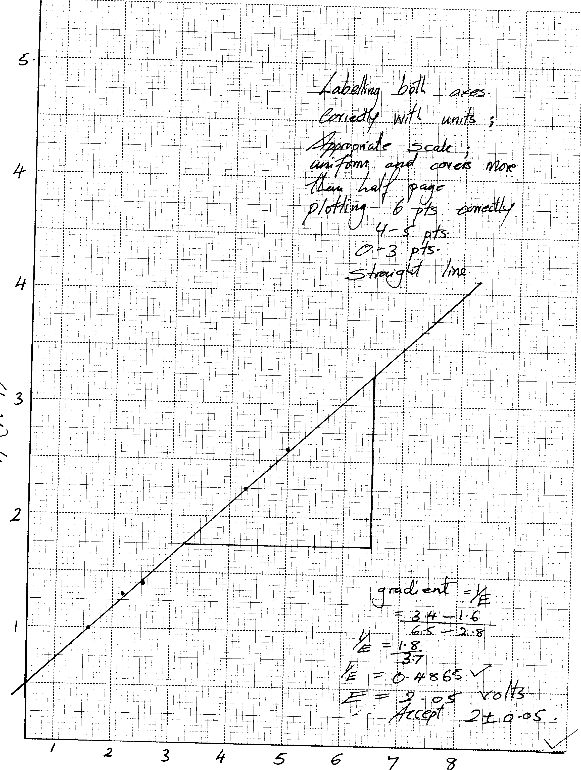

Labelling both axes correctly with units
Appropriate scale
Uniform and covers More than half page
Plotting 6 pts corrects 4-5 pts 0-3pts no mark
Straight line, positive gradient and cutting y-axis at positive value ;
Gradient = ¹/_{Ε}

= 3.4 - 1.6
6.5 - 2.8

¹/_{Ε} = 1.8
3.7

¹/_{Ε} = 0.4865
E = 2.058 volts
Accept 2 ± 0.05

15. (a)
(i) -They leave the surface of a charge body at right angles;
-the electric field lines are directed away from positive charges and towards the negative
charges;
-The closer the field lines the stronger the field at that point,
(ii) -The moving clouds get charged through friction;
When a charged cloud pass over a lightning arrestor it induces on opposite charge in it; Because of the structure of the arrestor at the top (sharp spikes) it releases charges into the air which discharges the charged cloud as shown in the diagram; (1mark)
The arrestor acts as an easy way of discharging the clouds because it is a good conductor;
(b)
(i) Is the charge stored per unit voltage .
Capacitance, C=Charge
Voltage;
(ii) The type of dielectric materials between the plates

  - C =E.d;
A
Can be in words Where C – Capacitance
E – Dielectric constant
d – Separation distance
A – Area of overlap

(c) Charge store =CV
= 2x10⁻⁶x200
= 4.0x10⁻⁴
Charge stored when both capacitor and connected is the same
=4.0x10⁻⁴
Total capacitance
C₁=2.0x10⁻⁶+C₂
Hence
4.0x10⁻⁴= (2.0x 10⁻⁶+C₂)80;;
4.0x10⁻⁴=160x10⁻⁴+ 80C₂
C₂ =4.0 x 10⁻⁴-160x 10⁻⁶
=400x10⁻⁶-160x10⁻⁶
=40x10⁻⁶
=4.0x10⁻⁵F;
16.a) i) Point on principal axis to which all rays originally close and parallel to the
principal axis converge to or from which they appear to diverge from after reflection
from the mirror.
ii) Distance between the pole of the mirror and principal focus
b)
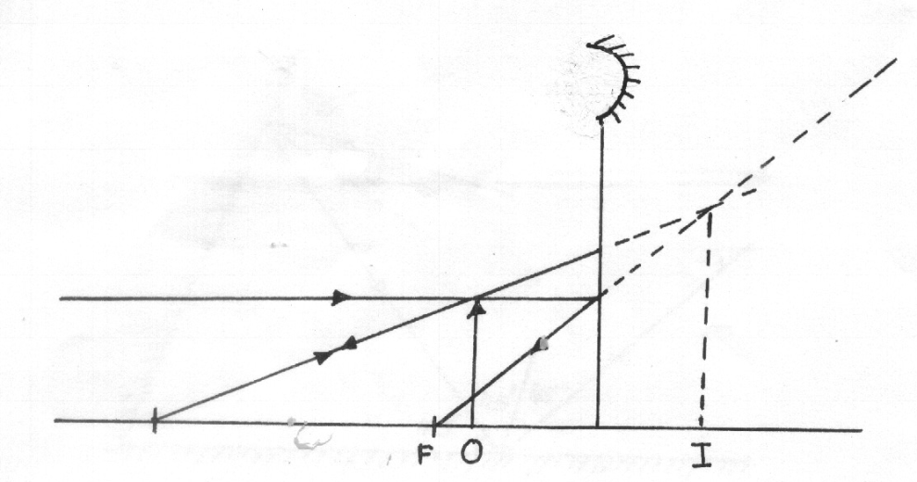

c) i) Focus image of distant object on the screen.
ii) Measure distance between screen and mirror
iii) Repeat the procedure several times
iv) Determine the average value of d
v) Focal length of mirror f = d

d)For convex mirror, its formula is

Multiply terms in

e)
F
I
C
C
o
I
Ray parallel to principal focus diverged but seem to diverge from F ;
Ray seeming to pass through C are undeviated ;
Position of image
Characteristics
Virtual
upright
between F and O
smaller

