FORM THREE
END OF TERM 3 EXAMINATION 2021
PHYSICS PAPER 1
DURATION: 2 HOURS

INSTRUCTIONS TO THE CANDIDATE
- Write your name and the admission number in the spaces provide above
- Answer all questions
For Examiner’s use only

SECTION | QUESTION | MAXIMUM SCORE | CADIDATE SCORE
A | 1-11 | 28
B | 12-20 | 52

PHYSICS QUESTIONS

SECTION 1
1. Figure (a) below shows a velocity-time graph of motion an object
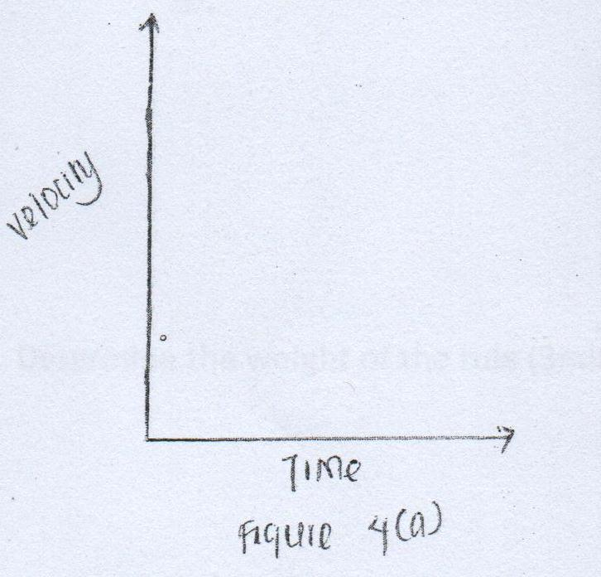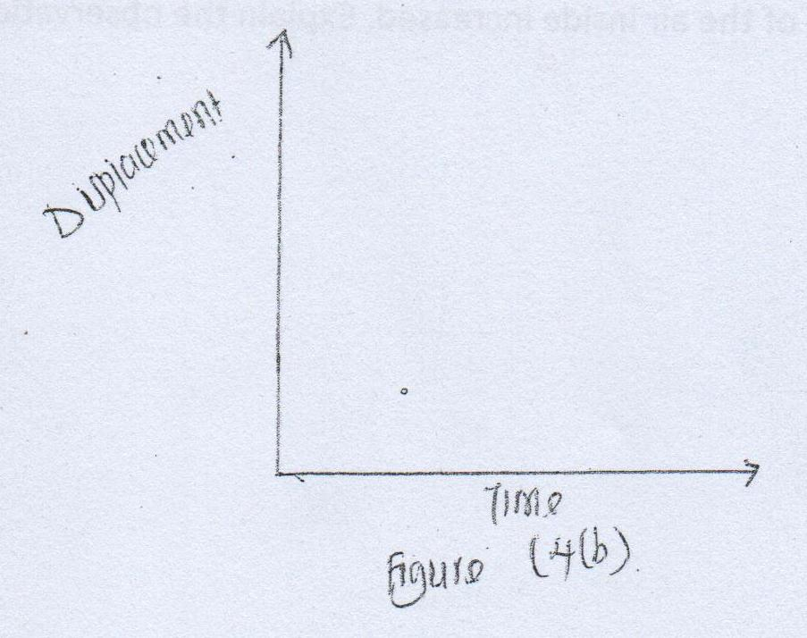
Sketch on the axis the provided In figure (b) the displacement-time graph of the motion (2mks)

2. A car starts from rest accelerates uniformly for 5seconds to reach 30m/s. It continues at this speed for the next 20 seconds and then decelerates uniformly to come to stop in 10 seconds. On the axis provided, draw the graph of the velocity against time for the motion of the car (.4mk)
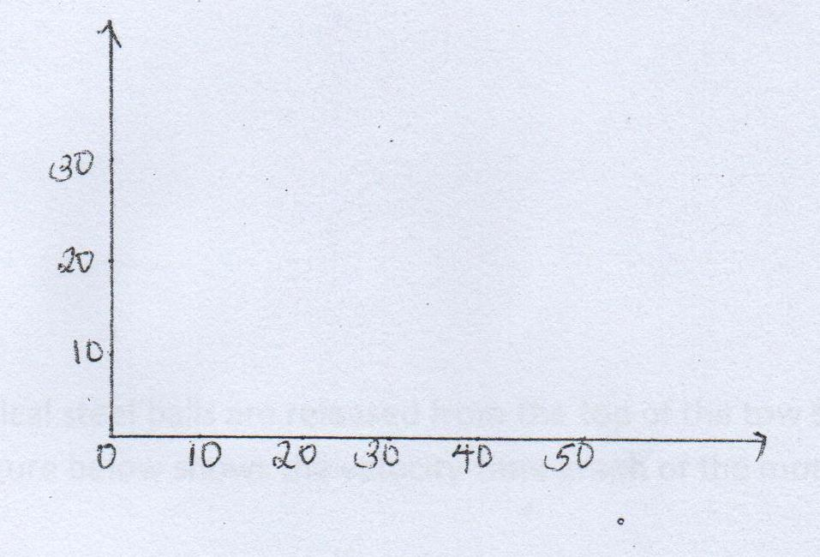

3. Water in a tin-can was boiled for some time. The tin-can was then sealed and cooled. After some time it collapsed. Explain this observation.2mks
………………………………………………………………………………………………………………………………………………………………………………………………………………………………………………………………………………………………………………………………………………………………………………………………………………………………………………………………………………………………………………………………………………………………………………………………………………………………………………………………………..
4. When a bicycle pump was sealed at the nozzle and the handle slowly pushed towards the nozzle the pressure of the air inside increased. Explain the observation. 2mks
………………………………………………………………………………………………………………………………………………………………………………………………………………………………………………………………………………………………………………………………………………………………………………………………………………………………………………………………………………………………………………………………………………………………………………………………………………………………………………………………………..
5. An immersion heater rated 90W is immersed in a liquid of mass 2kg.When the heater is switched-on for 15 minutes the temperature of the liquid rises from 20ºc to 30ºc. Determine the specific heat capacity of the liquid (assume no heat loses). 3mks
…………………………………………………………………………………………………………………………………………………………………………………………………………………………………………………………………………………………………………………………………………………………………………………………………………………………………………………………………………………………………………………………………………………………………………………………………………………………………………………………………………………………………………………………………………………………………………………………………………………………………………..

6. The figure below show a uniform meter rule pivoted at 30cm mark. It is balanced by weight of 2N suspended at the 5cm mark.

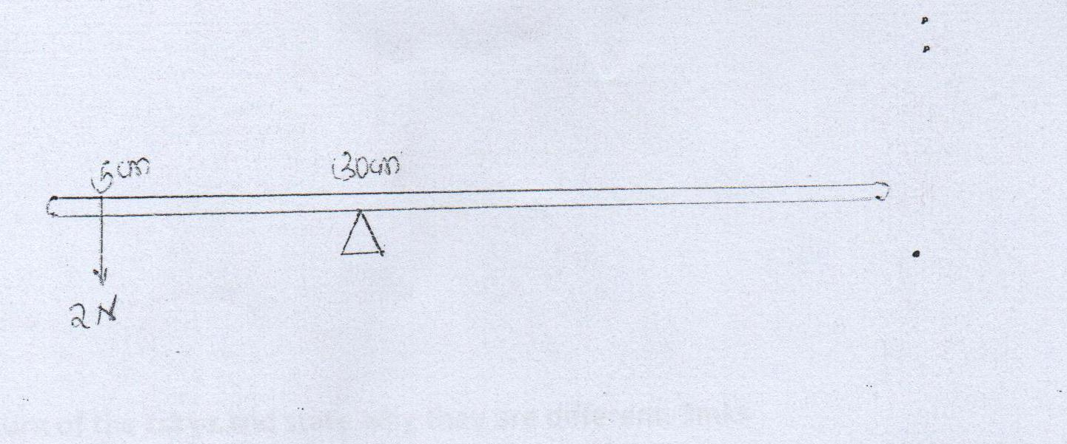

Determine the weight of the rule (2mks)
………………………………………………………………………………………………………………………………………………………………………………………………………………………………………………………………………………………………………………………………………………………………………………………………………………………………………………………………………………………………………………………………………………………………………………………………………………………………………………………………………..

7. Small quantities of hydrogen and helium at the same temperature are released simultaneously at one end of a laboratory. State with reason which gas is more likely to be detected earlier on the other end. 2mks
………………………………………………………………………………………………………………………………………………………………………………………………………………………………………………………………………………………………………………………………………………………………………………………………………………………………………………………………………………………………………………………………………………………………………………………………………………………………………………………………………..
8. Two identical spherical steel balls are released from the top of two tall jars containing liquid L₁ and L₂ respectively. The figure below shows the velocity-time graph of the motion of the balls.

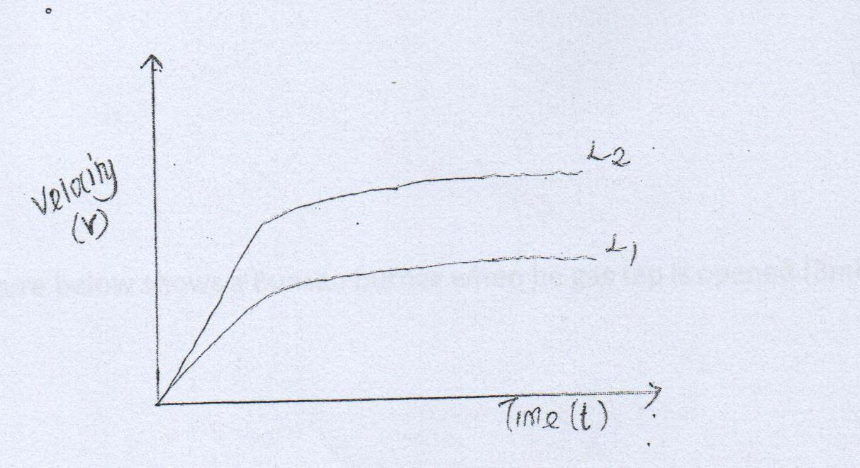

Explain the nature of the curve and state why they are different. 3mks
………………………………………………………………………………………………………………………………………………………………………………………………………………………………………………………………………………………………………………………………………………………………………………………………………………………………………………………………………………………………………………………………………………………………………………………………………………………………………………………………………
9.The figure below shows a round bottom flask fitted with a long capillary tube containing a drop of coloured water.
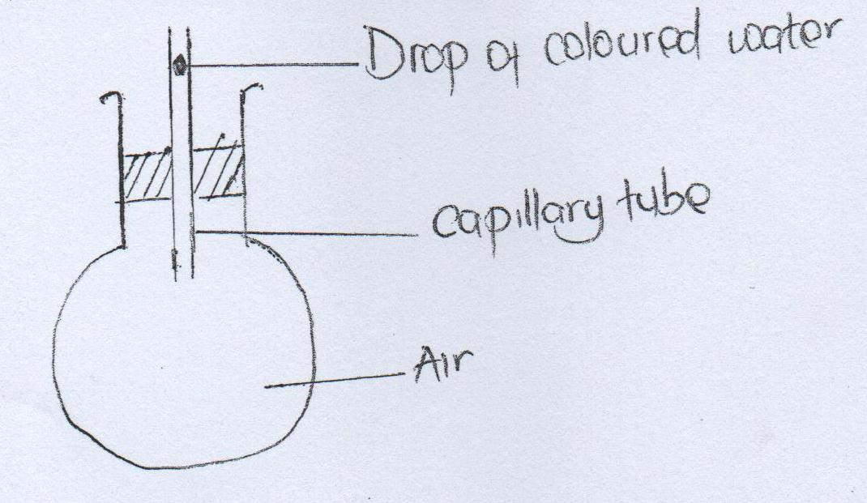

The flask is immersed in ice for some time. State the observation made (2mks)
………………………………………………………………………………………………………………………………………………………………………………………………………………………………………………………………………………………………………………………………………………………………………………………………………………………………………………………………………………………………………………………………………………………………………………………………………………………………………………………………………..
10. The figure below shows a Bunsen burner when he gas tap is opened .
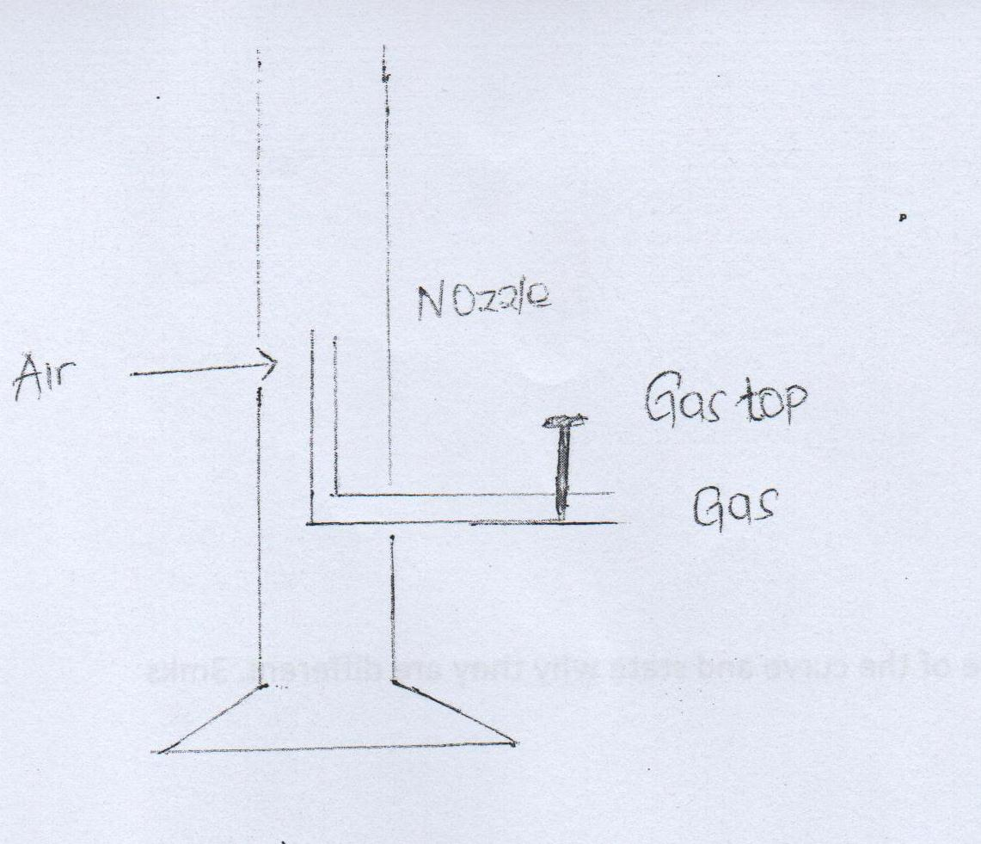

Explain how air is drawn into the burner when the gas tap is opened.( 3mks)
………………………………………………………………………………………………………………………………………………………………………………………………………………………………………………………………………………………………………………………………………………………………………………………………………………………………………………………………………………………………………………………………………………………………………………………………………………………………………………………………………..
11. A bag of sugar is found to have same weight on the planet earth as an identical bag of a dry saw dust on the planet Jupiter. Explain why the masses of the two bags must be different. 2mks
………………………………………………………………………………………………………………………………………………………………………………………………………………………………………………………………………………………………………………………………………………………………………………………………………………………………………………………………………………………………………………………………………………………………………………………………………………………………………………………………………………………………………………………………………………………………………………………………………………………………………………………………………………………………………………………………………………………………………………………………………………

SECTION 2
12 (a)A hole of area 2.0cm² at the bottom of the tank 2.0M deep is closed with a cork. Determine the force of the cork when the tank is filled with water.(density of water is 1000kg/m³ and acceleration due to gravity is 10m/s²) 4mks
………………………………………………………………………………………………………………………………………………………………………………………………………………………………………………………………………………………………………………………………………………………………………………………………………………………………………………………………………………………………………………………………………………………………………………………………………………………………………………………………………..
(b)The total weight of car with passengers is 25,000N.The area of contact of each of the four tyres is 0.025m² . Determine the minimum pressure (3mks)
………………………………………………………………………………………………………………………………………………………………………………………………………………………………………………………………………………………………………………………………………………………………………………………………………………………………………………………………………………………………………………………………………………………………………………………………………………………………………………………………………..

(c).A cyclist initially at rest moved down a hill without peddling .He applied brakes and continually stopped. State the energy changes as he cyclist moved down a hill. (1mk)
………………………………………………………………………………………………………………………………………………………………………………………………………………………………………………………………………………………………………………………………………………………………………………………………………………………………………………………………………………………………………………………………………………………………………………………………………………………………………………………………………..

13 The figure below shows a mass of 30kgs being pulled from the point P with force of 200N Parallel to an inclined plane .The distance between P and Q is 22.5 M . In being moved from P to Q it is raised through a vertical height of 7.5 M
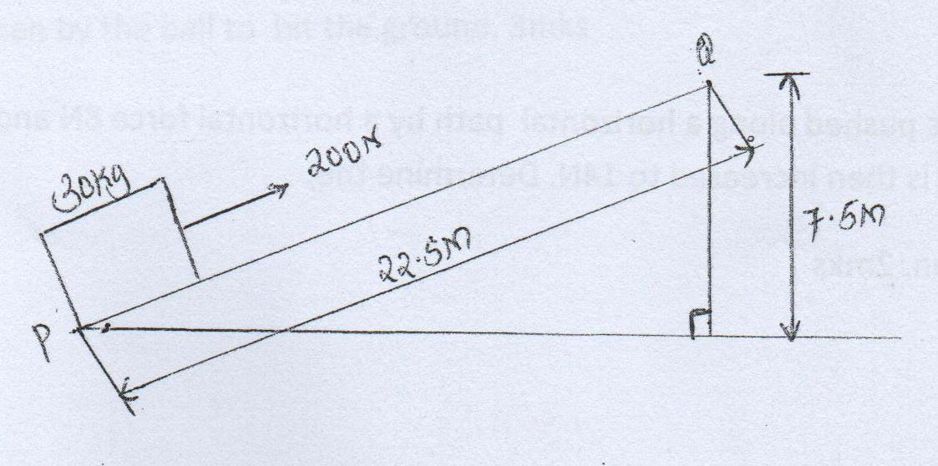

Determine the work done
- by force (2Mks)
………………………………………………………………………………………………………………………………………………………………………………………………………………………………………………………………………………………………………………………………………………………………………………………………………………………………………………………………………………………………………………………………………………………………………………………………………………………………………………………………………………………………………………………………………………………………………………………………………………..
- On the mass (2mks)
………………………………………………………………………………………………………………………………………………………………………………………………………………………………………………………………………………………………………………………………………………………………………………………………………………………………………………………………………………………………………………………………………………………………………………………………………………………………………………………………………..

- To overcome friction (1mk)
………………………………………………………………………………………………………………………………………………………………………………………………………………………………………………………………………………………………………………………………………………………………………………………………………………………………………………………………………………………………………………………………………………………………………………………………………………………………………………………………………..

- Determine the efficiency of the inclined plane .(2MKS)

………………………………………………………………………………………………………………………………………………………………………………………………………………………………………………………………………………………………………………………………………………………………………………………………………………………………………………………………………………………………………………………………………………………………………………………………………………………………………………………………………..

14. A cart of mass 30kgs is pushed along a horizontal path by a horizontal force 8N and moves with constant velocity. The force is then increased to 14N. Determine the;
(a)The resistance to the motion of the cart. 2mks
………………………………………………………………………………………………………………………………………………………………………………………………………………………………………………………………………………………………………………………………………………………………………………………………………………………………………………………………………………………………………………………………………………………………………………………………………………………………………………………………………..
………………………………………………………………………………………………………………………………………………………………………………………………………………………………………………………………………………………………………………………………………………………………………………………………………………………………………………………………………………………………………………………………………………………………………………………………………………………………………………………………………..

(b) The acceleration of the cart. 2mks
………………………………………………………………………………………………………………………………………………………………………………………………………………………………………………………………………………………………………………………………………………………………………………………………………………………………………………………………………………………………………………………………………………………………………………………………………………………………………………………………………..

14 (C) A horizontal force of 2N is applied on a wooden block mass of 2Kgs placed on horizontal surface .It causes the block to accelerate to 5ms^{-2.} .Determine the frictional force between the block and the surface. (3mks)
………………………………………………………………………………………………………………………………………………………………………………………………………………………………………………………………………………………………………………………………………………………………………………………………………………………………………………………………………………………………………………………………………………………………………………………………………………………………………………………………………..
………………………………………………………………………………………………………………………………………………………………………………………………………………………………………………………………………………………………………………………………………………………………………………………………………………………………………………………………………………………………………………………………………………………………………………………………………………………………………………………………………..

15. A ball is thrown horizontally from the top of vertical tower and strike the ground at A point 50 m from bottom of the tower. Given that the height OF the tower is 45m determine
(i) The time taken by the ball to hit the ground. 3mks
………………………………………………………………………………………………………………………………………………………………………………………………………………………………………………………………………………………………………………………………………………………………………………………………………………………………………………………………………………………………………………………………………………………………………………………………………………………………………………………………………..
……………………………………………………………………………………………………………………………………………………………………………………………………………………………………………………………………………………………………………………………………………………………………………………………………………………………………………………………………………………………………………………………………………………………………………………………………………………………………………………………………

(ii )the initial horizontal velocity of the ball. 3mks

(iii) Vertical velocity of the ball just before striking the ground (take acceleration due to gravity, g, as 10ms^{-2.}
^{(3MKS)}
………………………………………………………………………………………………………………………………………………………………………………………………………………………………………………………………………………………………………………………………………………………………………………………………………………………………………………………………………………………………………………………………………………………………………………………………………………………………………………………………………..
………………………………………………………………………………………………………………………………………………………………………………………………………………………………………………………………………………………………………………………………………………………………………………………………………………………………………………………………………………………………………………………………………………………………………………………………………………………………………………………………………..
16. A long horizontal capillary tube of uniform, bore sealed at one end containS dry air trapped by a drop of mercury. The length of the air column is 142mm at 17ºc. Determine the length of air column at 25ºC. (3mks)
……………………………………………………………………………………………………………………………………………………………………………………………………………………………………………………………………………………………………………………………………………………………………………………………………………………………………………………………………………………………………………………………………………………………………………………………………………………………………………………………………………………………………………………………………………………………………………………………………………………………………………………………………………………………………………………………………………………………………………………………………………..

(b) The pressure of air inside a car tyre increases if the car stands out in the sun for some time on a hot day. Explain the pressure increase in terms of the kinetic theory of the gas
(3mks)
……………………………………………………………………………………………………………………………………………………………………………………………………………………………………………………………………………………………………………………………………………………………………………………………………………………………………………………………………………………………………………………………………………………………………………………………………………………………………………………………………………………………………………………………………………………………………………………………………………………………………………………………………………………………………………………………………………………………………………………………………………..

17. An immersion heater rated 2.5KW is immersed into a plastic jug containing 2kg of water and switched on for 4 minute . Determine.
(i) The quantity of heat gained by water 3mks
……………………………………………………………………………………………………………………………………………………………………………………………………………………………………………………………………………………………………………………………………………………………………………………………………………………………………………………………………………………………………………………………………………………………………………………………………………………………………………………………………………………………………………………………………………………………………………………………………………………………………………………………………………………………………………………………………………………………………………………………………………..

(ii) The temperature change of water. (3mks)
(Take specific heat capacity of water as 4.2x 10³ Jkg⁻¹xk⁻¹
……………………………………………………………………………………………………………………………………………………………………………………………………………………………………………………………………………………………………………………………………………………………………………………………………………………………………………………………………………………………………………………………………………………………………………………………………………………………………………………………………………………………………………………………………………………………………………………………………………………………………………………………………………………………………………………………………………………………………………………………………………..

18. The figure bellow shows an incomplete set up that can be used in an experiment to determine specific heat capacity of a solid of mass M and temperature Ө₁ by electrical method.

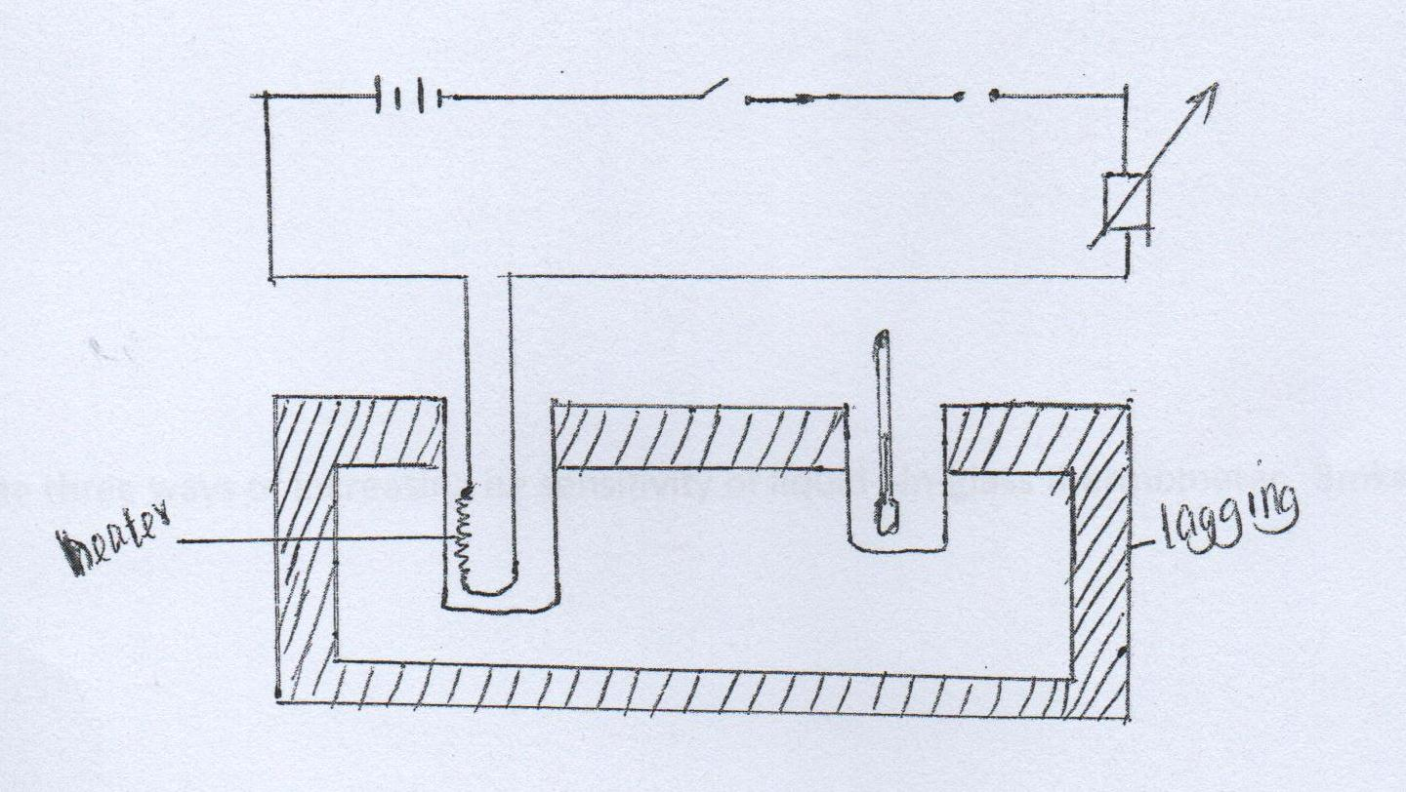

- Complete the diagram by inserting the missing component of the experiment. 2mks

- Other than temperature state three measurements that should be taken (3mks)

……………………………………………………………………………………………………………………………………………………………………………………………………………………………………………………………………………………………………………………………………………………………………………………………………………………………………………………………………………………………………………………………………………………………………………………………………………………………………………………………………………………………………………………………………………………………………………………………………………………………………………………………………………………………………………………………………………………………………………………………………………..
(iii)The final temperature was recorded Ө₂, write an expression that can be used to determine the specific heat capacity of the solid. 2mks
…………………………………………………………………………………………………………………………………………………………………………………………………………………………………………………………………………………………………………………………………………………………………………………………………………………………………………………………………………………………………………………………………………………………………………………………………………………………………………………………………………………………………………………………………………………………………………………………………………………………………………………………………………………………………………………………………………………………………………………………………………….

(B) State three ways of increasing he sensitivity of liquid –in-glass thermometer. 3mks
……………………………………………………………………………………………………………………………………………………………………………………………………………………………………………………………………………………………………………………………………………………………………………………………………………………………………………………………………………………………………………………………………………………………………………………………………………………………………………………………………………………………………………………………………………………………………………………………………………………………………………………………………………………………………………………………………………………………………………………………………………..

