NAME……………………………………………………………………………. ADM NO……………. CLASS……………………DATE………………..

PHYSICS, FORM TWO
TERM 3 2021
TIME:2 HOURS

INSTRUCTIONS TO STUDENTS
- Write your name and admission number in the spaces provided above
- Answer all the questions in the spaces provided
- All working must be clearly shown
- Take acceleration due to gravity=10N/kg
Density of water=1000kg/m³
Density of mercury=13,600kg/m³

SECTION | QUESTION | MAXIMUM SCORE | CANDIDATE’S SCORE
 | 1-19 | 80
TOTAL SCORE |  | 80

1. (a) State the basic law of magnetism. (2 marks)

- The figure below shows how magnets are stored in pairs with keepers at the ends.
S
N
N
S
Bar magnets
Keeper
Keeper

Explain how this method helps in retaining magnetism longer. (2 marks)

- The figure below shows a spherical ball placed between 2 wooden blocks and a metre rule.

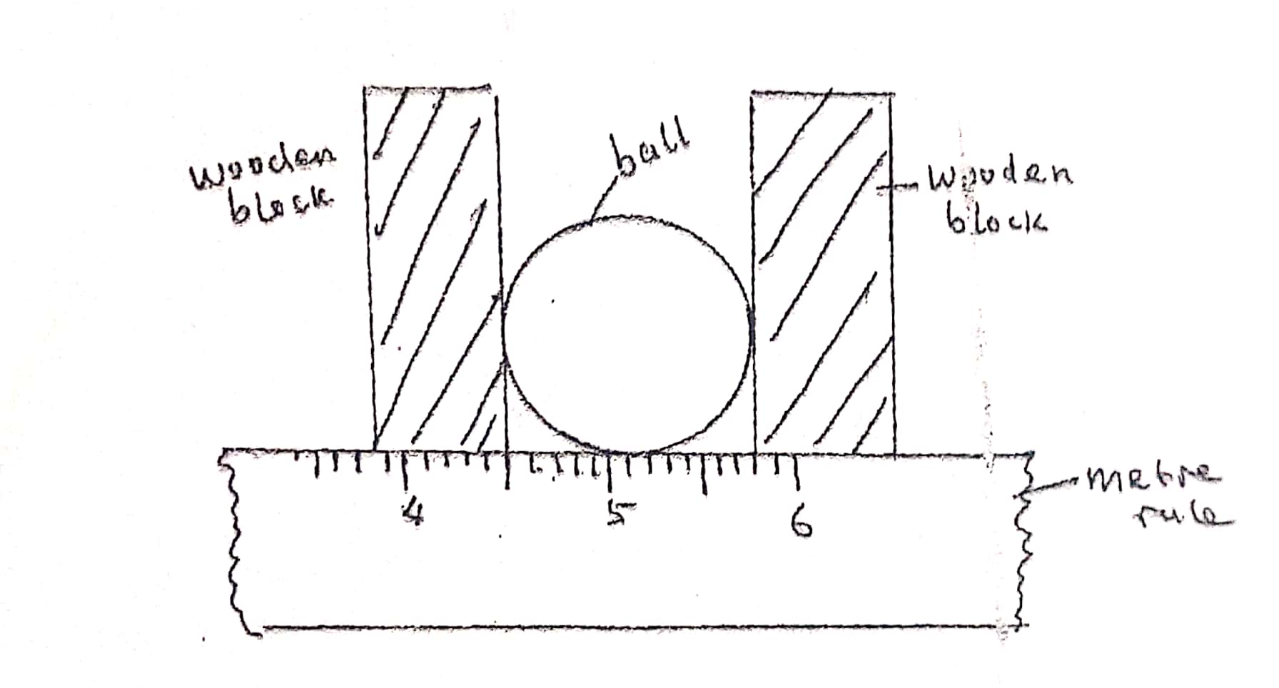
What is the volume of the ball? (3mks)

- A solid weighs 16.5N on the surface of the moon. The force of gravity on the moon is 1.7N/kg. Determine the mass of the solid. (2mks)

- The figure below shows two cylinders containing a liquid and connected with a tight-fitting flexible tube. The cylinders are fitted with air- tight pistons A and B as shown.
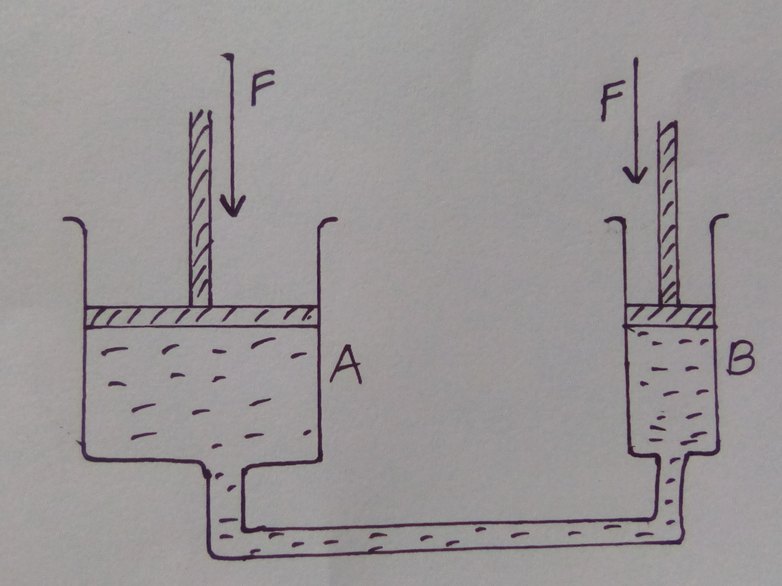
What is observed when forces of equal magnitude F, are on the pistons as shown? Explain the observation. (3mks)

- A bottle of soda stands on a bench. As the temperature of the surrounding rises the temperature of the bottle also rises. State and explain the effects of this on the stability of the bottle. (3mks)

- Explain how heat loss by:
- Radiation is minimized in a vacuum flask. (1mk)

- Conduction is minimized in a vacuum flask. (1mk)

- The figure below shows part of the main scale of vernier calipers.

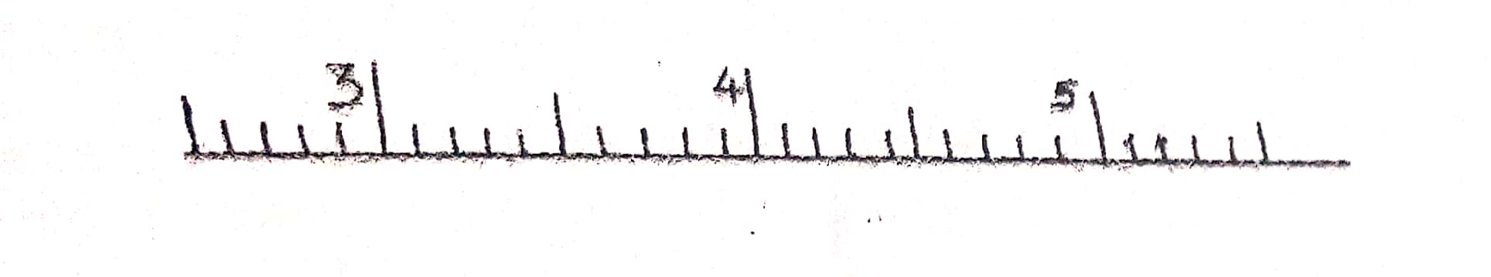

Insert the vernier scale to the main scale, to show a reading of 3.62cm. (2mks)

- The three springs shown below are identical and have negligible weight. The extension produced on the system of springs is 20cm. Determine the constant of each spring. (3mks)
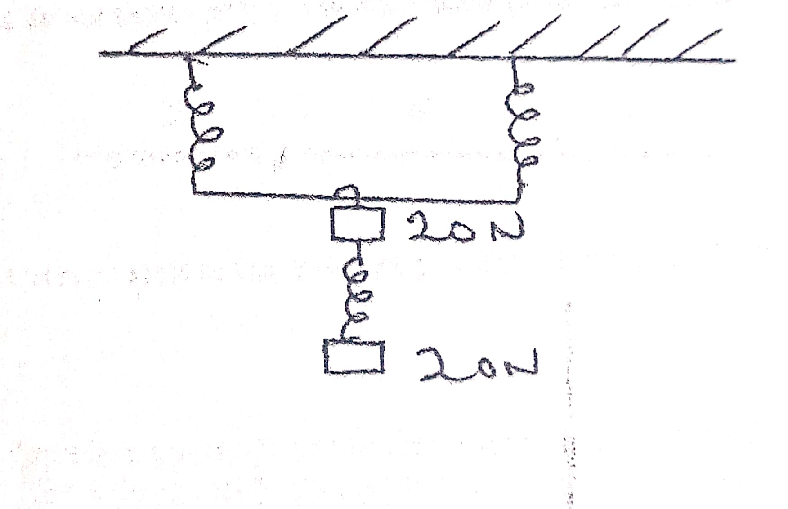

- An athlete runs at 4m/s from point A to point B and immediately turns and runs back from B to A with a speed of 8m/s. Calculate the average speed of the athlete. (2mks)

- (a) In an experiment to estimate the diameter of an oil molecule, an oil drop of diameter 0.06cm spread over a circular patch whose diameter is 20cm. Determine:-
- The volume of the oil drop (3mks)

- The area of the patch covered by oil. (3mks)

- The diameter of the oil molecule. (2mks)

(b) State any assumption made in (ii) above. (1mk)

(c) The figure below shows parts A and B of a glass tube.
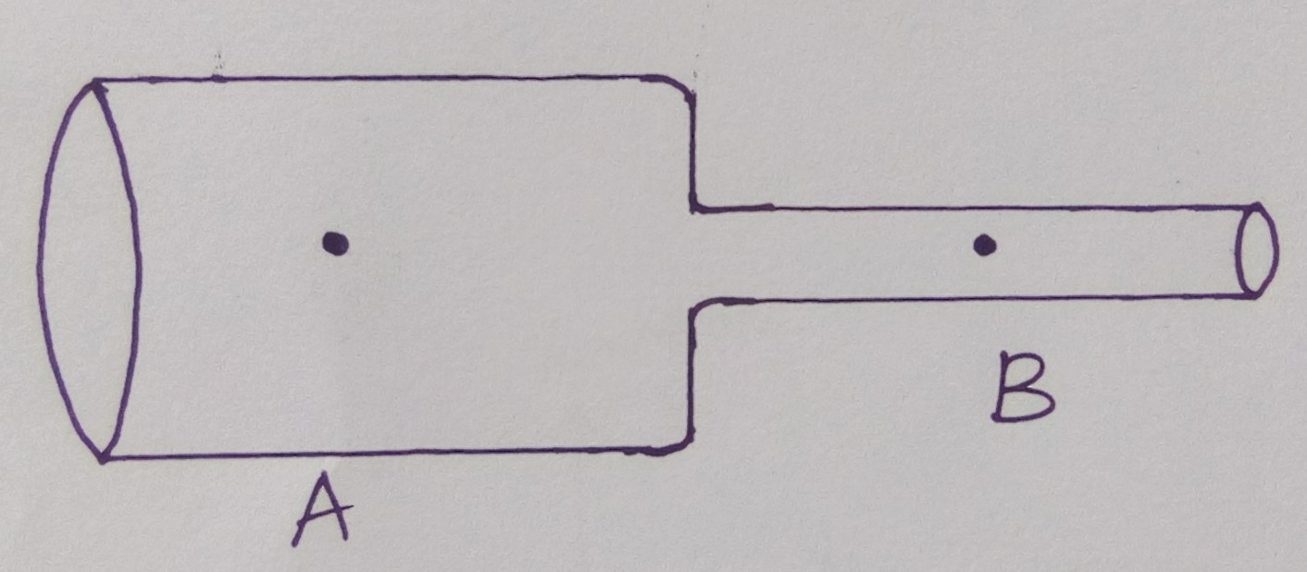
- State the part of the tube where the pressure will be lowest when air is blown through the tube. (1mk)

- What is the relationship between the velocity of air and its pressure at any point along the tube AB. (1mk)

(d) Water flows along a horizontal pipe of cross-section area 35cm² and constriction of cross-section 5cm², if the speed of water at the constriction is 2m/s,Calculate the speed in the wide section. (2mks)

- (a) State the principle of moments. (2mk)

(b) A uniform metal strip is 3.0cm wide 0.6cm thick and 100cm long. The density of the metal is 2.7 g/cm³.
- Determine the weight of the metal strip. (3mks)

- The strip is placed on a pivot and kept in equilibrium by forces as shown.
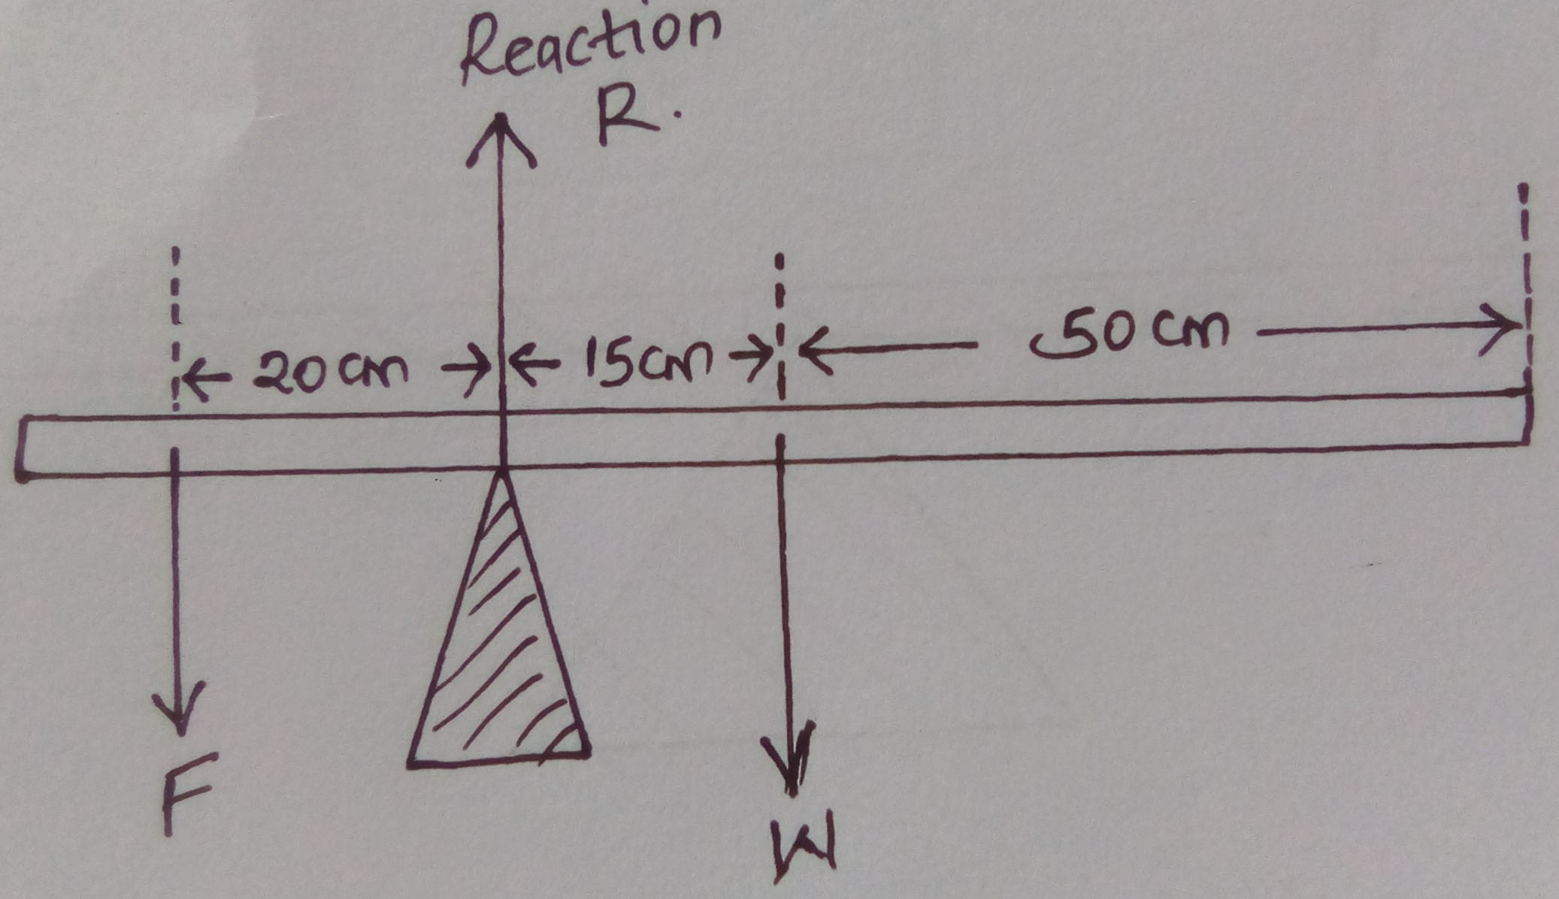
Determine the value of F and R. (4mks)

(c) (i) Define the centre of gravity of a body (1mk)

- State the factors that affect the stability of a body. (2mks)

- Give any state of equilibrium. (1mk)

- An object of height 10cm is placed 50cm in front of a concave mirror of focal length 30cm. By calculation, determine,
- Position of the image (2mks)

- Size of the image. (2mks)

- Calculate the magnification. (2mks)

.
13. The figure below shows a current-carrying conductor AB in a magnetic field..

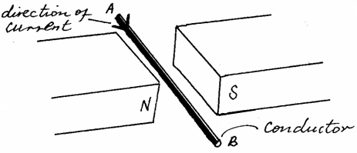

- Indicate the direction of force F acting on the conductor. (1mark)

- State two factors that determine the magnitude of the force F (2mark)

14. A girl standing at a distance claps her hands and hears an echo from a tall building 2 seconds later. Determine how far the building is. (Take the speed of sound in air =340m/s) (2marks)

15. State two ways in which one can increase the strength of an electromagnet. (2 marks)

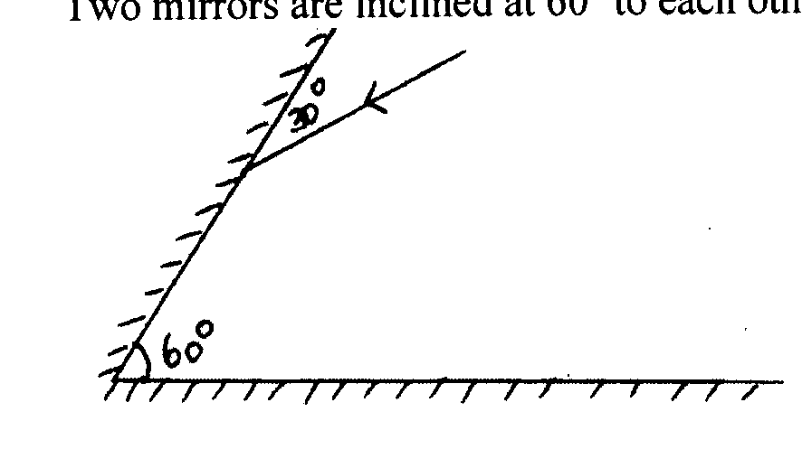
16. The figure belowshows two mirrors inclined at 60º to each other.

Complete the ray diagram to show how it travels after striking the two mirrors and find the angle of reflection on each surface. (2marks)

17. State two defects that occur in a simple cell. Explain how these defects can be minimized (2marks)

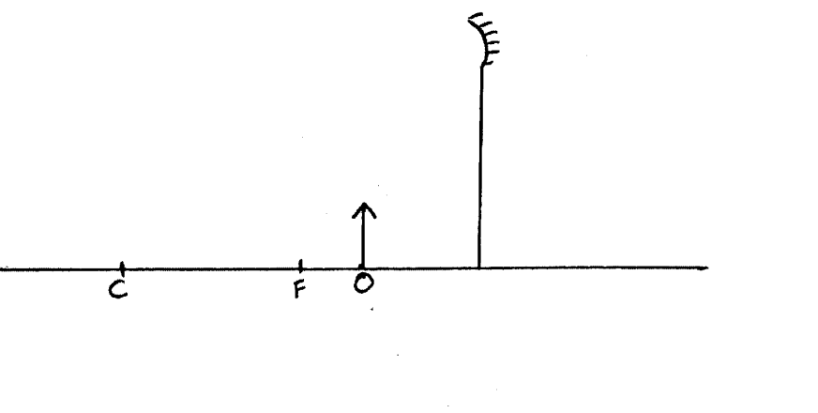
18. The figure below shows an object placed in front of a concave mirror. By use of correct ray diagram, locate the position of image. (3 marks)

- (a) Define pressure and state its SI units. (2mks)

b) State Pascal’s principle. (1mk)

c) Give a reason why ink is most likely to ooze out of a pen when one is up an airplane. (1mk)

- The figure below is a simple hydraulic machine used to raise heavy loads.
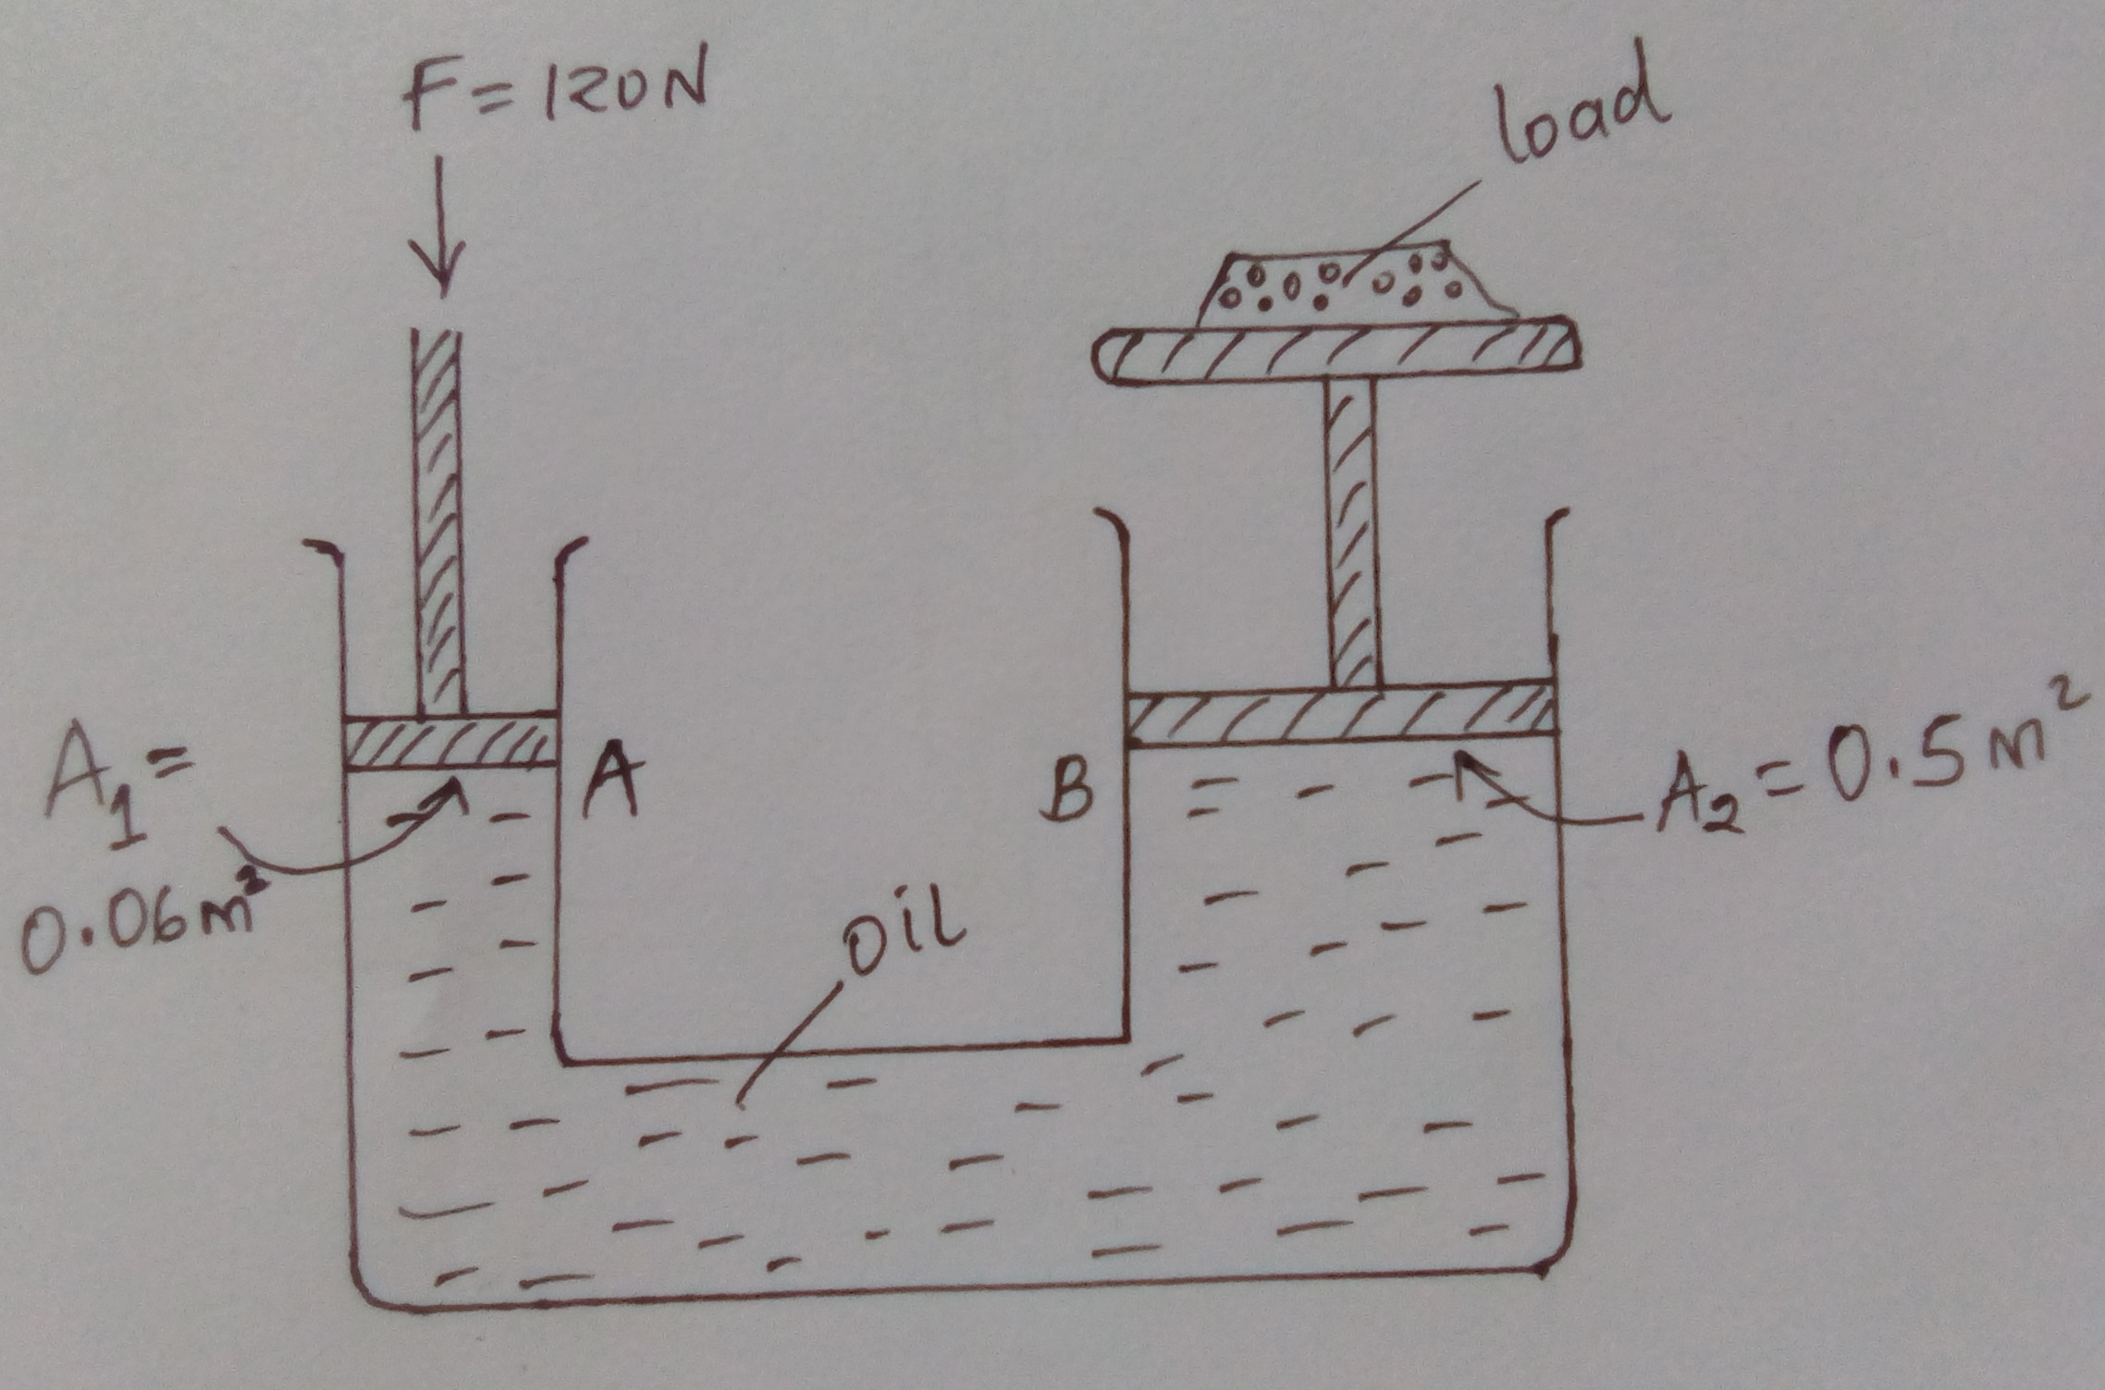
Calculate:-
- The pressure exerted on the oil by the force applied at A. (2mks)

- The load raised at B. (2mks)

- Give two properties which make the oil suitable for use in this machine. (2mks)

