Name……………………………………………………Adm No………………….Class...............

TERM THREE 2019
PHYSICS FORM ONE
TIME: 2 HOURS

Instructions
Answer all the questions in the spaces provided
Where necessary take:
- Earth’s gravitational intensity=10N/kg
- Density of water= 1000kg/m³

Answer all the questions
- (i)Define length (1mk)

(ii) Outline three steps that you should follow when measuring length using a metre rule
(3mks)

- (i) What is a basic quantity? (1mk)

(ii) State two examples of a basic quantity and their SI units (2mks)

- A plot of land is represented on a map by an area of 48.5cm². If the scale on the map is 1:5000, determine the actual area of the land in square metres (3mks)

- When a narrow tube is dipped in a beaker containing water, the water rises up the tube.
  - What is the name given to this effect? (1mk)

  - Explain the observation (1mk)

- State the two factors affecting the surface tension of a liquid. (2mks)

- The atmospheric pressure at a place was measured as 740mm of mercury. Calculate the pressure at the place in Pascals. (density of mercury is 13.6g/cm³) (3mks)

- Explain how a drinking straw works when used to drink a liquid. (2mks)

- State the kinetic theory of matter. (1mk)

- (a) In the smoke cell experiment, the smoke is observed to be in a random motion. Explain the cause of the motion (1mk)

(b) State and explain the effect on the motion when the temperature of the smoke cell is increased
(2mks)

- (i) What is diffusion? (1mk)

(ii) State the factors affecting the rate of diffusion of a gas (2mks)

- State any three differences between mass and weight (3mks)

- An object has a mass of 120g.what is the weight of the object at the moon surface? (gravitational intensity of the moon is a third that of the earth) (2mks)

- The water level in a burette is 40.6cm³. 50 drops of water each of volume 0.2cm³are added to the water in the burette. What is the final reading of the burette? (3mks)

- On the axis provided, sketch a graph of volume against temperature of water from 0º to 20ºC.
(2mks)

Temperature (ºC)
Volume (cm³)

- It is easier to detect a bad smell from a gaseous substance than a solid substance. Explain
(1mk)

- a) Define pressure (1 mark)

b) (i) State Pascal’s principal. (1 mark)

(ii) The figure below represents a section of a hydraulic machine. The area of Pistons A and B are 0.03m² and 0.5m respectively. A force of 60N is applied on the piston.
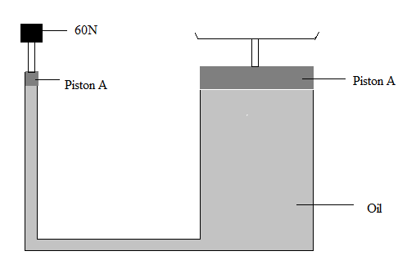
Determine the:
- Pressure exerted on oil by piston A (2mks)

- Maximum force that can be lifted by the system (2mks)

(iii) Give two reasons why oil and NOT water is selected for use in the system in (ii) above (2mks)

- The figure below shows a circuit diagram of a device for controlling the temperature in a room.
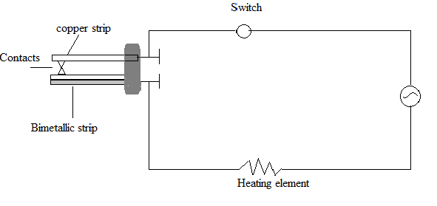
Iron
Brass
- Explain the purpose of the bimetallic strip. (2 marks)

- Describe how the circuit controls the temperature when the switch is closed. (3 marks)

- (a) The figure below shows two identical copper plates one painted black and the other is white. The corks are stuck to the plates using some wax and a Bunsen flame is placed equidistant from the two plates.
White plate
Bunsen flame
Black plate
Cork
Cork

Which cork is likely to fall off first from the plate? Give reason for your answer (2mks)

(b) The figure below shows a paddle wheel placed in a beaker containing water. When the water is heated at the point indicated, the wheel rotates.

Paddle wheel

Water

HEAT
- Explain why the wheel rotates (2mks)

- State the direction in which it rotates (1mk)

(c) A vacuum flask is designed to keep a liquid hot for a long time. Explain how heat losses are reduced in a vacuum flask (3mks)

- (a) Define density (1mk)

(b) A solid block measures 25cm by10cm by 8cm. if the block has a mass of 3.2kg, calculate:
- The volume of the block (2mks)

- The density of the block expressed in SI units (3mks)

(c) The mass of an empty density bottle together with its stopper is 24.8g. The bottle weighs 49.8g when filled with water. When the bottle is emptied and filled with another liquid, it weighs 48.8g. Determine the density of the liquid. (3mks)

- (a) What is a thermometric liquid? (1mk)

(b) State any three qualities of a good thermometric liquid (3mks)

(c) Give any two advantages that mercury has over alcohol as a thermometric liquid (2mks)

(d) Explain how each of the following can be increased in a liquid-in-glass thermometer:
(i) Sensitivity (1mk)

(ii) Accuracy (1mk)

- (a) State the laws of reflection (2mks)

(b) Two plane mirrors are inclined at an angle of 60⁰. How many images do the mirrors form?
(2mks)

(c) State one application of a plane mirror (1mk)

