END OF TERM 3 2021
FORM 1 GEOGRAPHY
MARKING SCHEME
- a) - Map work
- Photograph work
- Field study
- Statistics

b) - The earth and the solar system
- The internal land forming processes
- The external land forming processes
- Weather and climate
- Soils and vegetation

c) - helps to explain the origin of the earth.
- Helps to develop skills of observing, reading, analyzing and interpreting maps, data.
- Enables geographers to appreciate different environment influences at work on different societies.
- It encourages international awareness at local national and international levels.
- Teaches how to manage time.
- Acquire skills which contribute to local, regional and national development.
- Creates awareness in the people on significance of management and conservancy of environment.
- Is a career subject.

- a) The solar system is made up of the sun with the nine planets orbiting around it.

b) - Centrifugal force
- Centripetal force
- Force of gravity

c) - Original heat is still retained after cooling.
- The weight of the overlying burden.
- Radioactivity

- a) Absolute humidity is the actual amount of water in a given volume of air at a particular temperature whereas relative humidity is the ratio between absolute humidity of a given mass of air and the maximum amount of water vapour that it can hold at the same temperature.

b) The air should be calm so that it can remain in constant with the ground for long.
Daytime should be warm to accelerate evaporation.
A cloudless night that accelerates the rate at which the earth looses heat gained during the day.

- a) A rock is naturally occurring agglomeration of mineral particles forming part of the earth crust whereas a mineral is naturally occurring, crystalline, inorganic substance with a definite chemical composition and physical properties.

b) - By their mode of formation/origin.
- By physical and chemical characteristics.
- According to their age.

c) i. Are igneous formed by the cooling and solidification of magma in the earth’s crust after intrusion.
ii. Are igneous formed by the cooling ad solidification of magma in the earth’s surface after intrusion.
iii. These are igneous rocks that result from magma being intruded into other rocks.

d) i. Familiarizes the researcher with an area of study.
- Introduces the researcher to the authorities and respondents in the area of study.
- Helps researcher to identify and decide on the methods and tools to use in collecting information during the study.
- Helps determine the suitability of the area of study.
- Helps identify any problems the researcher is likely to encounter during the study.
- Enables the researcher to estimate the cost of study and plan accordingly.
- Helps in designing a working schedule.
ii. - Field sketching
- Mapping
- Tabulation
- Tallying
- Taking photograph
- Tape recording
- Note taking
- Labeling samples
- Filling in the questionnaires

iii. - In some places rocks form spectacular sceneries which act as tourist attraction.
- Certain types of rocks act as water reservoirs and store water.
- It provides the parent material for the formation of rich soils for agriculture.
- Some rocks are used in the building and construction.
- Minerals and other valuable substances are extracted from rocks and used in variety of ways.
- Are sources of income to some people.
- Rocks provide main record of past environment.
- Rocks play an important role in influencing landscape and landscape feature.

- a) Is a place where the elements of weather are observed, measured and recorded.

b) - Maximum thermometer
- Minimum thermometer
- Six’s thermometer
- Hygrometer

c) When the temperature fall, the alcohol contracts and its meniscus pulls the metal index backwards along the glass tube.
- When temperature rises, the alcohol expands leaving behind the index.
- The minimum temperature in the previous 24hours is shown by the end of the index nearest to the meniscus and reset by raising the bulb of the thermometer gently.
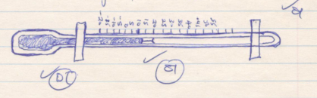

d) - Ancient methods
- Weather lore method
- Modern methods

- a i.
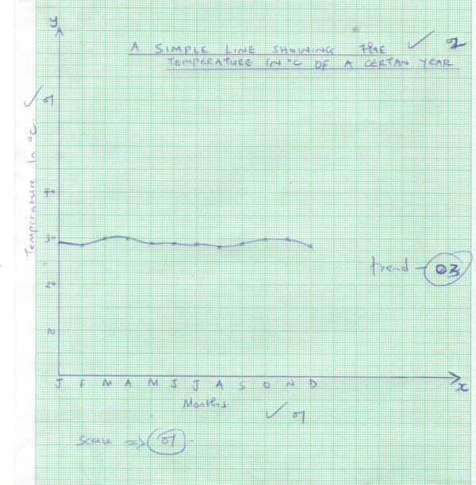

ii) - The causes of the illustrated relationship cannot be established from the graph.
- It shows no comparisons between two or more sets of data.
- Does not give a clear visual impression on the quality of data.
- It ignores some details of change and may give a false impression on the continuity of some data.

b) i. Mean annual rainfall
10+9+22+48+26+9+24+10+5+10+18+11=$\frac{202}{12}=16.8333$
ii. 29 + 29 = $\frac{58}{2}$ = 29
iii. 30 – 27 = 3⁰c
- a) Mining refers to all attempts to extract valuable minerals, solids, liquid or gas from the earth’s crust.

b) - Veins and lodes
- Beds and seams
- weathering products
- Alluvial or place deposits

c) - Opencast mining
- Underground mining
- Alluvial mining

d) - Inadequate capital for prospecting and mining minerals.
- Remoteness and poor transport systems.
- Insufficient skilled personnel.
- Control by multinational/foreign companies
- Occurrence of small mineral deposits.
- pollution
- Risk of death.
- Inadequate power supply and high cost of mining.
- Land use conflicts.

- a) - field study/field leaching
- Excursions
- Field work research

b) - apply skills learned in class in real life situation.
- Identify specific problems that may require geographical investigation.
- study geographical phenomena and processes like faulting.
- identify and categorise factors and features of given geographical phenomena.
- think and use the observations skills to reason logically.
- be familiar with the environment.
- draw local examples, from their own interpretation.
- break monotony in class.

c) - Must have an element of comparison.
- Quantitative words used should be measurable.
- leaves room for yes or no.
- must be related in one or more of objectives in question.
- should not be obvious.
d) - It gives ample time to each activity so that no activity is forgotten.
- reduces tendency of time wastage.
- provides an estimate of the time required.
- It provides basis for evaluating the field work while in progress.
- provides framework that guides the researcher to remain within the scope of the topic.

- a) Describe data is the data which is non-continuous overtime and may be given in whole numbers e.g. no of livestock whereas continuous data is data which is continuously distributed overtime e.g. temperature, distances, population growth rate.

b) - Questions asked should be simple and clear.
- The questions should not be too many that discourage the respondent.
- The questions should be related to the topic under research.
- Questions that annoy the respondent should be avoided.
- The questions should be free of bias.

c) - Random
- Systematic
- Stratified

d) - First hand data is obtained.
- When properly conducted it gives accurate results.
- It can lead to further discoveries.

