312/2
GEOGRAPHY
Paper 2

Paper 2
GEOGRAPHY
MARKING SCHEME

SECTION A
Answer all the questions in this section.
1. (a) Name two indigenous hardwood tree species in Kenya (2 marks)

- Meru oak
- Elgon Olive/East Africa Olive)
- Elgon Teak
- Comphor
- Mangroove

(b) State three factors that favour the growth of softwood forests in Kenya. (3 marks)

- Cool climate experienced in the Kenya highlands.
- The Kenya highlands receive heavy rainfall about 1000mm annually supporting growth of forests.
- Most parts of the Kenya highlands are steep and rugged unsuitable for settlement and farming.
- High demand for timber and wood products in Kenya.

2. Use the map of Kenya below to answer question (a).

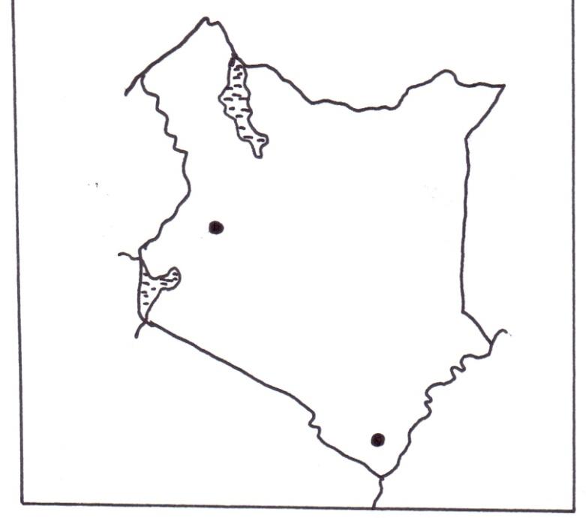
P
R
(a) Name the minerals mined in the areas marked P and R. (2 marks)

P - Flouspar
R - Titanium

(b) State three benefits of Gold mining to the economy of South Africa. (3 marks)

- Provides raw materials for industries.
- Create employment opportunities
- Earns foreign exchange.
- Led to industrial development
- Has led to urbanization.
- Development of social amenities.
- Development of transport facilities.
3 (a) Environmental hazards
- Wind storms
- Lightning
- Landslide
- Drought
- Heat waves 2 x 1 = 2

4 a)Presence of undulating landscape
Adequate water supply
Large tracks of land
Adequate pasture for animals
Tsetse fly free areas
b)Aberden angus
Hereford
Red Angus
Charolais
Short horn
Galloways
Santa gertrudes

5 a) a photograph is an image of an object,person or scene in a form of a print or slide recorded by a camera on a film and later transferred into a specially prepared paper
b) vertical aerial photograph
oblique aerial photograph

SECTION B
6. The table below shows the production of maize in tonnes between 2015 and 2017 in four divisions of Baringo County
Division | 2015 | 2016 | 2017
Bartabwa | 3005 | 3500 | 4000
Barwesa | 6087 | 6198 | 7786
Kabartonjo | 6753 | 6547 | 6698
Kipsaraman | 4078 | 5465 | 5567

a) i) Calculate the percentage increase of the total maize production in the four divisions between 2016-2017 (3mks)
Total 2016 = 21,710
Total 2017 = 24,051
Difference = 24,051-
21,710
2,341

% increase ²³⁴¹/₂₁₇₁₀ x 100 = 10.78% / 10.8%
ii) What is the difference in kilograms between the highest production and the lowest in three years? (2mks)
(7,786,000 – 3,005,000)kg = 4,781,000kg
b) i) Using a radius of 5cm draw a pie-chart to represent production of 2017 (6mks)
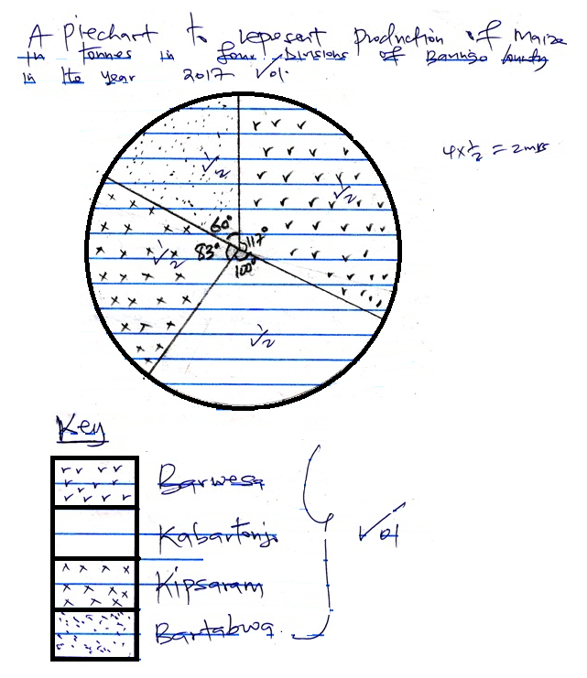

Bartabwa = ⁴⁰⁰⁰/₂₄₀₆₁ x 360⁰ = 59.8⁰ = 60⁰
Barwesa = ⁷⁷⁸⁶/₂₄₀₆₁ x 360⁰ = 116.5⁰ = 117⁰
Kabartonjo = ⁶⁶⁹⁸/₂₄₀₆₁ x 360⁰ = 100.2⁰ = 100⁰
Kipsaram = ⁵⁵⁶⁷/₂₄₀₆₁ x 360⁰ = 83.3⁰ = 83⁰
ii) Give three advantages of using a pie-chart in representing information (3mks)
- Give a good visual impression
- Can represent wide variety of data
- Easy to draw
- Easy to read/interpret
- Shows individuals values clearly
- Easy to interpret
c) State three climatic conditions favoring the growing of maize. (3mk)
- High rainfall/1200-2500mm annually
- High temperature / 18⁰C – 30⁰c
- High humidity for growth/maturity
- Dry sunny condition during harvesting
- Well distributed rainfall throughout the year
d) Explain four problems facing small-scale maize farmers in Kenya. (8mks)
- Shortage of rainfall/inadequate rainfall reducing the production of maize.
- Attack by pests e.g. army worms, stalk borer, locusts fowl carrying worms destroying maize plantation thus low yields/lowering profit margin.
- High cost of farm inputs e.g. fertilizer, maize seed thus increase the cost of production thus lowering yields.
- Importation of cheap maize that floods the market thus reduced farmers morale.
- Diseases i.e. maize streak, leaf rust that attack the crop thus reduces the production/farmers profit margin.
- Heavy rainfall during harvesting period destroying maize.

7. a)i) What is forestry? (2mks)
- It is the science of planting and caring of forests and their associated resources.
- Practice of managing and using trees/forests with associated resources. (any)
ii) Explain three factors that favour the growth of natural forests on the slopes of Mt. Kenya. (6mks)
- The area receives high rainfall 1000-2200mm throughout the year which encourages continuous growth of trees.
- Has deep fertile soils that allow roots to penetrate deep into ground to support the trees.
- Well drained soils thus there is no water logging which can interfere with the growth of variety of trees.
- The area is a gazette forest reserve which are prohibited hence allowing forests to grow without interference.
- The steep slopes discourage human activities thus enabling forests to thrive. (first)
b) Name three exotic species of trees planted in Kenya. (3mks)
- Pine
- Cypress
- Wattle
- Blue gum/Eucalyptus
c) State four ways in which the clearing of the forests has affected the natural environment in Kenya. (4mks)
- Lead to reduce volume of water in the rivers/cause rivers to dry up.
- Lead to destruction of natural habitat for wildlife.
- Changes in rainfall pattern/desertification
- Interfere with the natural beauty of the environment
- Disrupted the ecosystem
- Accelerated the soil erosion
d) Discuss 3 challenges experienced in the exploitation of tropical hardwood forests in Kenya. (6mks)
- Trees occur in mixed stand – exploitation is difficult.
- Huge buttress roots as the base of the trees making felling cumbersome
- Dense undergrowth – thick forest – hinder accessibility
- Huge trunks – difficult to exploit.
- Trees are heavy limiting use of rivers to transport
e) Give the differences in the exploitation of softwood forests in Kenya and Canada under the following sub-headings
i) Period of harvesting (2mks)
- Kenya – Done throughout the year while Canada is done in winter and early spring.
ii) Distribution of softwood. (2mks)
- Kenya – mainly in highlands while in Canada is both highlands and lowlands
- Kenya – Small percentage of the total land while in Canada large tracts are covered.

8 (a)State three physical conditions that favour large scale sugarcane farming in Kenya (3mks)
  - Well drained fertile soils
  - Gently sloping undulating landscape
  - Hugh rainfall of 1000mm – 1500mm per annum which is well distributed throughout the year.
  - Moderate to high temperature ranging of 20ºC – 28ºC
  - Long periods of sunlight. Any 3 x 1 = 3mks

(b) Describe the cultivation of sugarcane in the lake region of Kenya from the preparation of land to the harvesting stage.
    - The land is cleared of its natural vegetation.
    - It is ploughed using either tractors or oxen drawn plough
    - Hallowing is done to loosen the large humps of soil
    - Shallow furrows are dug at intervals of 1.2m to 1.8metres apart
    - Cuttings / seed cane are planted in the furrows and then top dressing is applied.
    - Weeding is done regularly
    - Herbicides are applied
    - After 18 months the cane is ready.
    - The cane is cut / harvested using pangas.
    - The harvested cane is loaded into lorries for transportation to the factory. 6x1=6mks
\(c) Explain five problems facing sugarcane farming in Kenya (10mks)
- Pests such as termites and white grab and diseases such as ** stunting diseases attack the plants and
lowers yields leading to low income for the farmers
- Accidental fires destroy the cane resulting into heavy losses to the farmers.
- Flooding of the market by cheap imported sugar results in unfair competition thus causing delay in
Payment to the farmers.
- Delay in harvesting reduces the quality and tonnage of the cane thus reducing the farmers earnings
- Closure of some factories such as mumias has deprived the farmers of their income.
- Poor roads in some areas leads to delayed delivery of the cane to the factory lowering the quality and
subsequently profit to the farmers
- Prolonged droughts in some areas destroy crops leading to heavy losses.
- High cost of farm inputs reduces the farmer’s profit margin.
- Mismanagement of factories and cooperatives lead to delayed payments thus discouraging farmers Any 5 x2 = 10mks
(d) Your class visited a sugar factory for a field study on sugar processing.
(i) Outline four stages of sugar processing that the class may have observed. (4mks)
- Weighing of the cane
- Chopping of the cane
- Crushing of the cane
- Boiling
- Filtering
- Grading
- Drying
- Weighing of sugar
- Packing/ bagging
- Crystallization
- Breaching 4x1=4mks

(ii) Name two by products of sugar processing the class nay have identified during the study 2mks
- Molasses
- Bagasse
- Wax
- Aconitic acid
- Filter coke
- Filter mud Any 2x1 = 2mks

9 a) i) Is the extracton of valuable minerals from inside the earth to the surface (2marks)
ii)causes dereliction of land
loss of biodiversity
facilitates soil erosion
cause air and soil pollution
b)a vertical shaft is sunk to reach the mineral
horizontal tunnels are dug
blasting is done with explosives
the minerals ores are transported on light rail track into a lift to the surface
c)temperature
bedrock
rivers inlets
amount of water
depth of the waterbody
presence of outlets
human factors
d)inadequate capital
insufficient skilled personnel
collapse of mines
stiff competition from developed countries
remoteness and poor transport network
small mineral deposits which are uneconomical to exploit

10a)i)Differentiate between Horticulture and Market gardening.
Horticulture is the growing of fruits, vegetable sand flowers for export while market gardening is the growing of fruits and vegetables mainly for local consumption.
ii)State four factors that favor horticulture in Kenya..
- Varied climate conditions that allow variety of crops to grow.
- Presence of fertile volcanic soils.
- -Hot climate for quick growth.
- -Availability of water for irrigation from rivers.
- -Reliable and well distributed rainfall in some areas.
B )i) Name one horticulture farming area in the Netherlands.
- Around Rotterdam.
- The large and the Hook of Holland triangle.
- Laiden a Harlem.1x1=1mks
Ii)State four ways through which Kenya has benefited from horticultural farming.4mks)
- Earns foreign exchange through export.
- Provides income through self-employment.
- Has ensured effective use of land due to intensive farming.
- It provides raw material for canning and vegetable industries.
- Has led to improved infrastructure in some areas.4x1=4mks
iii)Explain three problems facing horticultural farming in Kenya.
- High cost of input discourages farmers.
- Fluctuation of prices demoralizes farmers.
- Stiff competition on international market.
- Pests and diseases destroy crops and increase costs
- High flight charges reduce profit.
- Poor marketing systems lead to rotting in farms.3x2=6 mks
iv)Explain 4 conditions that have made horticultural farming in Netherlands more successful than Kenya.8mks)
- More advanced technology that lead to highly mechanized farming.
- Good transport system that include harbors
- Centralized position in Europe which makes it accessible to market
- Highly organized marketing system.
- Cooperative society market and provide loans.
- Cooler climates maximize profit.
4x2=8mks

