Name…………………………………………………… Adm No……………… Class…………….
Student’s Signature………………………. Date ……………………………………

FORM 2
233
CHEMISTRY

2 Hours

TERM 3 2021 CHEMISTRY
THEORY
2 HOURS

Instructions to students
- Write your name and admission number in the spaces provided above.
- Sign and write the date of examination in the spaces provided above.
- Answer all the questions in the spaces provided.
- KNEC mathematical tables and silent non-programmable electronic calculators may be used for calculations.
- All working MUST be clearly shown where necessary.
- This paper consists of 11 printed pages.
- Students should check the question paper to ascertain that all the pages are printed as indicated and that no questions are missing.
- Students should answer the questions in English.

For examiner’s USE only
questionS | maximum score | STUDENT’S score
1 - 17 | 80
- Name a method that can be used to separate each of the following substances. (3mks)
- A mixture of petrol and diesel.
_______________________________________________________________________________________________________________________________________________________________________________________________________________
- Kerosene and water.
_______________________________________________________________________________________________________________________________________________________________________________________________________________
- Food coloring ingredients in a sauce.
_______________________________________________________________________________________________________________________________________________________________________________________________________________
- The table below shoes the formulae of elements P, Q, R and S (not actual symbols) and their chlorides.

Elements | P | Q | R | S
Formulae of chlorides | PCl | QCl₂ | RCl₃ | SCl₅

- State the group in which element Q belongs. (1mrk)
____________________________________________________________________________________________________________________________________________________________________________________________________________
- Identify one element which is a non-metal. (1mk)
________________________________________________________________________________________________________________________________________________________________________________________________________________________
- Write down the formulae of P oxide. (1mk)
_____________________________________________________________________________________________________________________________________________________________________________________________________________________

- Hydrogen can be prepared by passing steam over heated Zinc powder as shown in the diagram
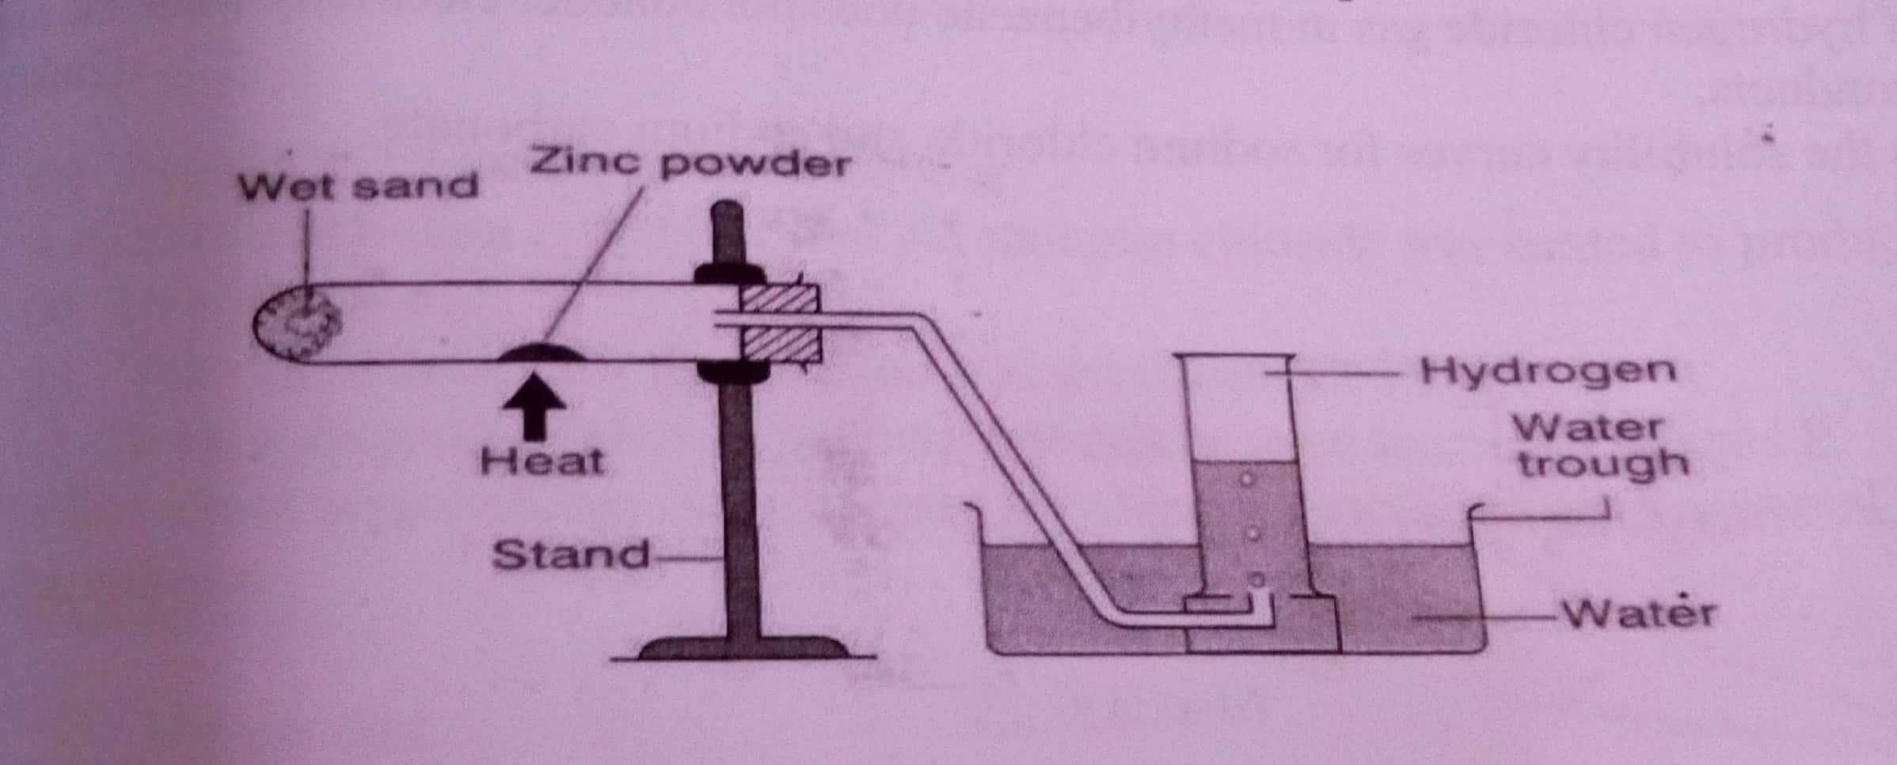
a) Write down the chemical reaction that produces hydrogen gas. (1mrk)
________________________________________________________________________________________________________________________________________________________________________________________________________________________________________________________________________________________________
b) Explain why hydrogen should be burned if not collected over water. (1mrk)
____________________________________________________________________________________________________________________________________________________________________________________________________________________________________________________________________________________
c) Give another metal that can be used instead of Zinc. (1mrk)
_______________________________________________________________________________________________________________________________________________________________________________________________________________

- A piece of sodium metal was placed in a trough half filled with cold water. State the observations that were made. (3mrks)
________________________________________________________________________________________________________________________________________________________________________________________________________________________________________________________________________________________________

- The curves below represents the variation of temperature with time when pure and impure samples of a solid were heated separately.
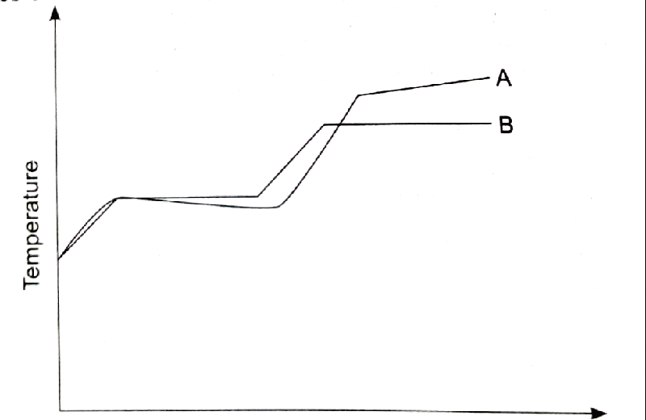

- Which curve shows the variation in temperature of the pure solid. Explain (2Mrks)
____________________________________________________________________________________________________________________________________________________________________________________________________________________________________________________________
- State the effect of impurities in the melting and boiling points of a pure substance. (2Mrks)
______________________________________________________________________________________________________________________________________________________________________________________________________

- Air was passed through several reagents as shown below;
CHAMBER 3
Heated copper turnings
CHAMBER 2
Concentrated
Sulphuric VI acid
CHAMBER 1
Concentrated
Sodium hydroxide
CHAMBER 4
Heated magnesium
Powder
AIR Escaping
Gasses
a.) Name the main inactive component of air (1mk)
b.) Name the components of air that are removed in the following chambers
- Chamber 1
________________________________________________________________________________________________________________________________________________

- Chamber 3
________________________________________________________________________________________________________________________________________________

- Chamber 4
________________________________________________________________________________________________________________________________________________

c.) What is the purpose of passing air through concentrated Sulphuric (VI) acid? (1mk)
__________________________________________________________________________________________________________________________________________________________________________________________________________________________________________

d.)Write a chemical equation for the reaction which takes place in
- Chamber 1
________________________________________________________________________________________________________________________________________________________________________________________________________________________

- Chamber 4
________________________________________________________________________________________________________________________________________________________________________________________________________________________
e.) Explain the observation made in chamber 3 during the reaction. (2mrks)
______________________________________________________________________________________________________________________________________________________________________________________________________________________________________________________________
f.)Name one gas which escapes from the scheme above. (1mrk)
__________________________________________________________________________________________________________________________________________________________________________
7.a) Distinguish between hygroscopy and efflorescence. (2mrks)
________________________________________________________________________________________________________________________________________________________________________________________________________________________________________________________________________________________________________________________
b.)Starting with lead (II) oxide describe how you would prepare Lead (II) sulphate (3mrks)
____________________________________________________________________________________________________________________________________________________________________________________________________________________________________________________________________________________________________________________________________________________________________________________________________________________________________________________________________________________
8.a) discuss the criteria for testing purity of water. (2mrks)
________________________________________________________________________________________________________________________________________________________________________________________________________________________________________________________________________________________________________________________
b.) write the word equations for the reaction between dilute hydrochloric acid and the following.
(i) magnesium oxide

(ii) calcium hydrogen carbonate

(ii) zinc metal
(iv) potassium hydroxide (4mrks)
________________________________________________________________________________________________________________________________________________________________________________________________________________________________________________________________________________________________________________________
9. a) Using dots and crosses to represent electrons, draw a diagram to show bonding in Sodium Chloride(NaCl) (2mrks)

b.) name and draw two apparatus used in measuring exact volumes of solutions in the laboratory (2mrks)

10. Both ions Y²⁻ and Z²⁺ have an electron configuration of 2.8.8
a.) Write the electron arrangement for (2mrks)
Y
____________________________________________________________________________________________________________________________________________________________

Z
____________________________________________________________________________________________________________________________________________________________
b.) What is the mass number of atom Z given that it has 20 neutrons (1mrk)
____________________________________________________________________________________________________________________________________________________________
11. The diagram on the next page shows a set up which was used by a student to investigate the effect of electricity on molten Lead (II) Bromide.

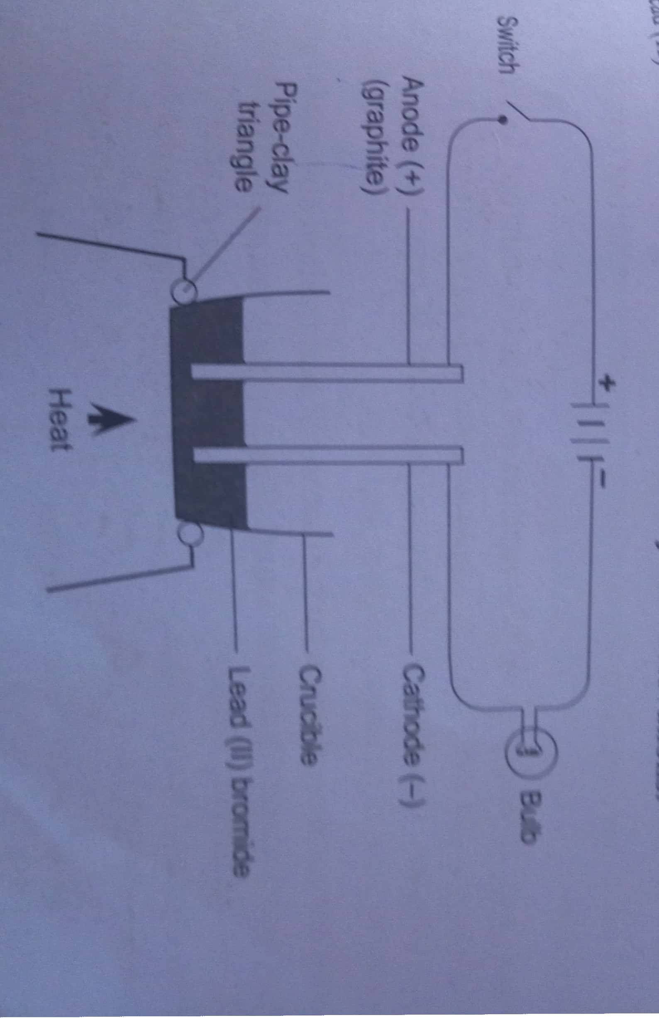

- Explain the observation at the cathode (2mrks)
__________________________________________________________________________________________________________________________________________________________________________________________________________________________________________
- Why does solid lead (II) Bromide not allow the passage of electricity (2mrks)
________________________________________________________________________________________________________________________________________________________________________________________________________________________
c.)Write equations to show the reactions taking place
- At the cathode (1mrk)
_____________________________________________________________________________________________________________________________________________________________________________________________________________________
- At the anode (1mrk)
_____________________________________________________________________________________________________________________________________________________________________________________________________________________

12. Study the set up below and answer the questions that follow
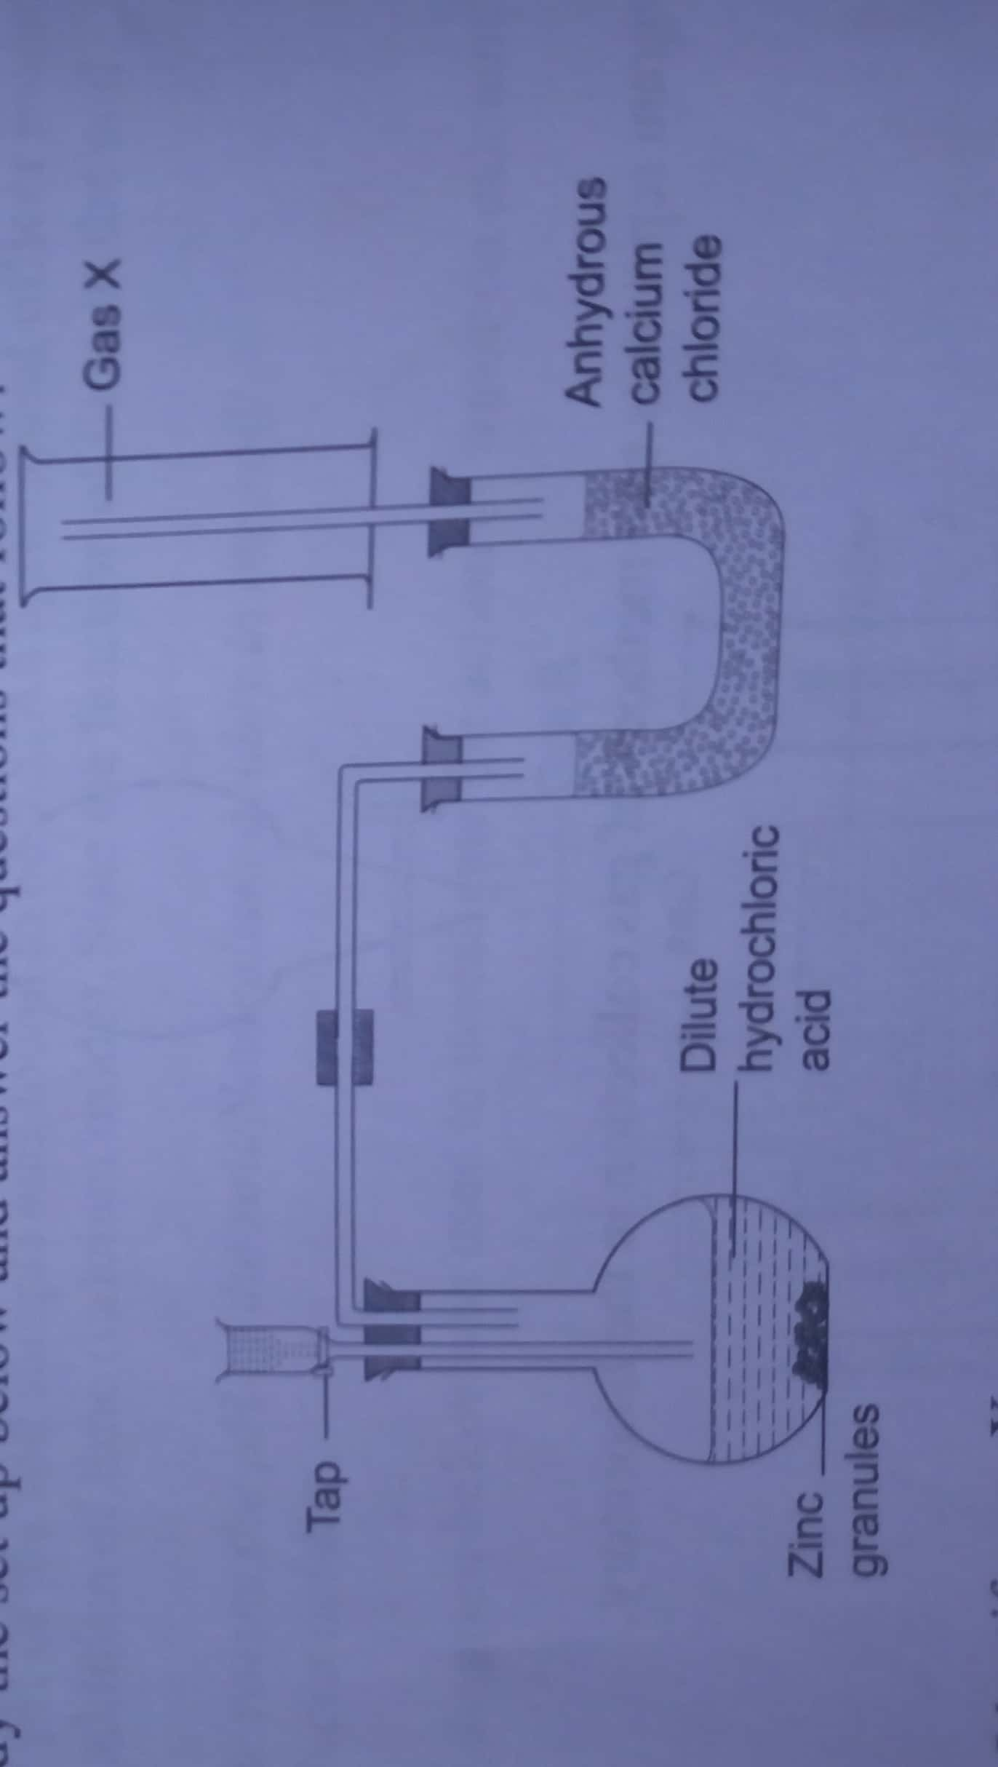
- Identify gas X (1mrk)
_______________________________________________________________________________________________________________________________________________________________________________________________________________________

- Write a chemical equation for the reaction liberating gas X (1mrk)
________________________________________________________________________________________________________________________________________________________________________________________________________________________________________________________________________________________________
- Why is it not advisable to use calcium in this method of preparing gas X? (2mrks)
________________________________________________________________________________________________________________________________________________________________________________________________________________________

- Give the use of anhydrous calcium chloride in the U-tube (1mrk)
________________________________________________________________________________________________________________________________________________________________________________________________________________________

- Name another substance that could serve the same purpose as anhydrous calcium chloride (1mrk)
________________________________________________________________________________________________________________________________________________________________________________________________________________________
- Name the method used to collect gas X (1mrk)
________________________________________________________________________________________________________________________________________________________________________________________________________________________
13. The grid below shows part of the periodic table. Use it to answer the questions that follow.
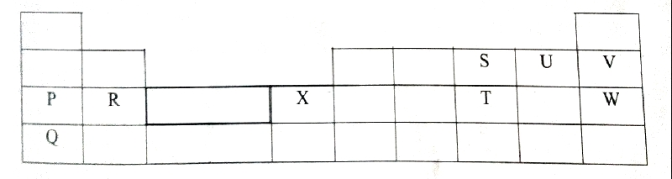
- Which of the elements has the largest atomic radius? Explain (2mrks)
________________________________________________________________________________________________________________________________________________________________________________________________________________________________________________________________________________________________
- Identify the most reactive metal. Explain (2mrks)
________________________________________________________________________________________________________________________________________________________________________________________________________________________________________________________________________________________________

- Name the chemical family to which P and Q belong. (1mrk)
________________________________________________________________________________________________________________________________________________________________________________________________________________________
- Compare the atomic radius of S and U. Explain (2mrks)
________________________________________________________________________________________________________________________________________________________________________________________________________________________________________________________________________________________________________________________________________________________________________
- Select an element that does not form an ion. Explain (2mrks)
________________________________________________________________________________________________________________________________________________________________________________________________________________________________________________________________________________________________

- Give the formula of one stable cation with an electron arrangement of 2.8.8 (1mrk)
__________________________________________________________________________________________________________________________________________________________________________________________________________________________________________
14.a) Define the term isotope (1mrk)
_______________________________________________________________________________________________________________________________________________________________________________________________________________________________________________________________________________________________________________________
b.)Chlorine gas has a relative atomic mass of 35.5. It is made up of two isotopes ³⁵₁₇CL and ³⁷₁₇CL. Determine the relative abundance of each isotope in the chlorine gas. (3mrks)
________________________________________________________________________________________________________________________________________________________________________________________________________________________________________________________________________________________________________________________
15. Write a balanced equation for the decomposition of the following solids (3mrks)
- PbCO_{3(s)} HEAT
________________________________________________________________________________________________________________________________________________

- Na₂CO₃. 10H₂O_{(s)} HEAT
___________________________________________________________________________
- KNO_{3(s)} HEAT
________________________________________________________________________________________________________________________________________________
16. Though Sodium and aluminium are in the same period and are both metals, aluminium is a better conductor of electricity. Explain (2mrks)
________________________________________________________________________________________________________________________________________________________________________________________________________________________________________________________________________________________________________________________________________________________________________________________________________________________________________________________________________________________________________________________________________________________________________________________________________________________________________________

17.(a) List any three uses of oxygen gas` (3mrks)
______________________________________________________________________________________________________________________________________________________________________________________________________________________________________________________________________________________________________________________________________________________________________________________________________
(b) State the conditions necessary for rusting. (2Mrks)
________________________________________________________________________________________________________________________________________________________________________________________________________________________________________________________________________________________________________________________

