Name…………………………………… ………………Adm.No:…………………….

233/2 Candidate’s Signature …………..……………

CHEMISTRY Date……………………..
PAPER 2
THEORY
TIME: 2 HOURS
FORM THREE
EXAMS TERM 3 – 2021
233/2
Chemistry
Paper 2
2 Hours

INSTRUCTIONS TO CANDIDATES
- Write your name and Admission number in spaces provided above.
- Sign and write the date of examination in the spaces provided above.
- Answer all the questions in the spaces provided above.
- KNEC Mathematical tables and Silent electronic calculators may be used.
- All working must be clearly shown where necessary.
- Candidates should answer the questions in English.

For Examiners Use Only
Question | Maximum score | Candidate’s score
1 | 12
2 | 13
3 | 11
4 | 11
5 | 10
6 | 12
7 | 11
Total score | 80
This paper consists of 12 printed pages. Candidates should check to ascertain that all pages are printed as indicated and that no questions are missing.
- A compound D of molar mass 42 was found to have the following composition by mass. Carbon = 85.7 %, and the rest hydrogen. (C=12, H=1)
- Find the molecular formula of the compound. (3mks)
…………………………………………………………………………………..

…………………………………………………………………………………..

…………………………………………………………………………………..

…………………………………………………………………………………..
.
- Draw the structural formula of compound D (1mk)
…………………………………………………………………………………..

…………………………………………………………………………………..

…………………………………………………………………………………..

…………………………………………………………………………………..

- Name the homologous series to which compound D belongs. (1mk)

…………………………………………………………………………………..
- About 5cm³ of compound D was bubbled into a boiling tube containing hydrogen bromide. The mixture was shaken and then allowed to stand for about 2 hours. A new compound K was formed. Name and draw the structural formula of compound K. (2mks)
…………………………………………………………………………………..

…………………………………………………………………………………..

…………………………………………………………………………………..
- Give two functions of compounds to which compound D belongs. (2mks)

…………………………………………………………………………………..

…………………………………………………………………………………..

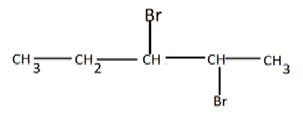
- A compound X reacts with bromine to form another compound W whose structural formula is as follows: -

- Name compound X and W (1mk)
X ………………………………………………………………………………………W ………………………………………………………………………………………

- What observation is made in this reaction? (1mk)

…………………………………………………………………………………..
- Write a balanced equation for the reaction between X and bromine (1mk)

…………………………………………………………………………………..
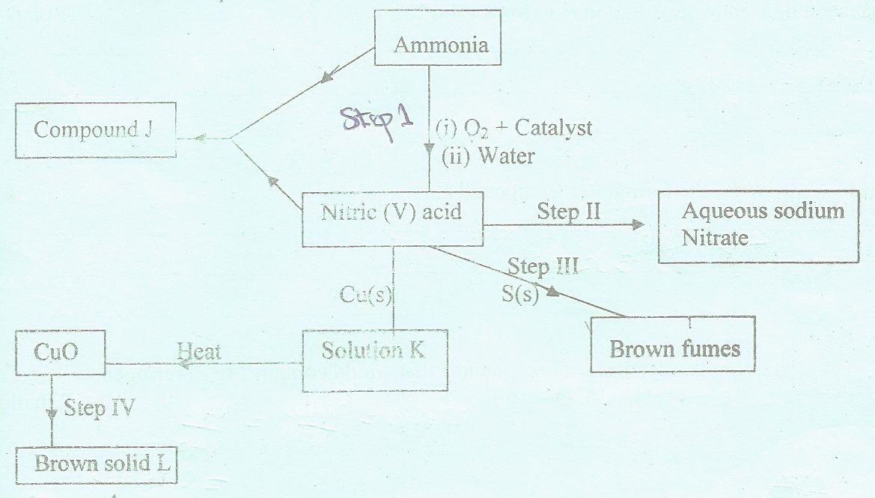
- a) The scheme below shows various reactions starting with ammonia. Study it and answer the questions that follow.

- Name the raw materials used in the manufacture of ammonia. ( 2 mks )

…………………………………………………………………………………..
…………………………………………………………………………………..
- Name a catalyst that is used in step I ? ( 1 mk )
..…………………………………………………………………………..
- Write an equation for the reaction that occurs between ammonia and nitric (V) acid ( 1 mk )

…………………………………………………………………………………..
- Identify the process in step II ( 1 mk )

…………………………………………………………………………………..
- State the condition necessary for the reaction in step III to occur. ( 1 mk )

…………………………………………………………………………………..
- Name solution K ( 1 mk )
………………………………………………………………………………………..
- Write the formula of solid L. ( 1 mk )
………………………………………………………………………………………..

- Calculate the mass of solid L that would be formed by using 12 dm³ of hydrogen at room temperature in step IV (Molar gas volume at r.t.p. = 24 dm³, R.A.M of L = 63.5) ( 3mks)
…………………………………………………………………………………..
…………………………………………………………………………………..
…………………………………………………………………………………..
…………………………………………………………………………………..
(b) (i) Identify the brown fumes in Step III. (1mk)
…………………………………………………………………………………..
(ii) State the property of nitric(V) acid demonstrated by the reaction in Step III above. (1mk)
…………………………………………………………………………………..

3. A form three student was provided with the following reagents:
(i) Solid L; containing 5.0g per litre of a dibasic organic acid H₂X.2H₂O.
(ii) Solution M; which is acidified Potassium manganate(VII)
He was required to standardize solution M using solution L.
A burette was filled with solution M and 25.0 cm³of solution L was pipetted into a conical flask. It was then heated to about 70ºC, the hot solution L was titrated with solution M while shaking the flask thoroughly until a permanent pink colour just appeared. The procedure was repeated two more times and the results entered in table 1 below.
Table 1

 | 1 | 2 | 3
Final burette reading (cm3) | 24.4 | 34.8 | 44.7
Initial burette reading (cm3) | 0.0 | 10.0 | 20.0
Volume of M used (cm3)

(a) Complete the table. (3mks)

(b) Calculate the average volume of solution L used. (1mk)

…………………………………………………………………………………..
(c) Given that the concentration of the dibasic acid is 0.05M, determine the value of X in the formula H₂X.2H₂O (H=1.0,O=16.0) (2mks) …………………………………………………………………………………..
…………………………………………………………………………………..
…………………………………………………………………………………..
…………………………………………………………………………………..
(d) Calculate the number of moles of the dibasic acid H₂X.2H₂O used. (1mk)

…………………………………………………………………………………..

…………………………………………………………………………………..

(e) Given the mole ratio manganate(VII)(MnO₄⁻): acid H₂X is 2:5, calculate the number of moles of manganate(VII) (MnO₄⁻) in the average titre. (2mks)

…………………………………………………………………………………..
…………………………………………………………………………………..

(f) Calculate the concentration of the manganate(VII), (MnO₄⁻) in moles per litre. (2mks)
…………………………………………………………………………………..
…………………………………………………………………………………..
…………………………………………………………………………………..

- Dry hydrogen chloride gas was passed through heated iron wire as shown in the diagram below

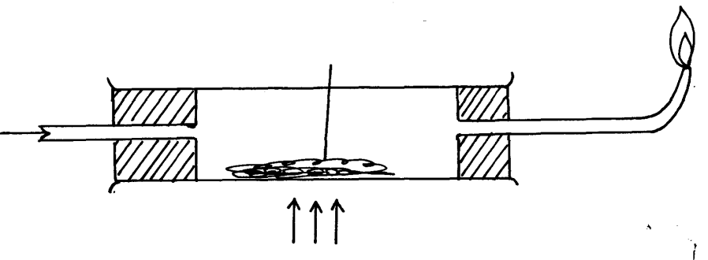
Flame Z
Iron wire

Dry Hydrogen chlorine gas

Heat

- (i) How can the identity of the substance burning with flame Z be confirmed. (1mk)

…………………………………………………………………………………..

(ii) What is observed in combustion tube during the experiment? (1mk)

…………………………………………………………………………………..
(iii) Write the equation for the reaction taking place in the combustion tube. (1mk)
…………………………………………………………………………………… (iv) (iv) Chlorine gas was passed over the product obtained in the combustion tube to give another product Q
a) State one precaution that should be taken. Explain (2marks)

…………………………………………………………………………………..
…………………………………………………………………………………..

b) Identify product Q (1mark)

. …………………………………………………………………………………..

c) The total mass of product Q formed was found to be 5.3g. Calculate the volume of chlorine gas used.(Cl = 35.5, Fe= 56, Molar gas volume at room temperature = 24000cm³ (3marks) ……………………………………………………………………………………

…………………………………………………………………………………..
…………………………………………………………………………………..
…………………………………………………………………………………..
……………………………………………………………………………………

d) Chlorine bleaches by oxidation while Sulphur (IV)oxide does so by reduction. Explain. (2 mks)

…………………………………………………………………………………..
…………………………………………………………………………………..
…………………………………………………………………………………..
5. a) What name is given to a compound that contains carbon and hydrogen only? (1mk)

…………………………………………………………………………………….

b) Hexane is a compound containing carbon and hydrogen .

i) What method is used to obtain hexane from crude oil? (1 mk)

……………………………………………………………………………

ii) State one use of hexane. (1 mk)

………………………………………………………………………….

- Study the flow chart below and answer the questions that follow.

R
L + H₂O
Ca(OH)₂
Gas J
K
Cl H

C C

H H n
CH₃CH₂OH
C₂H₄
CH₃CH₃
step 3
1 mole HCL

step 1
step 2

1 mole H₂
step 4

H₂O Catalyst Ni/ H₂ 150ºc R
step 5 step 6

i) Identify reagent L (1 mk)

………………………………………………………………………………….

ii) Name the catalyst used in step 5. (1 mk)

……………………………………………………………………………………..

iii) Draw the structural formula of J (1 mk)
…………………………………………………………………………………..
…………………………………………………………………………………..
…………………………………………………………………………………..
…………………………………………………………………………………..

iv) What name is given to the process that takes place in step 5? (1 mk)

……………………………………………………………………………………

v) State;
a) One use of product R (1 mk)

……………………………………………………………………………..

……………………………………………………………………………..

b) A commercial application of the process which takes in step 6. (1 mk)

………………………………………………………………………………….

vi) 30cm³ of ethene gas was exploded with 100cm³ of oxygen gas.
Determine the volume of carbon(IV)oxide gas generated. (2mks)

…………………………………………………………………………………..
…………………………………………………………………………………..
…………………………………………………………………………………..
…………………………………………………………………………………..
…………………………………………………………………………………..
…………………………………………………………………………………..
…………………………………………………………………………………..

- Study the periodic grid below and answer the questions which follow. The letters do not represent actual symbols of the elements.
M |  |  |  | Q |  |  | X
 | T |  | C | E |  | U |  | Z
S |  | N |  |  |  |  | Y
(i) To which category of elements does element N belong? (1mk)

………………………………………………………………………………..
(ii) Compare the atomic radius of element E and U. Explain. (2mks)

…………………………………………………………………………………..
…………………………………………………………………………………..
…………………………………………………………………………………..

(iii)An ion A³⁻ has a configuration of 2.8. Place element A on the grid above. (1mk)

(iv) Which of the group 1 elements will require the greatest amount of energy to remove the outermost electron. Explain. (2mks)

…………………………………………………………………………………..
…………………………………………………………………………………..
…………………………………………………………………………………..

(v) Why is element Z used in light bulbs? (1mk)

…………………………………………………………………………………..
(vi) Write the formula of the phosphate of element T. (1mk)

…………………………………………………………………………………..
(vii) State the type of bond and structure found in the oxide of element Q (2 mks)
…………………………………………………………………………………..

(viii) Select from the grid:
The most electropositive element ……………….. (1mk)

The most electronegative element ……………….. (1mk)

- In the preparation of magnesium carbonate, magnesium was burnt in air and the product collected. Dilute sulphuric acid was added and the mixture filtered and cooled. Sodium carbonate was added to the filtrate and the content filtered. The residue was washed and dried to give a white powder.
a) Give the chemical name of the product formed when magnesium burns in air (1mk)

…………………………………………………………………………………..
b) Write a chemical equation for the formation of product in (a) above. (1mk)

…………………………………………………………………………………..

c) Name filtrate collected after sodium carbonate was added (1mk)

…………………………………………………………………………………..

d) Write a chemical equation for the reaction between product in (a) and acid. (1mk)

…………………………………………………………………………………..

e) Write an ionic equation to show the formation of the white powder (1mk)

…………………………………………………………………………………..
f) Write an equation to show what happened when white powder is strongly heated. (1mk)

…………………………………………………………………………………..

- Study the set-up below and answer the questions that follow:

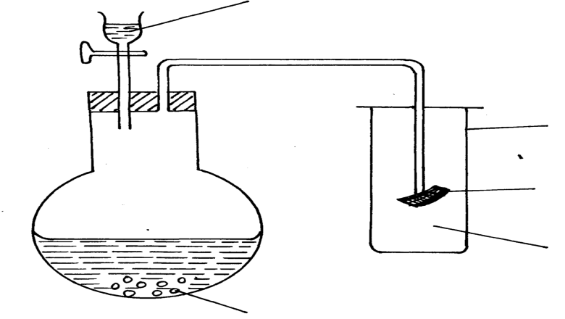
Dilute hydrochloric acid

A gas jar

Red litmus paper

gas x
Sodium sulphite

i) Identify gas X (1mk)

…………………………………………………………………………………..
ii) Write an equation for the reaction that produces gas x. (1mk)

…………………………………………………………………………………..
iii) What is the effect of the gas X above on the red-litmus paper? (1mk

…………………………………………………………………………………..

iv) What observation is made when gas X is bubbled through lead(ii)nitrate solution. Explain. (2 marks)

…………………………………………………………………………………..
…………………………………………………………………………………..

THIS IS THE LAST PRINTED PAGE

