NAME: __________________________________________________ADM No____________

SCHOOL: ………………………………………………………….
CANDIDATE’S SIGN…….....…...…........………
BUSINESS STUDIES FORM THREE.
TERM THREE 2021
565/1
TIME: 2 HOURS

INSTRUCTIONS TO CANDIDATES:

- Write your name and index numbers in the spaces provided
- All answers should be written in the spaces provided in this booklet.

For Examiner’s Use Only

QUESTION | 1 | 2 | 3 | 4 | 5 | 6 | 7 | 8 | 9 | 10 | 11 | 12 | 13 | 14
MARKS

QUESTION | 15 | 16 | 17 | 18 | 19 | 20 | 21 | 22 | 23 | 24 | 25
MARKS

`1. State whether each of the following activities would satisfy basic or secondary wants.
(4 marks)
 | Activities | Basic | Secondary
(a) | Buying clothes for the family.
(b) | Transporting milk.
(c) | Providing food for school children.
(d) | Entertaining the President.

2. Give FOUR reasons why the production in subsistence sector is usually low. (4 Marks)

……………………………………………………………………………………………………………..
……………………………………………………………………………………………………………..……………………………………………………………………………………………………………..……………………………………………………………………………………………………………..
………………………………………………………………………………………………….................
3. Equity bank in Nakuru wishes to change their office layout and adopt an open office layout. Advise them on the advantages of an open office layout. (4 Marks)
……………………………………………………………………………………………………………..
……………………………………………………………………………………………………………..……………………………………………………………………………………………………………..……………………………………………………………………………………………………………..
………………………………………………………………………………………………….................
4. Describe four roles of Nairobi stock exchange as a market a for securities. (4 Marks)
……………………………………………………………………………………………………………..
……………………………………………………………………………………………………………..……………………………………………………………………………………………………………..……………………………………………………………………………………………………………..
………………………………………………………………………………………………….................

5. Outline four reasons why a new business may fail. (4 marks)
……………………………………………………………………………………………………………..
……………………………………………………………………………………………………………..……………………………………………………………………………………………………………..……………………………………………………………………………………………………………..
………………………………………………………………………………………………….................

6. Outline any four measures an organization can take to improve the efficiency of labour in production. (4 Marks)
……………………………………………………………………………………………………………..
……………………………………………………………………………………………………………..……………………………………………………………………………………………………………..……………………………………………………………………………………………………………..
………………………………………………………………………………………………….................
7. Give four reasons for the existence of small firms in the economy despite the advantages experienced by large scale business (4 marks)
……………………………………………………………………………………………………………..……………………………………………………………………………………………………………..……………………………………………………………………………………………………………..
………………………………………………………………………………………………….................

8. Outline FOUR disadvantages of using television in advertising organization’s products. (4 marks)
……………………………………………………………………………………………………………..
……………………………………………………………………………………………………………..……………………………………………………………………………………………………………..……………………………………………………………………………………………………………..
………………………………………………………………………………………………….................

9. Highlight four advantages of a bonded warehouse to the government. (4 marks)
……………………………………………………………………………………………………………..
……………………………………………………………………………………………………………..……………………………………………………………………………………………………………..……………………………………………………………………………………………………………..
………………………………………………………………………………………………….................

10. Outline four implications of a rapid growing population in a country. (4 marks)
……………………………………………………………………………………………………………..
……………………………………………………………………………………………………………..……………………………………………………………………………………………………………..……………………………………………………………………………………………………………..
………………………………………………………………………………………………….................
11. State four ways in which the utility of a commodity can be increased. (4 marks)
……………………………………………………………………………………………………………..
……………………………………………………………………………………………………………..……………………………………………………………………………………………………………..……………………………………………………………………………………………………………..
………………………………………………………………………………………………….................
12. Outline four external factors that may influence the operations of a business negatively.(4 Marks)

……………………………………………………………………………………………………………..
……………………………………………………………………………………………………………..……………………………………………………………………………………………………………..……………………………………………………………………………………………………………..
………………………………………………………………………………………………….................

13. Highlight four causes of unemployment in Kenya. (4 Marks)
……………………………………………………………………………………………………………..
……………………………………………………………………………………………………………..……………………………………………………………………………………………………………..……………………………………………………………………………………………………………..
………………………………………………………………………………………………….................

14. The following balances relate to the business of Roba Traders during the period ended 31st March 2014.
Shs.
Cash at bank 680,000
Premises 500,000
Machinery 175,000
Creditors 190,000
Furniture 85,000
Motor van 200,000
Cash in hand 50,000
Capital 1,000,000
Sales 500,000
Extract the trial balance of Roba Traders as at 31st March 2014. (4mks)

15. Outline four factors that may give rise to monopoly power in an economy. (4mks
……………………………………………………………………………………………………………..
……………………………………………………………………………………………………………..……………………………………………………………………………………………………………..……………………………………………………………………………………………………………..
………………………………………………………………………………………………….................

16. Outline four requirements for one to start a limited liability company as one of the forms of business units. (4 mks)
……………………………………………………………………………………………………………..
……………………………………………………………………………………………………………..……………………………………………………………………………………………………………..……………………………………………………………………………………………………………..
………………………………………………………………………………………………….................

17. Below is a demand and supply curve.
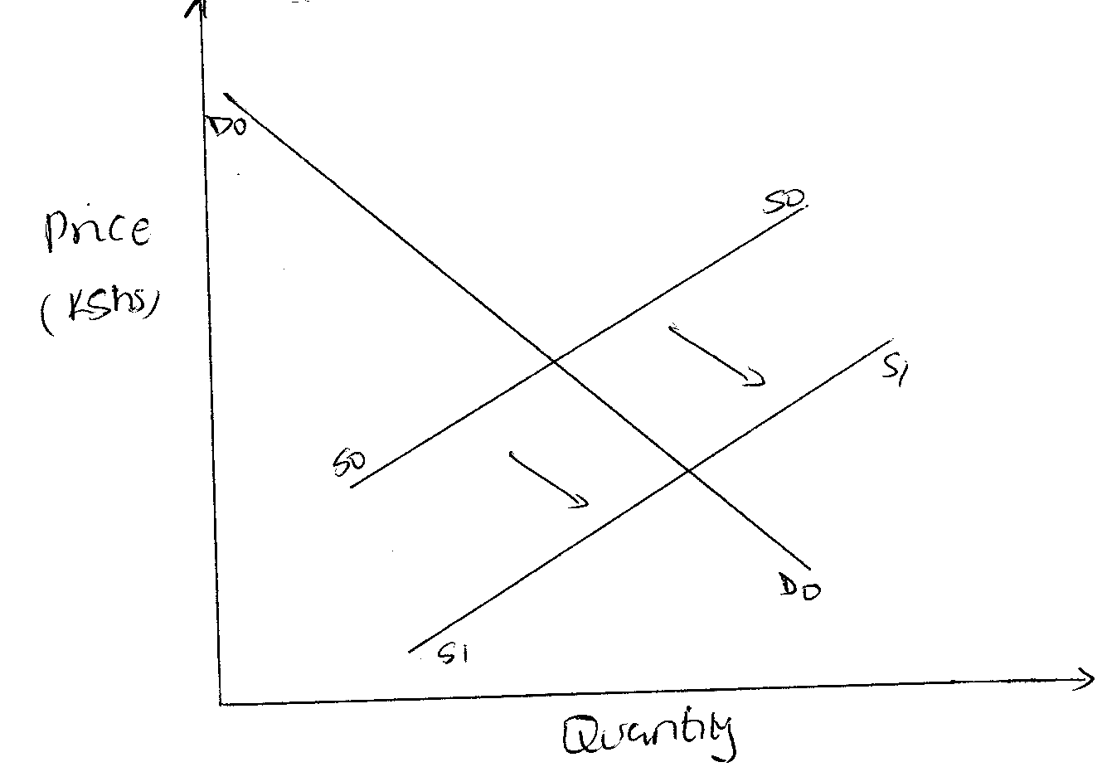

Highlight the factors that may have led to the above behavior. (4 mks)
……………………………………………………………………………………………………………..
……………………………………………………………………………………………………………..……………………………………………………………………………………………………………..……………………………………………………………………………………………………………..
………………………………………………………………………………………………….................

18. Outline four factors that would lead to increase in national income of a country. 4mrks
……………………………………………………………………………………………………………..
……………………………………………………………………………………………………………..……………………………………………………………………………………………………………..……………………………………………………………………………………………………………..
………………………………………………………………………………………………….................

19 Define the following terms as used in insurance. (4 Marks)

(i). Insured……………………………………………………………………………………………………………………………………………………………………………………………………………
(ii). Risk…………………………………………………………………………………………………………………………………………………………………………………………………………………...
(iii) Premium……………………………………………………………………………………………………………………………………………………………………………………………………………..
(iv).Sum insured ………………………………………………………………………………………………………………………………………………………………………………………………………………………………
20. Enter each of the following transactions in the relevant ledger accounts. (4 Marks)
- Started business in June 15th 2014 with Ksh. 500,000 in bank.
- Bought a motor vehicle in June 16th 2014 for KSh. 250,000, payment made by a cheque.

21. State FOUR features of chain stores. (4 Marks)

……………………………………………………………………………………………………………..
……………………………………………………………………………………………………………..……………………………………………………………………………………………………………..……………………………………………………………………………………………………………..
………………………………………………………………………………………………….................

22. Identify the machine used to perform the following tasks. (4 Marks)

- To count coins and notes
- To trim paper into required sizes and shapes
- To fold documents, place them in envelope and seal the envelope
- To print postage impression on envelopes

23. Outline four ways which the government can use to influence the supply of maize in Kenya. (4 Marks)
……………………………………………………………………………………………………………..
……………………………………………………………………………………………………………..……………………………………………………………………………………………………………..……………………………………………………………………………………………………………..
………………………………………………………………………………………………….................

24. Give FOUR reasons why a consumer should satisfy basic wants before secondary wants. (4mks)
……………………………………………………………………………………………………………..
……………………………………………………………………………………………………………..……………………………………………………………………………………………………………..……………………………………………………………………………………………………………..
………………………………………………………………………………………………….................

25. State four factors that an entrepreneur would consider before investing in a business opportunity. (4mks)
……………………………………………………………………………………………………………..
……………………………………………………………………………………………………………..……………………………………………………………………………………………………………..……………………………………………………………………………………………………………..
…………………………………………………………………………………………………................

