BIOLOGY FORM ONE TERM 3 YEAR 2021

NAME………………………………………………ADM.NO………………CLASS………..

INSTRUCTIONS
- Write your name and admission number in the spaces provided.
- Answer all questions in the space provided
- This paper consists of all printed pages and ensure no blank pages.

- Differentiate between Botany and Zoology (2 mks)
………………………………………………………………………………………………………………………………………………………………………………………………………………………………………………………………………………………………
- Motor vehicle move, use energy and produce carbon iv oxide and water similar characteristics occur in living organisms yet motor vehicles are not classified as living organism. Explain (2 mks)
……………………………………………………………………………………………………………………………………………………………………………………………………………………………………………………………………………………………….
……………………………………………………………………………………………….

- List skills that are gained on studying Biology (2 mks)
………………………………………………………………………………………………………………………………………………………………………………………………………………………………………………………………………………………………
………………………………………………………………………………………………
- Give three difference between the light and electron microscopes
Light microscope Electron microscope (3 mks)

…………………………… …………………………….
…………………................ ……………………………
……………………………. ……………………………..
…………………………….. …………………………….
A
B

C

- The diagram above was obtained from a certain organism.
- Identify the structure (1 mk)
………………………………………………………………………………………..
………………………………………………………………………………………..
- Which type of microscope was used to view the structure (1 mk)
………………………………………………………………………………………..
………………………………………………………………………………………..
……………………………………………………………………………………….

- Name the parts labelled (2 mks)
B ………………………………..

C………………………………..

- State the function of the part labelled A (2 mks)
…………………………………………………………………………………………
…………………………………………………………………………………………
- State the functions of the following parts of a light microscope
- Diaphragm ………………………………. (1 mk)
- Objective lens ……………………………. (1 mk)
- Explain the importance of doing the following when testing a leaf for starch (4 mks)
- Boiling the leaf in water ………………………………………………………….
……………………………………………………………………………
- Boiling the leaf in methlylated spirit ………………………………………..
……………………………………………………………………………….
- Boiling the methylated spirit in water bath ………………………………………………
………………………………………………………………………………..
- Placing a potted plant in the sun for 5 hours……………………………………
…………………………………………………………………………………..
- Describe what happens during the light stage of photosynthesis (3 mks)
……………………………………………………………………………………………
……………………………………………………………………………………………
……………………………………………………………………………………………

- State two factors that affect enzymatic activities (2 mks)

……………………………………………………………………………………………
……………………………………………………………………………………………
- State a function of the large intestine in humans (1 mk)
……………………………………………………………………………………………..
……………………………………………………………………………………………..
- State the role of
- Vitamin C in human (1 mk)
…………………………………………………………………………………
…………………………………………………………………………………
- Iron in humans (1 mk)
……………………………………………………………………………………
……………………………………………………………………………………
- State two roles of HCL in the stomach (2 mks)
…………………………………………………………………………………………..
…………………………………………………………………………………………..
- a) Complete the table given below (3 mks)
Eye –piece lens magnification | Objective lens magnification | Total magnification
X 5  X 10  ______ | _______  X5  X10 | X20  _______  X100
b) State two activities of the cell that are controlled by nucleus (2 mks)
……………………………………………………………………………………….
……………………………………………………………………………………….
…………………………………………………………………………………………
…………………………………………………………………………………………
c) Identify the specialized cell illustrated below (1 mk)
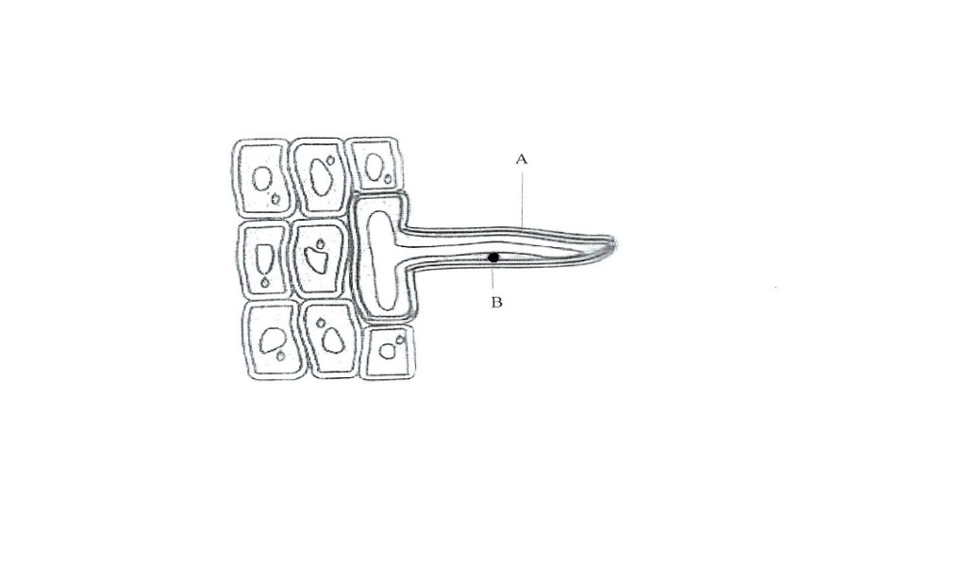

- ………………………………………………. (1 mk)

- Name the parts labelled (2 mks)
A…………………………………..

B…………………………………..

- What is Binomial nomenclature (1 mk)
………………………………………………………………………………………
………………………………………………………………………………………
- Name the organelles that would be found in large numbers in cells of a:
- Rapidly respiring tissue (1 mk)
……………………………………………………………………………………
……………………………………………………………………………………
- Secretory gland (1 mk)
…………………………………………………………………………………..
………………………………………………………………………………….
- State the function of each of the following tissues
- Meristematic (1 mk)
…………………………………………………………………………………..
…………………………………………………………………………………..
- Blood (1 mk)
……………………………………………………………………………………
…………………………………………………………………………………….
- Differentiate between plasmolysis and crenation (2 mks)
…………………………………………………………………………………………….
…………………………………………………………………………………………….
…………………………………………………………………………………………….
- The scientific name of an onion is Allium cepa Identify the genus and the species to which the organism belongs (2 mks)
- genus…………….

species…………….

- Outline three functions of carbohydrate in living organism (2 mks)
……………………………………………………………………………………………………………………………………………………………………………………
…………………………………………………………………………………………
- What are the building blocks of proteins (1 mk)
…………………………………………………………………………………………
………………………………………………………………………………………….
- Give two factors that determine energy requirement in human beings (2 mks)
………………………………………………………………………………………….
…………………………………………………………………………………………..
…………………………………………………………………………………………..
- Name the monosaccharides that make up the following substances
- Sucrose………………………. (1 mk)

- Lactose …………………………. (1 mk)

- The table below shows the number of teeth in the jaws of an animal
 | Canines | Incisors | Premola | Molars
Upper jaw | 0 | 0 | 6 | 4
Lower jaw | 8 | 0 | 6 | 6

- Write the dental formula of the organism (1 mk)
………………………………………………………………………………………….
………………………………………………………………………………………….
- i) State the mode of feeding of this animal (1 mk)
………………………………………………………………………………………….
…………………………………………………………………………………………..
- Give two reasons for your answer (2 mks)
………………………………………………………………………………….
………………………………………………………………………………….
- Name any two dental diseases (2 mks)
…………………………………………………………………………………………………………………………………………………………………….
- The diagrams below represents common equipment used by Biologists
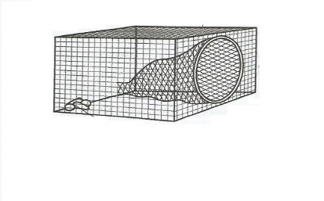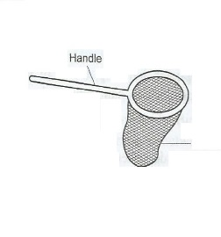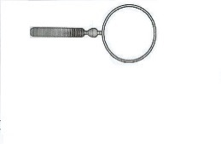
Q
P
O

- Identify the equipment
O……………………………….. (1 mk)

P………………………………. (1 mk)

Q………………………………. (1 mk)

- a) Give the uses of the following apparatus (2 mks)
- Speciment bottle
……………………………………………………………………………….
- Pooter
…………………………………………………………………………………
- State two necessary precautions to be observed when collecting specimens (3 mks)
……………………………………………………………………………
……………………………………………………………………………
……………………………………………………………………………
- Name the carbohydrate that is
- Stored in plant seeds (1 mk)
………………………………………………………………………
- Stored in mammalian muscles (1 mk)
………………………………………………………………………
- Most abundant in human blood (1 mk)
………………………………………………………………………

- A group of students set up the experiment below to investigate a certain physiological process
Set up A
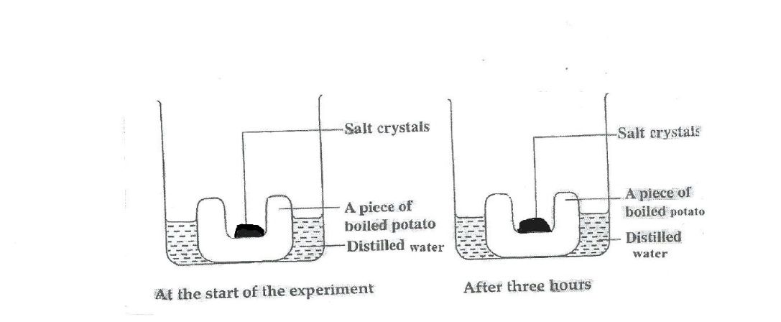
Set up B
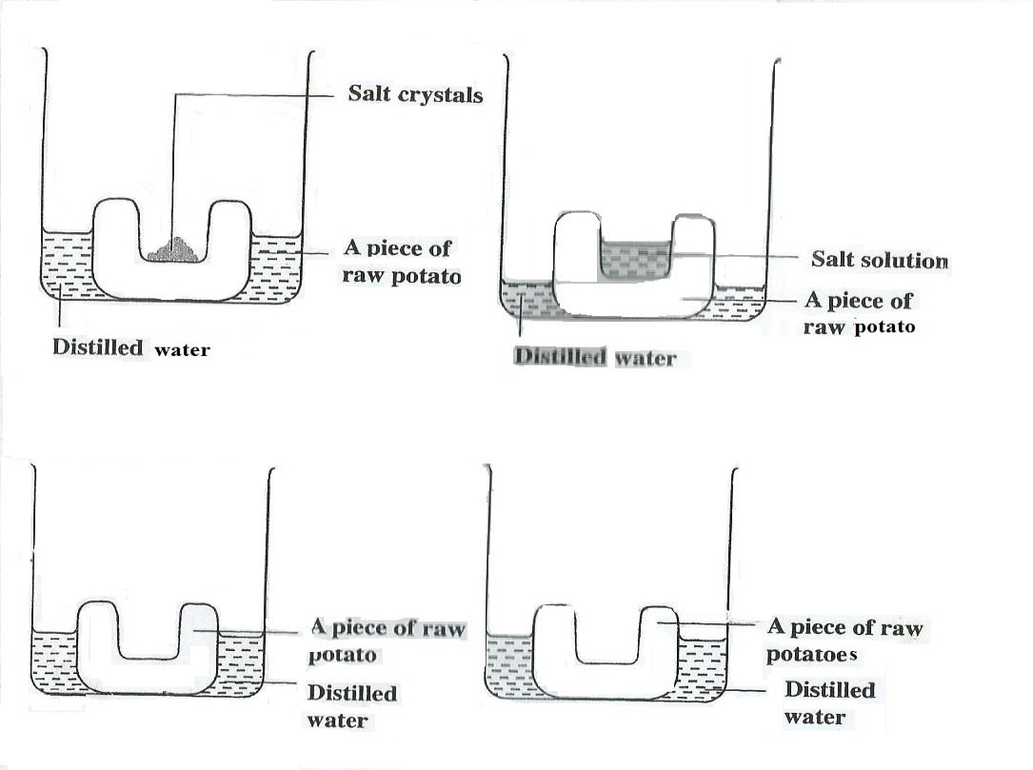
At the start of the experiment After three hours
Set up C

At the start of the experiment After three hours
Set up C
At the start of the experiment After three hours
- Name the physiological process being investigated (1 mk)
………………………………………………………………………………………

- Account for the results in set-up A and B
A………………………………

B……………………………….

- What was the purpose of set-up C? (1 mk)
………………………………………………………………………………….
…………………………………………………………………………………..
- Name two structures found in plant cell that are absent in animal cell (2 mks)
……………………………………………………………………………………………
……………………………………………………………………………………………
a) Define active transport (1 mk)
………………………………………………………………………………………………
b) What is the significance of active transport in living organisms (2 mks)
……………………………………………………………………………………………..
…………………………………………………………………………………………….
…………………………………………………………………………………………….

