NAME………………………………………ADM NO. ……………………….
CLASS……………..……………………….DATE…………………………….
END OF TERM 3 YEAR 2021
BIOLOGY FORM 3
Paper 1
(Theory)
2 hours

Instructions to candidates
- Write your name and index number in the spaces provided above
- Sign and write the date of examination in the spaces provided above
- Answer ALL the questions in the spaces provided
- This paper consists of 9 printed pages.
- Candidates should check the question paper to ascertain that all the pages are printed as indicated and that no questions are missing.

For Examiner’s Use Only
Questions | Maximum Score | Candidates Score
1-26 | 80

- a)State two characteristics that are specific to plants (2mks)
...................................................................................................................................................................................................................................................................................................................................................
b) Name three mechanisms that ensure cross pollination takes place in flowering plants. (3mks)
……………………………………………………………………………………………………………………………………………………………………………………………………………………………………………………………………………………………………………………………………………..
- a) State two differences between complete and incomplete metamorphosis. (2mks)

………………………………………………………………………………………………………………………………………………………………………………………………………………………………
b) State the importance of moulting to an insect. (2mks)
................................................................................................................................................................................................................................................................................................................................................
- A student collected an organism and observed the following features: simple eyes, four pairs of legs and two body parts.
- State the class to which the organism belongs. (1 mark)
…………………………………………………………………………………………………..

- Give an example of an organism in this class. (1 mark)
…………………………………………………………………………………………………….

- Name the kingdom to which plasmodium belongs (1 mark)
………………………………………………………………………………………………….

- Name the three end products of anaerobic respiration in plants. (3 marks)
…………………………………………………………………………………………………………………………………………………………………………………………………………………………………………………………………………………………………………………………………………….
- State two reasons why accumulation of lactic acid leads to an increase in heart beat. (2 marks)
………………………………………………………………………………………………………………………………………………………………………………………………………………………………
- Name the flower parts that produces gametes. (2 marks)
………………………………………………………………………………………………………………………………………………………………………………………………………………………………
- What is meant by the following terms? (2 marks)
- Ecology
……………………………………………………………………………………………………………………………………………………………………………………………………
- Carrying capacity
…………………………………………………………………………………………………………………………………………………………………………………………………….
- How is the human sperm cell structurally adapted? (2 marks)
……………………………………………………………………………………………………………………………………………………………………………………………………………………………………

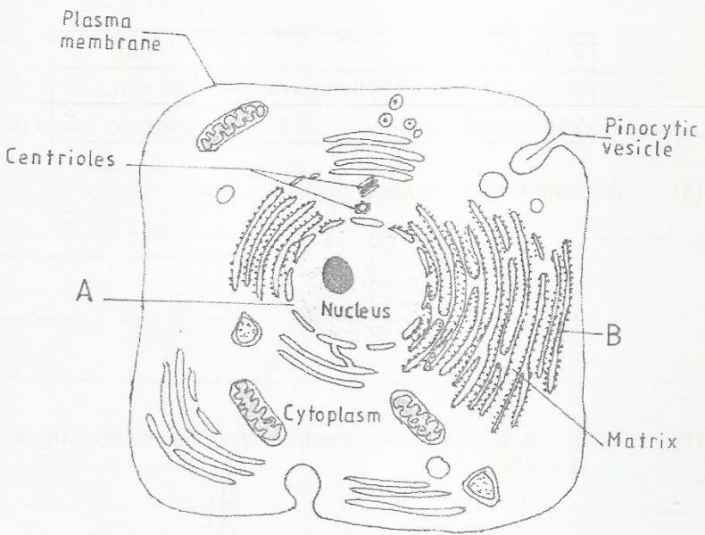
- The figure below is a fine structure of a generalized animal cell as seen under an electron microscope.

(a) Name the parts labeled A and B. (2 marks)
A………………………………………………………………………
B………………………………………………………………………
(b) How is the structure labeled B adapted to its function? (2 marks)
……………………………………………………………………………………………………………………………………………………………………………………………………………………………..
- What name is given to a group of hormones that controls the development of secondary sexual characteristics in a human male? (1 mark)
…………………………………………………………………………………………………………….
- Name two substances that leave the foetal blood through the placenta (2 marks)
………………………………………………………………………………………………………………………………………………………………………………………………………………………………
- Name two nutrients that are absorbed without being digested by enzymes in humans.(2 marks)
…………………………………………………………………………………………………………………………………………………………………………………………………………………………...
- State one use for each of the following apparatus in the study of living organisms. (2 marks)
- Pooter
……………………………………………………………………………………………………….
- Pitfall trap
……………………………………………………………………………………………………..

- The figure below illustrates a food web in a certain ecosystem.
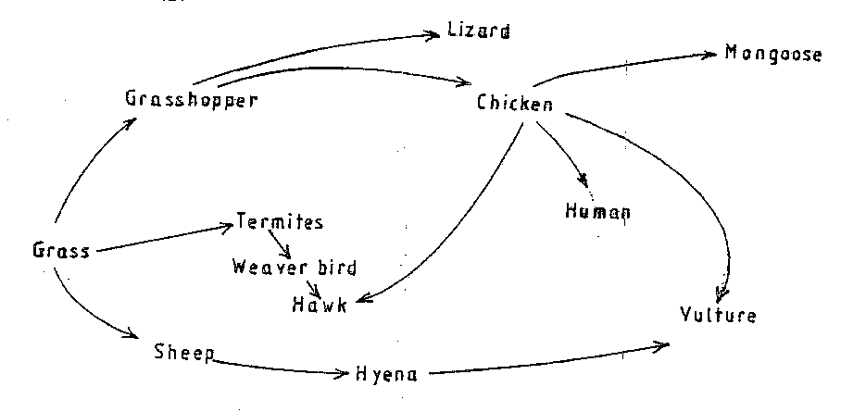

From the food web:
- Draw the shortest food chain; (2 marks)

- Identify the organisms with the highest
- Number of predators (1 mark)
………………………………………………………………………………………………
(ii) Biomass (1 mark)
………………………………………………………………………………………………..
- State two functions of the following parts of a light microscope.
- Fine adjustment knob (2 marks)
…………………………………………………………………………………………………………………………………………………………………………………………………………….
- Stage (2 marks)
……………………………………………………………………………………………………………………………………………………………………………………………………………………………..
- The diagram below represents a certain plant.

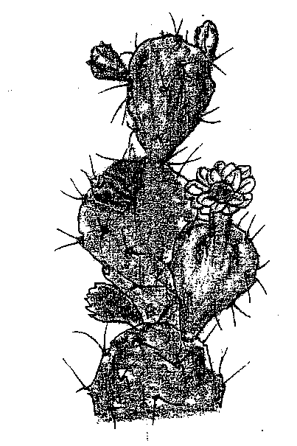
- What is the likely habitant of the plant? (1 mark)
……………………………………………………………………………………………………

- Give two reasons for your answer in (a) above. (2 marks)
…………………………………………………………………………………………………………………………………………………………………………………………………………………………….
- The number of stomata on the lower and upper surface of two leaves from plant X and Y were counted under the field of view of a light microscope. The results were as shown in the table below.
Leaf | Number of stomata
 | Upper surface | Lower surface
X | 4 | 12
Y | 20 | 23

- Which of the leaves would be expected to have a lower rate of transpiration? (1 mark)
………………………………………………………………………………………………………

- Given a reason for your answer in (a) above (2 marks)
……………………………………………………………………………………………………………………………………………………………………………………………………………..
- The diagram below represents a transverse section of an ovary from a certain flower.
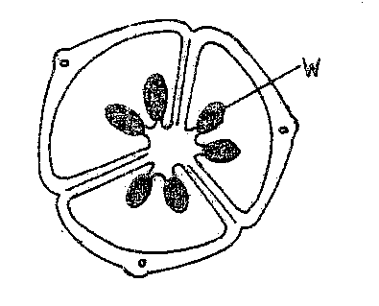
- (i) Name the structure labeled W (1 mark)
…………………………………………………………………………………………………………….

- Name the type of placentation illustrated in this diagram. (1 mark)
…………………………………………………………………………………………………..

- Give an example of a fruit that show the type of placentation illustrated in this diagram. (1 mark)
……………………………………………………………………………………………………….

- The diagram below illustrates the structure of bread mould.

- Name the part labeled J (1 mark)
………………………………………………………………………………………………………….
- State the function of the structure labeled K (2 marks)
……………………………………………………………………………………………………………………………………………………………………………………………………………………………….
- What is meant by the following term?
- Habitat; (1 mark)
…………………………………………………………………………………………………….
- Ecosystem (1 mark)
……………………………………………………………………………………………………….
- State two ways by which acquired Immune deficiency syndrome (A.I.D.S) Virus is transmitted. ( 2 mks)
……………………………………………………………………………………………………………………………………………………………………………………………………………………………..
- Figures 1 and 2 below represent reproductive organ of plants and an animal respectively.

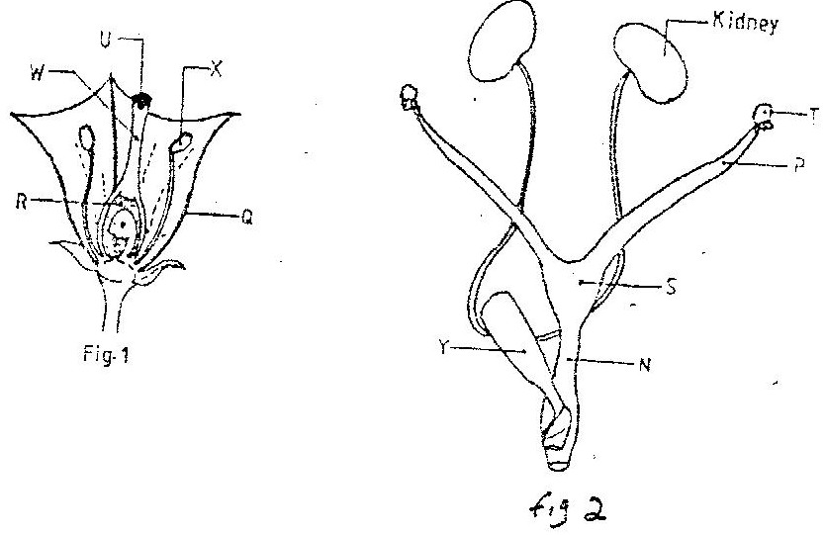

  - Which letters in figures 1 and 2 represents the organs that produce female gametes? (2mks)
Figure 1…………………………………………….
Figure 2…………………………………………………
  - What is the function of the structure labeled S? (2mks)
……………………………………………………………………………………………………………………………………………………………………………………………………………………
  - Name the structure labeled W (1mk)
…………………………………………………………………………………………………………
  - Which letters in figures 1 and 2 represents the structures where fertilization takes place (2mks)
............................................................................................................................................................................................................................................................................................................................
  - Which letter in figure 1 represents the structure where male gametes are produced (1mk)
...........................................................................................................................................................
- What is the function of the following structures in the human reproductive organ?
- Fallopian tubes. (2 mark)
………………………………………………………………………………………………………………………………………………………………………………………………………………
- Epididymis (1 mark)
…………………………………………………………………………………………………………………………………………………………………………………………………………………
- Scrotal sac (2 mark)
……………………………………………………………………………………………………………………………………………………………………………………………………………………

- State any three fruit and seed dispersal mechanisms (3mks)
………………………………………………………………………………………………………………………………………………………………………………………………………………………………………………………………………………………………………………………………
- A student observing a leg of an insect under a hand lens made a drawing of the leg whose length was 4cm a width magnification of X2.what was the actual length of the leg? (3mks)
……………………………………………………………………………………………………………………………………………………………………………………………………………………………………………………………………………………………………………………………..
- Give two reasons why mitosis is important to organisms. (2mks)
………………………………………………………………………………………………………………………………………………………………………………………………………………………………………………………………………………………………………………………………

THIS IS THE LAST PRINTED PAGE

