BIOLOGY MARKING SCHEME PAPER 3

MARKING SCHEME

SUBSTANCE | FOOD SUBSTANCE BEING TESTED FOR | PROCEDURE | OBSERVATION | CONCLUSION
M | Reducing Sugars√ | Put about 2cm³ of M into a test tube.  Add equal amount of Benedict’s solution; and / heat to boil; (2mks) | Co colour changes from blue to green and yellow. / colour changes from blue to green. (½ mk)  ( | Reducing sugars present / little reducing sugar is present;√ (½ mk)
 | Proteins√ | (To M)  Add (10%) sodium hydroxide solution then (1%) copper sulphate solution√ (drop wise)(1mk) | Colour changes to purple  (½ mk) | Proteins present √(½ mk)
 | Lipids√ | Pour a drop of M onto the filter paper and dry√(1mk) | No permanent translucent spot formed√.(½ mk) | Lipids absent;√ (½ mk)
N | Reducing sugars | (To N) add Benedict’s solution and / heat to boil / boil | Colour changes from blue to green;√ (½ mk) | Little / traces reducing sugars present √(½ mk)
 | Proteins | (To N) add (10%) sodium hydroxide solution then (1%) copper sulphate solution ( drop wise) | Colour changes to purple  (½ mk) | Proteins present;√ (½ mk)
 | Lipids | Pour a drop of N onto the filter paper and dry. | A permanent translucent spot forms √(½ mk) | Lipids present;√ (½ mk)

b) Reducing sugars;
- Source of energy when oxidized
- Are condensed to form starch for storage in plants / glycogen for storage in animals
Proteins
- Forms structures in living organisms
- Forms metabolic regulators / enzyme / hormones
- Source of energy during starvation;

2.a)
X | Y
Xylem in a ring | Xylem star shaped
No root hair | Presence of root hair
Pith present | Pith absent

b)
.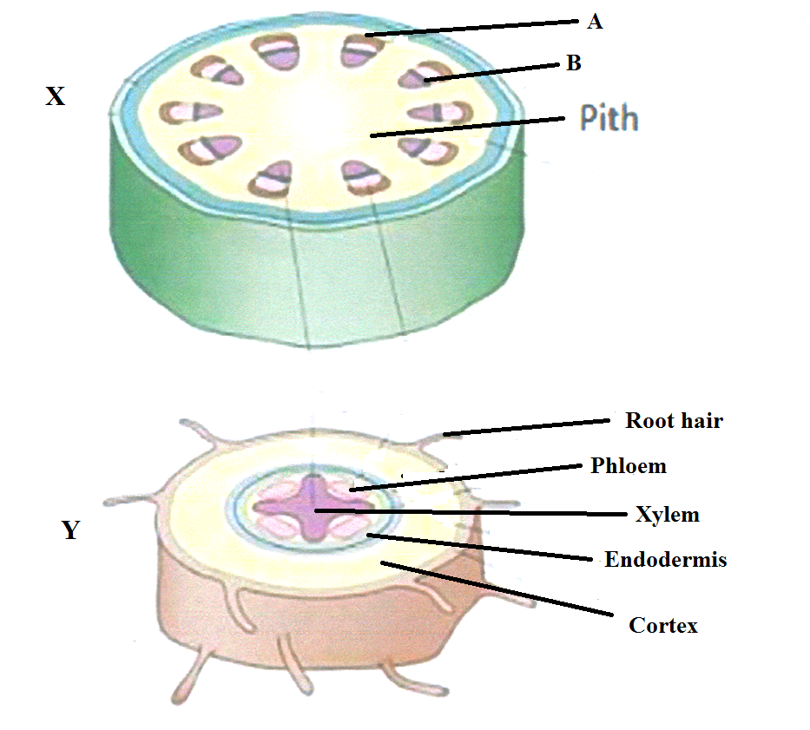
c). A Sclerenchyma;- provide strength and support
B ; cambium; -Give rise to new Xylem and new phloem/secondary growth
d). In monocots, the vascular bundle is scattered in the ground tissue; No pith; No cambium;

3. a) Drupe
b) M – wind dispersal; – has hair like structures to increase surface area so that they can be blown by wind;
K- Animal dispersal; – has persistent calyx to attach to the animals;
N – Wind dispersal; – has extended pericarp to increase surface area so that it can be blown by wind;

