AGRICULTURE

SECTION A (30Marks)
- State four factors that influence soil formation. (2Mrks)

- Name four aspects of rainfall a farmer will consider in crop production. (2Mrks)

- Define the following terms (1 ½ Mrks)
- Pomology

- Soil profile

- Minimum Tillage

- State the disadvantages of shifting cultivation. (2Mrks)

- State three ways in which soil PH influence plant growth and production (1 ½ Mrks)

- State four characteristics of Topsoil (Horizon A) (2Mrks)

- Differentiate between the following terms (2Mrks)
- Drenching gun and bolus gun.

- Rolling and sub soiling.

- List four methods of land clearing. (2Mrks)

- Name four types of water pumps. (2Mrks)

- State four importance of drainage. (2Mrks)

- State three conditions under which irrigation should be practiced (1 ½ Mrks)

- State three characteristics of a well rotten manure. (1 ½ Mrks)

- Name four types of beef cattle breeds (2Mrks)

- State the meaning of the following terms (2Mrks)
- Billy

- Buck

- Capon

- Boar

- Differentiate between Bactrian and Dromedary. (1Mrk)

- Name two types of labor records (1Mrk)

- Name two examples of metal pipes commonly used on the farm (1Mrk)

- Differentiate between pumping and piping (1Mrk)

SECTION B (20 Marks) ANSWER ALL QUESTIONS
19.
c)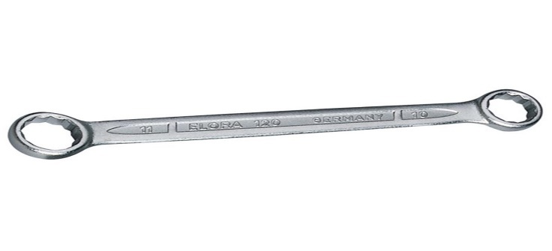
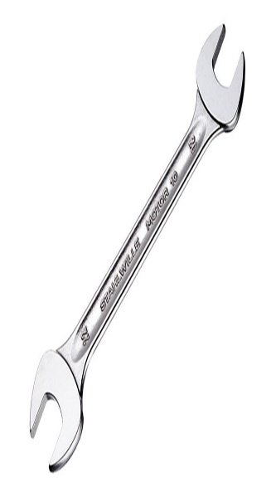b
a

A) Name the above tools. (3mrks)
a –

b –

C –

B) State the functional difference between tool a and b. (1mrk)

20

a 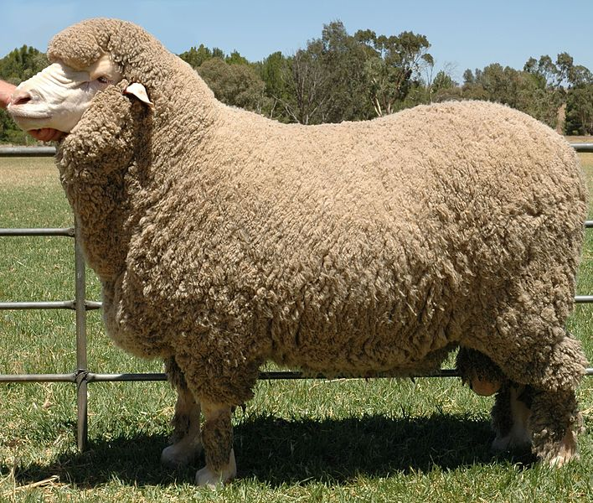
b

c

i) Name the sheep breed above (½ mrks)

ii) Name the following parts labelled (1 ½ mrks)
A.
B.
C.

iii) State three characteristics of the above breed (3mrks)

21.
Z
Y
X
X

Field (1Mrk)
- Identify the method used in preparation of organic manure

- State the purpose of the following in organic manure preparation. (3mrks)
- Manure –

- Ash –

- Top soil –

- For how long does it take for the organic manure to be turned? (1mrk)

22.a Name the type of irrigation below. (1mrk)

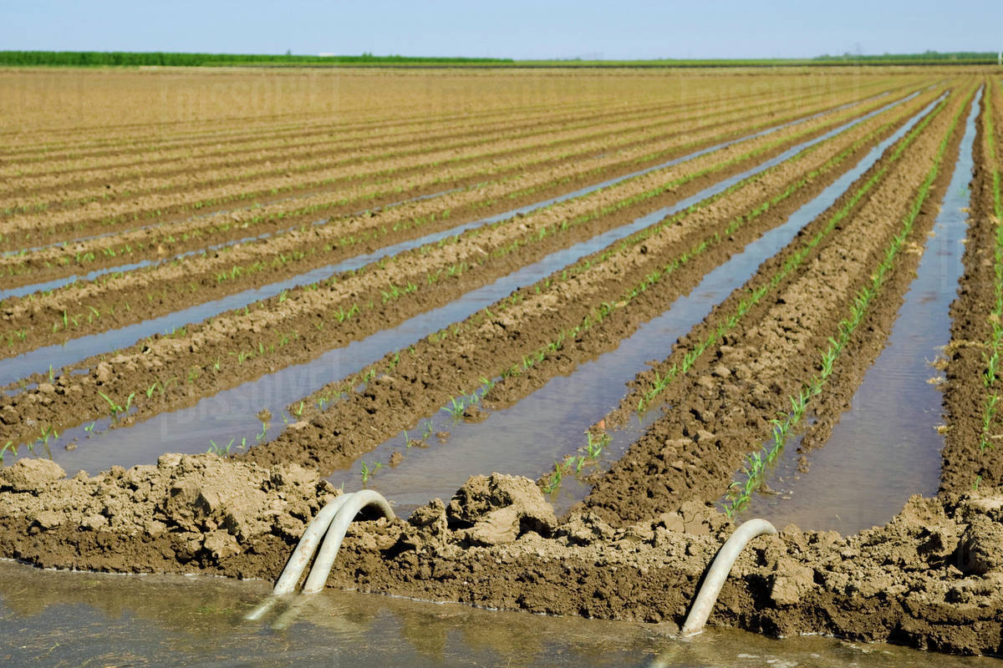

b.) State three factors to consider when choosing the above method of irrigation.(3mrks)

c.) Give two advantages of the above type of irrigation. (2mrks)

SECTION C (40 Marks) ANSWER ANY TWO QUESTIONS
23.a) Name four methods of farming (2mrks)

b) State five characteristics of small scale farming (5mrks)

c) Explain five reasons why agriculture is referred as a science (5mrks)

d) Discuss four harmful Biotic factors that affect agricultural production (10mrks)

24. a) Explain five ways of maintaining soil fertility. (10mrks)

b) Describe five characteristics of a fertile soil that influence crop productivity (10mrks)

25.a Discuss the process of water treatment by chemical method (12mrks)

b)Describe four methods of drainage (8Mrks)

