NAME………………………………………………………………….ADM…………………
DATE…………………………………………………………………SIGN………………….

AGRICULTURE FORM TWO
END OF TERM THREE 2021

INSTRUCTIONS TO STUDENTS
This paper has three sections A,B and C
Answer ALL the questions in section A and B in the spaces provided
Answer only TWO questions in section C in the spaces provided

FOR EXAMINERS USE ONLY
SECTION | MAXIMUM SCORE | STUDENTS SCORE
A | 30
B | 20
C | 20
 | 20
TOTAL | 90

SECTION A
Answer ALL the questions in this section
- Differentiate between apiculture and aquaculture (1mk)
……………………………………………………………………………………………………………………………………………………………………………………………………………………………………………………………………………….
- Name four methods of farming (2mks)
…………………………………………………………………………………………………………………………………………………………………………………………………………………………………………………………………………………………………………………………………………………………………………
- State four possible uses of income earned from sale of agricultural produce (2mks)
…………………………………………………………………………………………………………………………………………………………………………………………………………………………………………………………………………………………………………………………………………………………………………..
- List four human factors that influence agriculture (2mks)
…………………………………………………………………………………………………………………………………………………………………………………………………………………………………………………………………………………………………………………………………………………………………………..
- Give four reasons for treating water for use on the farm (2mks)…………………………………………………………………………………………………………………………………………………………………………………………………………………………………………………………………………………………………………………………………………………………………………..
- State the use of each of the following farm tool listed below (2mks)
Sickle…………………………………………………………………………………………..
Milk churn………………………………………………………………………………………
Elastrator………………………………………………………………………………………..
Drenching gun…………………………………………………………………………………..
- State four precautions that should be observed when using workshop tools (2mks)
…………………………………………………………………………………………………………………………………………………………………………………………………………………………………………………………………………………………………………………………………………………………………………..

- Give four reasons why burning is discouraged as a method of land clearing (2mks)…………………………………………………………………………………………………………………………………………………………………………………………………………………………………………………………………………………………………………………………………………………………………………..

- Name four practices that enhance minimum tillage (2mks)…………………………………………………………………………………………………………………………………………………………………………………………………………………………………………………………………………………………………………………………………………………………………………..
- Give two sources of underground water (1mk)
…………………………………………………………………………………………………………………………………………………………………………………….
- State four characteristics of a fertile soil (2mks)
………………………………………………………………………………………………………………………………………………………………………………………………………………………………………………………………………………………………………………………………………………………………………….
- Namefour breeds of dairy goats (2mks)
………………………………………………………………………………………………………………………………………………………………………………………………………………………………………………………………………………………………………………………………………………………………………….
- Name two types of labour records (1mk)
……………………………………………………………………………………………………………………………………………………………………………………

- List four symptoms of Nitrogen deficiency in plants (2mks)
…………………………………………………………………………………………………………………………………………………………………………………………………………………………………………………………………………………………………………………………………………………………………………
- Name two vegetative materials used to propagate pineapples (1mk)
……………………………………………………………………………………………………………………………………………………………………………………
- Outline four factors considered when selecting a nursery site (2mks)
…………………………………………………………………………………………………………………………………………………………………………………………………………………………………………………………………………………………………………………………………………………………………………
- State four characteristics of a good grain store (2mks)
…………………………………………………………………………………………………………………………………………………………………………………………………………………………………………………………………………………………………………………………………………………………………………..

SECTION B
ANSWER ALL THE QUESTIONS IN THIS SECTION
- The following is a list of plant nutrients; copper, calcium, nitrogen, zinc, molybdenum, phosphorus, carbon, sulphur, iron and magnesium.
Which of the above nutrients are?
- Macro elements (2mks)
…………………………………………………………………………………………………………………………………………………………………………………….
- Micro elements (1mk)
………………………………………………………………………………………….
- Fertilizer elements (1mk)
…………………………………………………………………………………………
- Liming elements (1mk)
…………………………………………………………………………………………

- The diagram below illustrates a feature observed after digging the soil several meters deep. Study the diagram carefully and answer the questions that follow

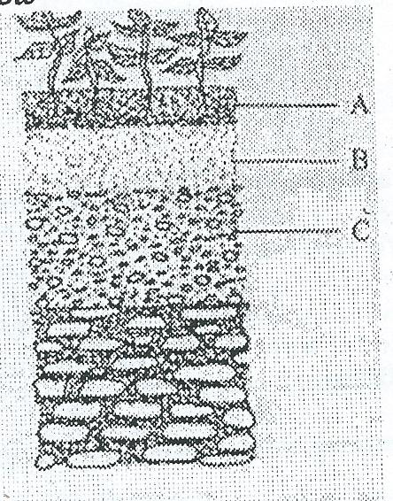s

- Identify the feature that the diagram above represents in the study of soil (1mk)
…………………………………………………………………………………………..
- Name the parts on the diagram labelled A,B,C and D (2mks)
…………………………………………………………………………………………………………………………………………………………………………………………………………………………………………………………………………………………………………………………………………………………………………
- State two ways in which the knowledge of the above feature would be of benefit to a farmer (2mks)
…………………………………………………………………………………………………………………………………………………………………………………………………………………………………………………………………………………………………………………………………………………………………………

- the diagram below illustrates a nursery practice

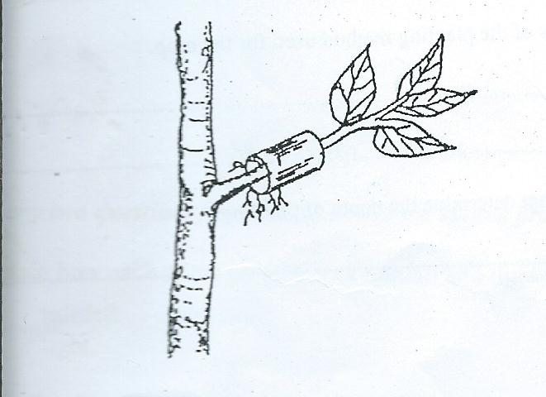

- identify the practice (1mk)
…………………………………………………………………………………………..
- describe the procedure followed in carrying out the practice illustrated (2mks)
………………………………………………………………………………………………………………………………………………………………………………………………………………………………………………………………………………………………………………………………………………………………………….
- state two advantages of the practice illustrated above in crop production (2mks)
………………………………………………………………………………………………………………………………………………………………………………………………………………………………………………………………………………

- The diagram below illustrates a livestock parasite
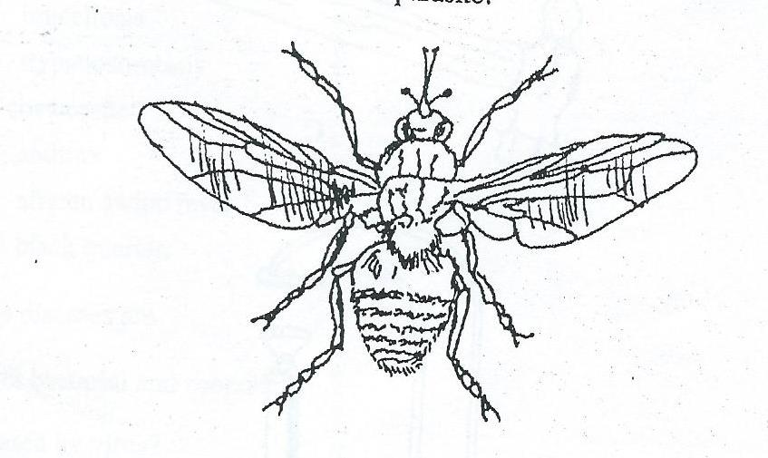

- identify the parasite illustrated above (1mk)
…………………………………………………………………………………………
- state the major harmful effect of the parasite (1mk)
…………………………………………………………………………………………
- explain three control measures of the parasite (3mk)
………………………………………………………………………………………………………………………………………………………………………………………………………………………………………………………………………………

SECTION C
ANSWER ONLY TWO QUESTIONS IN THIS SECTION
- a) Explain the importance of vegetables to a farmer (5mks)
………………………………………………………………………………………………………………………………………………………………………………………………………………………………………………………………………………………………………………………………………………………………………………………………………………………………………………………………………………………………………………………………………………………………..
- Briefly describe the production of onions under the following sub-headings
i)Varieties (1mk)
……………………………………………………………………………………………………………………………………………………………………………………………………
ii)Ecological requirements (3mks)
……………………………………………………………………………………………………………………………………………………………………………………………………………………………………………………………………………………………………………………………………………………………………………………………………………………………………………………………………………………………………………
iii)Land preparation (3mks)
…………………………………………………………………………………………………………………………………………………………………………………………………………………………………………………………………………………………………………………………………………………………………………………………………………
iv)Field management practices (4mks)
………………………………………………………………………………………………………………………………………………………………………………………………………………………………………………………………………………………………………………………………………………………………………………………………………………………………………………………………………………………………………………………………………………………………………………………………………………
v)Harvesting and marketing (4mks)
……………………………………………………………………………………………………………………………………………………………………………………………………………………………………………………………………………………………………………………………………………………………………………………………………………………………………………………………………………………………………………

23a) Define the following terms as used in livestock health (2mks)
- Disease……………………………………………………………………………………………………………………………………………………………………………
- Health……………………………………………………………………………………………………………………………………………………………………………
- State four pre-disposing factors of livestock diseases(2mks)
………………………………………………………………………………………………………………………………………………………………………………………………………………………………………………………………………………………………………………………………………………………………………….
- Give reasons for keeping livestock healthy (6mks)
…………………………………………………………………………………………………………………………………………………………………………………………………………………………………………………………………………………………………………………………………………………………………………………………………………………………………………………………………………………………………………………………………………………………………………………………………………………………………………………………

- Outline methods a farmer can use to control livestock diseases (5mks)
………………………………………………………………………………………………………………………………………………………………………………………………………………………………………………………………………………………………………………………………………………………………………………………………………………………………………………………………………………………………………………………………………………………………..

- Describe the harmful effects of parasites on livestock (5mks)
………………………………………………………………………………………………………………………………………………………………………………………………………………………………………………………………………………………………………………………………………………………………………………………………………………………………………………………………………………………………………………………………………………………………

24a) Explain five advantages of crop rotation (10mks)
………………………………………………………………………………………………………………………………………………………………………………………………………………………………………………………………………………………………………………………………………………………………………………………………………………………………………………………………………………………………………………………………………………………………………………………………………………………………………………………………………………………………………………………………………………………………………………………………………………………………………………………………………………………………………………………………………………………………………………………………………………………………………………………………………………………………………………………………………………………………………………………………………………………………………………………………………………………………………………………………………………………………………………………………………………………………………………………………………………………………………………………………………………………………………………………………………………………………………………………………………………………………………………………………………………………………………………………………
b) Outline five activities that may be undertaken in organic farming (5mks)
……………………………………………………………………………………………………………………………………………………………………………………………………………………………………………………………………………………………………………………………………………………………………………………………………………………………………………………………………………………………………………

- A farmer wanted to prepare 200kg of calf rearing ration containing 20 % DCP , using the pearsons square method calculate the amount of maize containing 18% DCP and sunflower containing 35% DCP the framer would need to prepare.
(5mks show your working)

