NAME………………………………………………………………….ADM…………………
DATE…………………………………………………………………SIGN………………….

AGRICULTURE FORM THREE
END OF TERM THREE 2021
PAPER ONE (443/1)

INSTRUCTIONS TO STUDENTS
This paper has three sections A,B and C
Answer ALL the questions in section A and B in the spaces provided
Answer only TWO questions in section C in the spaces provided

FOR EXAMINERS USE ONLY
SECTION | MAXIMUM SCORE | STUDENTS SCORE
A | 30
B | 20
C | 20
 | 20
TOTAL | 90

SECTION A

Answer ALL the questions in this section in the spaces provided
- Outline three reasons for treating water for use in the farm ( 1 ½ mks)

- Give four advantages of carrying out minimum tillage (2mks)

- State four disadvantages of communal land tenure system (2mks)

- Name any four surface sources of water in the farm (2mks)

- State four important reasons of keeping farm records in the farm…… .(2mks)

- Give two ways in which organic mulch helps in the control of soil erosion (1mk)

- Name any two examples of farm structures that are used in crop production (1mk)

- Give two reasons for siting a nursery bed at a well sheltered place (1mk)

- State four reasons as to why burning is not recommended in land …………. (2mks)

- Give four advantages of using certified seeds during planting…… (2mks)

- Why is it necessary to allow freshly cut sorghum (Columbus grass) to wilt before
Feeding it to livestock? (1mk)

- Give two roles of nitrogen in maize production (1mk)

- Distinguish between the terms hybrid and composite as used in maize breeding ( 1mk)

- Outline three important aspects of rainfall a farmer should consider when growing crops (1 ½ mks)

- State two harmful effects of strong wind in agricultural production (1mk)

- Give two ways in which cover crops help to conserve water in the soil (1mk)
- Give a reason for carrying out each of the following management practices on a tree nursery
  - Pricking out (1 mk)

(b) shading (1mk)

- Outline two ways of controlling damping off disease off disease of cabbages (1mk)

- State four effects of pests with both piercing and sucking mouth parts on crops
(2mks)

- Name four natural factors that may influence soil erosion (2mks)

21) What do you understand by the term opportunity cost ( 1 mk)

SECTION B ( 20 MARKS)

Answer ALL the questions in this section in the spaces provided
22) The diagram below illustrates a maize cob attacked by a disease. Study it carefully and answer the questions that follow.

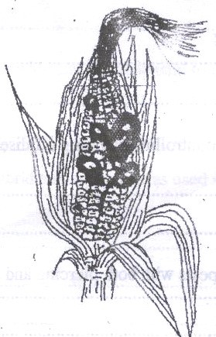

  - Identify the disease ( 1 mk)

  - Apart from maize, give two other crops that may be attacked by the disease
( 1mk)

  - State two methods of controlling the diseases (2mks)

- The diagram below illustrates an experiment on soil. Study it carefully and answer the questions that follow 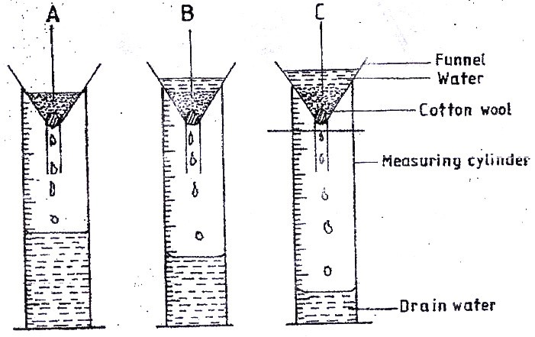

  - State the aim of the experiment ( 1 mk)

  - If the volume of water illustrated in the measuring cylinders was observed after one hour, identify the soil samples labeled A and B.

A ( ½mk)

B ( ½mk)
(c) State two ways in which the soil structure of the soil sample labeled C above
can be improved. ( 2mks)

- The diagram below illustrates a final seedbed after tertiary operation done during land preparation. Study it carefully and answer the questions that follow.

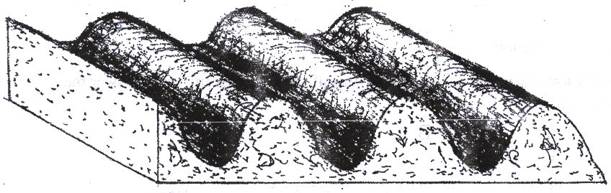
  - Name the tertiary operation carried out on the seedback (½mk)

  - Describe how the tertiary operation named in (a) above is carried out
( 1 ½ mks)

  - Give two advantages of planting crops on the final seed back illustrated above ( 2 mks)

- What is the function of each of the following substances in the preparation of compost manure?

  - Wood ash ( 1 mk)

  - Top Soil ( 1 mk)

  - Wooden stick (1mk)

  - Adding manure (1mk)

- Name the deficient nutrient element in plants showing the following symptoms

  - Stunted growth, die back of plant tips, leaves roll up and chlorosis along
Margins of younger leaves ( ½ mk)

  - Yellowing of leaves appears first lower leaves turn brown and fall
prematurely, stunted growth ( ½ mk)

  - Leaf curling, yellowing of leaves, tips and edges of leaves are scorched and
have small mottles ( ½ mk)

  - Purpling of leaves, stunned growth, slender stalks and lateral buds remain
dormant ( ½ mk)

- (a) Why is the use of the following items essential during the harvesting of tea?

    - Plucking stick ( 1 mk)

    - Woven basket ( 1 mk)

SECTION:C (4O marks)
Answer any TWO questions in this section
- (a) Explain five advantages of vegetative propagation in crop production ( 5 mks)

    - Outline five benefits of organic farming ( 5 mks)

    - Discuss five factors to consider when choosing the type of irrigation system to use in a farm. ( 10 mks)

29 a) Describe ten safety precautions that should be taken when using herbicides to
control weeds (10 mks)

b) Explain five biological agents of weathering (10 mks)

- Describe tomato production under the following sub headings
- Nursery management practices (6mks)

- Land preparation (4mks)

- Transplanting (7mks)

- Harvesting (3mks)

