AGRICULTURE FORM THREE PAPER 1 2021

SECTION A (30 MARKS)

Answer ALL the questions in this section in the spaces provided
- Outline three reasons for treating water for use in the farm ( 1 ½ mks)
- To kill disease causing micro-organism
- To remove chemical or impurities
- To remove bad smell and taste
- To remove sediments
- Give four advantages of carrying out minimum tillage (2mks)
- To reduce cost of cultivation
- To control soil erosion
- To consume soil moisture
- To maintain soil structure
- State four disadvantages of communal land tenure system (2mks)
- No incentive among the users to conserve the land
- There is tendency to overstock and well graze
- Problems in controlling livestock breeding programs
- Impossible to secure loans by no title deed
- There are diseases and parasites
- Name any four surface sources of water in the farm (2kms)
- Dam
- Weir
- River
- Swamp
- lake
- State four important reasons of keeping farm records in the farm…….(2mks)
- It shows the history of the farm
- It shows whether the farm is making profit or loss
- It shows assets and liabilities
- Used when supporting insurance claims
- Used in planning or budgeting
- Used when sharing profits
- When settling disputes

- Give two ways in which organic mulch helps in the control of soil erosion (1mk)
- It reduces the speed of the surface run-off
- I helps in intercepting the rain drops
- It assists in increasing the rate of infiltration
- Name any two examples of farm structures that are used in crop production (1mk)
- Nursery bed
- Silos
- Stores
- Green houses
- Give two reasons for siting a nursery bed at a well sheltered place (1mk)
- To prevent high rate of evaporation
- To prevent strong winds
- State four reasons as to why burning is not recommended in land (2mks)
- Destroys organic matter
- Destroys soil nutrients
- Kills soil living organisms
- Leads to loss of soil water
- Give four advantages of using certified seeds during during planting…… (2mks)
- Give high yields
- They all germinate
- They give products of high quality
- They are free from diseases
- They have high germination percentage.
- Why is it necessary to allow freshly cut sorghum (Columbus grass) to wilt before
feeding it to livestock? (1mk)
- to prevent poisoning by prussic acid
- Give two roles of nitrogen in maize production (1mk)
- Increases size of grains
- Helps to increase carbohydrate content
- Distinguish between the terms hybrid and composite as used in maize breeding
( 1mk)
- Hybrid- they are crops varieties developed by crossing two pure lines
- Composites- these are maize varieties developed through repeated mass section
- Outline three important aspects of rainfall a farmer should consider when growing crops (1 ½ mks)
- Rainfall reliability
- Rainfall distribution
- Rainfall intensity
- Rainfall amount
- State two harmful effects of strong wind in agricultural production (1mk)
- Cause soil erosion
- Destruction of farm structures
- Cause lodging of cereals
- Give two ways in which cover crops help to conserve water in the soil (1mk)
- Increase the rate of infiltration
- Prevent evaporation
- Prevent surface runoff
- Give a reason for carrying out each of the following management practices on a tree nursery
  - Pricking out (1 mk)
To prevent overcrowding in the nursery
  - Shading(1mk)
Prevents splash erosion
Prevents excessive evapotranspiration
Prevents direct sunlight which leads to excessive evaporation
18) Outline two ways of controlling damping off disease off disease of cabbages
- Removing shade
- Reducing the amount of water
- State four effects of pests with both piercing and sucking mouth parts on
Crops (2mks)

- Suck all the photosynthesized food substances
- Leading to distortion of leaves

- Name four natural factors that may influence soil erosion (2mks)
- Topography or gradient of slope
- Rainfall intensity
- Soil depth
- Soil type
- Vegetation cover
- Opportunity cost – value of the best foregone alternative
SECTION B ( 20 MARKS)

Answer ALL the questions in this section in the spaces provided
- The diagram below illustrates a maize cob attacked by a disease. Study it carefully and answer the questions that follow.

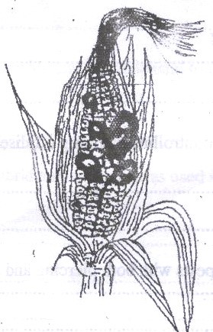

  - Identify the disease - ( 1 mk)
- Maize smut
  - Apart from maize, give two other crops that may be attacked by the disease (1mk)
- Sorghum
- Wheat
- Oats
- Millet
- Barley
- sugercane
  - State two methods of controlling the diseases (2mks)
- Useof copper sulphate
- Planting resistant crop varieties
- Crop rotation
- Planting certified seeds
- The diagram below illustrates an experiment on soil. Study it carefully and answer the questions that follow
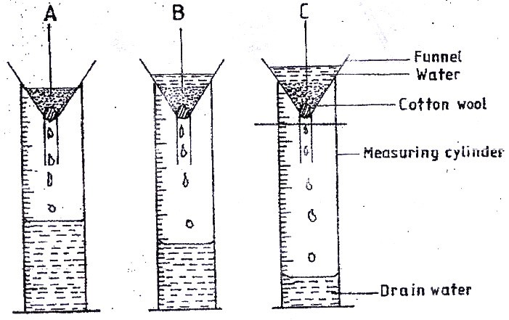
State the aim of the experiment ( 1mk)
- To experiment the rate of infiltration or water holding capacity of the soil
If the volume of water illustrated in the measuring cylinders was observed after one hour, identify the soil samples labeled A and B.
- Sandy soils ( ½ mk)
- Loamy soils ( ½ mk)
State two ways in which the soil structure of the soil sample labeled C above
can be improved. ( 2mks)
- adding organic manures
- liming
- sub soiling to break hand pan
- draining excess water

- The diagram below illustrates a final seedbed after tertiary operation done during land preparation. Study it carefully and answer the questions that follow.

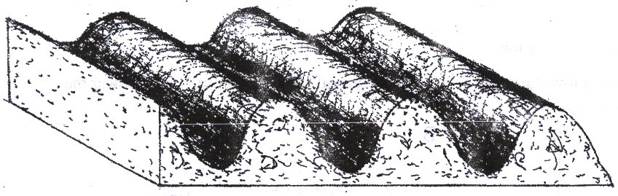
  - Name the tertiary operation carried out on the seedback ( ½ mk)
Ridging
  - Describe how the tertiary operation named in (a) above is carried out
- Soil is dug in a continuous line to form a ridge. A furrow is made and soil is helped on the side to form a ridge. ( 1 ½ mks)

  - Give two advantages of planting crops on the final seed back illustrated above ( 2 mks)
-promotes tube expansion
-Conserves water
-Controls soil erosion
-Easy harvesting
- What is the function of each of the following substances in the preparation of compost manure?
(a) Wood ash ( 1mk)
-promotes the amount of phosphorus and potassium in the manure
- Helps to modify soil ph
b ) Top Soil ( 1 mk)
- Introduces soil micro-organism which initiates the decomposition process
c) wooden stick – used to check temperature in the compost heap( 1 mk)
d) manure- acts as food for the microorganisms( 1 mk)

- Outline four deficiency symptoms of nitrogen in plants. (4mks)
- Chlorosis of leaves or yellowing of leaves
- Stunted growth
- Premature leaf fall
- Production of purple pigment
- Soughing of leaves
(any ½ x4= 2marks)

- (a) Why is the use of the following items essential during the harvesting of tea?

    - Plucking stick ( 1 mk)
It helps to maintain a uniform plucking table
    - Woven basket ( 1 mk)
Prevents decomposition of the leaves

SECTION:C (4O marks)
Answer any two questions in this section
- (a) Explain five advantages of vegetative propagation in crop production ( 5 mks)
- Plants grow faster
- Facilitates propagation of seedless plants
- Crops show uniformity in terms of qualities
- Crops have desirable shape or size
- Produce many different types of fruits on one plant

    - Outline five benefits of organic farming ( 5 mks)
- It’s cheap and cost effective
- It makes use of the locally available materials
- It’s useful in improving soil structure
- There is no side effects from crops and animal products.
- It doesn’t pollute the environment

    - Discuss five factors to consider when choosing the type of irrigation system to
use in a farm. ( 10mks)
- Topography of the area
- Soil type
- The type of crop to be grown
- Water availability
- Type of water
- Capital availability
(any 1 x 5)
(29a ) Describe ten safety precautions that should be taken when using herbicides to
control weeds (10mks)
- Read manufacturers instructions
- Avoid drift to unintended crops and pasture
- Never suck the blocked nozzles
- Wear correct attire
- Wash the knapsack sprayer properly after use
- Keep containers with chemicals out of reach from children
- Do not eat while spaying
- Dispose chemical containers properly
- Avoid spraying in the direction of wind
- Give crop enough time before harvesting sprayed crops
- Avoid washing equipments in water sources
- b ) Biological agents of weathering (10 mks)
large animals:
- Large animals like buffaloes elephant, cattle, when they move, they exert pressure on rocks breaking them.
Man’s activities
- Mans activities such as mining, building of house, construction of roads and rails leading to breaking of rock into small pieces.
Plants roots
- Plants roots make their way into rocks cracks and cravicesleading to further breakages.
- Plant roots produce weak acids which weaken the rock making it to break .
Arthropods
- Insects such as earthworms, termites help in soil formation.
Micro-organism (saprophytes)
- These feed on death organisms plants and animals leading to decay and formation of organic matter which is a component of soil.
(2x4=8)
- Describe tomato production under the following sub headings
- Nursery establishment (6mks)
- Select a site crops of tomato family have not been grown for the last one year.
- Clear the vegetation and remove all trash using a suitable tool.
- Then dig the site/area deeply in order to remove all the weeds.
- Measure and divide the nursery into beds of 1m wide and any convenient length.
- Leave a path of about 50 cm apart.
- Level the bed ensuring that it is of the right tilth.
- Broad cast phosphatic fertilizer
- Make shallow drills about 1cm deep and 10 – 15 cm apart.
- Put tomato seeds in those drills
- Apply light mulch
- Water
(1x6 = 6mks mark until procedure breaks)
- Land preparation (3mks)
- Dig the land deeply removing all the perennial weeds.
- Dig the planting holes the recommended spacing
- Apply DAP/ in the planting holes.
(1x3=3marks)
- Transplanting (7mks)
- Transplant when tomato seedlings are one month old, 3-4 weeks old or with - 3 true leaves
- Transplant in the evening in the morning on during a cloudy day.
- Water the nursery bed first to ensure that seedlings are uprooted with a ball of soil attached on their roots
- Uproot only healthy and vigorously growing seedlings
- Plant at same depth they were in the nursery.
- Firm the soil around the base of the seedling
- Apply a little mulch
- Water the seedlings.
(any 1x8=8marks)
- Harvesting (3mks)
- Tomatoes are ready for harvesting 3 months after transplanting.
- Harvest tomatoes for canning when they are fully ripe.
- Harvest for fresh market when they are partially ripe
- Grade tomatoes appropriately.(any 1 x3 = 3mks)

