OPENER EXAM YEAR 2021 TERM 2
PHYSICS FORM THREE PRACTICAL PAPER 3
TIME: 2HRS; 15MINS

1. You are provided with the following;
- a rectangular glass block
- 4 optical pins
- a soft board
- a plain paper
Proceed as follows:
(a) Place the glass block on the plain paper with one of the largest face upper most. Trace round the glass block using a pencil as shown below.
A
P₁

P₂
i

B

L
b
r

eye
D
P₄
P₃
c

(b) Remove the glass block and construct a normal at B. Construct an incident ray AB of angle of incidence, i = 20⁰.

(c) Replace the glass block and trace the ray ABCD using the optical pins.

(d) Remove the glass block and draw the path of the ray ABCD using a pencil. Measure length L and record it in the table below.

Angle i⁰ | L (cm) | L² (cm²) | $$\frac{1}{L^{2}} \left({cm}^{-2}\right)$$ | Sin²i
20 |  |  |  | 0.1170
30 |  |  |  | 0.2500
40 |  |  |  | 0.4132
50 |  |  |  | 0.5868
60 |  |  |  | 0.7500
70 |  |  |  | 0.8830
(6 marks)

(e) Repeat the procedure above for the angles of incidence given.

(f) Calculate the value of L² and $\frac{1}{L^{2}}$ ; Record in the table.

(g) Plot a graph of $\frac{1}{L^{2}}$ (y-axis) against Sin² i . (5 marks)

(h) Calculate the gradient, S. (3 marks)

Given that the equation of that graph is: : $\frac{1}{L^{2}}=- \frac{1}{n^{2}b^{2}} ∙ {Sin}^{2}i+ \frac{1}{b^{2}}$

(i) Determine the $\frac{1}{L^{2}}$ – intercept C and the Sin² i – intercept B.

C = _______________________________________ (1 mark)

B = _______________________________________ (1 mark)

(j) Calculate the value of Q given by; (2 marks)
$Q= -\left(\frac{C}{S}\right) ÷B$

(k) Hand in your constructions on the plain paper together with the answer script. (2 marks)

2 .You are provided with the following;
- A pendulum bob
- Two pieces of wood
- A retort stand
- A boss
- A clamp
- A ctop watch
- A metre rule/or half metre rule
- A piece of thread
Proceed as follows;
a) Suspend a pendulum bob on a retort stand as shown below.
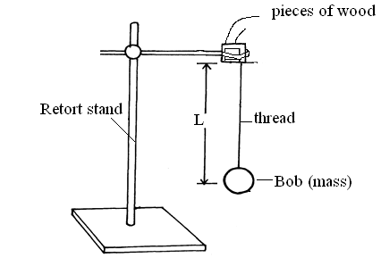

b) Displace the bob for a small angle. As it is oscillating time ten oscillations for every length of the string shown in the table below (9marks)
Length, l(m) | 0.4 | 0.6 | 0.8 | 1.0 | 1.2 | 1.4
Time ,t, for 10 oscillations(s)
Periodic time, T(s)
F=$1/{T }$(Hz)
F²(Hz²)
$1/L$(m⁻¹)
C) Plot a graph of F² against 1/L. (5 marks)

d) Determine the slope,S, of the graph. (3 marks)
………………………………………………………………………………………………………………………………………………..........................................................................................................................................................................................................................................................................................................................................................................................................................................................................................................................................................................................................................................................................................................................................................................................................................................................

e) Given that the relationship between F and L is given by, F² = $\frac{g}{4π²L}$ ,use the graph to determine the value of g giving its units . ( 3marks)
…………………………………………………………………………………………………
………………………………………………………………………………………………………
…………………………………………………………………………………………………

