OPENER EXAM YEAR 2021 TERM 2
NAME: ………………………..………. ADM NO: …………… CLASS: …..……
232/2
PHYSICS
PAPER 2
FORM THREE
TIME: 2 HOURS

INSTRUC TIONS:
- Answer all the questions in the spaces provided.
- Mathematical tables and electronic calculators may be used where necessary.

1. What property of light is suggested by the formation of shadows? (1 mk)

2. The figure below shows two point objects A and B placed infront of a mirror M.

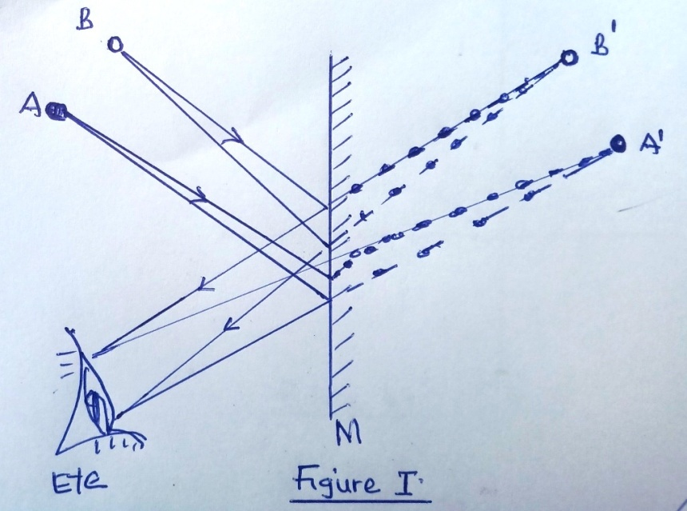
Sketch a ray diagram to show the positions of their images as seen by the eye. (3 mks)

3. The figure below shows a highly negatively charged rod being brought slowly near the cap of a
positively charged leaf electroscope. It is observed that the leaf initially falls and then rises.

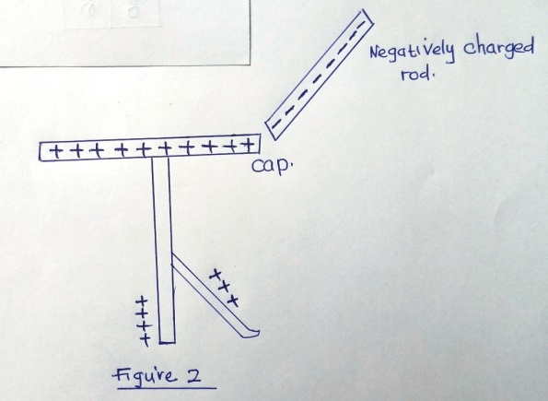
Explain this observation. (3 mks)

4. A current of 0.5A flows in a circuit. Determine the quantity of charge that crosses a point in 4
minutes. (3 mks)

5. A car battery requires topping with distilled water occasionary. Explain why this is necessary and
why distilled water is used. (2 mks)

6. The figure below shows an electrical circuit including three switches, S₁, S₂, S₃ and three identical
lamps L₁, L₂ and L₃. A constant potential difference is applied across X and Y.

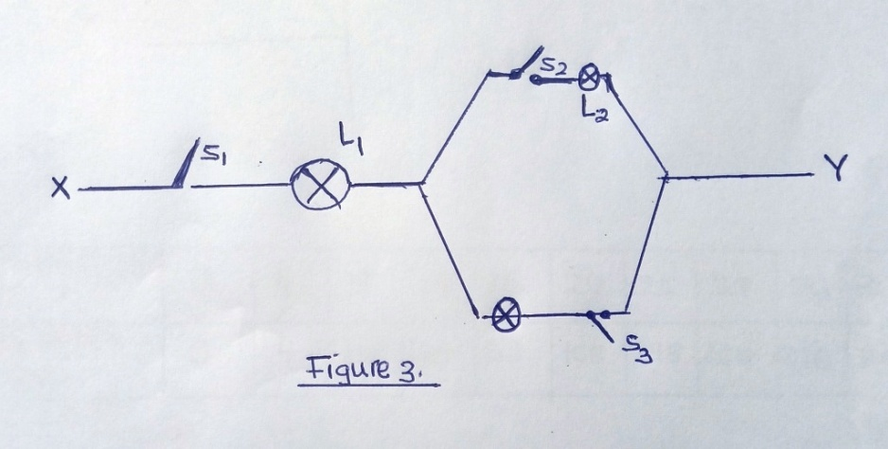
(i) Other than L₁, state the map that lights when S₁ and S₂ are closed. (1 mk)

(ii) How does the brightness in L1 in i) above compare with its brightness when all the switches
are closed? (1 mk)

(iii) Explain the observation in (ii) above. (1 mk)

7. The figure below shows a vertical object O, placed infront of a convex mirror. On the same grid,
draw the approximate rays to locate the image formed. (3 mks)

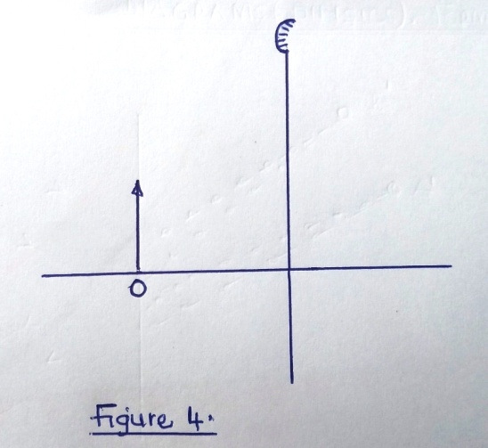

8. (a) Given a bar magnet, an iron bar and a string;
(i) Describe a simple experiment to distinguish between a magnet and iron bar. (4 mks)

(ii) State with reasons the observation that would be made in the experiment. (4 mks)

(b) The figure 5 below shows poles of two magnets closed together.

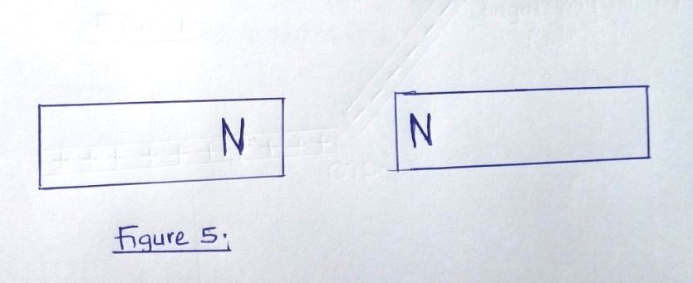
Sketch the magnetic field pattern in the space between the poles. (2 mks)

9. Figure 6 below shows a ray of light incident on a convex mirror.
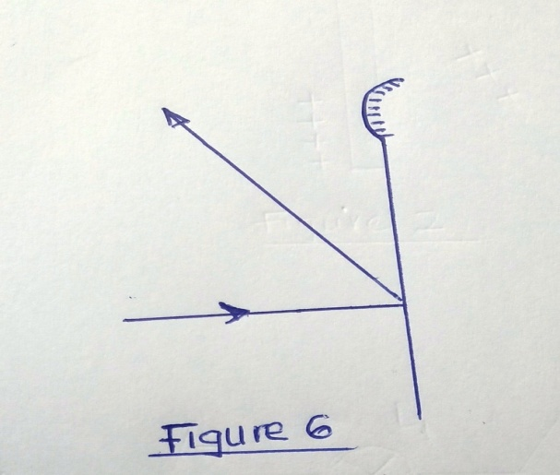

(i) Using a suitable construction on the same diagram, determine the radius of curvature of the
mirror. (2 mks)

(ii) State one application of each of the following:
(a) Convex mirror (1 mk)

(b) Parabolic mirror. (1 mk)

10. In an experiment to determine the strength of an electromagnet, the weight to pins that can be
supported by the electromagnet, was recorded against the number of turns. The current was kept
constant throughout the experiment.
The table below shows the data obtained.

Figure 7
No. of turns, n, | 0 | 4 | 8 | 12 | 16 | 20 | 24 | 28 | 32 | 36
Weight W, of pins X 10⁻³ (N) | 0 | 4 | 14 | 30 | 58 | 108 | 198 | 264 | 296 | 300

(i) Plot a graph of weight, W, (y-axis) against the number of turns, n (5 mks)

(ii) Use the domain theory to explain the nature of the curve. (3 mks)

(iii) Sketch on the same axes the curve that would be obtained using a higher current.
(1 mk)

(b) Using a labeled diagram, explain the working of a simple relay. (4 mks)

11. A girl standing 600m away from a cliff bangs two pieces of wood together and hears an echo 3.5s
later. Determine the speed of sound in air at that place. (3 mks)

12. The figure below shows the displacement-time graph for a certain wave.
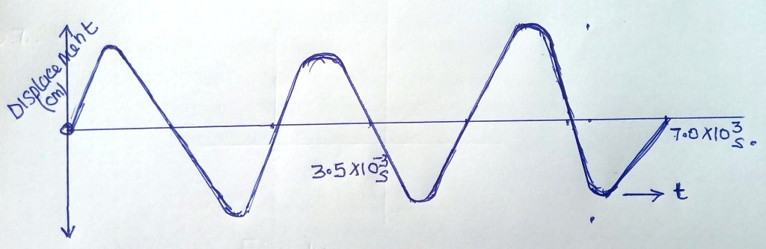
(a) Determine the frequency of the wave. (3 mks)

(b) (i) What is the difference between longitudinal and transverse waves. (2 mks)

(ii) State two distinctions between the way sound waves and electromagnetic waves are
transmitted. (2 mks)

(c) Calculate the wavelength of the KBC FM radio wave transmitted at a frequency of 95.6 mega
Hertz (3 mks)

(d) Give one example of a transverse wave and one example of longitudinal wave.(2 mks)

13. A small object lies at the bottom of a water pond at a depth of 1.2m. Given that the refractive
index of water is 1.3, determine the apparent depth of the object (Give your answer to 1 d.p.) (3 mks)

14. (a) Light travels through glass of refractive index 1.5 with a speed V.
Calculate the value of V. (Speed of light in air = 3.0 x 10⁸ m/s). (3 mks)

(b) The figure below shows a cross-section of an optical fiber made of two types of glass A
and B. The refractive of glass is lower than that of A.

A ray of light enters the optical fibre at P and emerges from Q.
(i) Sketch the path of the ray through the fibre. (2 mks)

(ii) State the reason why light travels through the fibre as in (i) above. (2 mks)

15. A train of mass 200 tonnes starts from rest and ac celebrates uniformly at 0 .5ms⁻².
Determine the momentum after moving 100m. (4 mks)

16. A higher jumber usually lands on thick soft mattress. Explain how the mattress helps in reducing
the force of impact.

17. A resultant force F acts on a body of mass M causing an acceleration A₁, on the body. When the
same force acts on a body of mass 2m, it causes an acceleration A₂. Express a₂ in terms of a₁.

