PHYSICS FORM TWO HOLIDAY ASSIGNMENT
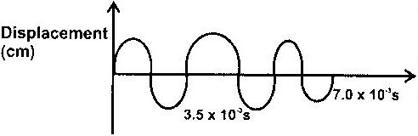
- Fig 1 shows the displacement – time graph for a certain wave

Determine the frequency of the wave?
- A source generates 40 waves in a second. If the wavelength is 8.5 cm. Calculate the time taken to reach a wall 102m from the source.
- State ONE difference between mechanical and electromagnet waves.
- Explain the following terms and state their S.I units
- Wavelength. (ii)Amplitude. (iii)Periodic time. (iv)Frequency
- State THREE differences between light waves and sound waves.
- (a) Fig 1 shows a displacement – time graph of a wave. The velocity of the
wave is 50cm/s.
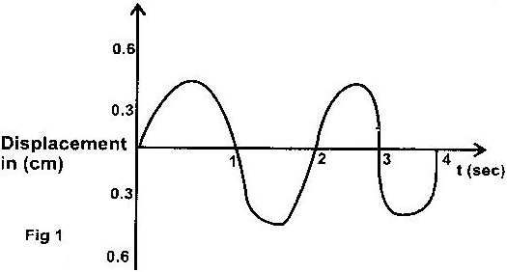

Determine the ;(i) Amplitude. (ii)Period. (iii)Wavelength. (iv)Frequency
- Give an example which show that speed of a wave depends on the medium in which it travels.
- Best FM station broadcasts on a frequency of 250 KHz and the wavelength of its signals is 1200m.determine the speed of radio waves in m/s
- What type of wave is sound
- What is an echo?
11. A gun is fired and an echo heard at the same place 0.5s later. How far is
the barrier, which reflected the sound from the gun? (Speed of sound 330m/s).

12. An observer watching a fireworks displays sees the light from an
explosion and hears the sound 2 seconds later. How far was the explosion from the observer? (Speed of sound is air 340m/s)
14. A girl standing 600m away from a cliff bangs two pieces of wood together
and hears an echo 3.5 seconds later. Determine the speed of sound in air at that place.
15. Describe an experiment to show that sound cannot travel in a vacuum.
16. Distinguish between the following terms
- Intensity and loudness
(ii) Frequency and pitch
17. State two factors that affect the frequency of the note produced by a vibrating string.
18.The audible frequency range for a certain person is 30Hz and 16500 Hz. Determine the largest wavelength of sound in air the person can detect.
(speed of sound in air=330m/s)
19.A ship in an ocean sends out an ultra sound whose echo is received after 3 seconds . If the wavelength of the ultra sound in water is 7.5cm and the frequency of the transmitter is 20kHz, determine the depth of the ocean.
20.The following results were recorded in an experiment where different masses were hung on the end of a long spring whose other end was firmly fixed. The length of the spring and the mass hanging from it were recorded as below. Original length of spring was 40cm.

Length of spring (cm) 44 48 52 56 60 65 70 74
Mass attached (kg) 0.15 0.30 0.45 0.60 0.75 0.90 1.05 1.20
Load(N)
Extension(m)

a)Complete the table for load and corresponding extensions
b)Plot a graph of extension of the spring against load on the spring on the grid provided c)Determine the spring constant using the linear section of the graph
d)Give an explanation why the slope of the graph changes when a mass greater than 0.75kg is attached to the spring
21.From the list of quantities below, select quantities that are vector quantities:- speed, density, force, acceleration and current
22.Sketch a graph of length of a helical spring against compressing force until the coils of the spring are in contact.

