**ANESTAR VICTORY BOYS**

**FORM ONE CHEMISTRY MARCH/APRIL 2021 HOLIDAY ASSIGNMENT**

1. The diagram below shows apparatus commonly used in a chemistry laboratory.



(i) What is the name of the above apparatus.

(ii) Label the region PQR.

(iii) What would happen if part B was closed?





(a) Identify the processes represented by the letters A, B, C, D, E and F (3 marks)

  (b) Name two substances that undergo the process labelled E and F. (2 marks)

(c) Name a method that can be used to extract the following:-

 (i) Common salt from a salt solution. (1 mark)

(ii) Paraffin from crude oil. (1 mark)

(d) A student separated liquid P (B.P 78°C) and liquid Q (B.P 100°C) using the apparatus shown below.

(i) Name the apparatus labelled



(a) M............................................................................................................................. (1 mark)

  (b) R.............................................................................................................................. (1 mark)

  (ii) State one function of the glass bead in apparatus labelled R (1 mark)

(iii) What is the reading on the thermometer when the first jar drops of the distillate appeared in the beaker

(iv) Which of the liquids remains in the flask. (1 mark)



**3.** (a) Above is a paper chromatogram of pure substances W, X and Y

The mixture K contains substances W and X only. Indicate on the diagram the chromatogram of K.

 (b) State **three** application of chromatography.

4. The set-up below was used to prepare a sample of oxygen gas. Study it and answer

the questions that follow.

H2O2

MnO2

(i) Complete the diagram to show how Oxygen can be collected

(ii) Write a chemical equation of the reaction to produce oxygen

5 Air was passed through several reagents as shown below:

Concentrated sodium hydroxide solution

Air

Excess copper turnings hydroxide solution

Escaping

gases

Excess heated magnesium powder

(a) Write an equation for the reaction which takes place in the chamber containing

Magnesium powder

(b) Name **one** gas which escapes from the chamber containing magnesium powder.

Give a reason for your answer

6. (a) What is rust?

(b) Give **four** methods that can be used to prevent rusting

(c) Name **two** substance which speeds up the rusting process

7. Oxygen is obtained on large scale by the fractional distillation of air as shown on the flow

chart bellow.

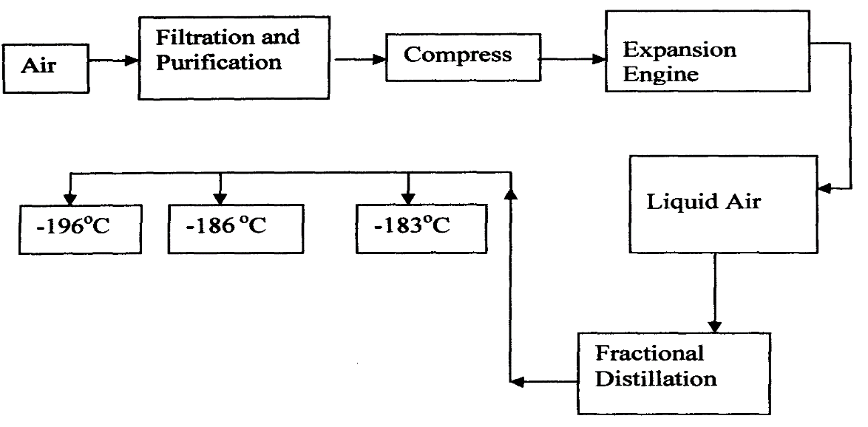

a) Identify the substance that is removed at the filtration stage

b) Explain why Carbon (IV) oxide and water are removed before liquefaction of air

c) Identify the component that is collected at -186°C

8. A form one class carried out an experiment to determine the active part of air. The diagram below shows the set-up of the experiment and also the observation made.

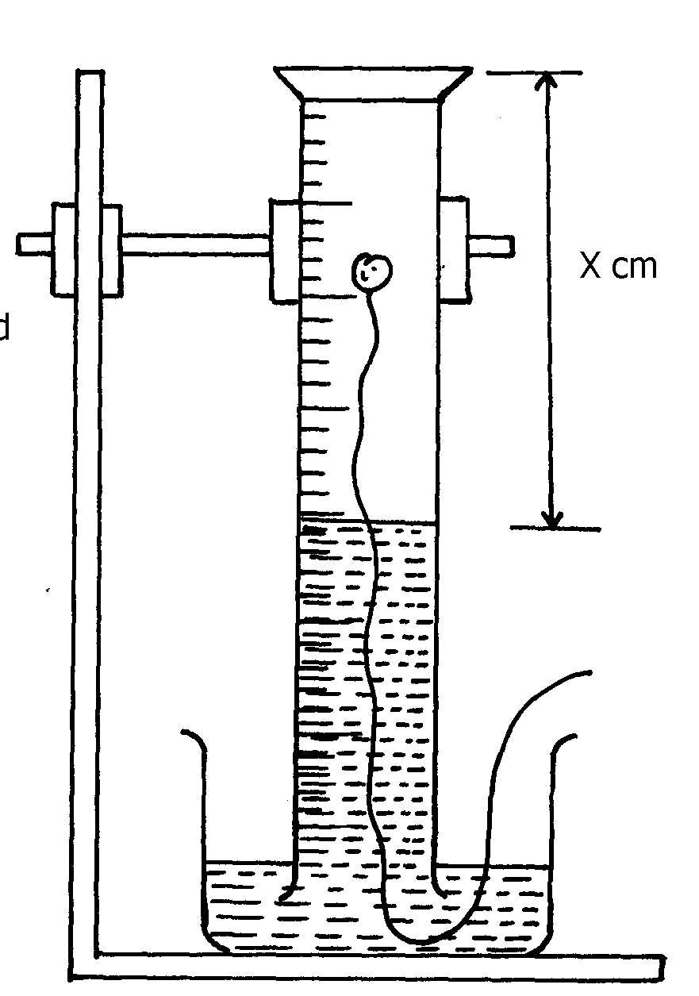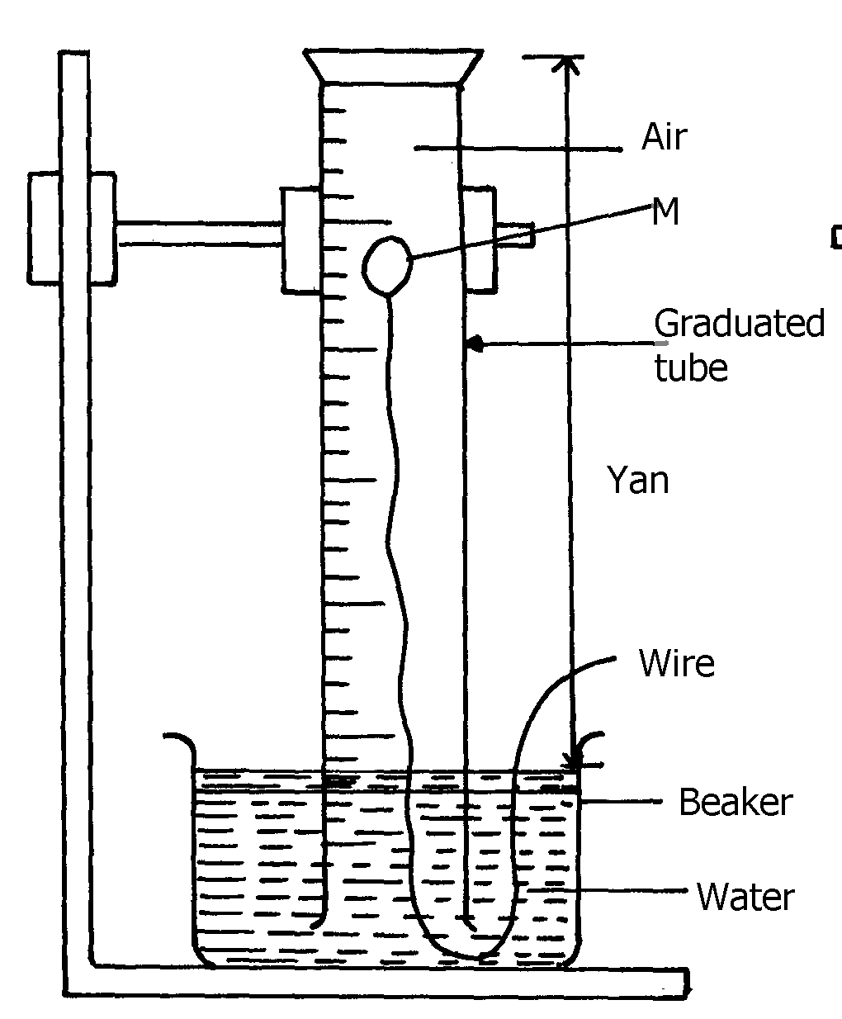 (i) At the beginning (ii) observation at the end of the experiment

**Ycm**

Air

Solid **A**

1. (i) Identify substance **M( 1 mark)**

(ii) State **two** reasons for the suitability of substance **M** for this experiment (2marks)

(b) Write the equation for the reaction of substance **M** and the active part of air (1mark)

(c) (i) Using the letters **Y** and **X** write an expression for the percentage of the active part of air( 2 marks)

(ii) The expression in **(c)(i)** above gives lower value than the expected. Explain (2marks)

(d) (i) Explain the observation made when litmus paper is dipped into the beaker at the end of the experiment (2mark)

(ii) Name the active part of air (1 mark)

(iii) Suggest another method that can be used to determine the active part of air (1mark)