OPENER EXAMINATION TERM 2 YEAR 2021
NAME: ___________________________ ADM NO: _______ CLASS:__________
BIOLOGY PAPER 1
FORM 3
2HRS

- State two functions of lipids (2 marks)

- The gill of a tilapia fish is composed of many outgrowths called gill filaments. Explain the significance of this observation (2 marks)

- A process that occurs in plants is represented by the reaction below
C₆H₁₂O₆ C₂H₅OH + CO₂ + Energy
- Identify the process (1 mark)

- Name the substance that accumulates in muscles when the food is broken down with insufficient oxygen (1 mark)

- State the side effect of accumulation of the substance named in (ii) above.
(1 mark)

- Name the disease in humans that is caused by lack of each of the following.(3 marks)
- Vitamin C

- Vitamin D

- State four ways by which the mammalian skin responds to low temperature in the environment. (4 marks)

- Explain how sunken stomata lower the rate of transpiration (2 marks)

- Distinguish between haemolysis and crenation (2 marks)

- Why should respiratory surfaces be (2 marks)
- Moist

- Thin

- State two functions of the cell sap (2 marks)

- What Osmoregulatory changes would take place in a marine amoeba if it was transferred to fresh water environment (3 marks)

- State two functions of the plasma membrane (2 marks)

- State the economic importance of anaerobic respiration (3 marks)

- Name the branch of Biology that involves the study of: (2 marks)
- Organisms for the sake of classifying them.

- Microscopic organisms.

- The diagram below represents a plant

- Name the division to which the plant belongs. (1 mark)

b) Give three reasons for your answer in (a) above. (3 marks)

- The diagram below represents a transverse section of a plant part. Study it and answer the Questions that follow.
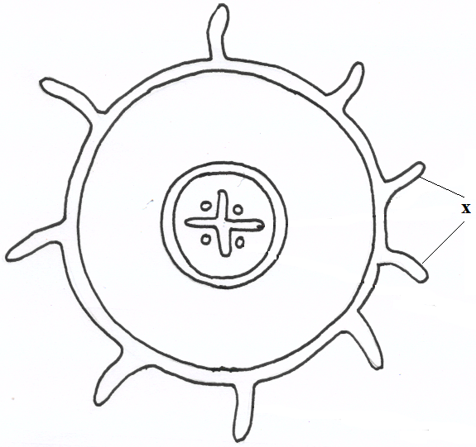

- Name the class in which the plant belongs. ( 1 mark)

- Give a reason for answer (a) above ( 1 mark)

- State one adaptation for the structures labeled X to their functions. (1 mark)

- The diagram below represents a set up that was used to investigate a certain process in a plant.
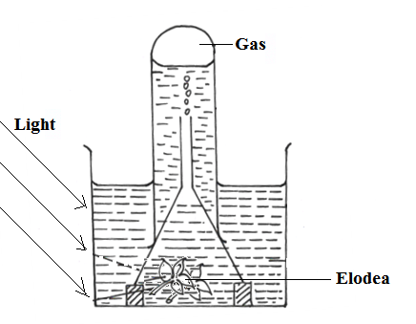

- State the process that was being investigated. (1 mark)

- Other than the factors shown, state two factors that would affect the process named in (a) above. ( 2 marks)

17. a) Name the causal organism for amoebic dysentery. (1 mark)

- State three preventive measures of schistosomiasis in human beings (3 marks)

c) Name the organism that causes cholera and state two precautionary measures to prevent cholera outbreak. (3 marks)
Organism-
Measures-

18. Describe capture - recapture method of estimating population. (3 marks)

19. The diagram below shows a simplified nitrogen cycle

(a) Name the processes labeled P,Q and R (3 marks)
P
Q
R

b) List down three adaptations of the preys against being predated upon by predators. (3 marks)

20. Give two reasons why primary productivity decreases with increase in depth in an aquatic ecosystem. (2 marks)

21. a) Give two ways by which the skins prevent entry of microorganisms into the body.
(2 marks)

b) What is the importance of deamination in excretion and homeostasis? (1 mark)
- a) What type of circulatory system is found in members of class insecta? (1 mark)

b) Name the blood vessel that transports blood from:
(i) Small intestine to liver. (1 mark)

ii) Lungs to heart (1 mark)

23. Distinguish between natural and acquired immunity. (2 marks)

- a) Describe the condition known as varicose veins (2mks)

- What is the role of blood platelets in the blood clotting process? (2mks)

25. What is meant by the following terms? (2 marks)
a) Habitat:

b) Ecosystem

26. Differentiate between the following pairs of terms:
- Guttation and transpiration. (2mark)

- Morphology and anatomy. (2mark)

27. The diagram below represents the structure of a nephron. Study it and answer the questions that follow.

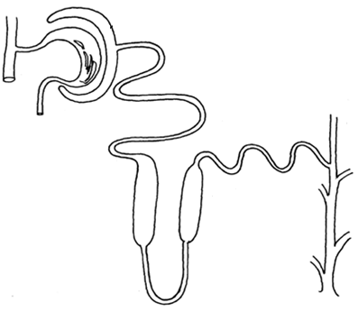
C
C
B
X

- State the roles of the part labelled B and C. (2 marks)
B:
C:
- Which hormone is involved in the function of the part labelled D? (1 mark)

- Name the part labelled X. (1 mark)

