FORM TWO BIOLOGY APRIL HOLIDAY ASSIGNMENT 2021.
  - Explain the following: -
    - Fresh water fish excrete ammonia.2mrks
    - Glucose is absent in urine yet present in glomerular filtrate 2mrks
- (a) State two structural modification of the kidneys of deserts animals like kangaroo rat. 2mrks
(b) Describe how ingestion of very salty food may reduce the amount of water excreted in urine.2mrks
- A student mixed a sample of urine from a person with Benedict’s solution and heated, the colour changed to orange.
    - What was present in the urine sample? 1mrk
    - What did the student conclude on the health status of the person?2mrks
    - Which organ in the person may not be functioning properly?1mrk
- (a) If the human pancreas is not functional: - 2mks
(i) Name the hormone which will be deficient
(ii) Name the disease the human is likely to suffer from
(b) What is diuresis?1mrk
- Name the nitrogenous wastes excreted by the following organisms: - 3mrks

Animal | Nitrogenous Waste
Desert mole
Marine fish
Tilapia
- Explain why sweat accumulates on a person’s skin in a hot humid environment 2mrks
- Distinguish between diabetes mellitus and diabetes insipidus. 4mrks
- State two processes through which plants excrete their metabolic wastes.2mrks
- The figure below shows a vertical section through a mammalian kidney. 3mrks
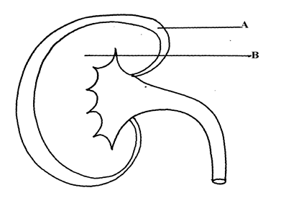

    - Label the parts A and B
    - Which part is the Bowman’s capsule found?
- State three importance of Osmosis in plants 3mrks
- A patient was complaining of thirst most of the times. A sample of the patient’s urine was found not to contain a lot of sugar but was dilute:- 3mrks
    - Name the hormone the person’s body was deficient of
    - Which gland produces the above hormone
    - Name the disease that the patient was most likely suffering from
- Discus the role is played by the liver in excretion? 10mrks

- (a) Distinguish between excretion and egestion 4mrks
(b) State the importance of excretion in the bodies of living organisms. 3mrks

- The equation below represents a metabolic process that occurs in a certain organ in the mammalian body: - 6mrks
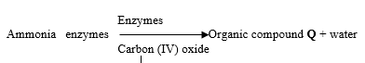
- Name the process represented in the equation.
- Name the organ in which the process occurs.
- Why is the process important to the mammal?
- Identify the organic compound Q.
- Explain the source of ammonia in the organ named in (b) above.
- What happens to organic compound Q?
- How does an Endotherm respond to both heat gain and heat loss? 5mrks
- The diagram below represents a mammalian nephron.

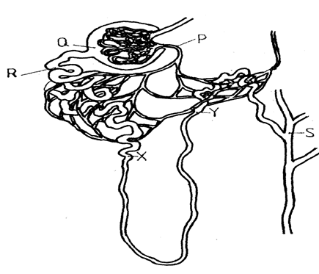

  - Name the: (i) Structure labelled P 1mrk
  - State the structural modifications of the part label led Q for 4mrks
- Desert mammals
- Fresh water mammals
  - (i) Name one substance present at point R but absent at point S in a healthy mammal.1mrk
(ii) The appearance of the substance you have named in (c)(i) above is a symptom of a certain disease. Name the disease 1mrk
- Describe how the mammalian skin regulates body temperature .10mrks
- Give the differences between aerobic and anaerobic respiration. 10mrks
- Discuss the importance of anaerobic respiration .10mrks

