OPENER EXAMINATION YEAR 2021 TERM 2

AGRICULTURE
FORM FOUR
NAME………………………………………….ADM………………….CLASS……………
SECTION A 30 MARKS
- Give four control measures of a liver fluke in livestock. (2mks)

- State two signs that shows that a cow is about to parturate. (2mks)

- State four signs of infestation by external parasites in livestock. (2mks)

- Name two notifiable diseases in Kenya.(1mks)
- State four reasons for feeding colostrums to calves immediately after parturition. (4mks)
- Distinguish between mathering ability and prolificacy as used in livestoch breeding. (2mks)
- Name the vegetative part of each of the following crops which is propagated. (2mks)
- Sweet potatoes……………………………………..
- Cassava………………………………………………
- Bananas………………………………………………
- Oranges………………………………………………..
- Name two methods of weed control in pasture.(1mk)
- Name four methods used in identifying farm animals. (2mks)
- State two reason s why it is necessary to have individual calf pens instead of communal calf pen. (1mks)
- State two effects of HIV/AIDS on agricultural production . (1mk)
- State four reasons for maintaining farm tools and equipment in proper condition. (2mks)
- Give four factors which characterrise small scale farming. (2mks)
- Give four benefits of conservation of farage. (2mks)
- Name four suitable sites for agroforestry. (2mks)
- Give objectives of land settlement and resettlement in Kenya.(2mks)
SECTION B 20MKS
- The diagrame below is an illustration of an egg. Study it carefully and answer the questions that follow.
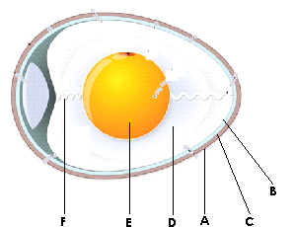

- Name the parts labeled (3mks)
A…………………………………
B………………………………..]
C…………………………………..
D…………………………………….
E…………………………………
F…………………………….
- State the qualities of the part labbede A that should be considered when selecting eggs for incubation. (2mks)

- What is the function of the part labeled E in a fertilized egg. (1mks)

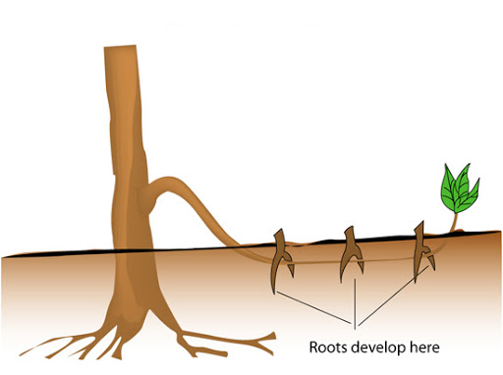
- Study the diagram below and answer the question that follow.

- What is layering?
- Identify the type of layering shown below
- Give two advantages of tissue culture in crop production
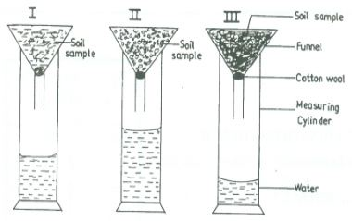
- The diagram below illustrates an experiment on soil. Study it carefully and answer the question that follow.

- State the aim of the experiment. (1mk)

- If the volume of water illustrated in the measuring cylinder was observed after one hour, identify the soil sample labeled I and II and give reasons.
Soil sample
I……………………………
Reasons
II…………………………………
Reason.
- State two ways in which the soil structure of the soil sample labeled III above can be improved. (2mks)

- State four reasons why docking/tailing is done in wool. (2mks)
- State two management practices that should be carried on a knapsack sprayer. (1mk)
- State two reasons why bees swarm. (2mks)
State two methods of tick control. (1mk)
SECTION C 40MKS
- i)State five difference between ruminants and non-ruminants. (5mks)
ii) Discuss calf rearing from birth to first calving.
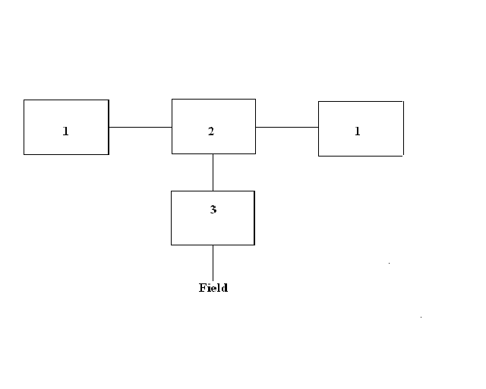
iii) State five problems that farmers are likely to face when marketing their produce.
- A) Illustrated below is a method of turning compost. Study the method and answer the questions that follow.

- Identify the methods. (1mk)
- Using arrows in the diagram show how the turning is done before the manure can be taken to the field. (2mks)
- I) which other methods can be used to prepare the manure.(1mk)
ii) After how long should the compost be ready for use? (1mk)
B i) state four reasons for maintaining farm tools and equipment in proper condition. (2mks)
ii) list three factors that makes embryo transplant unpopular with many livestock farmers.(3mks)
iii) An agriculture student was adviced to apply a comlete faerizer 40:30:10 in a 20m by 10m plot at a rate of 400g per hectare.
- Calculate the percentage of p2o5 in the cmlete fertizer. (3mks0
- Calculate the amount o fertilizer the student would require for the plot. (3mks)
- Calculate the amount of k2o that wwould be contained in 600kg of a compound fertilizer. 30:20:10 (NP2O2:K2O) respectively.
- Describe the production oftomateos under the following sub-heading:
- Nursery production (12mks)
- Transplanting
- Field management practices. (3mks)

