ANESTAR VICTORY BOYS
APRIL 2021 HOLIDAY ASSIGNMENT
FORM 2 AGRICULTURE

Instructions: Answer all questions in your assignments Book

1. (a) Which livestock disease is transmitted by each of the following ticks? (2mks)
(i) Blue tick (Boophilous decoloratus)
(ii) Brown ear tick (Rhipicephalous appendiculatus)
(b) How many hosts does the red-legged tick (Rhipicephalous averts) require to complete its life cycle? (1mk)
2. (a) State four signs of infestation by external parasites in livestock? (2mks)
3. (a) State four signs of infestation by external parasites in livestock? (2mks)
(b) Name the intermediate host for each of the following internal parasites. (2mks)
(i)Tape worm (Taenia solium) (ii) Liver fluke (Fasciola hepatica)
4. Describe the life cycle of a three- host tick. (8mks)
5. State four non-chemical methods of controlling ticks in cattle. (2mks)
6. Give four measures that should be taken to control tapeworms on the farm. (2mks)
7. What is a production ration as used in animal nutrition? (1mk)
8. Name two groups into which vitamins are classified. (1 mk)
9.State 3 factors that influence the amount of water intake by a farm Animal. (1¹/₂ mks)
10 (a)Differentiate between a roughage and a concentrate feed in animal nutrition. (2mks)
(b) State three ways in which a production ration may be utilized by cattle.(3 mks)
11. Explain the term hybrid vigour as used in livestock production.(1mk)
12.Describe the factors considered when selecting a young female pig (Guilt) for breeding. (8mks)
13.(a) Define the following terms as used in livestock breeding.(2mks)
(i) Inbreeding
(ii) Out crossing
(b) Outline three disadvantages of artificial insemination in cattle management (3mks)
(c)State desirable characteristics considered when selecting a heifer for milk production.(3mks)
14.State four factor which determine the amount of feed an animal can consume. (4mks)
15.State three reasons for feeding livestock. (1¹/₂mks)
16.(a) How does crossbreeding improve livestock production(3mks)
17. State six signs that are likely to be observed when a cow is on heat (6mks)
18.State four disadvantages of natural mating as a method of breeding in dairy cattle (4mks)
19.Define the term out crossing in animal breeding.(1mk)
20. Below is a diagram of a sheep with some parts labeled A, B, and C.
Study the diagram and answer the questions that follow.
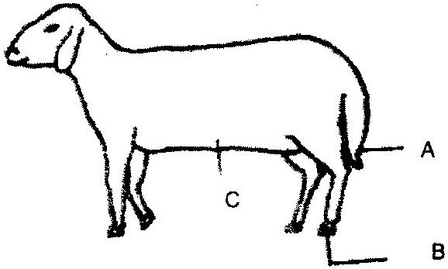

(i) What operation is usually carried out on the part labeled A during a sheep’s early stages of life?(1mk)
(ii) Why is it necessary to carry out the operation in (i) above?(1mk)
(iii) At what stage of sheep should the operation in (i) above be carried out? (1mk)
(iv) Give two methods of carrying out the operation in (i) above (2mks)
(v) Which operation is usually carried out on part labeled B (1mk)
21.Mention four categories of vegetables based on the part used as food (4mks)
22 (a) Describe the field production of Onions ( Aleum Cepa ) under the following sub topics;
i) Ecological requirements (3mks)
ii) Varieties (2mks)
iii) planting (4mks)
iv) Field management practices (4mks)
v) Harvesting (3mks)
b) Name Three diseases of cabbages (3mks)
23. Name any 4 management practices done in carrot production. (4mks)

