PHYSICS PAPER 3
MARKING SCHEME 2020

Question 1
b) e = 2.9v
c)
Length L(m) | 0.2 | 0.3 | 0.4 | 0.5 | 0.6 | 0.7
Current I (A) | 0.6 | 0.52 | 0.44 | 0.4 | 0.35 | 0.29
$\frac{1}{I}$ (A⁻¹) | 1.67 | 1.92 | 2.27 | 2.5 | 2.85 | 3.4

d) Gradient =$∆$ $\frac{1}{I}$(A-1) = 2.5 – 1.67
$∆$L (m) 0.5 – 0.2

= 0.83 = 2.767 A⁻¹m⁻¹
0.3

f)

h)i) d arc = 0.42mm

ii) X-section area A = 22/7 x (2.1 x 10⁻⁴)² = 1.38 x 10⁻⁷m²

i) Gradient = $\frac{K}{AE}$ from equation $\frac{1}{I }$ = $\frac{K}{AE}$L + $\frac{Q}{E}$

but E = 2.9V, A = 1.38 x 10⁻⁷
K = 2.767 x 1.38 x 10⁻⁷ x 2.9 = 1.107 x 10-6 Ωm

Q/E = intercept = 1.08A⁻¹
Q = 1.08 x 2.9 = 3.132Ω

Question 2
U(cm) | 40 | 45 | 50
V(cm) | 39 | 35 | 32
Magnification $\frac{v}{u}$ | 0.98 | 0.78 | 0.64

F= $\frac{v}{m+1}$

F₁ = 39 = 19.6
0.98 + 1

F₂ = 395 = 19.7
1.78

F₃ = 32 = 19.5
1.64

F avg = 19.6 + 19.7 + 19.5 = 19.6cm
3
Favg = 19.6

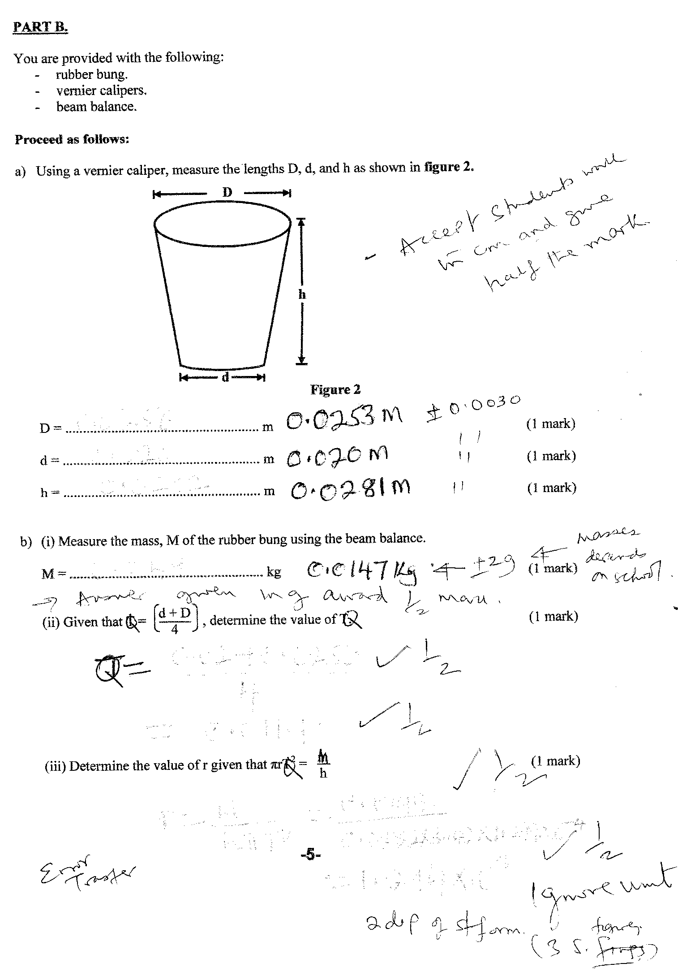
SECTION C

a) G = 50 ± 0.5cm

b) p = 58.6cm
c)when y =5cm, x = 8.6 cm
W x 5 = 50/100 x 8.6
W = 0.05x8.6/5 = 0.086N

