NAME: ………………………….....………………….. INDEX NO: ………………….......
CLASS: ……………………………
DATE:……………………………..

121/2
MATHEMATICS
TERM3, 2021
JANUARY 2021
TIME: 2 ½ HOURS

MURANG’A EAST CLUSTER EXAMINATION
INSTRUCTIONS TO CANDIDATES:
(a) Write your name and index number in the spaces provided above
(b) Sign and write the date of examination in the spaces provided above.
(c) This paper consists of TWO sections: Section I and Section II.
(d) Answer ALL the questions in section I and only five from Section II
(e) All answers and working must be written on the question paper in the spaces provided below each question.
(f) Show all the steps in your calculations, giving your answers at each stage in the spaces below each question.
(g) Marks may be given for correct working even if the answer is wrong.
(h) Non-programmable silent electronic calculators and KNEC Mathematical tables may be used except where stated otherwise.

FOR EXAMINER’S USE ONLY
Section I
1 | 2 | 3 | 4 | 5 | 6 | 7 | 8 | 9 | 10 | 11 | 12 | 13 | 14 | 15 | 16 | Total

Section II

17 | 18 | 19 | 20 | 21 | 22 | 23 | 24 | Total
Grand Total

SECTION 1:( 50 MARKS.) ANSWER ALL THE QUESTIONS

- Use logarithms to evaluate. ( 4mks)
$\frac{ 4.497 × \sqrt{0.3673}}{ 1-cos81.53° }$

2. Calculate the percentage error in the volume of a cone whose radius is 9.0cm and slant length 15.0cm. (3mks)

3. Make y the subject of the formula. (3mks)
$v={\left(\frac{ax^{2}y}{w-y}\right)}^{\frac{1}{2}}$

4. Solve for x: tan ² x – 2 tan x = 3 for the interval 0 $≤$x$≤$ 180º (3 mks)

5. Solve the equations (4mks)

6. Simplify give the answer in the form where a, b and c are integers. (3mks)

7. Kiprono buys tea costing sh 112 per kilogram and sh.132 per kilogram and mixes them, then sells the mixture at sh.150 per kilogram .If he is making a profit of 25% in each kilogram of the mixture, determine the ratio in which he mixes the tea. (4mks)

8. Find the value of x given that. (3mks)
$$\log_{2}\left(x^{2}-2\right)-\log_{2}\left(\frac{1}{2}x+5\right)-1=0$$

9. The tangent to the curve y = ax² + bx + c is parallel to the line y - 4x=0 at the point where x = 2. If the curve has a minimum value of –3 where x = 1, find the values of a, b and c. (3 mks)

10. The points A, B and C lie on a straight line. The position vectors of A and C are 2i + 3j + 9k and 5i – 3j + 4k respectively; B divides AC internally in the ratio 2:1. Find the
- Position vector of B. (2 mks)

(b) Distance of B from the origin. (1 mk)

11.(a) Find the inverse of the matrix $\left(\begin{matrix}4 & 3 \\ 3 & 5\end{matrix}\right)$ (1 mk)

(b) Hence solve the simultaneous equation using the matrix method. (2 mks)
4x +3y = 6
3x + 5y = 5

12. Find the radius and the centre of a circle whose equation is. (3mks)

3x² + 3y²+18y -12x-9=0

13. A model of the globe representing the earth has a radius of 0.2m. Point A and B are located at (60˚ N,140˚ E) and (60˚ N,120˚ W),respectively. If O is the centre of the latitude 60 N, find the area of the minor sector OBA, in square metres. (3 mks).

14.Find the length NX in the figure below that PQ = 9cm, PX = 12cm and MX = 15cm. (2 mks)
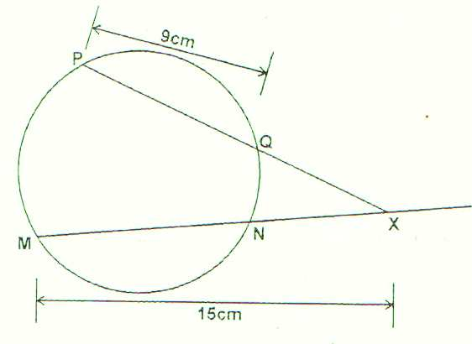

15. A colony of insects was found to have 250 insects at the beginning. Thereafter, the number of insects doubled every two days. Find the number of insects after 16 days. (3 mks)

16. The following data was obtained from the mass of a certain animal. Complete the table and the histogram below. (3 mks)
Mass(kg) | frequency
41-50 | 20
51-55
56-65 | 40
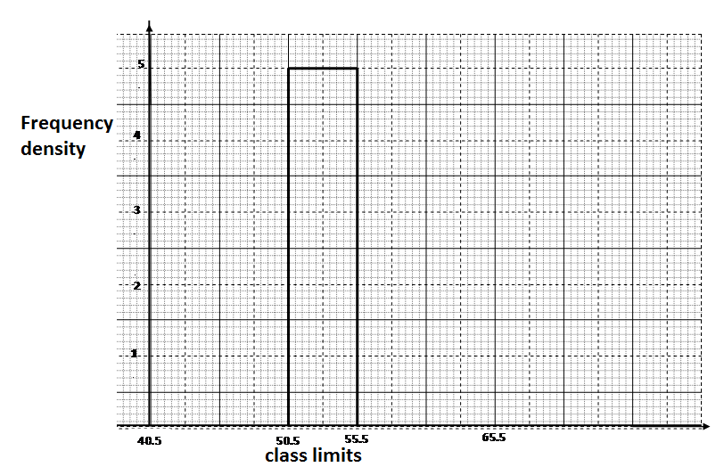

SECTION II (50 MARKS)
Answer ONLY FIVE questions in this section
17.The table below shows the rate at which income tax is charged for all income earned in a month in 2015.
Taxable Income p.m (Kenya pound) Rate in % per Kenya pound
1 -236 10%
237 -472 15%
473 -708 20%
709 – 944 25%
945 and over 30%
Mrs.mumanyi earns a basic salary of 18000.She is entitled to a house allowance of Ksh. 6,000 a person relief of Ksh. 1064 month
. Every month she pays the following.
- Electricity bill shs.580
- Water bill shs. 360
- Co-operative shares shs. 800
- Loan repayment Ksh. 3000
(a) Calculate her taxable income in k£ p.m. (2 mks)

(b)Calculate her P.A.Y.E (6 mks)

(c) Calculate her net salary. (2 mks)

18 (.a) Use the trapezium rule with six trapezia to calculate the areas bounded by the curve Y=2x²+ 3x +1, the axis and the ordinate x=0 and x=3. (5mks)

b) Calculate the exact axed in (a) above by integration. (3mks)

c) Assuming they are calculated in (a) above is an estimate, calculate the percentage error made when the trapezium rule is used leaving your answer to 2 decimal places. (2mks)

19. The figure below shows a cuboid.
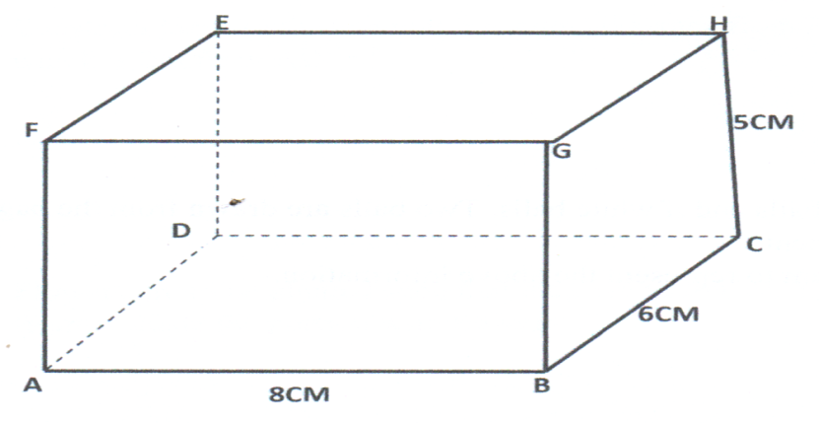

Calculate
- The length BE. (2 mks)
- The angle between BE and plane ABCD. (3 mks)
- The angle between FH and BC. (2mks)

- The angle between place AGHD and plane ABCD. (3 mks)

20. The figure below shows two intersecting circles radii 8cm and 6cm respectively. The common chord AB = 9cm and P and Q are the centres as shown.
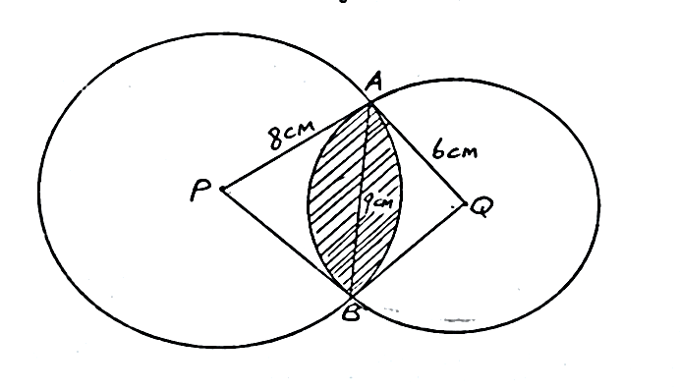
a. Calculate the size of angle
i. APB (1mk)

ii. AQB (1mk)

b. Calculate the area of
i. Minor segment of the circle centre P. (2mks)

ii. Minor segment of the circle centre Q (2mks)

iii. The quadrilateral APBQ (2mks)

iv. The shaded region (2mks)

21. In the figure below DA is a diameter of the circle ABCDE centre O. TCS is a tangent to the circle at C, AB = BC and angle DAC = 38⁰
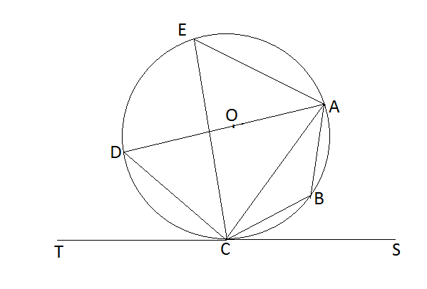
Giving reasons, determine the following angles:
(a) (2 mks)

(b) (2 mks)

(c) (2 mks)

(d) (2 mks)

(e) (2 mks)

22. A flower garden is in the shape of a triangle ABC such that
AB = 9M, AC=7.5M and angle ACB=75˚. Using a rule and a pair of compass only.
a) Construct ABC (3mks)

b) Construct a locus of P such that AP = PC. (2mks)

c) Construct locus of Q such that it is equal distance from AB and BC
and locus of R which is 2m from AC. (2mks)

d) Flowers are to be planted such that they are nearer AC than AB and
less than 5m from a shade the portion with flowers. (3mks)

23. Three variables p, q and r are such that p varies directly as q
and inversely as the square of r.
  - When p = 9, q = 12 and r = 2 find p when q = 15 and
r = 5 (4mks)

  - Express q in terms of p and r (1mk)

  - If p is increased by 20% and r is reduced by 10% find,
    - A simplified expression for the change in q in terms of q and r. (3mks)

    - The percentage change in q. (2mks)

24. The table below shows some values of the curve y = 2cos x and y= 3 sin x.
- Complete the table for values y=2cosx and y=3 sin x, correct to 1 decimal places. (3mks)
X | 0 | 30⁰ | 60⁰ | 90⁰ | 120⁰ | 150º | 180⁰ | 210⁰ | 240⁰ | 270⁰ | 300⁰ | 330⁰ | 360⁰
y=2cos x | 2 |  | 1 | 0 |  |  | -1.7 | -1.7 | -1 |  | 1 | 1.7 | 2
y=3sin x | 0 | 1.5 |  | 3 | 2.6 |  |  |  | -2.6 |  |  | -1.5 | 0
On the grid provided draw the graphs of y=2cos x and y=3sin x for 0⁰ $≤$ x $≤$ 360⁰ on the same axis. (5mks)

- Use the graph to find the values of x when 2cos x- 3sin x=0. (2mks)

- Use the graph to find the values of y when 2 cos x = 3sin x. (1mk)

