NAME: …………………………….....………………….INDEX NO: …………………..
CLASS: ………………………….
DATE: ……………………………
121/1
MATHEMATICS
PAPER 1
TERM 3, 2021
JANUARY 2021
TIME: 2 ½ HOURS

MURANG’A EAST CLUSTER EXAMINATION

INSTRUCTION
- Write your name and index number in the spaces provided above.
- Sign and write the date of the examination in the spaces provided above.
- This paper consists of TWO sections: section I and Section II.
- Answer ALL the questions in Section I and only five questions from section II.
- Show all the steps in your calculations, giving your answers at each stage in the stage in the spaces below each question.
- Marks may be given for correct working even if the answer is wrong.
- Non-programmable silent electronic calculators and KNEC mathematical tables may be used, except where stated otherwise.

FOR EXAMINER’S USE ONLY
Section I
1 | 2 | 3 | 4 | 5 | 6 | 7 | 8 | 9 | 10 | 11 | 12 | 13 | 14 | 15 | 16 | Total

Section II

17 | 18 | 19 | 20 | 21 | 22 | 23 | 24 | Total
Grand Total

SECTION 1: (50 MARKS) ANSWER ALL THE QUESTIONS

1. Simplify completely (4 mks)
2x² – 98 ÷ x + 7
3x² – 16x – 35 3x + 5

2. Given that x: y=1:2 and y: z=3:2 find the value of $\frac{x+y}{2z+5x}$(3mks)

3. Solve the simultaneous inequalities given below and list all the integral values
of x. (3mks)
$\frac{3-x}{2}≥\frac{x+1}{3}≥\frac{2x+1}{-3}$

4. The sum of K terms of sequence 3,9,15,21............is 7500. Determine the value of K. (3mks)

5. The length of a rectangle is (3x + 1) cm, its width is 3 cm shorter than its length. Given that the area of the rectangle is 28cm², find its length. (3 mks)

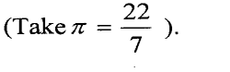
6. The curved surface area of a cylindrical container is 1980cm². If the radius of the container is 21cm, calculate to one decimal place the capacity of the container in litres. (4 mks)

7. The figure below is a triangular prism ABCDEF with sides AB = BF =AF = 3cm and BC = AD = EF = 5cm.
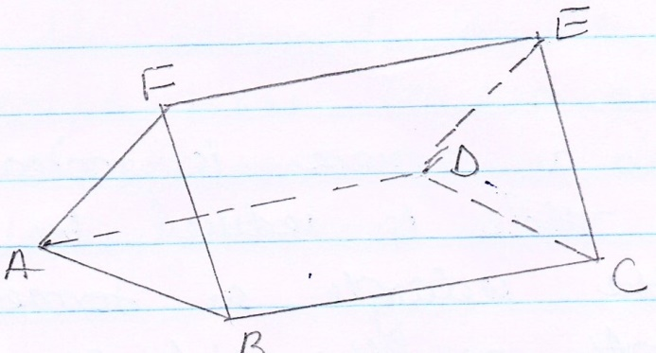
  - Draw the net of the solid. (2mks)

  - Calculate the surface area of the solid. (2mks)

8 .Two similar containers hold 2000cm³ and 6.75litres respectively. If the smaller container has a diameter of 15.50cm, what is the radius of the larger container correct to one decimal place. (3mks)

9 . A tourist on holiday in Kenya had Us£7500. She changed all the amount into Kenya Shillings at the rate of Us$ 1 = kshs. 80.04, While in Kenya she spent two thirds of the money and changed the remainder back to Us $ at Us $1 = kshs. 80.50. How much to the nearest Us dollars did she get? (3mks)

10. Determine the quartile deviation of the following data. (2mks)
4,9,5,4,7,6,2,1,6,7,8,3

11. A farmer has a piece of land measuring 840m by 396m. He divides it into square plots of equal size. Find the maximum area of one plot. (3 mks)

12. A seven sided polygon has two of its interior angles as 140º and 160º and the remaining angles are equal. Find the size of one of the equal angles. (3mks)

13. If$P=\left(\begin{matrix}1 \\ 1-y\end{matrix}\right) , Q=\left(\begin{matrix}3 \\ y+2\end{matrix}\right) and \left|P\right|=\left|Q\right|$. Find the value of y . (3 mks)

14. Find the value of x if. (3 mks)
${ \left(\frac{27}{8}\right)}^{x+7}$= ${\left(\frac{4}{9}\right)}^{-3x}$

15 .Use reciprocal and square tables to evaluate, to 4 significant figures, the expression. (3 mks)

$\frac{1}{ 0.03654}$ – ${4.151}^{2}$

16. The following were recorded on a field note book by a surveyor. Taking the base line as 550M find the area in M². (3 mks)
 |  | B
 |  | 550 | 120 | TO | A
C | 150 | 450
 |  | 250 | 90 | T O | D
E | 60 | 40
 |  | F

SECTION II (50 MARKS)
Answer ONLY FIVE questions in this section

17. A tank has two water taps P and Q and another tap R. When empty the tank be filled by tap P alone in 5 hours or by tap Q in 3 hours .When full the tank can be emptied in 8 hours by tap R
a)The tank is initially empty . Find how long it would take to fill up the tank
i) If tap R is closed and taps P and Q are opened at the same time (2mks)

ii) If all the three taps are opened at the same time .Giving your answer to the nearest minute (2mks)

b) Assume the tank initially empty and the three taps are opened as follows
P at 8:00 am
Q at 9:00 am
R at 9:00 am
- Find the fraction of the time that would be filled by 10:00 am. (3mks)

ii) Find the time the tank would be fully filled up. Give your answer to the nearest minute. (3mks)

18. A straight line L₁ has a gradient ˉ½ and passes through point
P (-1, 3). Another line L₂ passes through the points Q (1, -3) and
R (3, 5). Find.
(a) The equation of L₁. (2mks)

(b) The equation of L₂ in the from ax+by+c =0. (2mks)

(c) The equation of a line passing through a point S (0, 1.5) and is perpendicular to L₂. (3mks)

d) The point of intersection of a line passing through S and L_{2.} (3mks)

19.The figure below shows a velocity – time graph of a car journey.

22

Velocity(m/s)

O t 40 T time(s)
The car starts from rest and accelerates at 2.75m/s² for t seconds until its speed is 22m/s. It then travels at this velocity until 40 seconds after starting. Its breaks bring it uniformly to rest. The total journey is 847m long and takes T seconds.
Calculate the
- Value of t (3mks)

- Distance travelled during the first t seconds. (2mks)

- Value of T (3mks)

- Final deceleration (2mks)

20. Four towns P, R, T and S are such that R is 80km directly to the north of P and T is on a bearing of 290° from P at a distance of 65km. S is on a bearing of 330° from T and a distance of 30 km. Using a scale of 1cm to represent 10km, make an accurate scale drawing to show the relative position of the towns. (4mks)

Find:
(a) The distance and the bearing of R from T. (3mks)

(b) The distance and the bearing of S from R. (2mks)

(c) The bearing of P from S (l mk)

21. On the Cartesian plane given below, draw the quadrilateral ABCD with
vertices A(6,6)B(2,2)C(4,-6) and D(8,0). (1mk)
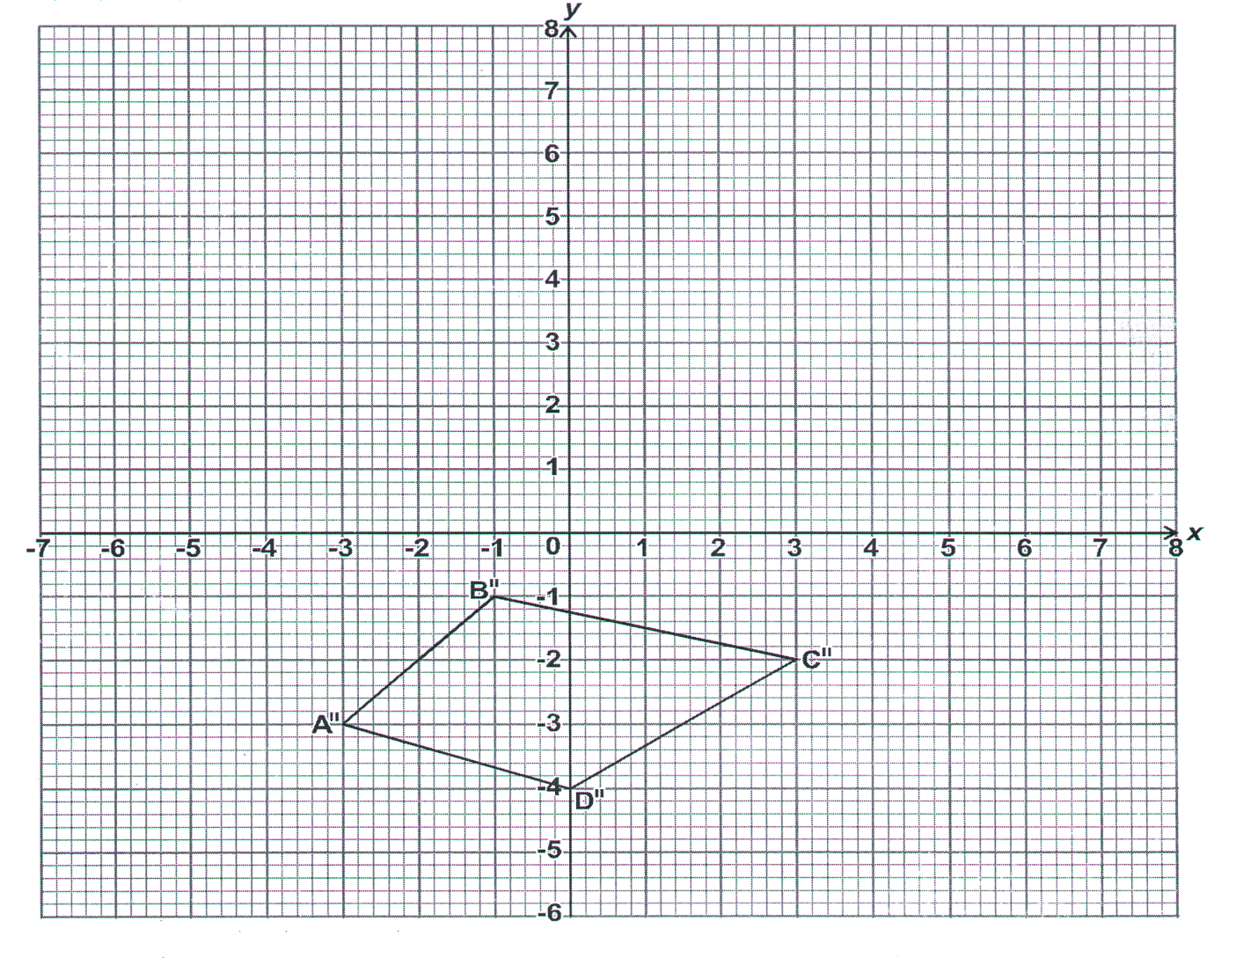
- Draw the image A¹B¹C¹D¹ of ABCD under enlargement scale factor$\frac{1}{2}$ ,centre origin. State the coordinate of A¹B¹C¹D¹ (3mks)

- Describe the transformation that maps A¹B¹C¹D¹ onto the given image A¹¹B¹¹C¹¹D¹¹ (2mks)

- Rotate A¹¹B¹¹C¹¹D¹¹ with center (-2,-1) through a positive quarter turn to get A¹¹¹B¹¹¹C¹¹¹D¹¹¹ .state the coordinate of A¹¹¹B¹¹¹C¹¹¹D¹¹¹.(3mks)

- State a pair of quadrilateral that are oppositely congruent. (1mk)
22. The figure below shows a triangle ABC inscribed in a circle.AC = 10cm,
BC = 7cm and AB = 10cm.
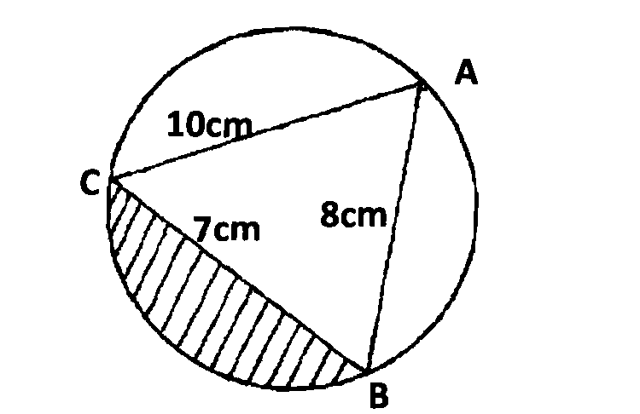
(a) Find the size of angle BAC. (3 mks)

(b) Find the radius of the circle. (2 mks)

(c) Hence calculate the area of the shaded region. (5 mks)

23. The diagram below shows a triangle OPQ in which QN:NP = 1:2, OT:TN = 3:2 and M is the midpoint of OQ.
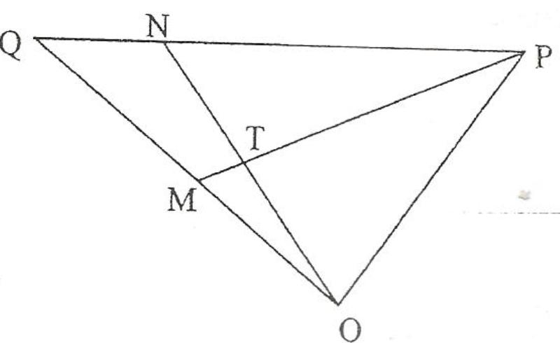

- Given that OP = p and OP = q, Express the following vectors in terms of p and q

- PQ (1 mk)

- ON (2 mks)

- PT (2 mks)

- PM (1 mk)

- (i) Show that point P, T and M are collinear. (3 mks)

(ii) Determine the ratio MT: TP. (1 mk)
24. A school in Murang’a East decided to buy x calculators for its students for a total cost of ksh.16,200. The supplier agreed to offer a discount of ksh.60 per calculator. The school was then able to get three extra calculators for the same amount of money.
(a) Write an expression in terms of x, for the
(i) Original price of each calculator. (1mk)

(ii) Price of each calculator after the discount. (1mk)

b) Form an equation in x and hence determine the number of
Calculators the school bought. (5mks)

c) Calculate the discount offered to the school as a percentage. (3mks)

