NAME…………………………………………………...… INDEX NUMBER…………….…
CANDIDATE SIGN …………………………………..… DATE ………………
MURANG`A EAST 2021 [K.C.S.E TRIAL EXAMINATION]
233/2
CHEMISTRY PAPER 2

TIME: 2 HOURS

INSTRUCTIONS TO CANDIDATES
- Write your name and index number in the spaces provided above
- Answer all the questions in the spaces provided
- KNEC mathematical tables and silent electronic calculators may be used
- All workings must be clearly shown where necessary
- Candidates should answer all questions in ENGLISH

FOR EXAMINER’S USE ONLY
QUESTION | MAXIMUM SCORE | CANDIDATES SCORE
1 | 12
2 | 14
3 | 12
4 | 12
5 | 10
6 | 10
7 | 10
Total score | 80 marks

- A student set-up the following apparatus to prepare carbon (II) oxide from charcoal in the laboratory.
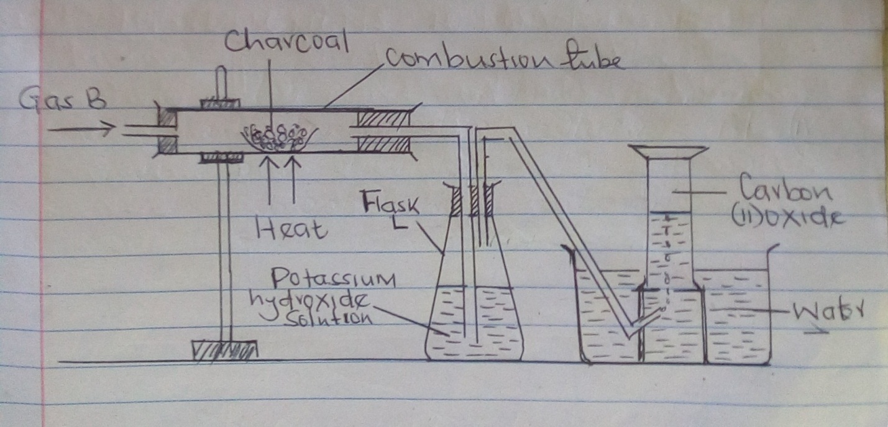
- State the purpose of potassium hydroxide solution (1mk)

- Identify gas B (1mk)

- Name two substances that react together to produce gas B (2mks)

- Write balanced equations for reactions in
- Combustion tube (1mk)

- Flask L (1mk)

- Describe two simple test that you would use to distinguish between Carbon (IV) oxide and Carbon (II) oxide. (2mks)

- In another experiment, the student reacted charcoal with excess hot concentrated nitric (v) acid.
- State one observation made (1mk)

- Write balanced equation for the reaction (1mk)

- State two use of Carbon (II) oxide (1mk)

- Use the information in the table below to answer the questions that follow. The letters are not the actual symbols of the elements.

Element | Atomic Number | M.P (⁰c)
A | 11 | 97.8
B | 13 | 660
C | 14 | 1410
D | 17 | -95
E | 20 | 839

- Write the electronic arrangement for the ions formed by elements D and A (2mks)

- Select an element which is :
- A poor conductor of electric current (1mk)

- The strongest reducing agent (1mk)
- Has a giant covalent structure (1mk)

- In which state will element B exists at 661⁰c Explain. (1mk)

- Compare the electrical conductivity of element A and B. Give a reason (1mk)

- Using dots (.) and crosses (x) to represent the outermost electrons, show the bonding in the compound formed between elements C and D. (2mks)

- Explain the difference in melting points in elements B and A (2mks)

- Write an equation for the reaction that takes place between element E and steam. (1mk)

- Describe how a solid mixture of the Chloride of E and lead (II) Sulphate can be separated into solid sample. (2mks)

- Study the flow chart below and answer the questions that follow.
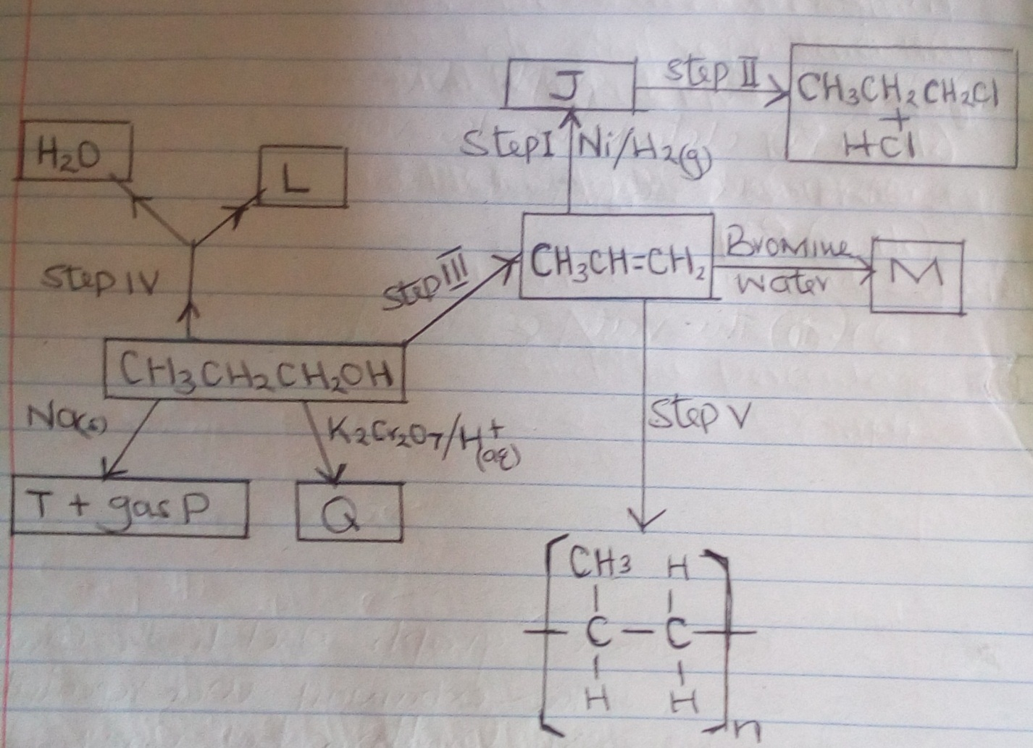

- Name substance J and draw its structural formula: (2mks)
Name
Structural formula

- What reagents and conditions are necessary for:
- Step (III) : Reagent (1mk)

Condition

- Step II: Reagent (1mk)

Condition

c) Name the following
i) L (1mk)

ii) Gas P (1mk)

iii) Q (1mk)

iv) M (1mk)

d) Write the equation of the reaction that occur in step (IV) (1mk)

e) Give the name of process in step (V) (1mk)
f) If the relative Molecular Mass of R is 21,000, determine the value of n. (C = 12.0, H = 1.0) (2mks)

- a) Define an electrolyte (1mk)

b) Explain why the following substances conduct an electric current (2mks)
i) Magnesium metal

ii) Molten magnesium Chloride

c) Study the reaction scheme below and answer the questions that follow.
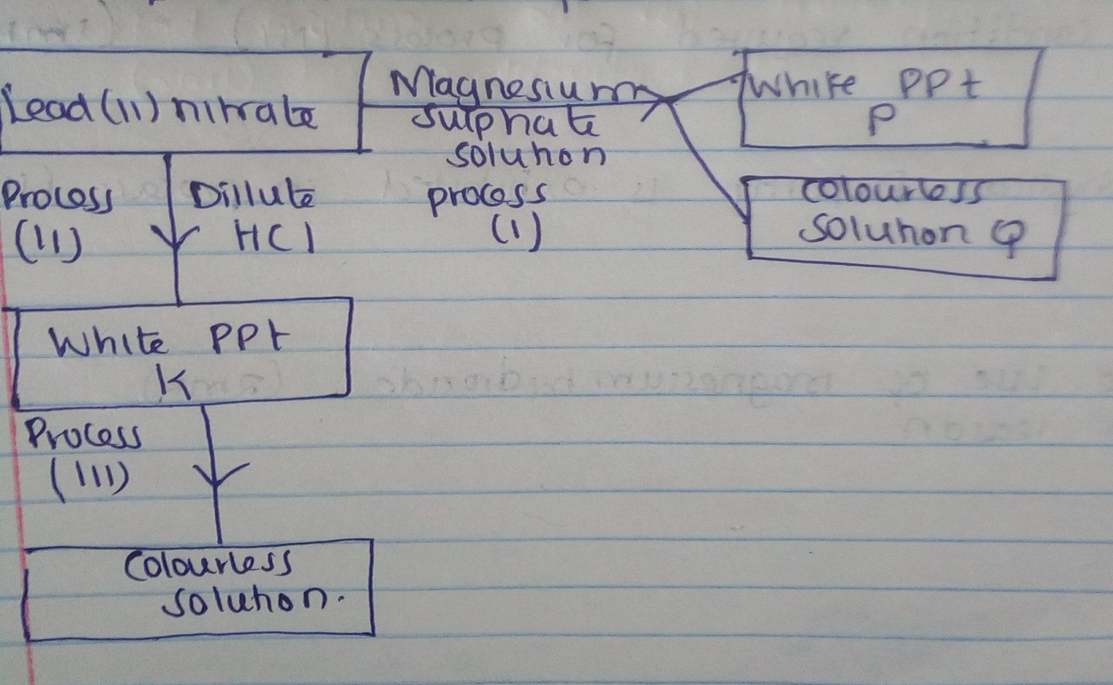
i) Write the formula of P and Q (2mks)

ii) Write an ionic equation for the formation of P (1mk)

iii) Name process (i) (1mk)

iv) Write a balanced equation for the formation of white precipitate K (1mk)

v) State the condition required for process (III) (1mk)

vi) Which physical property is exhibited in process (III) (1mk)

vii) State one use of magnesium hydroxide (2mks)
Give one reason

5 a) At 25⁰c, 50g of potassium nitrate were added to 100g of water to make a saturated solution. What is meant by a saturated solution? (1mk)

b) The table below gives the solubilities of potassium nitrate at different temperatures.
Temperature (⁰c) | 12 | 20 | 28 | 36 | 44 | 52
Solubility g/100g of water | 22 | 31 | 42 | 55 | 70 | 90

i) Plot a graph of the solubility of potassium nitrate (vertical axis) against temperature (3mks)
ii) Using the graph
i) Determine the solubility of potassium nitrate at 15⁰c. (1mk)
ii) Determine the mass of potassium nitrate that remained undissolved given that 80g of potassium nitrate were added to 100cm³ of water and water to 40⁰c. (2mks)

c) Determine the molar Concentration of potassium nitrate at 15⁰c.
(Assume there is no change in density of water at this temperature)
(K = 39.0, N = 14.0, O = 16.0) (3mks)

6 a) Aluminium oxide reacts with both acids and bases
i) Write an equation for the reaction between aluminium oxide and hydrochloric acid (1mk)

ii) Using the equation in (a) above, calculate the number of moles of hydrochloric acid that would react completely with 153.0g of aluminium oxide (Al = 27.0, O = 16.0) (3mks)

b) Sodium hydroxide pellet were accidentally mixed with sodium chloride, 8.8g of the mixture were dissolved in water to make one litre of solution. 50cm³ of the solution was neutralized by 20.0cm³ of 0.25M Sulphuric (vi) acid.
i) Write the equation for the reaction that took place. (1mk)
ii) Calculate the:
i) Number of moles of the substance that reacted with Sulphuric (vi) acid (2mks)

ii) Number of moles of the substance that would react with Sulphuric (vi) acid in the one litre
solution. (1mk)

iii)The percentage of sodium chloride in the mixture. (2mks)

7. The flow chart below illustrates the industrial extraction of lead metal.
Study it and answer the questions that follow.
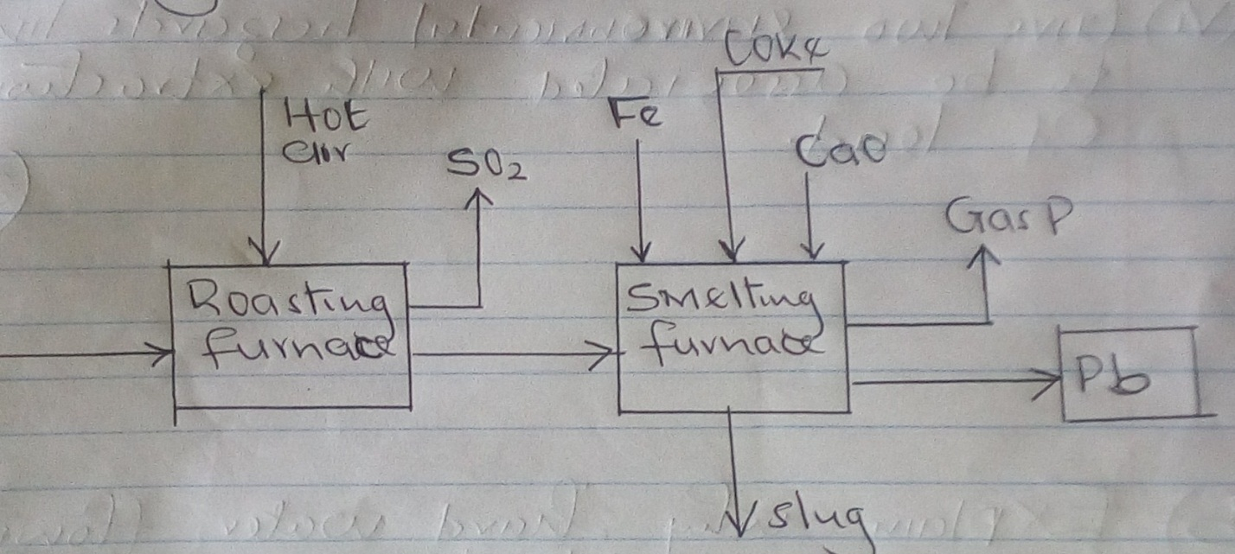
- i) Name the ore that is commonly used in the process (1mk)

ii) Explain what takes place in the roasting furnace (1mk)

- Identify gas P (1mk)

- Write the equation for the main reaction that takes place in the smelting furnace. (1mk)

- What is the purpose of adding iron in the smelting furnace? (1mk)

- Give two environmental hazards likely to be associated with extraction of lead. (2mks)

- Explain why hard water flowing in lead pipes may be safer for drinking than soft water flowing in the same. (2mks)

- State one use of lead other than the making of lead pipes (1mk)

