MURANG`A EAST 2021 [K.C.S.E TRIAL
CHEMISTRY
PAPER ONE
233/1
MARKING SCHEME

- a) Existence of element in more than one physical form in the same state
b) Graphite, diamond
c) Making of carbon papers / making tyres/ making printers ink

FeSO₄ | H₂O
Mass 2.84 | 2.36
RFM 152 | 18
No of moles 2.84 = 0.0187  1.52 | 2.36 = 0.1311  18
Mole ratio 0.0187 =1  0.0187 | 0.1311 = 7  0.0187

E.F = FeSO₄.7H₂O
3. a) Mg(s) + 2H⁺(aq) Mg²⁺ (aq) + H₂(g)

b) Acid R is stronger than acid S
Acid S is stronger acid while S is weak acid
It produces more H⁺ ions which react with magnesium
It ionizes fully in water or it produces high volume of hydrogen.

4. a) They gain K.E
They gain energy and vibrate faster

b) T1 – Melting point
T2 – Boiling point

c) Energy is used to weaken the intermolecular force of attraction so as to change the substance
from solid to liquid state.

5. Mass of solution = 128.9 - 94.3 = 34.6 (g)
Mass of dry salt = 103.9 -94.3 =9.6 (g)
Mass of solvent = 34.6 – 9.6 = 25 (g)
25.0g of solvent containing 9.6g
100g =? 9.6 x 100
25
Solubility = 38.4g/100g of water
6. a) Nitric (v) acid is more volatile than conc sulphuric (vi) acid or
Nitric (v) acid has a lower B.P than Sulphuric (vi) acid.

b) Sodium nitrate

7. React excess lead oxide with the nitric acid filter to form lead nitrate solution. Dissolve
sodium sulphate in water to form solution. Mix sodium sulphate solution with lead nitrate
solution to precipitate lead sulphate. Filter, wash the residue to dry between filter paper.

8 a) Z – concentrated nitric (v) acid

Y – Ammonia solution / ammonium hydroxide, aqueous ammonia.

b) (CU (NH₃)₄)²⁺

9. 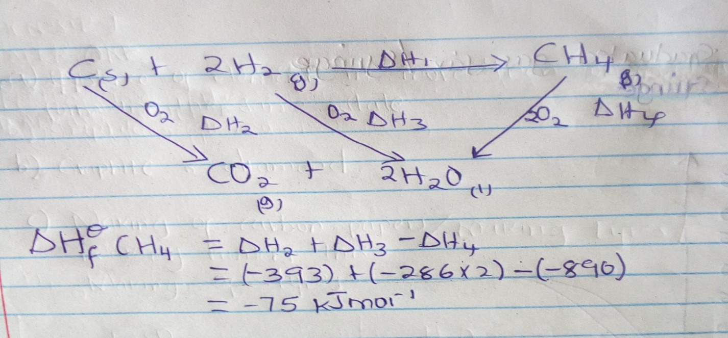
10. a) Brown colour intensifies, Reaction is exothermic
Increasing the heat will favour backward reaction
Equilibrium shift to the left and this reaction absorbs heat

b) Pale yellow colour intensifies
Equilibrium shifts to the right because volume is reduced

11 a) B – Unburnt gas/colourless region/almost colourless region
C – Pale blue region

b) Regulating amount of air entering the chimney
12 a) Graduated gas jar / syringe

b) 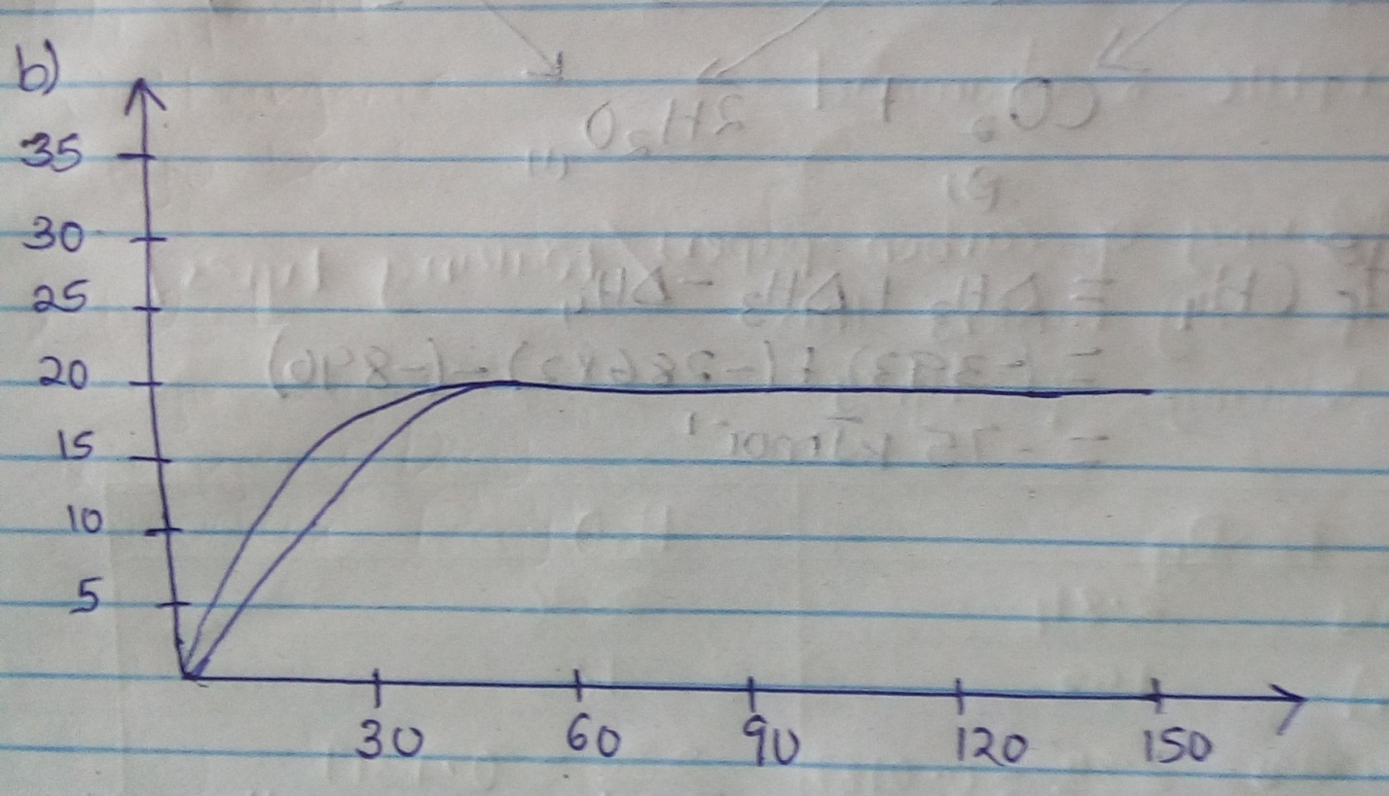

13 a) The solution turned from yellow to pale green
Red brown to pale green/ brown to pale green

b) 2FeCI₃ (aq) + H₂S (g) 2FeCI₂ (aq)+S(s) +2HCL(aq)

14. a) P and M, They have same atomic number

b) n = 15 – 7
= 8

15 a) Identify the solid P
Sodium Sulphite / Potassium Sulphite

b) i) Its denser than air /it was bleached/ it turned white.

ii) Remained red

16 a) The volume of a fixed mass of gas is directly proportional to its absolute temperature at
constant pressure.

b) V1 = V2 0.048 = 0.032 T2 = 198.667 K
T1 T2 298 T2
17 R.A.M = 7 X 62 + 3 X 64
10 10
= 43.4 + 19.2
= 62.6

18 a) Sublimation
b) Esterification

19 a) i) N
ii) G

b) E.M.F cell = E reduction – E oxidation
= (+ 1.36) – (-2.92)
= + 4.29v

20 a) Bond breaking
(C = C) + (Br – Br) + 4 (C – H)
+ 610 KJmol⁻¹ + 193 KJmol⁻¹ + 1652 KJmol⁻¹
= 2455 KJmol⁻¹

Bond formation
2 (C – Br) + (C – C) + 4 (C – H)
560 + 346 + 1652
= 2558

Heat of reaction = Bond breaking + Bond formation
= 2455 KJmol⁻¹ + (- 2558 KJmol⁻¹)
= -103KJmol

b) Addition reaction/Halogenation/Exothermic/Bromination

21. Add warm water to the mixture and stir
PbCl₂ dissolves while silver chloride does not
Filter to obtain lead(ii) chloride as filtrate
and silver chloride as residue.
Cool the filtrate to obtain solid lead (ii) chloride

22. Lead (ii) carbonate react with dilute hydrochloric acid
to form an insoluble coat of lead (ii) chloride
on the carbon which stops further reaction
23 a) S because it has a high M.P and B.P and also conducts in aqueous solution

b) P or Q

24. 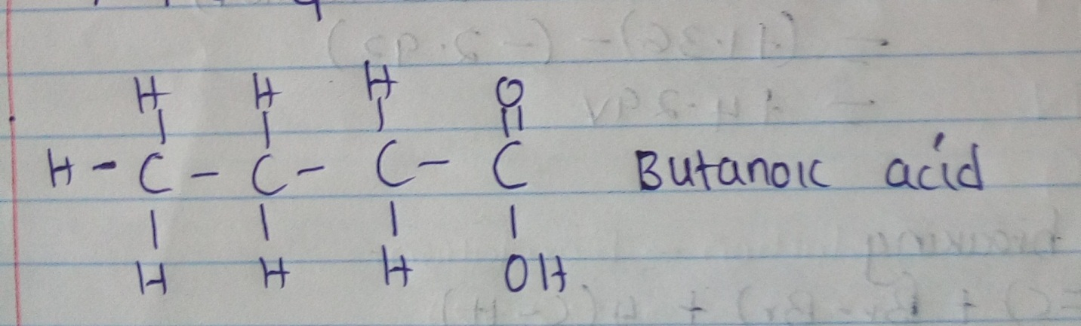
25. i) Carbon (iv) oxide / CO₂
ii) Leads to global warming/greenhouse effect/acid rain

26. a) 3Mg(s) + N₂(g) Mg₃N₂(g)
b) Neon/Argon, it is noble gas

27 i) Quantity of = 1t
Electricity = 6.42 x 10 x 60
= 6.42 x 600
= 3.852C

ii) 3852c produce 2.74g
2 x 96500 = 2 x 96500 x 2.74
3852

= 137.28

28 Alcl₃ is largely covalent /it sublimes when heated
It is made of molecules which do not conduct electricity.

29. i) Polyphenylethane/polystyrene
ii) It is non-biodegradable/pollutes environment

30 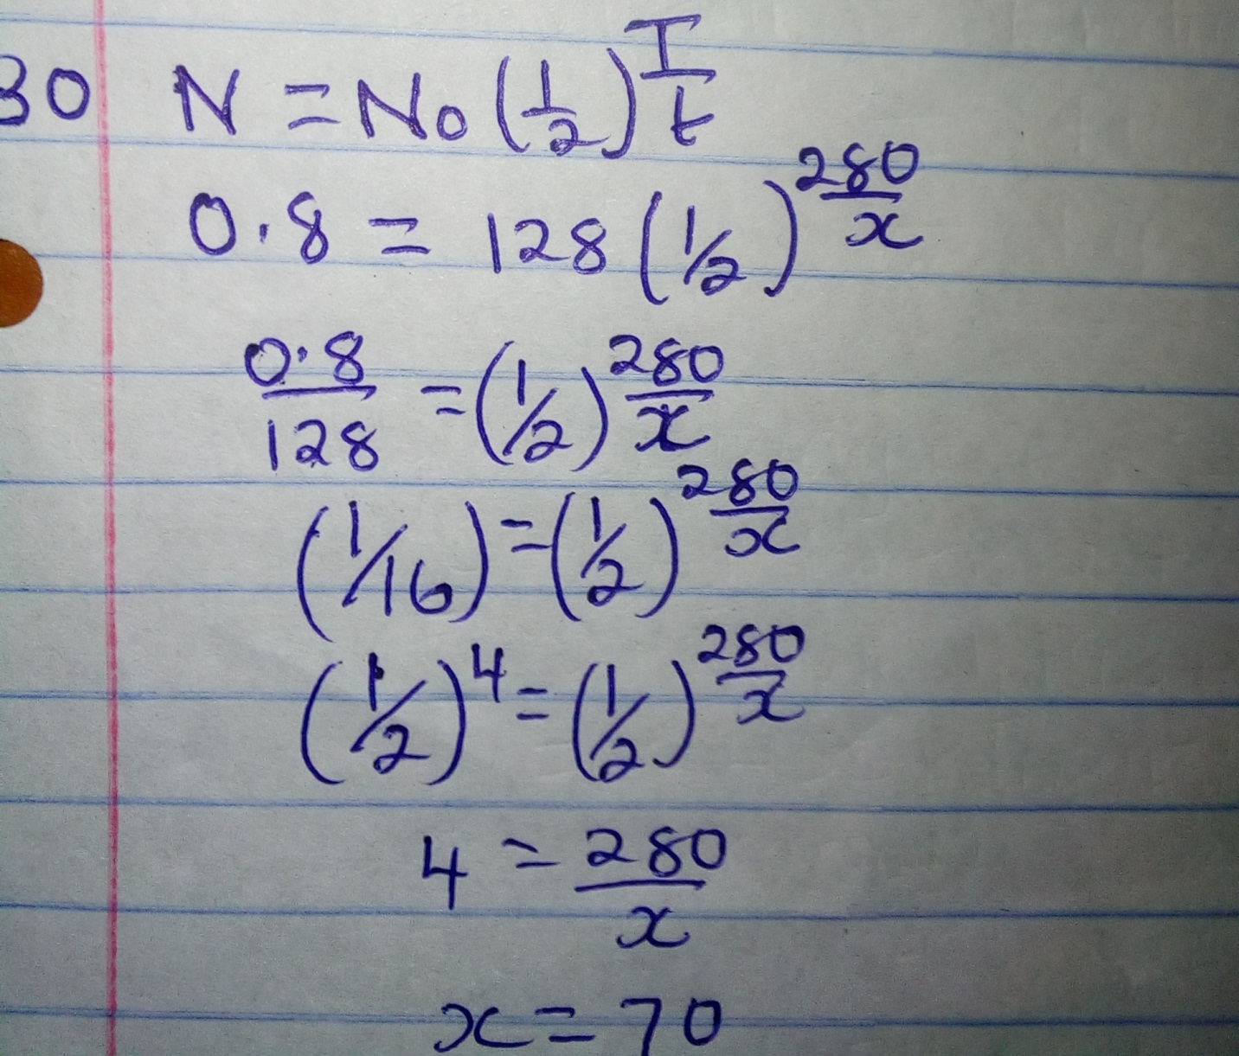

12.8(g) 6.4g 3.2g 1.6g 0.8g

4 t ½ = 280 days
t1/2 = 280
4
= 70 days

31. a) 4NH₃(aq) + 5O₂(g) 4NO(g) + 6H₂O(l)
b) HNO₃ (aq) and HN0₂ (aq)

32. The laboratory gas burns in excess oxygen / burns completely/produces CO₂ and H₂O
only/No unburnt carbon remains/No soot is produced.

