PAPER 2 MARKING SCHEME
- a) Explain 5 money transfer facilities offered by a commercial bank to its customers.
(10mks)
- Accepting deposits; they accept deposits from their customers for safe keeping.
- Providing means of payment; the provide convenient means of payments to their customers through standing orders, cheques, credit transfers e.t.c
- Providing loans; they facilitate various types of loans.
- Advisory services; they advise their customers on financial matters such as taxation and investment opportunities.
- Foreign exchange; they sell and buy foreign currency as a service to the public.
- Agents of stock of exchange; they do so by being contracted to channel new shares to the public or buying shares on behalf of their customers.
- Guarantor and referees; they can stand surety on behalf of clients seeking credit transactions from other business units.
- Safekeeping for valuables; they keep safely variable for their clients at a fee. (any 5x2 = 10)

b) Differentiate between a public limited company and a public corporation (10mks)
1. Formed by shareholders Formed by the government through the act of
parliament
2. Under the company’s act initially financed by the government
3. Financed by shareholders
4. Directors are welted and nominated -Directors are political appointees
by shareholders
5. Losses may result to collapse - Losses may be borne by the government
6. No political influence except - political influences
enacted laws
- a) Ways of correcting balance of payment
- Increasing volume of export-this is done through the provision of exports incentives eg export compensation scheme.
- Reducing volume of imports-is done through raising import duty and exchange controls.
- Devaluation of currency-lowering value of country currency relative to other currencies to make import expensive and export cheaper.
- Diversification of export-increasing range of commodities exported.
- Borrowing from IMF and other lender to finance the deficit.
- Encouraging the foreign direct investments in the country. 5x2=10 marks

b) Factors are likely to lead to high birth rate in Kenya
- Some culture practice taking children as security in old age therefore getting many children.
- Early marriage prolong woman’s reproductive life.
- People wanting to have many children in areas of high mortality so that if some dies other will be left.
- Children seen as cheap labour.
- Where people are opposed or ignorant of family planning methods e.g. catholic people. 5x2=10mks
- a) By the aid of a diagram, explain excess demand and excess supply (10mks)

price sh D
E S

--------------------------------------------------------
Pe -------------------------
D
S--------------------------------------------------

Quantity
Qe

b) Discuss any five circumstances under which an insured may not be compensated in the event of a loss. (10mks)
- If the insured has no insurable interest in the insured property
- If the property is insured in an act of nature
- If loss occurred due to willful action i.e. insured cancel the loss.
- If insured fails to report occurrence of the risk within the stipulated period of time.
- Incase of insolvent or bankruptcy of insurer.
- If insured went against the principle of utmost good faith.

- a) Explain five services offered by wholesalers to retailers. (10 marks)
- (Availing) a variety of goods from different producers / relieving the retailers of the burden of visiting the producer’s premises / meeting their different needs / choices.
- They break bulk into quantities desired by retailers / the retailers are able to purchase only in the quantities they can afford.
- They offer storage / warehousing services – this relieves the retailers from the risk of damage / cost of storage of goods / services.
- They provide credit / trade credit / financing to deserving retailers / which act as a source of capital to them / to be paid at a later date / as agreed.
- They advertise goods / product promotion to the benefit of retailers to obtain (a ready ) market / relieving them of the cost of advertising / accept any correct benefit of advertisement to the retailer as expansion.
- They offer transport to the retailers relieving them of transportation costs / the hustle of looking for means of transport.
- They inform / advice / educate retailers on available offers for certain commodities / this may help retailers improve on their profit margin / accept examples of advice as explanation.
- Blending the goods – mixing of different grades of goods / to get a desired / better quality.
- Packing / packaging the goods- putting the goods in suitable containers / sizes / fixing labels / wrapping.
- Sorting of goods – arranging / grouping goods in categories / in classes.
- Branding –giving a name / features to a product for easy identification.
- Steady supply of goods to the retailers whenever he / she needs them.
- Acts as a link between producers and the retailers / by buying goods from the producer and selling them to the retailers / bringing goods closer to the retailers.
- Grading goods – arranging / grouping goods according to the quality.
NB: If a candidate gives preparation of goods for sale as a point, give 2 marks if qualified by way of example; give 1 mark if not qualified.
- Preparation of goods for sale without expansion – 1 mark.
- Preparation of goods for sale with examples of preparation , a candidate earns 2 marks
- Where a candidate has earned 2 marks for preparation of goods for sale fully explained but goes ahead to come up with ways of preparing goods for sale fully explained, award 2 marks but retain 1 mark for the other response.
b. On March 1 2017, Martha had cash in hand shs 87,000 and cash at bank shs 250,000. During the month, the following transaction took place.
March 2: Cash sales shs 60,000
3: Paid salaries shs 101,500 by cheque.
7: Received a cheque shs 76,000 from Henry, after allowing him cash discount of 5 %.
13: Bought office furniture by cheque shs 86,000
17: Settled Maria’s account for shs 34,200 in cash, having deducted shs 800 cash discount
20: Received a cheque for shs 165,000 in respect of cash sales
22: Paid wages sh 25,000 in cash
24: Withdrew shs 32,000 from the bank for office use
25: Withdrew shs 4,000 cash for personal use
29: Received shs 17,000 cash Alvin in settlement of his account less shs 1,000 cash
discount
31: Deposited all the money into the bank except shs 24,000

Prepare three column cash book duly balanced. (10 marks)
Date | Details | D.A | Cash | Bank | Date | Details | D.R | Cash | Bank
1/3/17 | Bal b/d √ |  | 87,000 √ | 250,000 √ | 1/3/17 | Salaries √ |  |  | 101,500 √
2/3/17 | Sales √ |  | 60,000 √ |  | 3/3/17 | Furniture √ |  |  | 86,000 √
7/3/17 | Henry √ | 4,000 √ |  | 76,000 √ | 13/3/17 | Maria √ | 800 √ | 34,200 √
20/3/17 | Sales √ |  |  | 165,000 √ |  | Wages √ |  | 25,000 √
24/3/17 | Bank ‘c’ √ |  | 32,000 √ |  |  | Cash ‘c’ √ |  |  | 32,000 √
29/3/17 | Alvin √ | 1,000 √ | 17,000 √ |  |  | Drawings √ |  | 4,000 √
31/3/17 | Cash ‘c’ √ |  |  | 108,000 √ |  | Bank ‘c’ √ |  | 108,800 √√
 |  |  |  |  |  | Bal c / d √ |  | 24,000 √√ | 380,000 √
 |  | 5,000 √ | 196,000 | 599,800 |  |  | 800 √ | 196,000 | 599,800

38 × ¹/₄ = 9 ¹/₂ marks
NB: A tick on each side for dates 2 × ¹/₄ = ¹/₂ mark
- a) Explain five benefits of filing office documents to an organization. (10 marks)
- Tidiness in the office is maintained / office is kept tidy.
As documents are (neatly) arranged.
- Quick access / retrieval to / of information is made easy.
Since documents are serialized / coded.
- Safety of information from damage.
By bad weather / fire / pests / accept examples as an example.
- Saving on (storage) space / minimum space.
As documents are kept compactively / accept examples of compact storage media as an explanation e.g. CD’s, diskettes.
- Promote decision making possible / saves time in making decisions.
As information is readily / easily available.
- Encourages transparency / accountability.
As no document are easily misplaced / as movement of documents can be monitored.
- Security of information against loss.
Due to theft / misplacement.
- Safeguard secrets / confidential information.
As documents are kept away from unauthorized access / under key and lock.
- Storage / safe-keeping of information / documents.
For future reference.

b) A trader want to place an order to his suppliers. Explain five factors that he should consider before choosing the appropriate means of communication. (10 marks)
- Urgency of the message-use fast means when the message is urgent
- Cost-choose one which is cost effective / affordable
- Confidentiality –Choose a mean depending on the privacy the message content.
- Distance i.e. the geographical gap between the supplier and him eg telephone for long distance
- Evidence for future reference
- Reliability i.e. assurance that the message will reach
- Accuracy-exactness of the message
- Capacity of the mean-detailed message requires a method that would accommodate the volume of data involved.

- a.
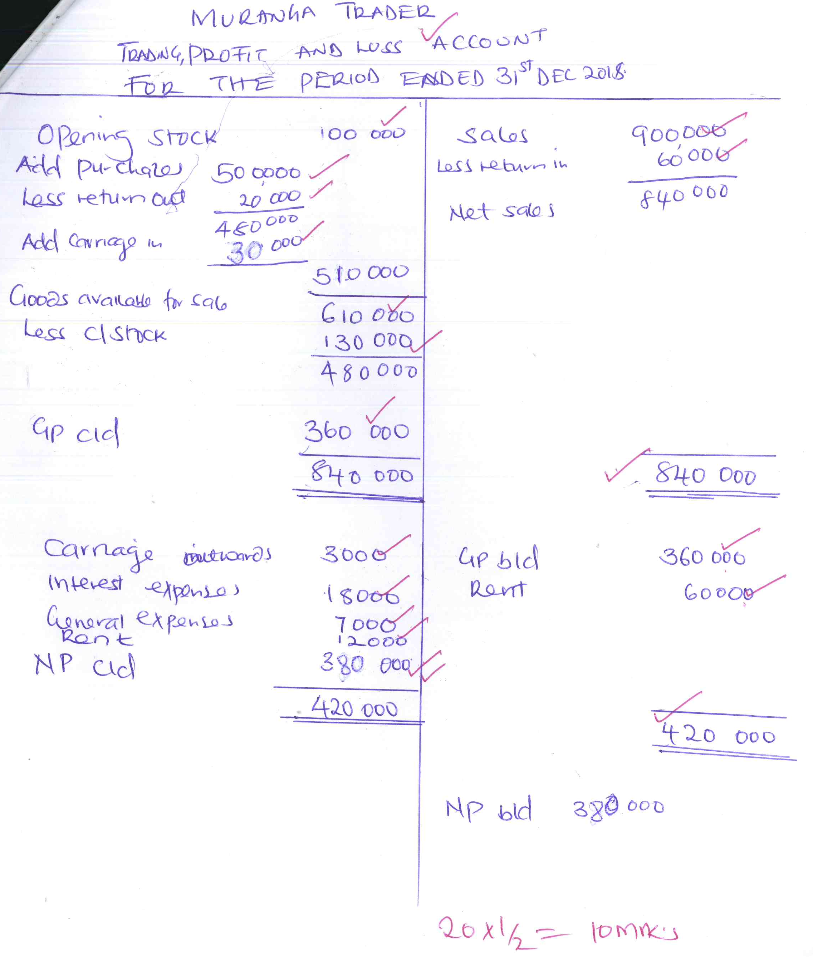

b. Limitations of advertising goods in newspapers
- Not all potential customers are able to read newpapers
- The newpapers may be written in a language or medium that is not familiar to customers
- It is expensive to buy newspapers and many people cannot afford
- It is expensive to advertise using newpapers as one incurs extra cost
- Newspapers are nto able to discriminate between the intended group and others
- Newspapers may not reach all parts of the country
- Newspapers have a short life and therefore easily discarded. 5x2=10mks)

