Murang’a East Biology Paper 3 Practical Marking Scheme
1. (a) Specimen A. Type of germination: Hypogeal;
Reason: Cotyledons remain underground during germination;
Specimen B. Type of germination: Epigeal;
Reason: Cotyledons raised above the ground level during germination;
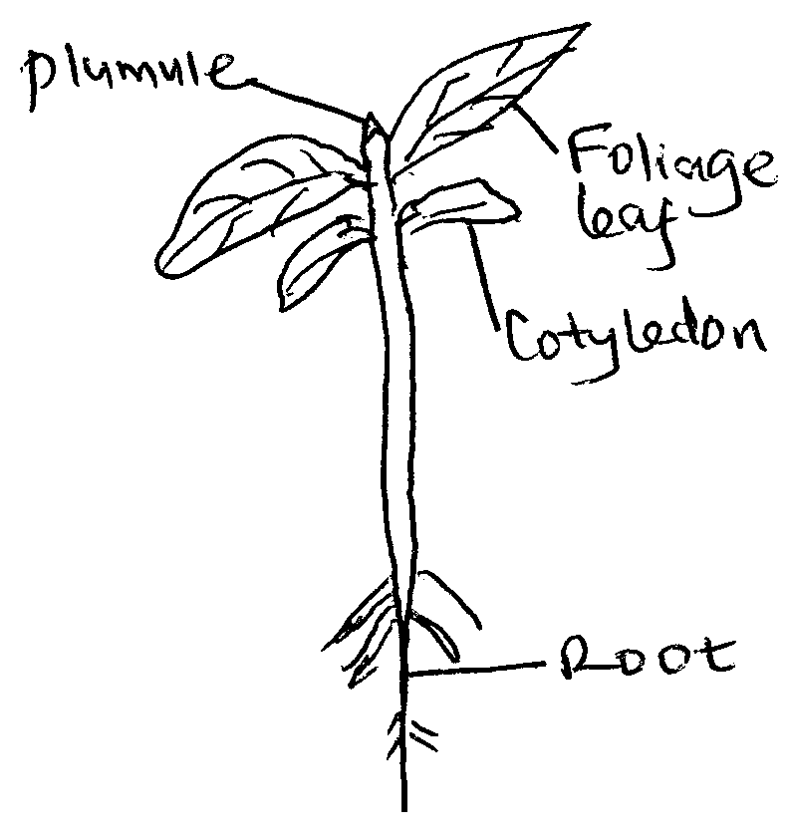
Drawing 1 mark(Check Accuracy /continuous outline/proportionality); Labelling 4 marks
(c) Specimen A. Class: Monocotyledonae;
Reason: Leaves have parallel venation; one cotyledon/seed leaves; Fibrous root system; Any one
Specimen B. Class: Dicotyledonae;
Reason: Leaves have network /reticulate venation; two cotyledons/seed leaves; Tap root system; Any one

2.a) 5mks
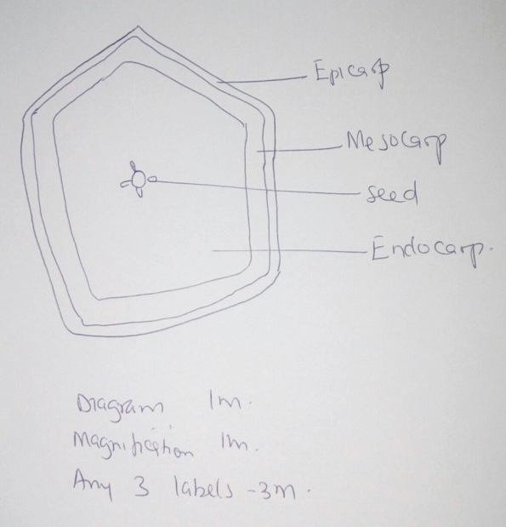
Magnification between X1 and X5
b) Type of fruit Berry 1mk
Reason has many seeds 1mk
c.)
Agent Animal 1mk
Reason brightly coloured; scented; fleshy; large; first 2mk
d)Axile; 1mk
e)Ethylene/ ethyne; 1mk

3.
Food substance | Procedure | Observation | Conclusion
starch | To ${1cm}^{3}$ of the solution add 2 drops of iodine solution 1 | Iodine colour is retained  1 | Starch absent  1
Protein | To ${1cm}^{3}$ of the solution add an equal amount of sodium hydroxide followed by 2 drops of ${CuSO}_{4}$ 1 | Purple colour  1 | Proteins present  1

b)Proteins present because their digestion is incomplete;
no starch because it has been digested/hydrolyzed into reducing sugars; max 2 mks
c)Inner surface has finger- like projections therefore it is rough and waxy; slimy/mucus; max 2mks
d) Finger-like projections are villi which increase surface area for absorption of digested food;
mucus/slimy to prevent it’s wall from being digested by digestive enzymes;mucus lubricates the food;max 2mks

