Name………………………………………………………. Index No…………………/…….
School……………………………………………………… Date ………………………….…
Candidate’s Signature………………………
231/2
BIOLOGY
(THEORY)
Paper 2
Time: 2 Hours
MURANG’A EAST JOINT EXAMS 2021
Kenya Certificate of Secondary Education (K.C.S.E)

INSTRUCTIONS TO CANDIDATES
- This paper consists of two sections A and B.
- Answer ALL questions in section A
- Answer question 6 (compulsory) and either question 7 or 8 in section B.

SECTION A (40 marks)

Answer all questions in this section in the spaces provided

- An experiment was set up to investigate a factor in autotrophism in green plants.
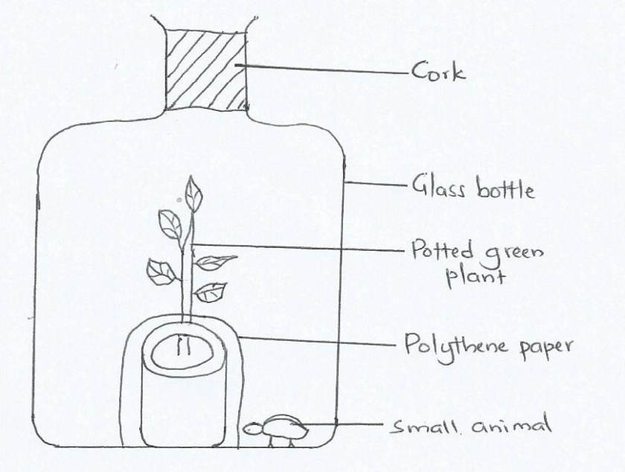
Vaseline was applied at joint between the cork and the mouth of glass bottle and set up was left under sunlight for 6 hours.
a) Explain why it was necessary to apply Vaseline. (1 mark)
………………………………………………………………………………………………………………………………………………………………………………………………………………………………………………
b) Explain why it was necessary to cover the pot with polythene paper. (1 mark)
………………………………………………………………………………………………………………………………………………………………………………………………………………………………………………
c) What was the purpose of including the small animal? (2marks)
………………………………………………………………………………………………………………………………………………………………………………………………………………………………………………………………………………………………………………………………………………………………………………………………………………………………………………………………………………………………
d)i)What would happen to the small animal if the set up was left overnight in darkness? (1mark)
………………………………………………………………………………………………………………………………………………………………………………………………………………………………………………
ii) Account for the answer above (1 mark)
………………………………………………………………………………………………………………………………………………………………………………………………………………………………………………
e)Explain why organisms in phylum Arthropoda die when Vaseline is applied on its thorax. (2marks)
………………………………………………………………………………………………………………………………………………………………………………………………………………………………………………………………………………………………………………………………………………………………………

2. (a) In a field study to estimate the population of grasshoppers in the school field of 0.4 km², 60 grasshoppers were caught using sweep nets, marked with red paint and released back to the field. The following day students went back with their sweep nets and caught 100 grasshoppers, of which 20 were found to be already marked.
(i) Calculate the population size of grasshoppers in the field. (2 marks)

(ii) Calculate the population density of the grasshoppers in the field. (2 marks)
(iii) What two factors would maintain the population of grasshoppers at the carrying capacity? (2 marks)
.................................................................................................................................................................................
..................................................................................................................................................................................
(b) Giving an example, state what is meant by the term symbiosis. (2 marks)
.................................................................................................................................................................................
..................................................................................................................................................................................
.................................................................................................................................................................................
..................................................................................................................................................................................

3 .The figure below shows the embryo sac before fertilization.

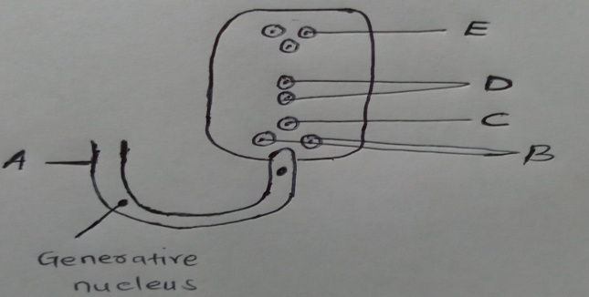

- Identify the structures labeled A and B (2mks)
A…………………………………………………………………………………………………………………………………………………………
B…………………………………………………………………………………………………………………………………………………………
- identify the structures labeled in the diagram that will develop into the following after fertilization (2mks)
(i) Embryo
………………………………………………………………………………………………………………………………………………………
Endosperm
…………………………………………………………………………………………………………………………………………………………
- State the ploidy of each of the following nuclei after fertilisation (2mks)
(i) C…………………………………………………………………………………………………………………………………………………

(ii)D………………………………………………………………………………………………………………………………………………
- Briefly outline the process of double fertilisation in flowering plant (2mks)
…………………………………………………………………………………………………………………………………………………………………
…………………………………………………………………………………………………………………………………………………………………
………………………………………………………………………………………………………………………………………………………………..
4. In an experiment, a black mouse was mated with a brown mouse; all the off-springs were
black. The off-springs grew and were allowed to mate with one another. The total number
of (F2) generation off-springs was 96.
- Using the letter symbols capital letter B for the gene of black colour and small b for brown colour, Work out the genotype of the F1 generation. (3mrks)

b) From the information above, work out the following for the F2 generation.
i) Genotypic ratio. (2mrks)
………………………………………………………………………………………………………
ii) Phenotypic ratio. (1mrk)
………………………………………………………………………………………………………
iiii) The total number of brown mice (2mrks)
- The diagram below shows part of gaseous exchange system in an insect. Study it and answer the questions that follows.

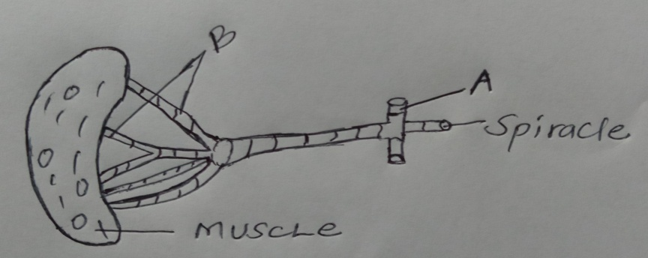

- What is the structural adaptations of the parts labeled A and B to their functions (2mks)
A…………………………………………………………………………………………………………………………………………………………
……………………………………………………………………………………………………………………………………………………………
………………………………………………………………………………………………………………………………………………………
B…………………………………………………………………………………………………………………………………………………………….

- Name the parts of the following animals that carry out the same functions as part B above (2mks)
(ii) Tilapia fish
- Name the structures used for gaseous exchange in plant growing in waterlogged soils (1mk)
………………………………………………………………………………………………………………………………………………………….
- (i) Give two reasons why accumulation of lactic acid during vigorous exercise leads to an increase of heart beat (2mks)
……………………………………………………………………………………………………………………………………………………………
……………………………………………………………………………………………………………………………………………………………
……………………………………………………………………………………………………………………………………………………………

(ii) In what form is oxygen transported from lungs to the tissues (1mk)
……………………………………………………………………………………………………………………………………………………………

SECTION B (40 MARKS)
Answer question 6(compulsory) and either question 7 or 8 in the spaces provided after question 8
- The table below shows how the quantities of urine and sweat vary with external temperature

External temperature(ºC ) | Urine (cm³/hr) | Sweat (cm³/hr )
0 | 100 | 5
5 | 90 | 6
10 | 80 | 10
15 | 70 | 20
20 | 60 | 30
25 | 50 | 60
30 | 40 | 120
35 | 30 | 200

- On the grid provided, plot the quantities of urine and sweat produced against external temperature (7 marks)

(b) At what temperature is the amount of sweat and urine produced equal? (1 mark)
..................................................................................................................................................................................
(c) What happens to the amount of sweat produced as the temperature rises? Explain your observation (3 marks)
.................................................................................................................................................................................
..................................................................................................................................................................................
.................................................................................................................................................................................
..................................................................................................................................................................................
(d) Explain the observation made on the amount of urine produced. (3 marks)
.................................................................................................................................................................................
..................................................................................................................................................................................
.................................................................................................................................................................................
..................................................................................................................................................................................
.................................................................................................................................................................................

(e) How are the following parts of the mammalian skin adapted for temperature regulation during cold weather? (6 marks)
Hair:.....................................................................................................................................
..................................................................................................................................................................................
.................................................................................................................................................................................
Sweat glands .......................................................................................................................................................
.................................................................................................................................................................................
.................................................................................................................................................................................
Blood vessels.......................................................................................................................................................
.................................................................................................................................................................................
.................................................................................................................................................................................
7. a) Describe the opening and closing of the stomata using the photosynthetic theory. (10marks)
b)Describe blood sugar regulation in mammals. (10marks)

8.a) Describe how urea is formed in the liver cells from excess amino acid (5mks)
b) Describe the roles of hormones in the growth and development in plants (15mks)

