Murang’a East Biology Paper 2 Marking Scheme 2021
1. a)To prevent entry of gases 1mk
b)Ensure soil microbes do not interfere with gas volume in glass bottles 1mk
c)Consume oxygen released when the plant photosynthesis. Release ${CO}_{2}$ from respiration to be used for photosynthesis by the plant 2mks
d)Small animal would die 1mk
ii)Lack of oxygen for respiration 1mk
e)Vaseline blocks spiracle, thus no inhalation 2mks

2. (a)(i) Population = first marked x second capture 100x60 ; = 300 ;grasshoppers.
Marked captured 20
(ii) Population density = total population = 300 ; = 750; grasshoppers /km²
Area 0.4
(iii) Competition; death of those not suitably adapted; Predation;
(b) Rhizobium in root nodules of leguminous plants; acc other relevant examples
Is an association between two organisms of different species where both benefit;

3. a) W – Polar nuclei; rej with cells
X – Ovum ( egg cell) ; rej. cells
Y- Integuments ; (3mks)
b) - Dissolves the tissues of the stroma ,style and ovary ;
- Forms pathway for the male nuclei to reach the embryo sac; (2mks)
Rej. –allows for passage
_ male nucleus for nuclei/ pollen grain
c) - They disintegrate ; (1mk)
d) - Male nuclei; carry out double fertilization. ;Rej nucleus
4 .Parental phenotype : Black mouse Brown mouse
Parental genotype : BB X bb ;
Gamete :

- F1 generation : Bb Bb Bb Bb ;

Rej. If it does not start from phenotype
If X is not there at the genotype
If X is placed at the gamates.
If gametes are not circled
If the circle has a tail or a gap- must be as smooth as possible.
If the fusion lines do not touch the line of the circle or if it penetrates into the circle.
If fusion lines join at the gamete.
If fusion lines are not at the same level at the F1 generation.
b) i) F2 offspring’s are BB, Bb, Bb, bb:
Genotypic ratio = 1BB:2Bb:1bb;
Rej. BB:Bb:bb
1 : 2 :1
ii) Phenotypic ratio -1brown: 3black ;
iii) ¼ x 96 = 24 ;

5. a.) i) A- presence of rings of chitin which keeps them always open
ii) B- Moist epithelium for dissolution of respiratory gases
Alveoli
ii) Gill filaments
c) Pheumatophores
d) i) To increase supply of oxygen to breakdown lactic acid into carbon (IV) oxide, water and ATP; to remove carbon (IV) oxide ‘produced;
ii) Oxyhaemoglobin ACC HbO₂/ HbO₈
(2mks)
6. (b) 24ºC +/- 0.5;
(c) Sweat production increases with increase in temperature high temperature increases the evaporation rate and hence more sweat converted to vapour; This uses latent heat of evaporation from body hence cooling.
(d) An increase in temperature deceases the amount of urine produced; this is due to sweating that raises the osmotic pressure of blood; A lot of water is then reabsorbed into the blood from the kidney tubules, resulting in production of little concentrated urine;
(e)Hair - When cold erector pili muscles contract; causes hair to stand and trap air which acts as an insulator; less heat loss
Sweat glands - When cold sweat glands releases less sweat; hence less evaporation hence less heat loss.
- Blood vessels - When cold, blood vessels constrict; less blood flows near skin surface reducing heat loss by radiation;

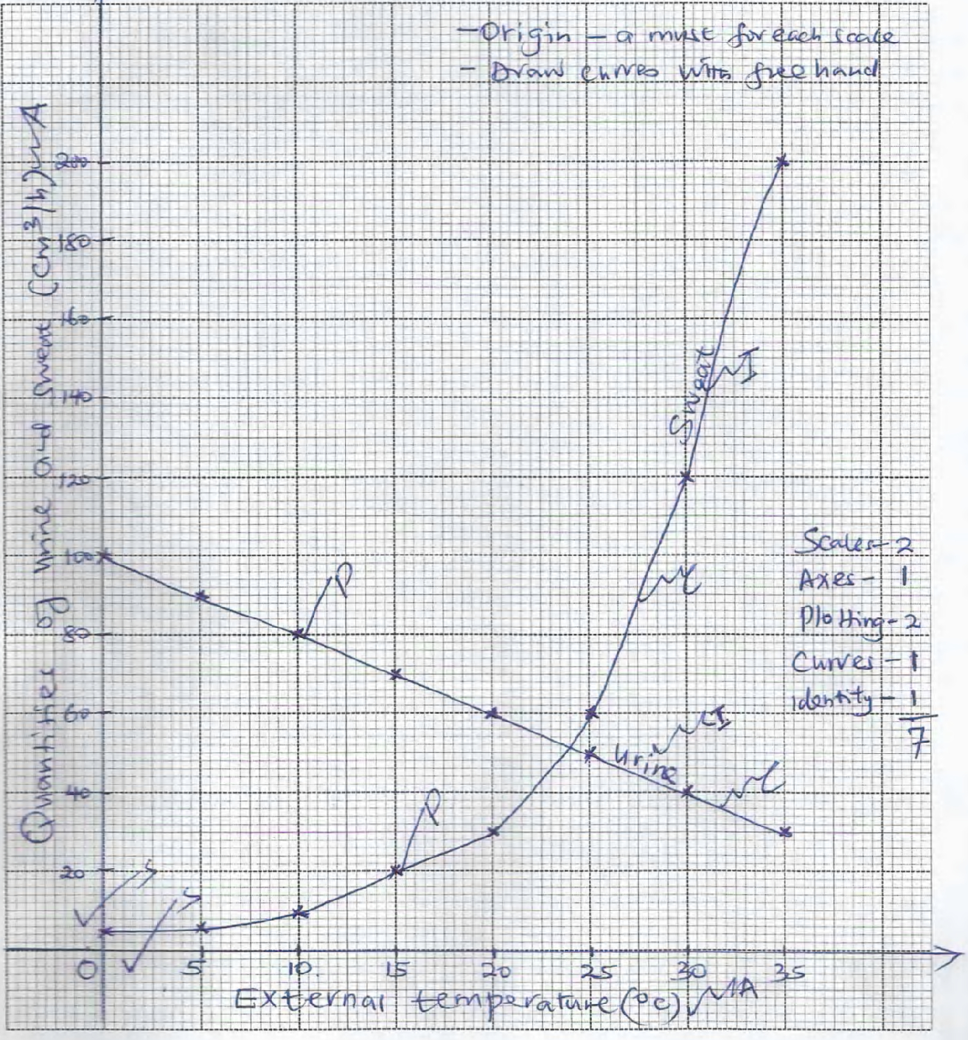

7a)During the day in the presences of sunlight guard gill synthesize glucose/sugar from the photosynthesis process, the synthesized sugar accumulates in the guard cells, increasing their osmotic pressure(makes them hypertonic to the adjacent cells of the epidermis. By osmosis, guard cells, draw in water and bulge outwards opening, the stoma. During the night in the absence of sunlight; guards cell are unable to carry out photosynthesis hence sugar is converted into starch; starch lowers the osmotic

pressure of the neighbouring cel, hence they low water by osmosis to the neighbouring epidermal cells become fluid hence closing the stomata max 10mks
b)When blood sugar rises above normal the hypothalamus stimulates the pancreatic cells to secrete insulin hormone which travels through the blood stream to the liver when it stimulates the liver cells to
i) convert excess glucose/sugar into glycogen
ii)Increase oxidation of sugar/glucose into energy, carbon(Iv)oxide and water
iii)Convert excess glucose/sugar into fats for storage in adipose tissues
iv)Inhibits conversion of glycogen into sugar
When blood sugar/glucose drops below normal; the hypothalamus stimulates the pancreatic cells to secrete hormone glucagon which travels through the blood stream to the liver; when it stimulates the liver cells to:
i)Convert stored glycogen into sugar/glucose
ii)Decrease the oxidation of sugar/glucose
iii)Convert stored fat into sugar/glucose
Blood glucose is then restored back to normal levels
max 10mks

8a.) Amino acid are deaminated
The amino group; combines with hydrogen ions forming ammonia; Ammonia enters ornithine cycle where it combines with carbon (IV) oxide forming urea;
Remaining part of amino acid (carboxyl) is either converted to carbohydrates for storage in the liver; urea is transported to kidney by blood.
AUXINS
- Indole acetic acid /AA/Auxins
- promotes cell division and cell elongation
- promotes trophic responses
- promotes formation of abscission layer/bring about leaf fall.
- Promotes cell differentiation (of vascular tissue)
- Promotes growth of adventitious roots (on stem)
- Cause epical dominance/ inhibits growth and development of lateral buds.
- AA + Cytokinin induce formation of callus tissue (during healing of wounds)
GIBBERELLINS
- promotecells division/cell elongation in dwarf varieties.
- Parthenocapy after fertilization.
- Promotes formation of side branches (of stem) and dormancy (in buds)
- Inhibits growth of adventitious roots
- Activates (hydrolytic) enzyme during germination/ promotes germination of seeds hence
- Breaks seed dormancy.
- Affect leaf expansion and shape/retard abscission.
CYTOKININS
- breaks dormancy ( in same species)
- promotes flowering in same species.
- Promotes cell division (in presence o 1AA
- Stabilizesprotein and chlorophyll.
- Promotes roots formation
- Low concentration encourage leaf senescence high concentrated protein increased cell
enlargement
- Promote flowering (in same species)
ETHYLENE/ETHENE
- stimulates lateral bud development.
- Ripening of banana/fruit.
- Induces thickening of stems/inhibits stem elongation.
- Causes abscission of leaves/fruits fall
- High concentration of ABA causes stomata closure (by interfering with uptake of potassium ions.
ABSCISIC ACID ABA
- Inhibits germination/growth of embryo/cause seed dormancy
- Causes abscission of leaves/fruits/leaf fall.
- Inhibits elongation growth inhibits sprouting of bud/ induces dormancy in bud.
FLORIGENS
- promotes flowering .

