MURANG’A EAST JOINT EXAM 2021
Name…………………………………… Index No…………………/…….
School…………………………………… Candidates Signature……………… Date ……………………………….
231/1
BIOLOGY
Theory
Paper 1
2 Hours
INSTRUCTIONS TO CANDIDATES
- Sign and write date of examination in the spaces provided above.
- Write your name and Index Number in the spaces provided above.
- Answer ALL questions in the spaces provided.
- All workings must be clearly shown where necessary.
For Examiners use only.
Question | Maximum Score | Candidates Score
1 – 25 | 80

1.State three activities of the cell that are controlled by the nucleus (3mks)
…………………………………………………………………………………………………………………………………………………
…………………………………………………………………………………………………………………………………………………
…………………………………………………………………………………………………………………………………………………
2.The graph below represents the growth pattern of animals in a certain phylum.
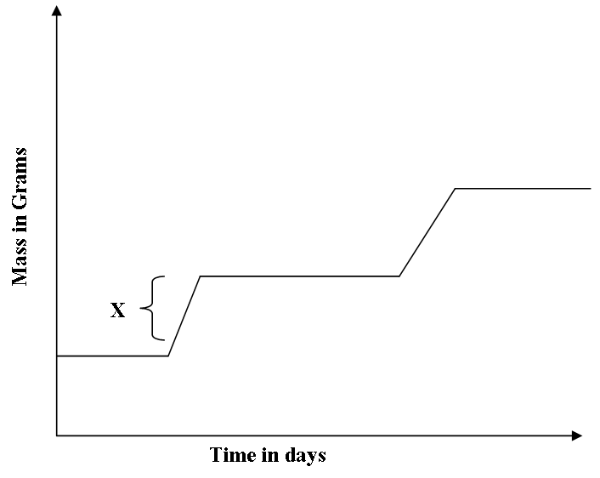

a) Name the type of growth curve shown above. (1mk)
…………………………………………………………………………………………………..
b) i) Identify the process represented by X. (1mk)
…………………………………………………………………………………………………..
ii) Name the hormone responsible for the process in b(i) above. (1mk)
c) State the importance of the growth of a pollen tube to a plant. (1mk)
…………………………………………………………………………………………………..
………………………………………………………………………………………………….

3 .Name the causative agent of the following diseases in human (3mks)
- Amoebic dysentery________________________________________________________
- Bilhazia _________________________________________________________________
- Typhoid
_________________________________________________________________
4.Give three reasons why plants do not require specialized excretory organs (3mks)
_____________________________________________________________________________________________________________________________________________________________________________________________________________________________________________
- An experiment was set up as shown below
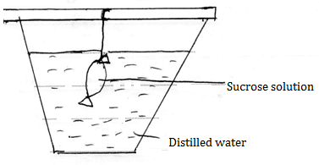
The set up was left for 30 minutes.

- State the expected results (1mk)
- Explain your answer in (a) above (3mks)
____________________________________________________________________________________________________________________________________________________________________________________________________________________________________
______________________________________________________________________

6.a)What is the function of Sodium hydrogen Carbonate that is added to test solution of non-reducing sugar. (1mk) ………………………………………………………………………………………………………....................................................................................................................................
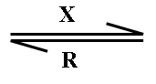
b)The equation below represents a process X which is controlled by enzymes .
Glucose + Fructose Sucrose + Water
i) Name the process X and enzyme R
Process X ……………………………………………………… (1mk)
Enzyme R ……………………………………………………….. (1mk)

7.a)What is the importance of the counter current flow in the exchange of gases in a fish. (2mks)
…………………………………………………………………………………………………..
…………………………………………………………………………………………………..…………………………………………………………………………………………………..
b)State two ways in which the tracheoles of an insect are adapted to their functions. (2mks)
…………………………………………………………………………………………………..
………………………………………………………………………………………………….

8.List down four phenotypic characteristics that have been selected for the production of strains suitable for modern agricultural purposes. (4mks)
……………………………………………………………………………………………………….......……………………………………………………………………………………………………….......……………………………………………………………………………………………………….......………………………………………………………………………………………………………………………………………………………………………………………………………………………………………………

9. State the branch of Biology that deals with: (2 marks)
(a) Study of birds

............................
.....................................................................................................................................................

(b) Study of the chemical composition of organisms
.................................................................................................................................................................................
10. A certain mammal has no incisors, no canines, 6 molars and 6 premolars on the upper jaw. It has 6 incisors, 2 canines, 6 premolars and 6 molars on the lower jaw.
(a) Write its dental formula (1 mark)
(b) Suggest with reasons the possible mode of feeding of the animal. (2 marks)
.................................................................................................................................................................................

11. (a)Some herbaceous plants have very little strengthening tissue yet they remain firm and upright. Give a reason for this observation. (1 mark)
.................................................................................................................................................................................
.................................................................................................................................................................................
.................................................................................................................................................................................
.................................................................................................................................................................................
(b) Name the strengthening material in the following tissues. (2 marks)
(i) Collenchyma
.................................................................................................................................................................................
(ii) Xylem vessels
.................................................................................................................................................................................
12. State two functions of Aerenchyma tissue in plants. (2 marks)
.................................................................................................................................................................................
.................................................................................................................................................................................
.................................................................................................................................................................................

13. A woman gave birth to a child of blood group B+ (B positive). Name two antigens that determined the child’s blood group. (2 marks)

14. In an experiment to investigate an aspect of digestion, two test tubes A and B were set up as shown below.
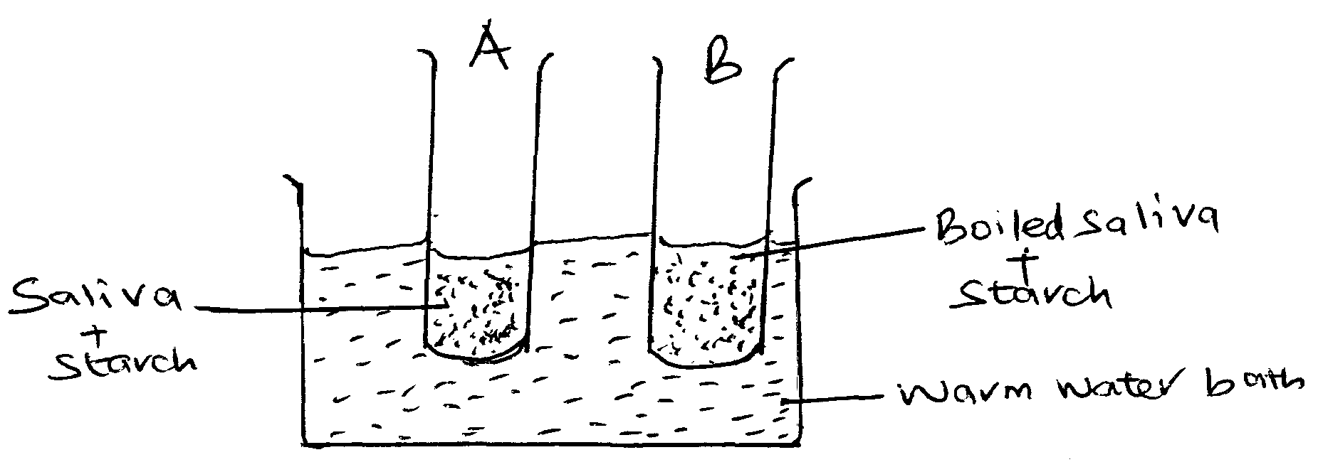
(a) The test tubes were left in the warm water bath for 30 minutes. The contents of the test tubes were tested for starch using Iodine solution.
State the observations in: (2 marks)
Test tube A
.................................................................................................................................................................................
.................................................................................................................................................................................
Test tube B
.................................................................................................................................................................................
.................................................................................................................................................................................

(b) Account for the results in (a) above. (2 marks)
..............................................................................................................................................................................
.................................................................................................................................................................................
.................................................................................................................................................................................
B................................................................................................................................................................................
.................................................................................................................................................................................
.................................................................................................................................................................................
- Explain each of the following
- Variegated plants accumulate less food than non-variegated plants under similar conditions.(1mark

- Most leaves are thin with broad leaf surface. (1mark)

- State three importances of photosynthesis in an ecosystem. (3marks)
……………………………………………………………………………………………………………………………………………………………………………………………………………………
……………………………………………………………………………………………………………………………………………………………………………………………………………………
…………………………………………………………………………………………

…………………………………………………………………………………………………………………………………………………………………………………………………………………………………………………………………………………………………………………………………………………………………………………………………………………………………………………………
16.Wing of an insect, wing of a bird, hand of a man, flipper of a whale, foreleg of a horse are locomotory structures in animals. Using the structures listed above state the ones considered as
a) Homologous structures (1mark)
…………………………………………………………………………………………………………………...
b)Identify the type of evolution that brings about homologous structures. (1mark)
……………………………………………………………………………………………………………………..

17. A certain plant was found to have the following features
Parallel venation of leaves
Sheath like petiole
Flower parts in multiple of three
- Name the class to which the plant belongs. (1mark)
……………………………………………………………………………………………………………..
- Suggest the expected arrangement of vascular bundle in the stem of the plant. (1mark)
………………………………………………………………………………………………………………

18. Explain the reason for each of the following in flowering plants
i) Wind pollinated flowers produce large number of pollen grains. (1mark)
………………………………………………………………………………………………………………………………………………………………………………………………………………………………………………
ii)Insect pollinated flowers have small sticky stigmas that an firmly attached to the style. (2marks)
………………………………………………………………………………………………………………………………………………………………………………………………………………………………………………………………………………………………………………………………………………………………………

19.The following is part of a kidney nephron,
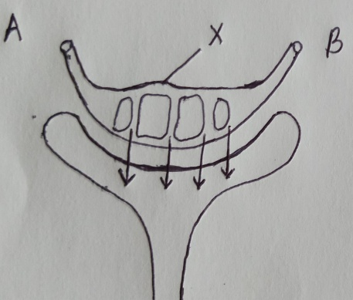

a) (i) Name the process represented by the arrows (1mk)
……………………………………………………………………………………………………………………………………………………………
(ii) Name the conditions necessary for the process named in (a)(i) above to take place (2mks)
………………………………………………………………………………………………………………………………………………………………………
………………………………………………………………………………………………………………………………………………………………………
………………………………………………………………………………………………………………………………………………………………………

b) Name one blood component that a) (i) Name the process represented by the arrows (1mk)
……………………………………………………………………………………………………………………………………………………………
(ii) Name the conditions necessary for the process named in (a)(i) above to take place (2mks)
………………………………………………………………………………………………………………………………………………………………………
………………………………………………………………………………………………………………………………………………………………………

- a) what is seed dormancy (1mk).
………………………………………………………………………………………………………………………………………………………………………
………………………………………………………………………………………………………………………………………………………………………
………………………………………………………………………………………………………………………………………………………………………
b) state two ways in which seed dormancy can be broken (2mks)
…………………………………………………………………………………………………………………………………………………………………………………
…………………………………………………………………………………………………………………………………………………………………………………
…………………………………………………………………………………………………………………………………………………………………………………
21. Explain why several lateral buds sprout when a terminal bud in a young tree is removed. (3mks)
……………………………………………………………………………………………………….……………………………………………………………………………………………………….…………………………………………………………………………………………………………………………………………………………………………………………………………

22.Below is a diagram of an organelle that is involved in aerobic respiration.
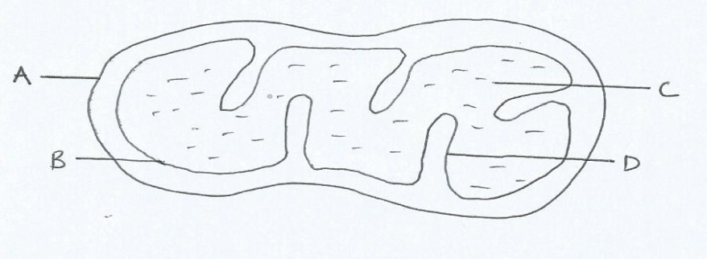
- Name the organelle (1mark)
…………………………………………………………………………………………………………..
- Name the parts labeled;
A………………………………………………………………………………………… (1mark)
B…………………………………………………………………………………………..(1mark)
C…………………………………………………………………………………………...(1mark)
- What is the purpose of the in-foding labeled D? (1mark)
- Give the mechanical compound which is formed in the organelle and forms the immediate source of energy (1mark)
22.State the function of the following parts of a light microscope
- Clip (1mark)
……………………………………………………………………………………………………………………………………………………………………………………………………………………

- Eye piece lens (1mark)
……………………………………………………………………………………………………………………………………………………………………………………………………………………
- When focusing under high power objective lens the coarse adjustment knob should never be used for focusing. Explain (2marks)
……………………………………………………………………………………………………………………………………………………………………………………………………………………………………………………………………………………………………………………………….
23a) Name two defects of the circulatory system in humans. (2marks)
………………………………………………………………………………………………………………………………………………………………………………………………………………………………………………………………………………………………………………………………………………
b) Explain two protective functions of mammalian blood. (3marks)……………………………………………………………………………………………………………………………………………………………………………………………………………………………………………………………………………………………………………………………………………………………………………………………………………………………………………………………………………………………………………………………………………………………………………………………………………………………………………………………………………………………...

