**NAME……………………………………………….………….ADM NO…………..CLASS..…….……..**

**END OF TERM II**

**FORM 3 PHYSICS PP2**

**TIME: 2 HOURS**

**SECTION A : (25 MARKS)**

**Answer all the questions in this section in the spaces provided.**

1. Figure 1 below shows an object in front of plane mirror.

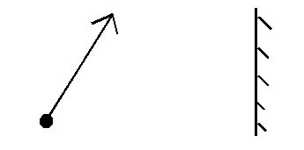

Figure 1

Sketch image of object using mirror shown. (1mk)

1. Figure 2 below shows an object infront of concave mirror and it’s image.

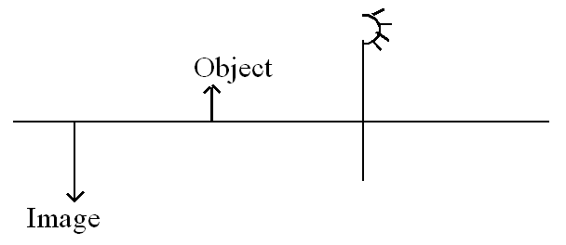

Figure 2

Locate position of its principal focus. (2mks)

3. State the use of Manganese (IV) oxide in dry cell. (1mk)

4. Use figure 3 below to answer following questions.

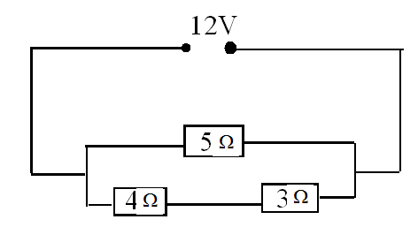

Determine

(a) Total resistance. (3mks)

(b) Potential difference across 4Ω resistor. (3mks)

5. Figure 4 shows conductor carrying current in magnetic field and moves in direction shown.

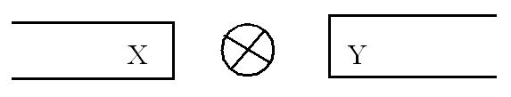

Figure 4

Identify polarities X and Y. (2mks)

6. A man standing between two parallel walls fires a gun. He hears an echo after 1.5 seconds and another one after 2.5 seconds and yet another one after 4 seconds. Determine the separation of the walls. (Take velocity of sound 340 m/s)

7. A student shouts and hears an echo after 0.6 seconds. If the velocity of sound is 330m/s. Calculate the distance between student and reflecting surface. (3mks)

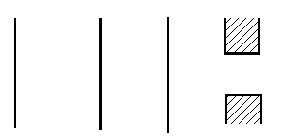8. Figure 6 shows water waves moving towards barrier. Show the emergence of the reflected waves

Figure 6

9. (a) Define refractive index. (1mk)

(b) The critical angle of a material is 43.20. Determine the refractive index of that material. (2mks)

(b) A battery of emf E drives a current of 0.25A when connected to 5.5W resistor. When the 5.5W resistor is replaced with 2.5W resistor, the current flowing becomes 0.5A. Find the emf E and the internal resistance r of the battery. (3 marks)

10. Define the term sulphation as applied to lead acid cells. (1 mark)

**SECTION: B (55MARKS)**

***ANSWER ALL QUESTIONS IN THIS SECTION***

11. (a) An uncharged metal rod brought close but not touching the cap of a charged electroscope causes a decrease in the divergence of the leaf. Explain the observation. (1mark)

(b) In experiment to investigate factors affecting capacitance of a capacitor, a student increased the area of the plates and decreased the separation of the plates. Explain the effect on the capacitance when

(i) the area of plates increased (1 mark)

(ii) the distance of the separation of the plates decreased (1 mark)

(c) Figure 7 illustrates a method of charging a metal sphere.

**++++**

**++++**

(i) (ii) (iii)

**Fig. 7.**

1. Name the method of charging shown in fig 8.(1mar(ii) Indicate the final charge on the sphere in fig 8. (1 mark)

(d) Figure 9 shows an arrangement of capacitors connected to a 10V d.c supply.

3μF

3μF

2μF

1μF

10V

Determine

(i) the combined capacitance (2 marks)

(ii) the total charge in the circuit (1 mark)

(iii) the total energy stored in the circuit. (2marks)

1. (a) Distinguish between e.mf. and terminal voltage of a battery. (2 marks)

(b) The graph in figure 8 shows the variation of potential difference V against current I for a cell when current is drawn from it.

 .

  (i) From the graph determine

  (a)The e.m.f of the cell. (2 marks)

(b)The internal resistance of the cell. (4marks)

(c) on the space provided below, draw a circuit that could be used to obtain the results represented by the graph. (2 marks)

**13. (a)** Figure 9 is an illustration of a wave pattern.



1. State with reason the type of wave shown. (2 marks)

ii) Determine the wavelength of the wave. (1 mark)

iii) Calculate the frequency of the wave given that the speed of the wave is 9m/s. (3 marks)

**b)** Figure 10 show s monochromatic source of light L behind a barrier with a single slit S placedbehind another barrier with two identical slits S1 and S2. A screen PQ is placed in position as shown.



 i)Explain what is observed on screen PQ. (2 marks)

ii)What is the significance of S1 and S2 ? (1 mark)

**14.Figure 11** shows an electromagnetic relay being used to switch an electric motor on and off. The electromagnet consists of a coil of wire wrapped around a core. The motor in figure is switched off.

Motor

Springy metal strips

Contacts

Soft iron armature

Core

S

A

B

Pivot

Insulator

**Figure 11**

1. Suggest suitable material for the core. (1mark)

(b)What happens to the core when switch S is closed? (2marks)

(c) Why do the contacts A and B close when the switch S is closed. (2marks)

(d)When the switch S is opened, what will happen to;

1. The core (1mark)
2. Soft iron armature. (1mark)
3. Give **one** other application of an electromagnet. (1mark)
4. State **two** ways in which an electromagnet could be made more powerful. (2marks)

15. Figure 12 below shows a narrow beam of white light onto a glass prism.

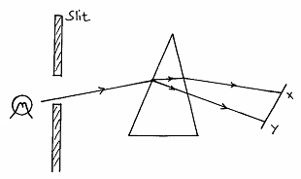

(i) What is the name of the phenomenon represented in the diagram? (1mk)

1. Name the colour at **X** and **Y**. Give a reason. (3mks)

(iii) What is the purpose of the slit? (1mk)

16. The figure 4 shows a circuit with a coil used to warm oil in a beaker.

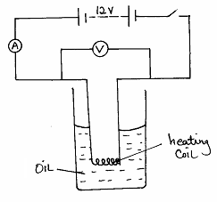

Figure 4

(a) State the Ohm’s Law. (1mk)

(b) (i). Explain how heat is produced in the coil. (2mks)

(ii )Given that the reading of the ammeter is 2.5A, determine the resistance of the coil. (3mks)

(iii).How much heat is produced in the coil in a minute? (3mks)

(iv).Give **two** changes that can be made in the set-up in order to produce more heat per minute. (2mks)

(iii)How much heat is produced in the coil in a minute? (3marks)