END TERM EXAM

PHYSICS

232/2

PHYSICS PAPER 2

MARKING SCHEME

**SECTION A**

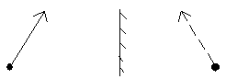1.

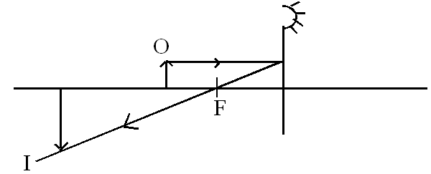

2. rays with arrowsposition of F

.

3. Depolarizer

4. (a) 4 + 3 = 7

            

           

(b) I = 12 + 12 = 144 = 4.1143A

35 35

C(4 ) = 5/12 x 4.1143 x 4 = 6.857V

5 X - North

Y - South

.

Alternative

6 Let the cliff be χcm apart   . 🗸¹

Time for 1st echo = 3/2 in 1.5sec.  . 🗸¹

2χ = 990 

χ = 495m 🗸¹ = 1320m . 🗸¹

Time for the second echo = 5/2 = 2.5sec.

1.5 + 25 = 4.0sec. 🗸¹

D = 5 x t

= 330 x 4

= 1320m

7. S = vt =330 x 0.6 = 99m

 b) (i) E = IR + Ir

E = 0.25 × 5.5 + 0.25 r

E = 0.5 × 2.5+ 0.5 × 5

E = 1.35 + 0.25r

E = 1.25 + 0.5 r

0 = 0.10 - 0.25 r

  ⇒ 0.25r = 0.10



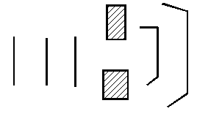

8

9. a) Ration of sine of angle of incidence to sine of angle of refraction for a given pair of media.

b) n = 1 = 1

Sin C Sin C 43.20 = 1.461

10 Hardening of lead sulphate on the lead plates ✓1

SECTION B 55 MARKS

11 (a) A metal rod is a good conductor of charge hence the electroscope 🗸

(b) (i) Increase 🗸

(ii) Increases 🗸

(c) (i) Induction 🗸

(ii) Electrons from the earth to the sphere 🗸 to neutralize the repelled positive charges 🗸

(iii) Negative charges 🗸

(d) (i) Series = $\frac{3 x 3}{3+2}$ = $\frac{9}{6}$ = 1.5μF🗸

in parallel with 2μF

CT = 1.5 + 2 = 3.5μF

In series with 1μF

CT = = 🗸

= 0.78μF

= 7.8 x 10-7F 🗸

(ii) 7.8 x 10-7 x 10 🗸

= 7.8 x 10-6 C🗸

(iii) E = ½CV2🗸

= ½ x 7.8 x 10-6 x 10 🗸

= 3.9 x 10-5J 🗸

12. (a) E.m.f is the p.d. across the battery in the ü1 open circuit while terminal voltage is the p.d. across the cell is a closed

circuit.

(b) (i)E.m.f = 1.625V ü1 (show unit)

  (ii) E = IR + Ir

V = E - Ir

V = Ir + Slope =



**13.** a) i)Transverse wave ✓1

The particles vibrate at right angle to the direction of motion of the wave ✓1

ii) The wavelength = 50cm or 0.5m ✓1

  iii) v = f ✓1

f = 9✓1

0.5

= 18Hz ✓1

b) i) Bright and dark fringes are formed ✓1

Bright fringes are formed where constructive interference occurs while dark fringes are

formed were destructive interference occurs ✓1

  ii) Produce coherent sources of light ✓1

14

1. Soft iron
2. The current flows through the solenoid; it is magnetized and attracts the soft iron armature.;
3. The magnetized core attracts the soft iron armature. The pivot armature pushes the springy metal strip which joins contact B and A.;;
4. The core (1mark)

It loses its magnetism;

1. Soft iron armature. (1mark)

Soft iron goes back to its original position thus switching off the current in the circuit.;

1. Give **one** other application of an electromagnet. (1mark)

Electric bell, telephone receiver, moving coil loudspeaker and circuit breaker.

1. State two ways in which an electromagnet could be made more powerful. (2marks)

Using a soft iron core, increasing the current and

Increasing the number of turns;;

15. (a) (i) Dispersion of light.

(ii) X – Red

Y – Violet

- Red has the lowest frequency/longest wavelength hence least deviated while violet has the highest frequency/shortest wavelength hence most deviated.

(iii) Act as point source of light.

16. (a) The current flowing through the conductor is directly proportional to the potential difference across its ends provided

temperature and other physical conditions are kept constant.

(b) (i)When the switch is closed the current flows through the coil which offer resistance hence dissipating heat.

1. V = IR 🗸¹

🗸¹ = 4.8Ω🗸¹

1. Heat = Vlt 🗸¹

= 12 x 2.5 x 60 🗸¹

= 1800J 🗸¹

1. - Increasing the number of coils. 🗸¹

- Increasing the current. 🗸¹

1. The readings will decrease because the resistance is decreased. 🗸¹