NAME:…………………………………………….CLASS:…………..ADM NO:……….….
END TERM 2 EXAM - 2021
FORM 3
MATHEMATICS PAPER 2.
TIME:2HRS 30MIN
Instructions.
Answer all questions in this section in the spaces provided.
SECTION A : 50MKS.
- Use mathematical tables to evaluate: (4mks)

3√0.8423 x 72.5
930.5

- After how many y years would kshs. 15000 amount to ksh 24015.50 at a rate of 16% p.a. (3mks)

- Three years ago, Juma was three time as old as Ali. In two years time, the sum of their ages will be 62. Determine their present ages. (3mks)

- Evaluate:
¹/₃ of (2 ¾ - 5 ½ ) x 3 ⁶/₇ ÷ ⁹/₄ (3mks)

- Find the height of an isosceles triangle if the equal sides are each 26cm and the base is 48cm long. (2mks)

- A straight line L1 has a gradient of – ½ and passes through the point P( -1, -3). Another straight line L2 passes through the points Q( 1,-3) and R (4,5), find:
- The equation of L1. (2mks)

- The equation of L2. (2mks)

- Solve the following quadratic equation by completing the square. (3mks)
2x² – 5x + 3 =0

- Make A the subject of the formula. (3mks)

T= 2m√L - A
n 3K

- In the figure below, chords AB and XY interest in a circl at R. Given that AR = 4cm, XR = 5cm and RY=3cm. find AB. (2mks)

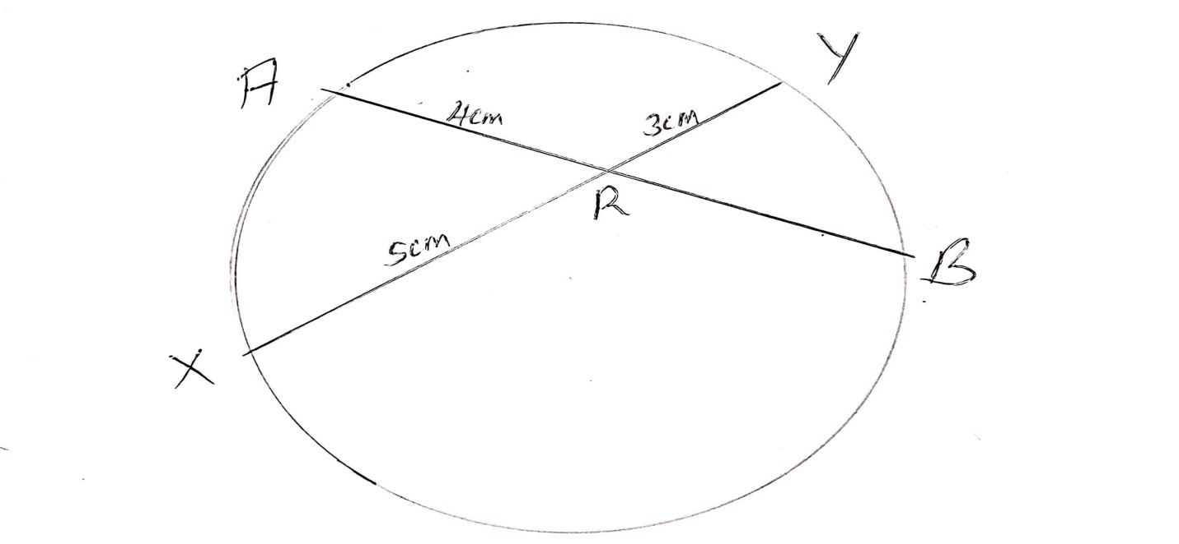

- Given the matrix M = 3 -5 Find the inverse of M and hence or otherwise, solve the
5 2
simultaneous equations. (3mks)
3x – 5y = -9
5x – 2y = 16

- Solve the equation 2 - 1 = 1 (3mks)
x-1 x +2 x

- Solve for x in the equation: (3mks)
Log (x-1) = log 12 – log (x-2)

- Using binomial expression, expand and simplify ( 1 – 2x)³ up to the term x³. (1mk)

b. Use the simplified expansion in (a) above to calculate to 4 decimal places the approximate value of (0.98)³ (3mks)

- A trader bought two brands of sugar labeled Grade A and Grade B. Grade A sugar costs sh 60 per kg and grade B sugar costs sh 50 per kg. he mixed them in a ratio such that after selling the mixture at sh 81 per kg, he made a profit of 50%. Determine the ratio in which he mixed grade A sugar to grade B. (3mks)

- A quantity P is partly constant and partly varies as the square of Q when Q=2, P= 40 and when Q=3 P=65. Determine the value of P when Q=4. (3mks)

- A cold water tap can fill a bath in 6 minutes while a hot water tap can fill it in 12 minutes. The drainage pipe can empty the bath in 8 minutes. All the three are opened fully for 3 minutes and then the hot water tap is closed. How many more minutes will it take to fill the bath? (4mks)

SECTION B (50 MKS)
Answer any five questions in this section.

- Personal tax relief p.a is sh 12672 p.a

Income (K£per annum) | Rate (Sh per pound)
1-5808 | 2
5809-11280 | 3
11281-16752 | 4
16753-22224 | 5
Excess over 22224 | 6

- Mr. Omondi earns a basic salary of sh 15000 per month. In addition, he gets a medical allowance of sh 2400 and a house allowance of sh 12000. Use the tax brackets above to calculate the tax he pays in a year. (10mks)

- A student at Anestar school tossed a coin three times and recorded the results on every successive toss.
- By use of a tree diagram, show all the possible outcomes. (3mks)

- Find the probability of getting:
- One head (1mk)

- Two heads and a tail, in the order. (1mk)

- Two heads and a tail, in any order. (1mk)

- Three heads. (1mk)

- At least one head. (1mk)

- No head. (2mks)
- The diagram below shows a frustrum made by cutting off a small cone on a plane parallel to the base of the original cone. The frustum represents a bucket with the open – end diameter of 28cm and the bottom diameter of 21cm. The bucket is 20cm deep as shown. Calculate to one decimal place, the capacity of the bucket in litres. (10mks)

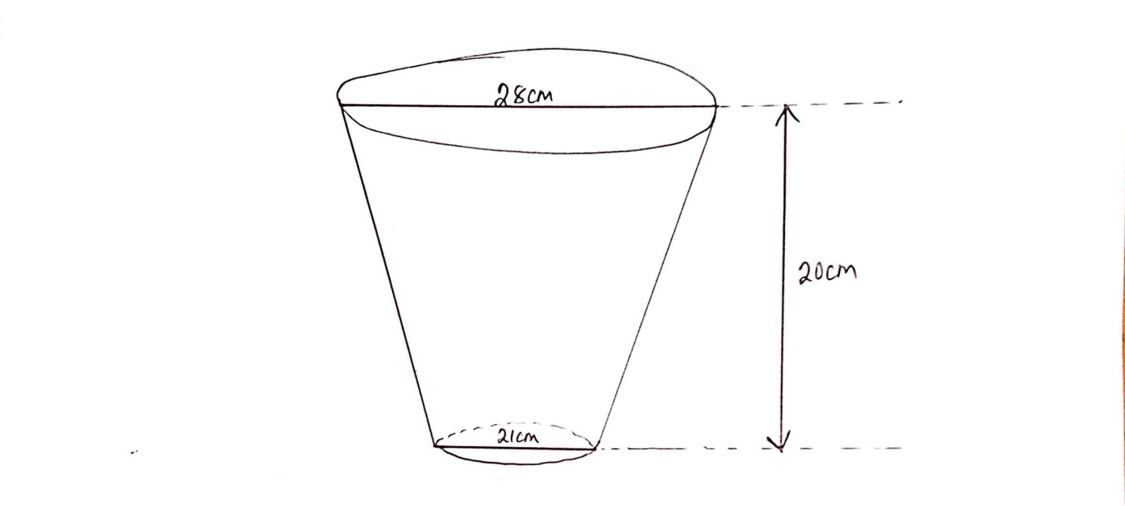

- Town B is 180km on a bearing of 050^{O} from town A. another town C is on a bearing of 110^{O} from town A and on a bearing of 150^{O} from town B. A fourth town D is 240km on a bearing of 320^{O} from town A. using a scale drawing 1cm to represent 30km, calculate to the nearest kilometer:

- The distance AC (2mks)

- The distance CD (2mks)

- The distance BC. (2mks)

- In the figure below OPQ is a triangle in which OS= ¹/₃ OP and OR = ¹/₃OQ. T is a point on QS such that QT = ¾ QS.

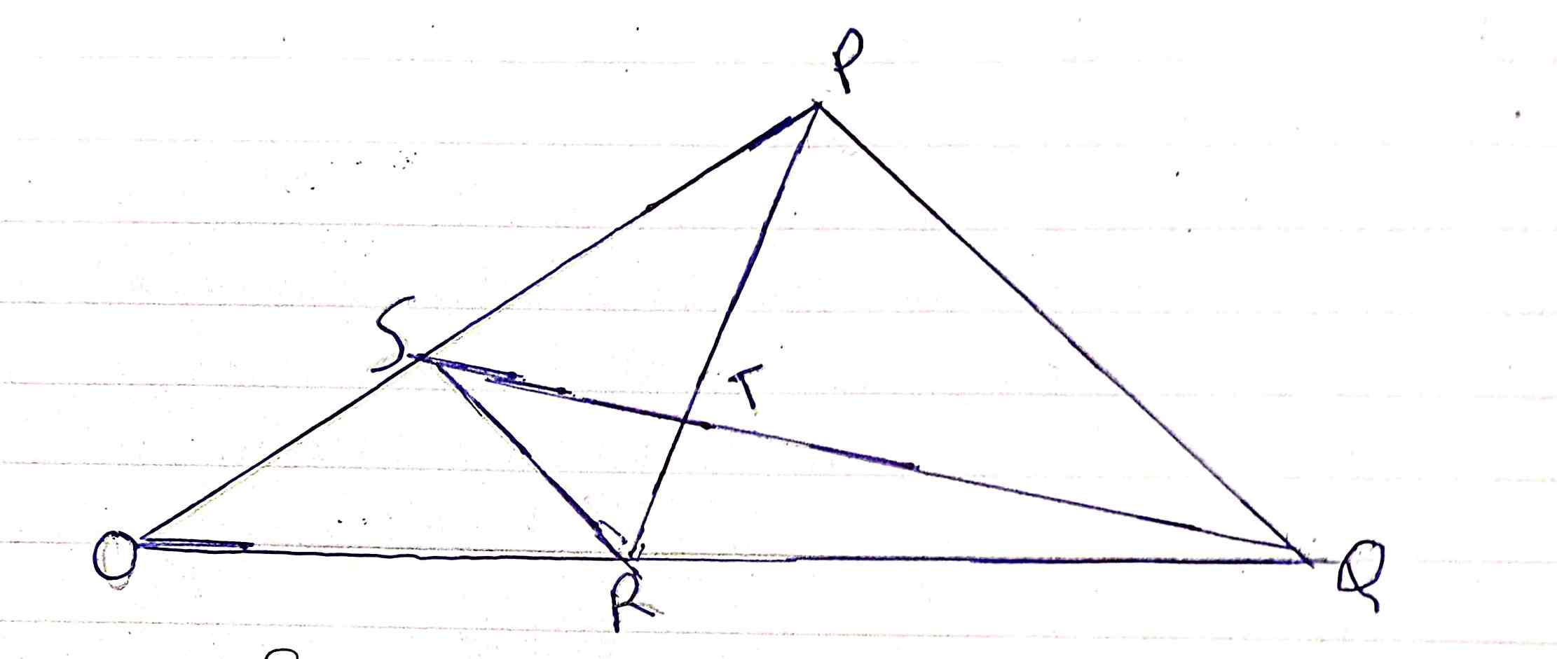

- Given that OP = p and OQ=q, express the following vectors in terms of p and q.
- SR (2mks)

- QS (2mks)

- PT (2mks)

- TR (2mks)

- Hence or otherwise show that the points P,T and R are collinear. (2mks)

- The first term of an arithmetic progression is 2, the sum of the first 8 terms of the AP is 240.
- Find the common difference of the AP. (2mks)

- Given that the sum of the first n terms of the AP is 1560, find n. (2mks)

b. The 3rd, 5th and 8th term of another AP form the first three terms of a G.P if the common difference of the AP is 3. Find
- The first term of G.P (4mks)

- The sum of the first 9 terms of the GP to 4 s.f (2mks)

- James is a sale executive earning a salary of ksh. 20,000 and commission of 8% for the sales in excess of kshs. 100,000. If in January 2010 she earned a total of ksh. 48,000 in salaries and commissions.
a. Determine the amount of sales he made in the month. (4mks)

b. If the total sales in the month of February and March increased by 18% and they dropped by 25% respectively. Calculate:
- James’s commission in the month of February. (3mks)

- His total earning in the month of March. (3mks)

- At the beginning of the year 2000, Gachago bought two houses, one in Thika and another one in Nakuru each at sh. 1,240,000. The value of the house in Thika appreciated at a rate of 12% p.a.
a. Calculate the value of the house in Thika after 9 years to the nearest shillings. (2mks)

b. After n years, the value of the house in Thika was 2,741,245 while the value of the house in Nakuru was 2917231.
i. Find n (4mks)

ii. Find the annual rate of appreciation of the house in Nakuru. (4mks)

