NAME:…………………………………………….CLASS:…………..ADM NO:…………….
121/1MATHEMATICSPAPER 1
FORM THREE
END TERM 2 EXAM - 2021
TIME: 2 ½ HOURS
Instructions.
Answer all questions in this section in the spaces provided.

- Without using mathematical tables or calculators, evaluate: (3mks)
0.38 x 0.23 x 2.7
0.114 x 0.0575

- Determine the equation of the line through the point A (5,3) and parallel to the line y = 2x + 3. (3mks)

- The figure below is a sketch of the net of an open box. The dimensions are in centimeters.
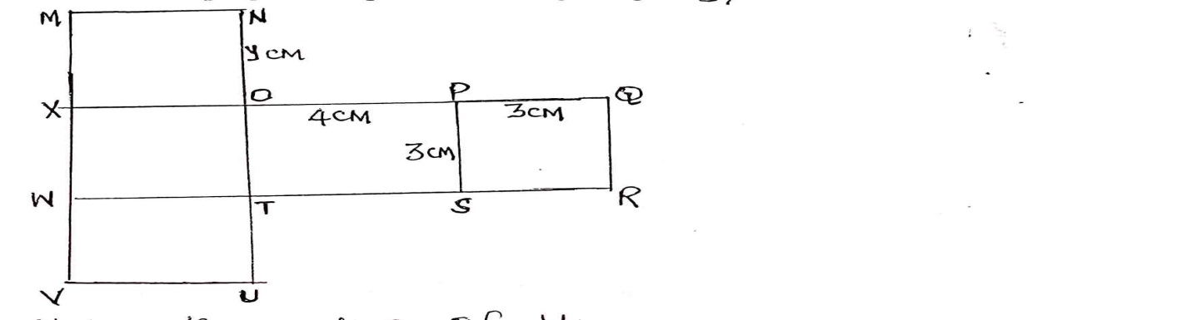
a. State the value of y. (1mk)

b. Calculate the surface area of the box (2mks)

- Given that 3 - 4m = 2 -9 , find the value of m. (2mks)
m m

- The table below shows speeds of vehicles measured to the nearest 10Kph as they passed a certain point.
Speed (Kph) | 30 | 40 | 50 | 60 | 70 | 80 | 90 | 100 | 110
Frequency | 1 | 4 | 9 | 14 | 38 | 47 | 51 | 32 | 4

- Calculate the mean speed of the vehicles. (3mks)

- State the modal speed. (1mk)

(3mks)
- Given that A = 4 3 and C = 14 7 , find B if
-1 2 -4 2

2A + B = C

- A container is in the form of a frustrum of a right pyramid 4m square at the bottom, 2.5m square at the top and 3M deep. Calculate the capacity of the container. (4mks)

- The unshaded region in the figure below is bounded by lines L₁, L₂ and L₃. State the three inequalities that define the region. (3mks)
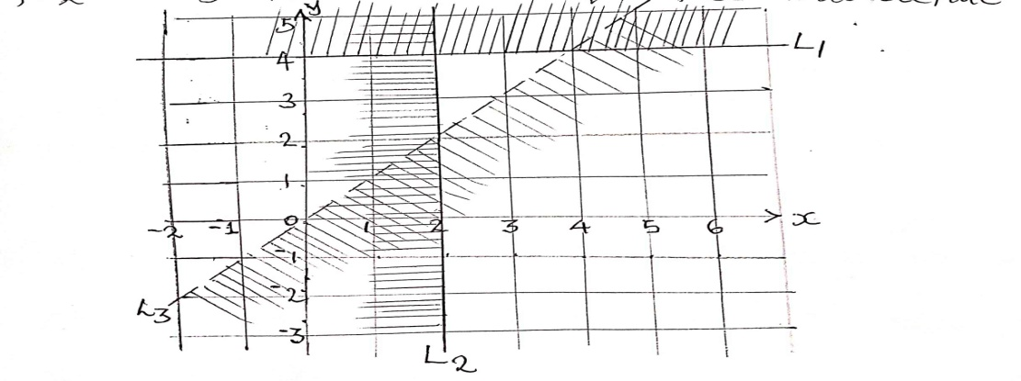

- Simplify: √54 + 3√3 (3 mks)
√3

- In the figure below, O is the centre of the circle. A, B, C and D are points on the circumference of the circle. Line AB is parallel to line DC and angle ADC= 55^{O}.

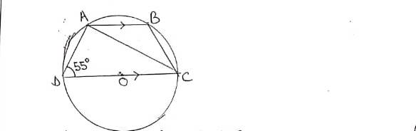

Determine the size of angle ACB. (2mks)
- The results of a survey activity are shown in the field book below.

Y
250
240 70D
C 80 170

70 60B
A 60 50
X

If all the measurements are in metres, calculate the area of the field in :
(i) m² (3mks)

(ii) Ha (1mk)

- Construct a circle centre x and radius 2.5cm. Construct a tangent from point p, 6cm from x to touch the circle at R. measure the length of PR. (3mks)

- Given that a= 2 , b= -5 and c = 0 , find
-3 4 -2

a+ b + c to four significant figures. (3mks)

- Two matrices A and B are such that A= K 4 and B= 1 2 , given that the
3 2 3 4
determinant of AB = 4, find the value of K. (3mks)

- A solid metal cone has a diameter of 14cm and a height of 24cm. calculate the surface area of the cone. (2mks)

- Without using a calculator, evaluate : (3mks)
2 ½ - 1 ¹/₅ of 2
¼ - ( - ½ )³

SECTION II (50 MARKS)
Answer any five questions from this section.
- The figure below shows the cross section of a cylinder of a petrol tanker. Its length is 7M and internal diameter 2.1M. The depth of the petrol it contains is 0.525M, AB being the horizontal level of the petrol.

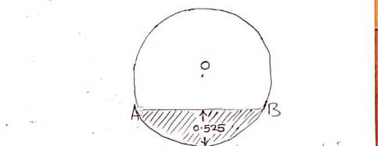
Calculate:
- <AOB where O is the centre of the circular section. (3mks)

- The area of sector AOB. (2mks)

- The shaded area. (3mks)

- The mass of the petrol in the tanker, given that one cubic metre of petrol has a mass of 700kg. (2mks)

- On the grid provided draw the graph of y = 2x²+ 3x + 1 for -4≤x≤3. (6mks)

b. Use your graph to solve the equation.
i. 2x² + 4x – 3 = 0 (2mks)

ii. x² - x – 45 = 0 (2mks)

- Atieno and Muthoni invested in a matatu business. They bought a min bus whose carrying capacity was 26 passengers. 25 of whom would be paying. They put the mini bus on a route connecting two towns A and B, where the fare was sh. 120 one way. Every day the matatu made 3 round trips between the two towns. On each day, fuel used was shs. 2500. The driver and conductor were paid shs. 450 and sh. 250 respectively. A further shs. 3500 was set aside daily for mainatainance, insuarance and loan repayment.
- How much was:
i. The amount of the day’s collections. (2mks)

ii. The net profit. (2mks)

- The agreement between Atieno and Muthoni was that they would be sharing each day’s profit in the ratio 3:4. Calculate how much each got on a day when the mini bus was 75% full per round trip. (6mks)

- The length of 40 athletes in a country athletics competition were as shown in the table below:
Height (cm) | Frequency (f)
150-159 | 2
160-169 | 8
170-179 | 10
180-189 | Y
190-199 | 6
200-209 | 2
- Find the value of y. (2mks)

- State the modal class (1mk)

- Calculate the mean height of the athletes. (4mks)

- On the grid provided below, draw a histogram to represent the information shown above. (3mks)

- A line L passes through points (-2,3) and ( -1, 6) It is perpendicular to a line at (-1, 6)
- Find the equation of L. (2mks)

- Find the equation of P in the form y = mx+ c. (2mks)

- Another line Q is parallel to L and passes through point (1,2). Find the equation of Q. (3mks)

- Find the point of intersection of lines P and Q. (3mks)

- The figure below is a right pyramid VEFGH with a square base of 8cm and a slant edge of 20cm. points A,B,C and D lie and plane ABCD is parallel to the base EFGH.

- 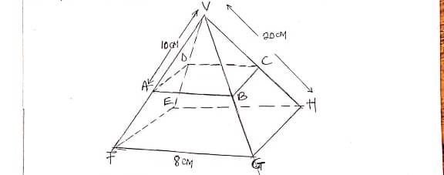Find the length of AB. (2mks)

- Calculate to 2 decimal places.
i. The length of AC. (2mks)

ii. The perpendicular height of the pyramid VABCD. (2mks)

- The pyramid VABCD was cut off. Find the volume of the frustrum ABCDEFGH correct to 2 decimal places. (4mks)

- The diagram below shows a design model of a race course drawn to scale of 1cm represents 50km. it consists of two circles centre A and B radii 0.5cm and 0.8cm respectively. The distance between their centres is 3.0cm,

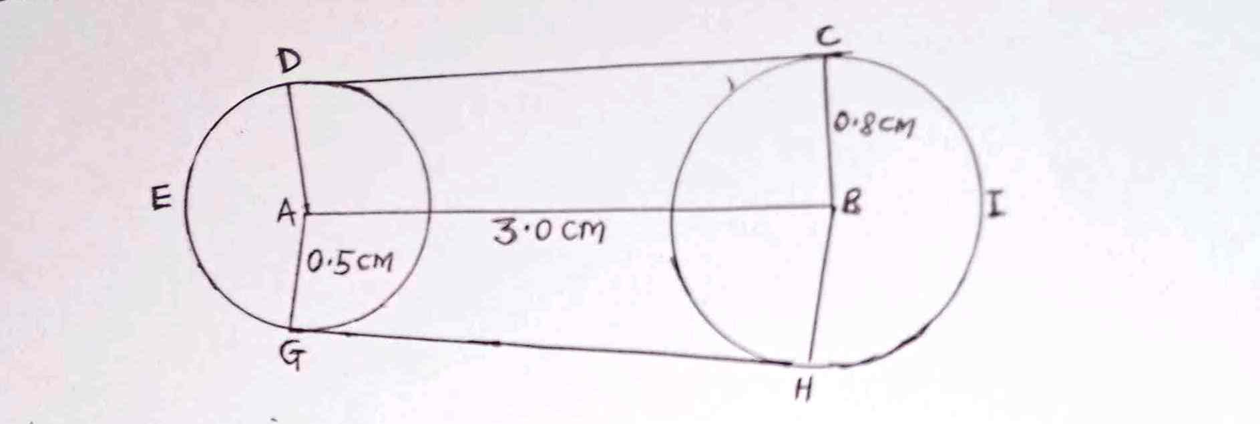

Calculate in km:
- The length of CD. (2mks)

- The length of DEG (take π = 3.142) (2mks)

- The length of HIC (take π = 3.142) (2mks)

- During a race, the course is managed by race officials placed 500M apart and each is paid Ksh. 2300 per day. How much is needed to pay race officials for one day’s event. (4mks)

- A bus left Nairobi at 6.00a.m and travelled towards Kapsabet Boys at an average speed of 100km/hr. At 6.30 am, a van left kapsabet Boys and travelled towards Nairobi to receive the bus with a number of students moving at an average speed of 125km/h given that the distance between Nairobi and Kapsabetis 500km Calculate:
a. The time the two vehicles met. (4mks)

b. On meeting the bus proceeded with its journey but the van had a break of 30 minutes before proceeding for Kapsabet Boys. Calculate:
i. The time the bus arrived at Kapsabet Boys. (3mks)

ii. The time the van arrived at Kapsabet. (3mks)

