NAME: ……………………………………… ADM NO: …………. CLASS: ………..

443/2
AGRICULTURE
PAPER 2
FORM 3
END OF TERM 2 EXAM
TIME: 2 HOURS

INSTRUCTIONS:
This paper consists of 3 sections; A, B and C.
Answer all questions in section A and B and any two in section C.

SECTION A (30MKS)
1. State four reasons for castration in rams. (2 mks)

2. List any four conditions that pre-dispose an animal to disease or injury (2 mks)
- Age of the animal
- Sex
- Colour
- Breed
- Environmental conditions
- Physiological conditions
- Heredity
- Overcrowding

3. State four functions of vitamins in Livestock. (2 mks)
- Help in blood clotting
- Act as organic catalyst
- Prevent diseases in livestock
- Help in bone formation
- Help in muscular activities

4. State four factors one would consider when choosing feed (2 mks)
- Availability of food
- Cost
- Nutrient composition
- Type of livestock
- Age of the animal
5. State four factors that may lead to dip wash being exhausted or weakened
while in the dip tank. (2 mks)

- Getting
- Evaporation
- Leakage at the bottom
- Dirt/impurities from animal’s body.

6. Give two reasons why walls of dairy shed should be white washed instead of
painting with oil paints. (2 mks)
- To avoid poisoning by lead in paints
- Discourage insects
- To avoid tainting of milk.

7. List four tools used in laying concrete blocks. (2 mks)
- Trowel
- Plumb bob/line
- Mason’s square
- String line
- Spirit level
- Wood flat

8. State four reasons for treating timber used for fencing. (2 mks)
- To prevent warping
- To prevent rotting/damage by fungi
- Reduce damage by insects
- To enhance strength

9. State four harmful effects of ticks to livestock (2 mks)
- Transmit diseases
- Cause
- Cause irritation
- Lower quantity and value of skin

10. State four symptoms of liver fluke attack, that may be observed in animals
(2 mks)
- Digestive upsets
- Swollen abdomen
- Emaciation

11. Outline four methods of controlling the fresh water snail. (2 mks)
- Drain stagnant water
- Physically killing the snail
- Routine drenching of animals
- Spray pasture with lime
- Burning pasture during the dry season

12. State four ways of preparing the sow for furrowing. (2 mks)
- Deworming the sow
- Wash the sow
- Reduce feeding gradually
- Move the sow to the furrowing pen

13. Give two factors that may lead to conception failure after service in heifers.
(2 mks)
- Poor timing of service
- Poor nutrition

14. Give two causes of soft shell in eggs. (2 mks)
- Lack of calcium

15. State four management practices that would ensure maximum harvest of
fish from fish pond. (2 mks)
- Control stocking rate
- Control water pollution
- Supply of fish food
- Aerating water
- Maintaining appropriate depth of water.

SECTION B: (20 MARKS)
16. Use the diagram below to answer the questions that follow.

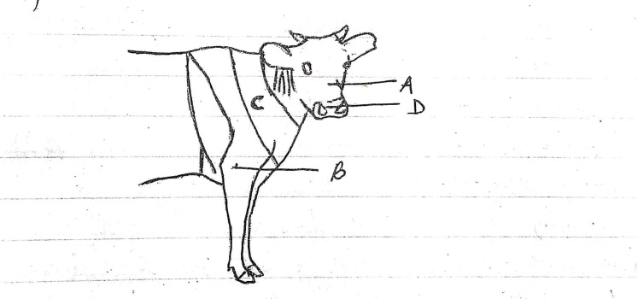

(a) Name the parts labeled A – D (2 mks)

(b) Name the breed of dairy cattle with the highest butter fat content in milk.
(1 mk)

(c) Distinguish between a large white and a landrace breeds of pigs (2 mks)

- Large white: White, broad and slightly dished snout and has upright ears .
- Landrace: White, straight snout and long drooping ears.

17. Use the diagram below to answer the questions that follow

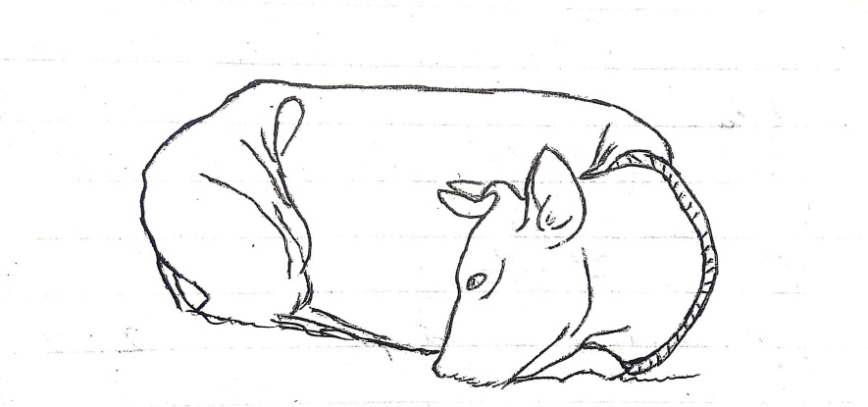

(a) Name the disease or disorder that makes the animal behave as shown
above. (1 mk)
- Milk fever

(b) State three prevention measures of the above problem. (3 mks)
- Partial milking
- Feeding an animal with ration rich in phosphorous and calcium
- Allow animal to sunlight

(c) Define the term Pica as used in livestock nutrition. (1 mk)
- Deprived appetite when phosphorus is missing in an animal’s diet.

18. Use the diagram below to answer the questions that follow

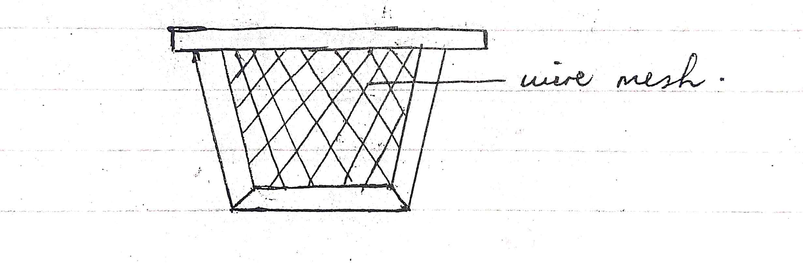

(a) Name the structure shown above. (1 mk)
- Queen excluder

(b) State the importance of the above structure where it’s used. (1 mk)
- Prevents the queen bee from laying eggs in all combs.

(c) State three pests that affect organisms that use the above structure. (3 mks)
- Ants
- Wax moth
- Bee louse

19. (a) State 3 systems involved in outbreeding (3 mks)
- Outcrossing
- Cross breeding
- Upgrading (grading up)

(b) State two advantages of natural mating. (2 mks)
- More accurate
- Less laborious (No need of checking heat signs)
- Useful when heat period is not easily detected.

SECTION C: (40 MARKS)

20. (a) Discuss the factors considered during selection of a breeding stock.
(10 marks)
(b) Discuss five methods used during identification of animals. (10 mks)

21. (a) Discuss the mechanical methods used to control ticks. (10 mks)

(b) Discuss the general effects of parasites on livestock. (10 mks)

22. (a) Discuss the structural requirements of a calf pen. (14 mks)

(b) State six methods employed in parasites and disease control in
livestock. (6 mks)

………………………………………………………………………………………………………………………………………………………………………………………………………………………………………………………………………………………………………………………………………………………………………………………………………………………………………………………………………………………………………………………………………………………………………………………………………………………………………………………………………………………………………………………………………………………………………………………………………………………………………………………………………………………………………………………………………………………………………………………………………………………………………………
……………………………………………………………………………………………………………………………………………………………………………………………………………………………………………………………………………………………………………………………………………………………………………………………………………………………………………………………………………………………………………………………………………………………………………………………………………………………………………………………………………………………………………………………………………………………………………………………………………………………………………………………………………………………………………………………………………………………………………………………………………………………………………….
……………………………………………………………………………………………………………………………………………………………………………………………………………………………………………………………………………………………………………………………………………………………………………………………………………………………………………………………………………………………………………………………………………………………………………………………………………………………………………………………………………………………………………………………………………………………………………………………………………………………………………………………………………………………………………………………………………………………………………………………………………………………………………….
………………………………………………………………………………………………………………………………………………………………………………………………………………………………………………………………………………………………………………………………………………………………………………………………………………………………………………………………………………………………………………………………………………………………………………………………………………………………………………………………………………………………………………………………………………………………………………………………………………………………………………………………………………………………………………………………………………………………………………………………………………………………………………
………………………………………………………………………………………………………………………………………………………………………………………………………………………………………………………………………………………………………………………………………………………………………………………………………………………………………………………………………………………………………………………………………………………………………………………………………………………………………………………………………………………………………………………………………………………………………………………………………………………………………………………………………………………………………………………………………………………………………………………………………………………………………………
………………………………………………………………………………………………………………………………………………………………………………………………………………………………………………………………………………………………………………………………………………………………………………………………………………………………………………………………………………………………………………………………………………………………………………………………………………………………………………………………………………………………………………………………………………………………………………………………………………………………………………………………………………………………………………………………………………………………………………………………………………………………………………
………………………………………………………………………………………………………………………………………………………………………………………………………………………………………………………………………………………………………………………………………………………………………………………………………………………………………………………………………………………………………………………………………………………………………………………………………………………………………………………………………………………………………………………………………………………………………………………………………………………………………………………………………………………………………………………………………………………………………………………………………………………………………………
………………………………………………………………………………………………………………………………………………………………………………………………………………………………………………………………………………………………………………………………………………………………………………………………………………………………………………………………………………………………………………………………………………………………………………………………………………………………………………………………………………………………………………………………………………………………………………………………………………………………………………………………………………………………………………………………………………………………………………………………………………………………………………
………………………………………………………………………………………………………………………………………………………………………………………………………………………………………………………………………………………………………………………………………………………………………………………………………………………………………………………………………………………………………………………………………………………………………………………………………………………………………………………………………………………………………………………………………………………………………………………………………………………………………………………………………………………………………………………………………………………………………………………………………………………………………………………………………………………………………………………………………………………………
……………………………………………………………………………………………………………………………………………………………………………………………………………………………………………………………………………………………………………………………………………………………………………………………………………………………………………………………………………………………………………………………………………………………………………………………………………………………………………………………………………………………………………………………………………………………………………………………………………………………………………………………………………………………………………………………………………………………………………………………………………………………………………………………………………………………………………………………………………………………………………………………………………………………………………………………………………………………………………………………………………………………………………………………………………………………………………………………………………………………………………………………………………………………………………………………………………………………………………………………………………………………………………………………………………………………………………………………………………………………………………………………………………………………………………………………………………………………………………………………………………………………………………………………………………………………....
………………………………………………………………………………………………………………………………………………………………………………………………………………………………………………………………………………………………………………………………………………………………………………………………………………………………………………………………
………………………………………………………………………………………………………………………………………………………………………………………………………………………………………………………………………………………………………………………………………………………………………………………………………………………………………………………………………………………………………………………………………………………………………………………………………………………………………………………………………………………………………………………………………………………………………………………………………………………………………………………………………………………………………………………………………………………………………………………………………………………………………………
………………………………………………………………………………………………………………………………………………………………………………………………………………………………………………………………………………………………………………………………………………………………………………………………………………………………………………………………………………………………………………………………………………………………………………………………………………………………………………………………………………………………………………………………………………………………………………………………………………………………………………………………………………………………………………………………………………………………………………………………………………………………………………
………………………………………………………………………………………………………………………………………………………………………………………………………………………………………………………………………………………………………………………………………………………………………………………………………………………………………………………………………………………………………………………………………………………………………………………………………………………………………………………………………………………………………………………………………………………………………………………………………………………………………………………………………………………………………………………………………………………………………………………………………………………………………………………………………………………………………………………………………………………………
………………………………………………………………………………………………………………………………………………………………………………………………………………………………………………………………………………………………………………………………………………………………………………………………………………………………………………………………………………………………………………………………………………………………………………………………………………………………………………………………………………………………………………………………………………………………………………………………………………………………………………………………………………………………………………………………………………………………………………………………………………………………………………………………………………………………………………………………………………………………………………………………………………………………………………………………………………………………………………………………………………………………………………………………………………………………………………………………………………………………………………

