NAME: …………………………………………….……… ADM NO: …………. CLASS: ………..

443/1
AGRICULTURE
PAPER 1
FORM 3
END OF TERM 2 EXAM
TIME: 2 HOURS

INSTRUCTIONS:
This paper consists of 3 sections; A, B and C. Answer all questions in section A and B and any two in section C.

SECTION A 30MKS
1. Name three branches of horticulture. (1 ½ mks)

2. State four advantages of organic farming. (2mks)

3. What is the importance of decomposers in agriculture. (1 mk)

4. State three basic economic concepts. (1 ½ mks)

5. (a) What is concession company? ( ½ mk)

(b) Give two examples of individual land tenure system. (1 mk)
6. (a) Differentiate between solifluction and landslide. (2 mks)

(b) Name four types of landslide. (2 mks)

7. Give three control measures of Blossom-end rot disease. (1 ½ mks)

8. How are crop pests classified according to the mode of feeding. (2 mks)

9. State any three effects of diseases to crops. (1 ½ mks)

10. a. State six effects of weeds in a pasture crop. (3 mks)

b. Define a weed. ( ½ mk)

11. List two ways of classifying herbicides based on mode of action. (1 mk)

12. State four factors considered when grading tomatoes for fresh market.
(2 mks)

13. Give possible causes of swelling on roots of legumes. (1 mk)

14. What is a companion crop? (1 mk)

15. List two main methods of pruning. (2 mks)

16. State two functions of polythene sheet when used as mulch material.
(1 mk)

17. Give any four factors that influence seed rates. (2 mks)

SECTION B: (20 MARKS)
18. The diagram below illustrates a crop. Study it and answer the questions that
follow.

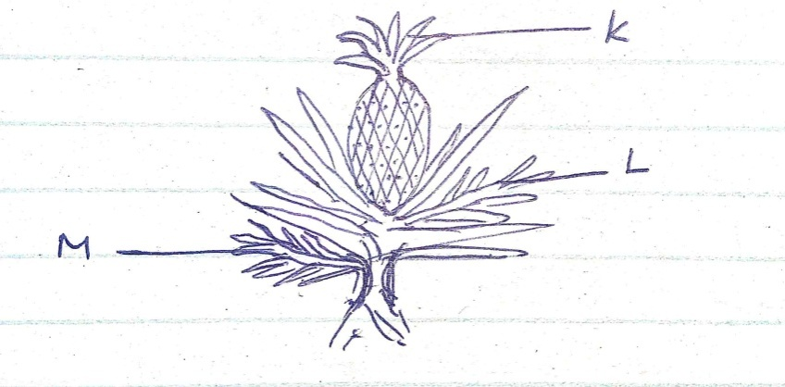
(a) Identify the parts labeled K, L and M. (3 mks)

(b) Apart from the parts mentioned above, list down five other vegetative
materials used for crop propagation. (2 mks)

19. Study the diagram below and answer the questions that follow.

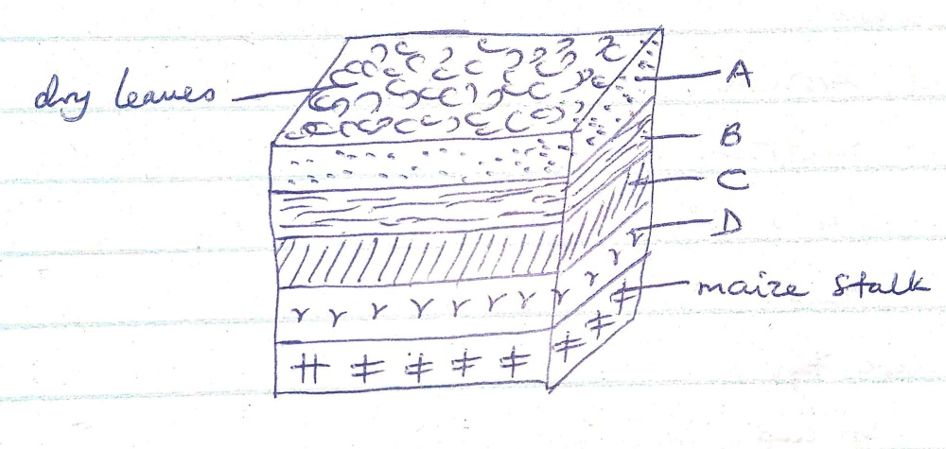
(i) What are the dimensions of the figure shown above? (1 mk)

(ii) Name the parts labeled A, B , C and D. (2 mks)

(iii) State the importance of level A in this set up. (1 mk)

(iv) State two factors considered when selecting a site for a compost pit.
(2 mks)

20. A farmer with one hectare of land requires 40kg of N in his farm. He applied
CAN which costs Ksh 35 per kilogram. CAN contain 20kg N.

(a) Calculate the amount of CAN the farmer requires. (2 mks)

(b) How much will a farmer with one and a half hectares spend to apply in his
farm? (3 mks)

(c) List five characteristics of nitrogenous fertilizers. (2 ½ mks)

(d) State the two methods employed during soil sampling. (1 mk)

(e) Define soil sampling. ( ½ mk)

SECTION C: (40 MARKS)
21. (a) Discuss the importance of crop rotation to a farmer. (12 mks)

(b) Discuss the factors that determine harvesting of a crop. (8 mks)

22. (a) Discuss the process of water treatment using a chemical treatment system. (12 mks)
(b) State and explain various methods used during land clearing. (8 mks)

23. (a) Explain various harmful effects of weeds. (10 mks)

(b) State ten cultural methods employed in pest control. (10 mks)

………………………………………………………………………………………………………………………………………………………………………………………………………………………………………………………………………………………………………………………………………………………………………………………………………………………………………………………………………………………………………………………………………………………………………………
………………………………………………………………………………………………………………………………………………………………………………………………………………………………………………………………………………………………………………………………………………………………………………………………………………………………………………………………………………………………………………………………………………………………………………
………………………………………………………………………………………………………………………………………………………………………………………………………………………………………………………………………………………………………………………………………………………………………………………………………………………………………………………………………………………………………………………………………………………………………………
………………………………………………………………………………………………………………………………………………………………………………………………………………………………………………………………………………………………………………………………………………………………………………………………………………………………………………………………………………………………………………………………………………………………………………
………………………………………………………………………………………………………………………………………………………………………………………………………………………………………………………………………………………………………………………………………………………………………………………………………………………………………………………………………………………………………………………………………………………………………………
………………………………………………………………………………………………………………………………………………………………………………………………………………………………………………………………………………………………………………………………………………………………………………………………………………………………………………………………………………………………………………………………………………………………………………
………………………………………………………………………………………………………………………………………………………………………………………………………………………………………………………………………………………………………………………………………………………………………………………………………………………………………………………………………………………………………………………………………………………………………………
………………………………………………………………………………………………………………………………………………………………………………………………………………………………………………………………………………………………………………………………………………………………………………………………………………………………………………………………………………………………………………………………………………………………………………
………………………………………………………………………………………………………………………………………………………………………………………………………………………………………………………………………………………………………………………………………………………………………………………………………………………………………………………………………………………………………………………………………………………………………………
………………………………………………………………………………………………………………………………………………………………………………………………………………………………………………………………………………………………………………………………………………………………………………………………………………………………………………………………………………………………………………………………………………………………………………
………………………………………………………………………………………………………………………………………………………………………………………………………………………………………………………………………………………………………………………………………………………………………………………………………………………………………………………………………………………………………………………………………………………………………………
………………………………………………………………………………………………………………………………………………………………………………………………………………………………………………………………………………………………………………………………………………………………………………………………………………………………………………………………………………………………………………………………………………………………………………
………………………………………………………………………………………………………………………………………………………………………………………………………………………………………………………………………………………………………………………………………………………………………………………………………………………………………………………………………………………………………………………………………………………………………………
………………………………………………………………………………………………………………………………………………………………………………………………………………………………………………………………………………………………………………………………………………………………………………………………………………………………………………………………………………………………………………………………………………………………………………
………………………………………………………………………………………………………………………………………………………………………………………………………………………………………………………………………………………………………………………………………………………………………………………………………………………………………………………………………………………………………………………………………………………………………………
………………………………………………………………………………………………………………………………………………………………………………………………………………………………………………………………………………………………………………………………………………………………………………………………………………………………………………………………………………………………………………………………………………………………………………
………………………………………………………………………………………………………………………………………………………………………………………………………………………………………………………………………………………………………………………………………………………………………………………………………………………………………………………………………………………………………………………………………………………………………………
………………………………………………………………………………………………………………………………………………………………………………………………………………………………………………………………………………………………………………………………………………………………………………………………………………………………………………………………………………………………………………………………………………………………………………
………………………………………………………………………………………………………………………………………………………………………………………………………………………………………………………………………………………………………………………………………………………………………………………………………………………………………………………………………………………………………………………………………………………………………………
………………………………………………………………………………………………………………………………………………………………………………………………………………………………………………………………………………………………………………………………………………………………………………………………………………………………………………………………………………………………………………………………………………………………………………
………………………………………………………………………………………………………………………………………………………………………………………………………………………………………………………………………………………………………………………………………………………………………………………………………………………………………………………………………………………………………………………………………………………………………………
………………………………………………………………………………………………………………………………………………………………………………………………………………………………………………………………………………………………………………………………………………………………………………………………………………………………………………………………………………………………………………………………………………………………………………
………………………………………………………………………………………………………………………………………………………………………………………………………………………………………………………………………………………………………………………………………………………………………………………………………………………………………………………………………………………………………………………………………………………………………………
………………………………………………………………………………………………………………………………………………………………………………………………………………………………………………………………………………………………………………………………………………………………………………………………………………………………………………………………………………………………………………………………………………………………………………
………………………………………………………………………………………………………………………………………………………………………………………………………………………………………………………………………………………………………………………………………………………………………………………………………………………………………………………………………………………………………………………………………………………………………………
………………………………………………………………………………………………………………………………………………………………………………………………………………………………………………………………………………………………………………………………………………………………………………………………………………………………………………………………………………………………………………………………………………………………………………………………………………………………………………………………………………………………………………………………………………………………………………………………………………………………………………………………………………………………………………………………

