NAME:………………………………………….CLASS:…………..ADM NO:……………….
MATHEMATICS
FORM 2
END TERM 2 EXAM- 2021
TIME: 2 HOURS

SECTION A (50MKS)
Instructions.
Answer all questions in this section in the spaces provided.
- Use logarithms to evaluate. (4mks)

√415.2 x 0.0761
135

- Three similar bars of length 200 cm , 300cm and 360 cm are cut into equal pieces. Find the largest possible area of square which can be made from any of the three pieces.(3mks)

- A triangle has vertices A(2,5), B(1, -2) and C(-5,1). Determine:
- The equation of the line BC. (3mks)

- The equation of the perpendicular line from A to BC. (3mks)

- The ratio of the radii of two spheres is 2:3. Calculate the volume of the first sphere if the volume of the second is 20cm³. (3mks)

- Without using a mathematical table or calculator solve the following. (3mks)

3√0.729 x 409.6
0.1728

- Three boys shared some money, the youngest boy got ½ of it and the next got ¹/₉, and the eldest got the remainder. What fraction of money did the eldest receive? If the eldest got sh 330, what was the original sum of money? (4mks)

- Ten men working 6 hours a day take 12 days to complete a job. How long will it take 8 men working 12 hours a day to complete the same job? (3mks)

- An electric pole is supported to stand vertically by a tight wire as shown below. Find the height of the pole and leave to 2 decimal places. (3mks)
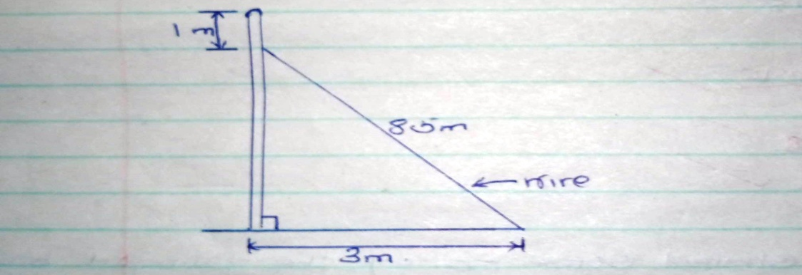
- From a window 25m above a street, the angle of elevation of the top of a wall on the opposite side is 15⁰. If the angle of depression of the base of the wall from the window is 35⁰ find:
- The width of the street. (2mks)

- The height of the wall on the opposite side. (2mks)

- Simplify: (2mks)
25^{3/2} x 9 ^{½} x 2²
5² x 3²

- Solve the in equality: (3mks)
2x – 1 ≤ 3x + 4 < 7 – x

- Solve the following: (3mks)
x² + 3x – 54 = 0

- The figure below shows a circle with centre O and radius 5cm. if ON= 3cm, AB = 8cm and <AOB= 106.3^{O}. Find the area of shaded region. (3mks)

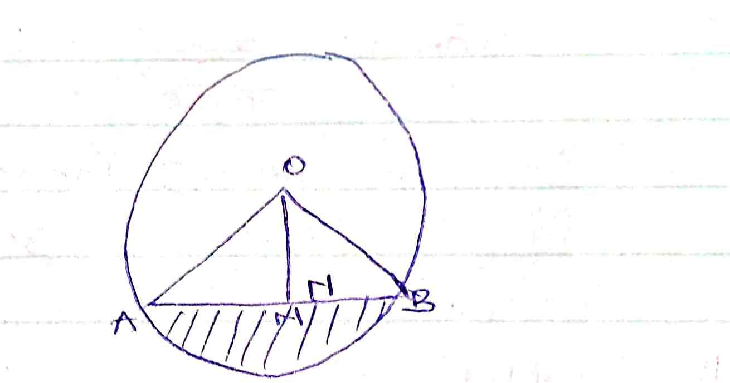

- Expand and simplify: (2mks)
4(q + 6 ) + 7 (q – 3)

- The length of a rectangle is three times its breadth. If its perimeter is 24cm what is the length of the rectangle. (2mks)

b) Area of rectangle. (2mk)

SECTION B
Answer any two questions.
- A rectangular tank whose internal dimensions are 1.7m by 1.4m by 2.2m is filled with milk.
- Calculate the volume of milk in the tank in cubic metres. (2mks)

- The milk is to be packed in small packets. Each packet is in the shape of a right pyramid on an equilateral triangular base of side 16cm. The height of each packet is 13.6cm. Calculate the volume of milk contained in each packet. (3mks)

ii. If each packet was to be sold at sh 25 per packet, what is the sale realized from the sale of all exact packets of milk. (5mks)

- A triangle ABC with vertices A(-2,2), B (1, 4) and C(-1, 4) is mapped on to triangle A’B’C’ by a reflection in the line y=x+1.
a. On the grid provided draw:

i. Triangle ABC (1mk)

ii. The line y=x+1 (2mks)

iii. Triangle A’B’C’ (3mks)

b. Triangle A’’B’’C’’ is the image of triangle A’B’C’ under a negative quater turn, with the centre of rotation as origin (0, 0). On the same grid draw triangle A”B”C” (4mks)

- The following measurements were obtained while measuring a coffee field. The measurements were entered in a field book as follows:
Y
360 80 to Q
280
To R 80 200
To S 160 80 200 to P
X
- Taking the baseline XY = 400 m. draw the map of the coffee field using a scale of 1cm represents 40m.

- Calculate the area of the coffee field. (5mks)

- The figure below represents a right pyramid. On a square base of side 3cm. the slant edge of the pyramid is 4cm.

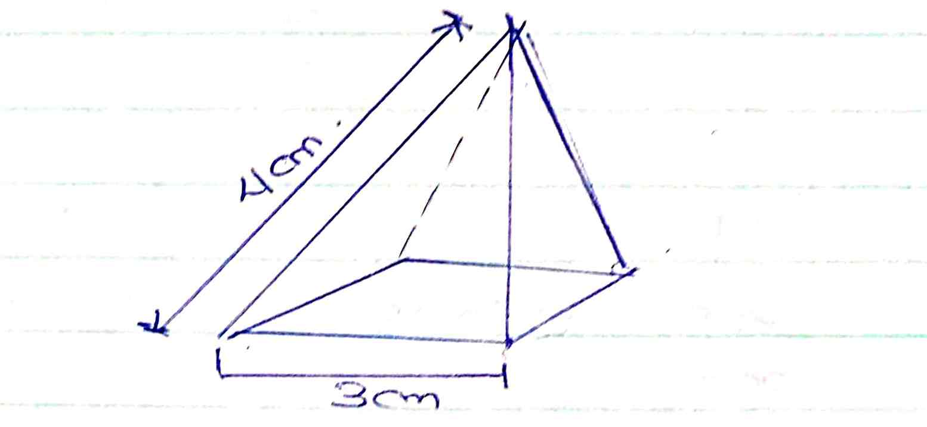

- Draw the net of the pyramid. (2mks)

- Calculate the surface area of the pyramid. (4mks)

- Calculate the volume of the pyramid to 2 decimal places. (4mks)

