GEOGRAPHY FORM II, TERM 2 -2021. TIME: 2 HOURS

NAME………………………………………………………………….. CLASS………ADM………………………
Answer all the questions in the spaces provided
- List three types of field work. (3mks)
………………………………………………………………………………………………………………………………………………………………………………………………………………………………………………………………………………………………………………………………………………………………………………………………………………………………………………………………………………………………

- Give four methods of data presentation. (4mks)

……………………………………………………………………………………………………………………………………………………………………………………………………………………………………………………………………………………………………………………………………………………………………………………………………………………………………………………………………………………………………………………………………………………………………………………………………………………………………………………………………………………………………………………………………………..

- State four negative effects of mining on the environment? (4mks)

………………………………………………………………………………………………………………………………………………………………………………………………………………………………………………………………………………………………………………………………………………………………………………………………………………………………………………………………………………………………………………………………………………………………………………………………………………………………………………………………………………………………………………………………………………

- State four economic importance of minerals in Kenya. (4mks)

………………………………………………………………………………………………………………………………………………………………………………………………………………………………………………………………………………………………………………………………………………………………………………………………………………………………………………………………………………………………
………………………………………………………………………………………………………………………

- The diagram below show the occurrence of a fossil fuel

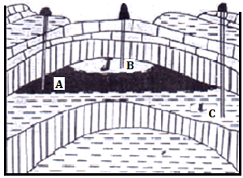

Name the substances in the area labeled A, B and C. (4mks)
………………………………………………………………………………………………………………………………………………………………………………………………………………………………………………………………………………………………………………………………………………………………………………………………………………………………………………………………………………………………

- The table below shows petroleum production in thousand barrels per day for countries in the Middle East in April 2006 use it to answer questions.
COUNTRY | PRODUCTION IN ‘000’ BARRELS
Iran  Kuwait  Qatar  Saudi Arabia  U.A.E  Iraq | 3800  2550  800  9600  2500  1900

a) What in the difference in introduction between the highest and the lowest producer. (1mk)
………………………………………………………………………………………………………………………………………………………………………………………………………………………………………………
b) What is the total amount of petroleum produced in April 2006 in the region?(2mks)

………………………………………………………………………………………………………………………………………………………………………………………………………………………………………………

c) What is the mean of petroleum produced in the April 2006 in the region? (3mks
d) Draw a simple bar graph to represent the data in the table above. Use a scale of 1cm represents 1,000,000 barrels. Use the graph paper provided. (7mks)
- Draw a diagram to show a simple field and on it mark and name;
i) An anticline
ii) A limb
iii) Syncline. (4 marks)

- The diagram above represents features as vulcanicity. Use it to answer the question that follows;
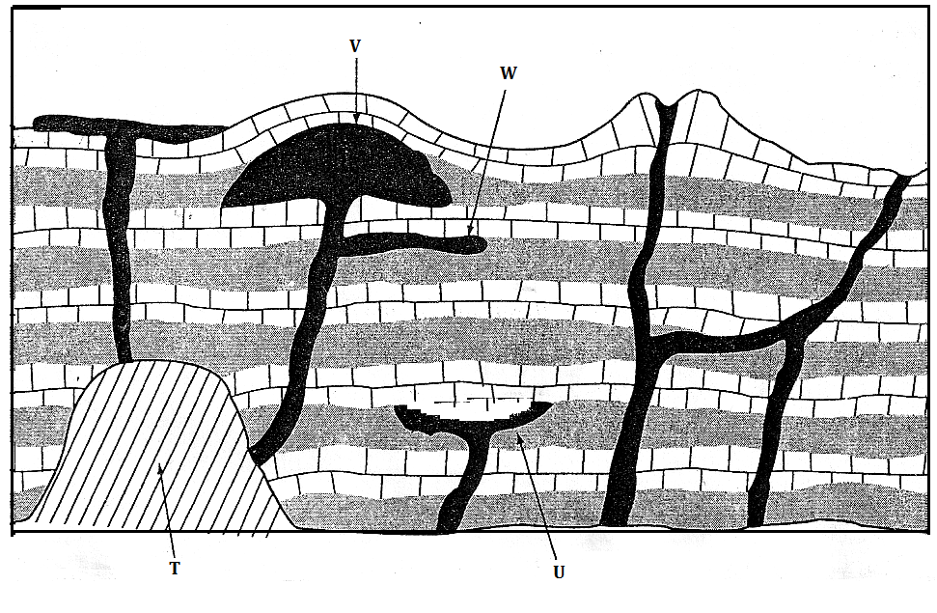
a) Name the features labeled T, U, V and W (4mks)

………………………………………………………………………………………………………………………………………………………………………………………………………………………………………………………………………………………………………………………………………………………………………………………………………………………………………………………………………………………………………………………………………………………………………………………………………………………

b) Differentiate between magma and lava. (2mks)
………………………………………………………………………………………………………………………………………………………………………………………………………………………………………………………………………………………………………………………………………………………………………………………………………………………………………………………………………………………………

- Name two fold mountain in Africa. (2mks)
………………………………………………………………………………………………………………………………………………………………………………………………………………………………………………………………………………………………………………………………………………………………………

- What is a photograph? (2mks)
………………………………………………………………………………………………………………………………………………………………………………………………………………………………………………………………………………………………………………………………………………………………………

- State three characteristics of ground general view photographs. (3mks)
………………………………………………………………………………………………………………………………………………………………………………………………………………………………………………………………………………………………………………………………………………………………………………………………………………………………………………………………………………………………

- What is climate? (2mks)
………………………………………………………………………………………………………………………………………………………………………………………………………………………………………………………………………………………………………………………………………………………………………………………………………………………………………………………………………………………………

- Give four factors influence climate. (4mks)
………………………………………………………………………………………………………………………………………………………………………………………………………………………………………………………………………………………………………………………………………………………………………………………………………………………………………………………………………………………………

- The diagram below shows the climatic regions of Kenya.
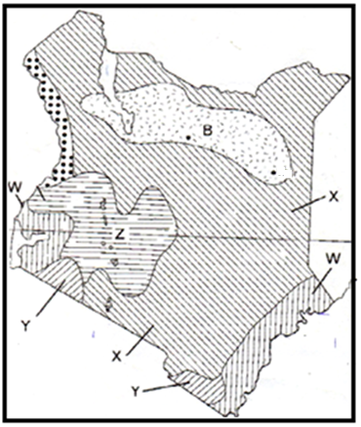
a) Identify the climatic regions marked W, X, Y and Z. (4mks)
………………………………………………………………………………………………………………………………………………………………………………………………………………………………………………………………………………………………………………………………………………………………………………………………………………………………………………………………………………………………………………………………………………………………………………………………………………………
b) Describe the characteristics of climate region marked B. (5mks)

………………………………………………………………………………………………………………………………………………………………………………………………………………………………………………………………………………………………………………………………………………………………………………………………………………………………………………………………………………………………
………………………………………………………………………………………………………………………………………………………………………………………………………………………………………………………………………………………………………………………………………………………………………………………………………………………………………………………………………………………………

15. (a) Differentiate between natural vegetation and secondary vegetation. (2mks)

………………………………………………………………………………………………………………………………………………………………………………………………………………………………………………………………………………………………………………………………………………………………………………………………………………………………………………………………………………………………
………………………………………………………………………………………………………………………

(b) Outline four factors that influence the distribution and type of natural vegetation in Kenya. (4mks)

………………………………………………………………………………………………………………………………………………………………………………………………………………………………………………………………………………………………………………………………………………………………………………………………………………………………………………………………………………………………
………………………………………………………………………………………………………………………
………………………………………………………………………………………………………………………

