NAME………………………………………………ADM.NO:………………CLASS………..……..

CHEMISTRY
FORM 2
END OF TERM 2 EXAM - 2020
TIME: 2 HOURS

INSTRUCTIONS TO STUDENTS
1. Answer all questions in this question paper.
2. All your answers must be written in the spaces provided in this question paper.
Question | Maximum score | Candidates score
1-15 | 70

1. Define the following terms:
- Atomic Number (1mk)

- Mass Number (1mk)

- The Isotopes (1mk)

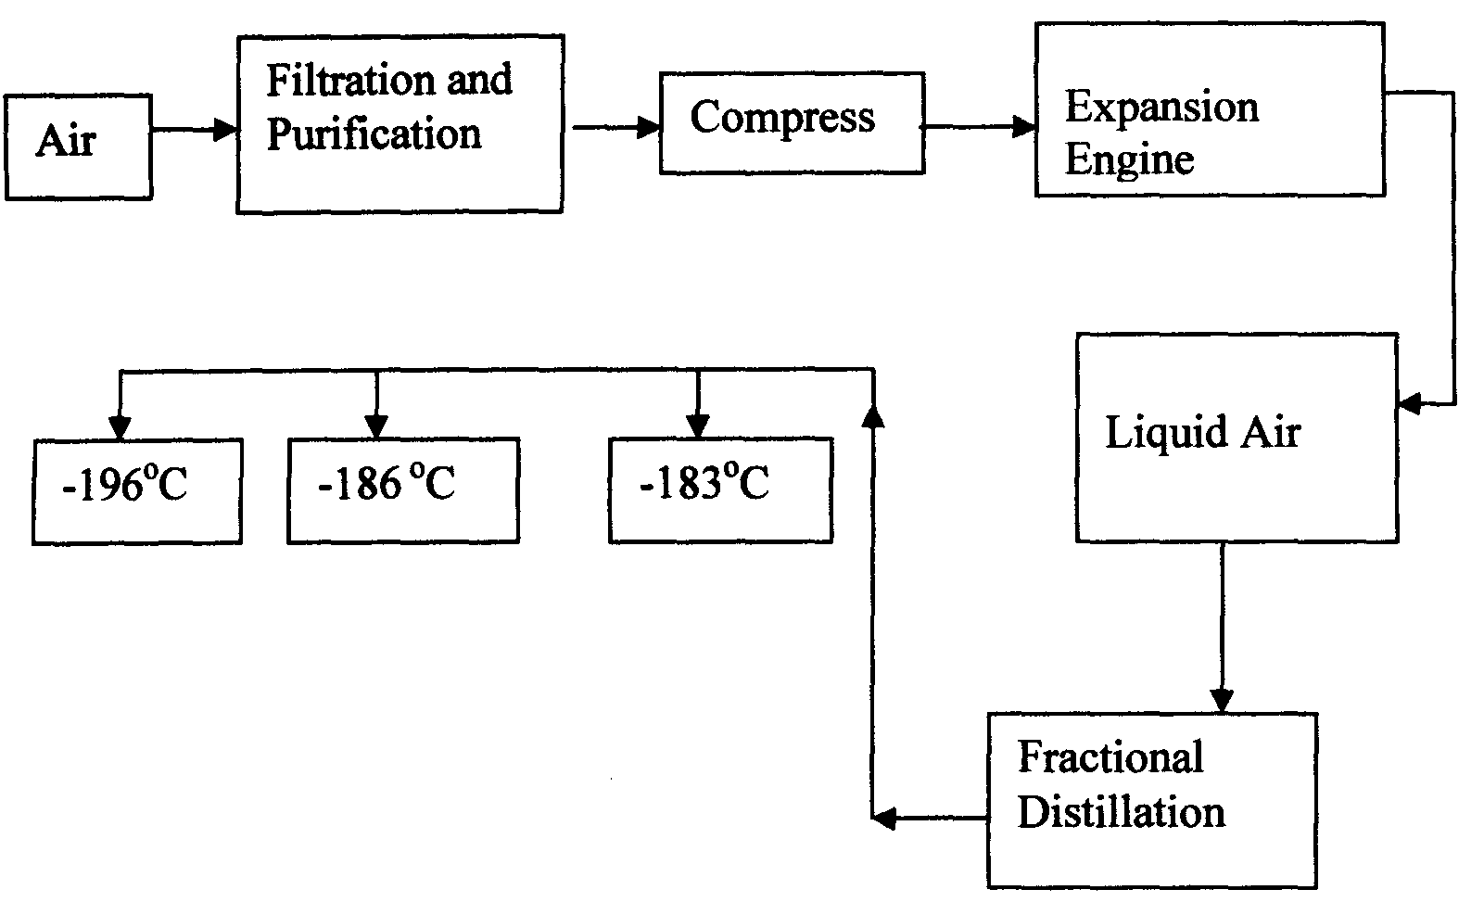
- Oxygen is obtained on large scale by the fractional distillation of air as shown on the flow chart below.

a) Explain why air is considered as a mixture (1mk)

b) Identify the substance that is removed at the filtration stage (1mk)

c) Explain why Carbon (IV) oxide and water are removed before liquefaction of air. (1mk)

d) Identify the component that is collected at -186°C (1mk)

- Study the table below and answer the questions that follow:-
Substance  Melting Point (ºC )  Boiling point (ºC) |  | A | B | C | D | E | F
 |  | 801 | 113 OR 119 | -39 | 5 | -101 | 1356
 |  | 1410 | 445 | 457 | 54 | -36 | 2860
Electrical  Conductivity | Solid | Poor | Poor | Good | Poor | Poor | Poor
 | liquid | Good | Poor | Good | Poor | Poor | Poor

Identify with reasons the substances that:
(i) Have a metallic structure (2mks)

(ii) Have a molecular structure (2mks)

(iii) Substances A and C conduct electric current in the liquid state. State how the two
substances differ as conductors of electric current (2mks)

- Atoms of element X exists as $\begin{matrix}14 \\ 6\end{matrix}X$and $\begin{matrix}12 \\ 6\end{matrix}X$
(a) What name is given to the two types of atoms. (1mk)
………………………………………………………………………………………………………
(b) Use dot (∙) and cross (x) diagrams to illustrate the atomic structure of $\begin{matrix}14 \\ 6\end{matrix}X$ (2mks) ………………………………………………………………………………………………………………………………………………………………………………………………………………………………………………………………………………………………………………………………………………………………………………………………………………………………………………………………………………………………………………………………………
- Give two reasons why most laboratory apparatus are made of glass. (2mk)

6 . Define the following terms:
- A saturated solution. (1mk)

- Crystallization. (1mk)

- Describe how copper (II) sulphate crystals can be obtained from copper (II) sulphate solution. (3mks)

- Study the table below and use it to answer the questions that follows. Letters are not the actual symbols of the elements
Ion | Electronic configuration
L⁻ | 2,8,8
M²⁺ | 2,8
N³⁺ | 2,8,8
- Which elements belong to the same period of the periodic table? (1 mark)
--------------------------------------------------------------------------------------------------------------------
- What is the formula of the compound formed by L and N.? (1 mark)
---------------------------------------------------------------------------------------------------------------------
- Compare the atomic and ionic radii of element L. (1 mark)
--------------------------------------------------------------------------------------------------------------------
---------------------------------------------------------------------------------------------------------------------
- Write the chemical fomular of the following compounds. 3mks
- Sodium sulphate
- Magnesium hydroxide
- Calcium nitrate.
- State the reasons why carbon ( iv) oxide is used by ice cream venders instead of ordinary ice. (2mks)

- A student set-up the apparatus below in order to determine the percentage by volume of oxygen in air.
AT END
AT BEGINING

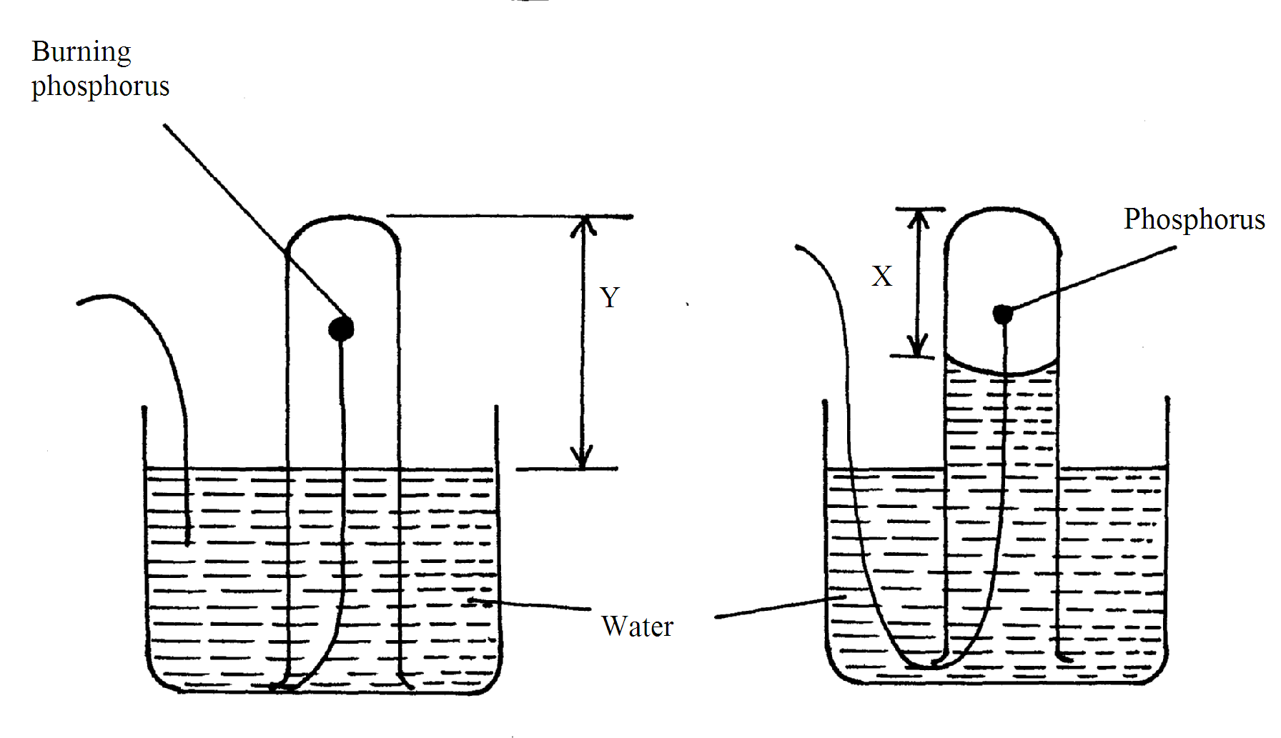

a) Why did water rise when the reaction had stopped? (2mks)
........................................................................................................................................................................................................................................................................
b) The student wrote the expression for the percentage by volume of oxygen in air as
Why was the volume of oxygen calculated using the above expression incorrect? (1mk)
..................................................................................................................................................................................................................................................................................................
c) What should have been done after the reaction had stopped in order to get a correct volume. (1mk)

..................................................................................................................................................................................................................................................................................................

12. Explain how you would obtain solid lead carbonate from a mixture of lead carbonate and sodium chloride. (3mks) ………………………………………………………………………………………………………………………………………………………………………………………………………………………………………………………………………………………………………………………………………………………………………………………………………………………………
13. Aluminium metal is a good conductor and is used for overhead cables. State any other two properties that make aluminium suitable for this use. (2mks)
……………………………………………………………………………………………………………………………………………………………………………………………………………’………………………………………………………………………………………………………14. In an experiment, a test tube of chlorine gas was inverted in water as shown in the diagram. It was then left to stand in sunlight for one day.
Sun light
Gas M
Test tube

Chlorine water

At the end of experiment (after one day)
After one day, a gas M was found to have collected in the test tube as shown above.
(i). identify gas M. (1mk)

(ii). Suggest whether the PH of the solution in the beaker would increase or decrease after one day. Give an explanation. (2mks)

(iii). Thecolour of chlorine water was observed to have changed from pale yellow to colourless after one day. Explain. (2mks)

(iv) Write an equation to support your answer in (iii) above. (1mk)

(v). State and explain the observation made when a moist blue litmus paper was placed at the mouth of the test tube containing chlorine gas. (3mks)

(vi). Write an equation to show how the process in (v) above occurs. (1mk)

(vii). Give two uses of chlorine gas. (2mks)

15. A student set up the experiment below to collect gas K. the glass wool was heated before heating the magnesium coil.

Gas K
Cotton wool soaked in water magnesium coil
Coil

heat heat

(a). Explain why it was necessary to heat the moist cotton wool before heating the magnesium.
(2mks)

(b).Identify gas K. (1mk)

(c).what property of gas K makes it possible to be collected by the method shown? (1mk)

(d). Write a chemical equation for the reaction that produced gas K. (1mk)

16.The diagram represents two methods of gas collection in the laboratory.

Gas
(a) (b)
Gas

(i). Name the methods of gas collection above. (2mks)

(ii). Which method is suitable for collecting dry carbon (IV) oxide gas? Give a reason. (2mks)

17. The curves bellow represent the variation of temperature with time when pure and impure samples of a solid were heated separately.

A
B

Temperature

(a). Which curve represents the variation in temperature for pure solid? Explain. (2mks)

(b)State the effect of an impurity on the melting and boiling points of a pure substance.(2mks)

18. Cars in Mombasa are found to rust faster than cars in Nairobi. Explain. (2 mks)

(iii). State one disadvantage of rusting. (1mk)

19. The PH of a soil sample in a given area was found to be 5.5. An Agricultural officer the addition of lime (calcium oxide). State the function of lime in the soil. (1mk)

20. By use of dot (.) and cross (x) diagram show bounding in magnesium chloride (mgCl₂) (2mks)

