NAME……………………………………………………………………ADM.NO:………………
SIGN…………………DATE………..
CHEMISTRY
FORM 2
TIME: 2 HOURS

INSTRUCTIONS TO STUDENTS
1. Answer all questions in this question paper.
2. All your answers must be written in the spaces provided in this question paper.
Question | Maximum score | Candidates score
1-19 | 70

1. Define the following terms:
- Atomic Number (1mk)
No. of protons in the nucleus of an atom

- Mass Number (1mk)
Sum of proton and neutrons in the nucleus

- The Isotopes (1mk)
Element with same atomic no. but different mass number

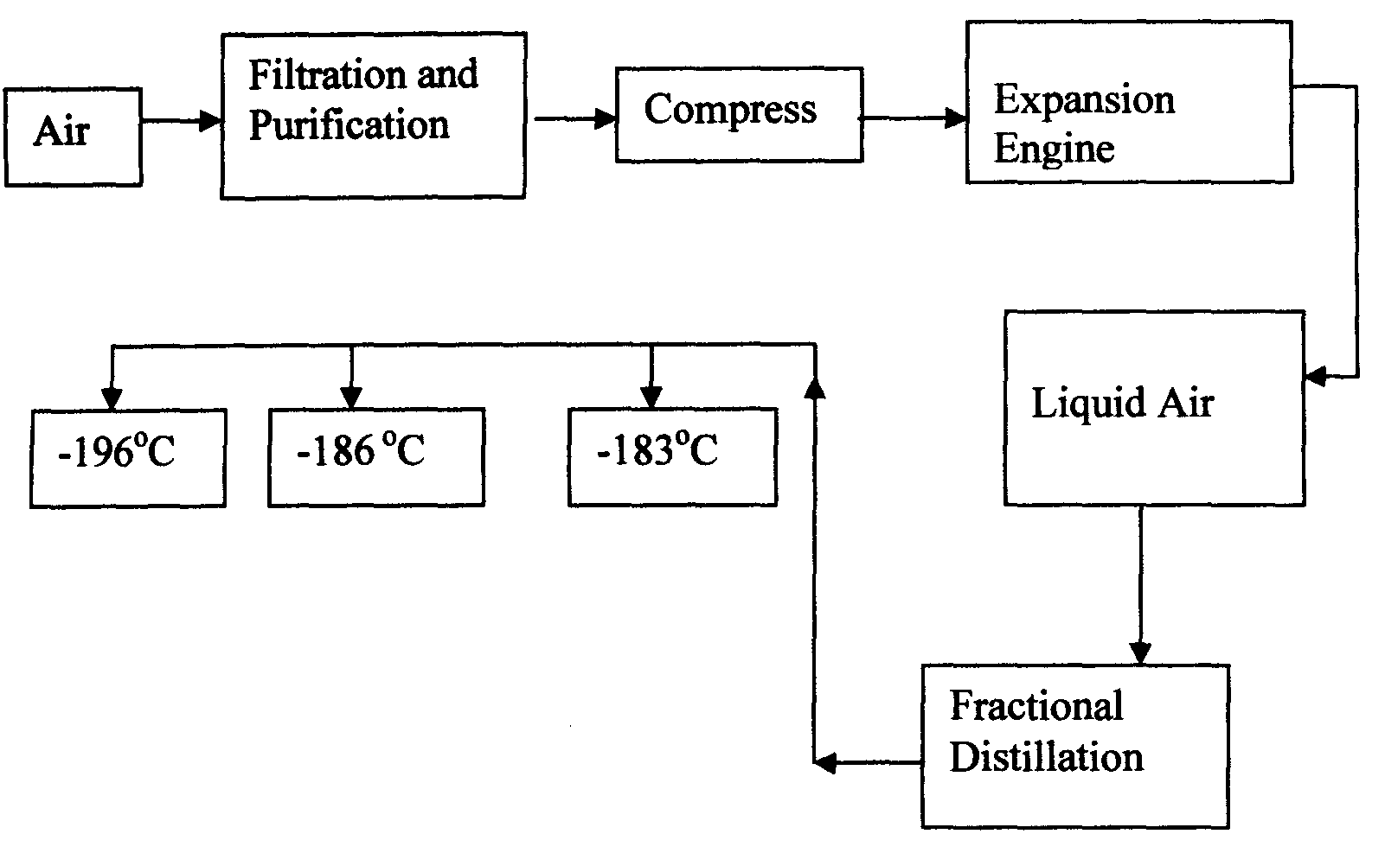
- Oxygen is obtained on large scale by the fractional distillation of air as shown on the flow chart below.

a) Explain why air is considered as a mixture (1mk)
- Various components can be separated using a physical means / method.
- Components in air are not in fixed proportions.
It contains several gases which are not chemically combined
b) Identify the substance that is removed at the filtration stage (1mk)
Dust particles 1
c) Explain why Carbon (IV) oxide and water are removed before liquefaction of air. (1mk)
- They would readily solidify ½ and block the pipes ½

d) Identify the component that is collected at -186°C (1mk)
Argon 1
- Study the table below and answer the questions that follow:-
Substance  Melting Point (ºC )  Boiling point (ºC) |  | A | B | C | D | E | F
 |  | 801 | 113 OR 119 | -39 | 5 | -101 | 1356
 |  | 1410 | 445 | 457 | 54 | -36 | 2860
Electrical  Conductivity | Solid | Poor | Poor | Good | Poor | Poor | Poor
 | liquid | Good | Poor | Good | Poor | Poor | Poor

Identify with reasons the substances that:
(i) Have a metallic structure (2mks)
C 1 Good conductor of electricity 1 in both solid and liquid state due to delocalized
(ii) Have a molecular structure (2mks)
D or E 1 Are poor conducts in both solid / liquid state.
Have relatively low M.P and B.P due to molecular structure.

(iii) Substances A and C conduct electric current in the liquid state. State how the two
substances differ as conductors of electric current (2mks)
A – mobile/free ions
B – Delocalized electrons
- Atoms of element X exists as $\begin{matrix}14 \\ 6\end{matrix} X$and $\begin{matrix}12 \\ 6\end{matrix} X$
(a) What name is given to the two types of atoms? (1mk)
isotopes
(b) Use dot (∙) and cross (x) diagrams to illustrate the atomic structure of $\begin{matrix}14 \\ 6\end{matrix} X$ (2mks) ………………………………………………………………………………………………………………………………………………………………………………………………………………………………………………………………………………………………………………………………………………………………………………………………………………………………………………………………………………………………………………………………………
- Give 2 reasons why most laboratory apparatus are made of glass. (2mk)
Glass can be used for heating
Glass cannot react with chemicals
6. Define the following terms:
- A saturated solution. (1mk)
A solution that cannot take any more solute at any given temperature
- Crystallization. (1mk)
Formation of crystals from a saturated solution
- Describe how copper (II) sulphate crystals can be obtained from copper (II) sulphate solution. (3mks)
Heat copper (ii)sulphate solution to evaporate excess water /to obtain a saturated solution
Cool the saturated solution to obtain copper (ii) sulphate crystals.
Dry the crystals between filter papers.

- Study the table below and use it to answer the questions that follows. Letters are not the actual symbols of the elements
Ion | Electronic configuration
L⁻ | 2,8,8
M²⁺ | 2,8
N³⁺ | 2,8,8
- Which elements belong to the same period of the periodic table? (1 mark)
L and M
- What is the formula of the compound formed by L and N.? (1 mark)
NL₃
- Compare the atomic and ionic radii of element L. (1 mark)
The ion of L has a larger radius than the atom of L.
- Wright the correct formula of the following compounds. 3mks
- Sodium sulphate
Na₂SO₄
- Magnesium hydroxide
Mg (OH)₂
- Calcium nitrate.
Ca (NO3)2
- State the reason why carbon ( iv) oxide is used by ice cream venders instead of ordinary ice. (1mks)
Dry carbon (IV) oxide evaporates leaving no wetness.
Carbon (IV) oxide is a better coolant

- A student set-up the apparatus below in order to determine the percentage by volume of oxygen in air.
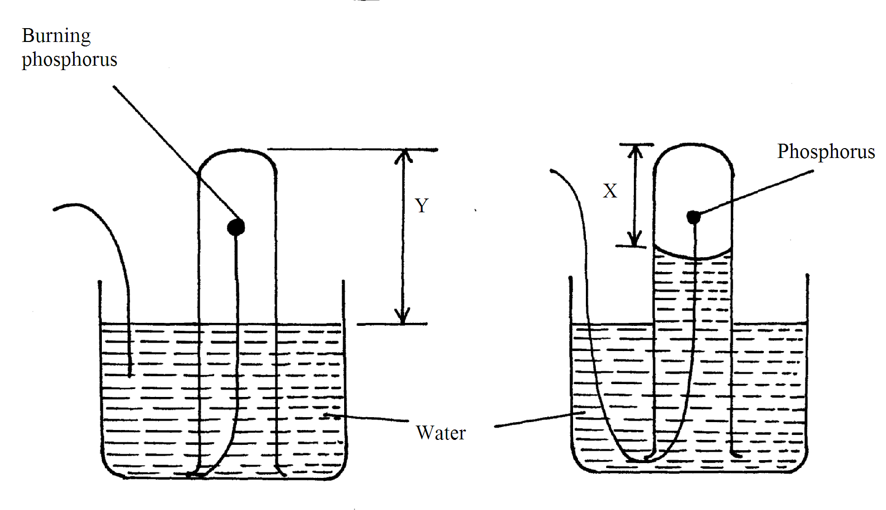
AT END
AT BEGINING

a) Why did water rise when the reaction had stopped? (1mk)
To occupy the space that was initially occupied by oxygen gas
b) The student wrote the expression for the percentage by volume of oxygen in air as
Why the volume of oxygen was calculated using the above expression incorrect? (1mk)
- Because oxides of phosphorous formed still occupy space enviously occupied by oxygen.
(P₂O₅, P₂O₃) 01
c) What should have been done after the reaction had stopped in order to get a correct volume.
(1mk)

- Let all the fumes dissolve in water before final reading is taken 01
12. Explain how you would obtain solid lead carbonate from a mixture of lead carbonate and sodium chloride. (3mks)
Add water to the mixture and stir to dissolve sodium chloride
Filter to obtain sodium chloride as a filtrate and lead carbonate as a residue

Wash the residue and dry it between filter paper
13. Aluminium metal is a good conductor and is used for overhead cables. State any other two properties that make aluminium suitable for this use. (2mks)
Al does not rust
Al has more delocalized electrons hence a better conductor of electricity.
14. In an experiment, a test tube of chlorine gas was inverted in water as shown in the diagram. It was then left to stand in sunlight for one day.

Chlorine water
sunlight
Gas M
Test tube

After one day, a gas M was found to have collected in the test tube as shown above.
(i). identify gas M. (1mk)
Oxygen gas
(ii). Suggest whether the PH of the solution the beaker would increase or decrease after one day. Give an explanation. (2nks)
- PH would decrease.
- Chloric (i) acid (unstable) decompose to hydrochloric acid, which is a strong acid.
(iii). The colour of chlorine water was observed to have changed from pale yellow to colourless after one day. Explain. (2mks)
Chloric (i) acid is yellow in colour. When exposed to sun light it decomposes to HCl acid and oxygen gas. HCl acid is colourless.
(iv) Write an equation to support your answer in (iii) above. (1mk)
2HOCl 2 HCl (aq) +O_{2 (g)}

(v). State and explain the observation made when a moist blue litmus paper was placed at the mouth of the test tube containing chlorine gas. (3mks)
The litmus paper turned red then white. It turned red because of the presence of hydrogen ions then white/ breached by chloric (i) acid though oxidation.
(vi). Write an equation to show how the process in 3(v) above occurs. (1mk)
HClO(aq) + Dye HCl (aq) + (dye + O)
(coloured) colourless
(vii). Give two uses of chlorine gas. (2mks)
Used in the manufacture of hydrochloric acid
Used in making breaches
Used to make plastics (pvc)
Used to kill microorganism in water treatment
15. A student set up the experiment bellow to collect gas K. the glass wool was heated before heating the magnesium coil.
Gas K
Cotton wool soaked in water magnesium coil

heat heat

(a). Explain why it was necessary to heat the moist cotton wool before heating the magnesium. (2mks)
To produce steam this will react with magnesium. Heating magnesium first will make magnesium to react with oxygen.
(b).Identify gas K. (1mk)
Hydrogen gas
(c). What property of gas K makes it possible to be collected by the method shown? (1mk)
It’s lighter than air
(d). Write a chemical equation for the reaction that produced gas K. (1mk)
Mg +H₂O MgO + H₂
16. The diagram represents two methods of gas collection in the laboratory.

Gas
(a) (b)

Gas

(i). Name the methods of gas collection above. (2mks)
(a) Upward delivery
(b) Downward delivery
(ii). Which method is suitable for collecting dry carbon (IV) oxide gas? Give a reason. (2mks)
Downward delivery
Carbon (iv) oxide is denser than air.

17. The curves bellow represent the variation of temperature with time when pure and impure samples of a solid were heated separately.

A
B

Temperature

(a). Which curve represents the variation in temperature for pure solid? Explain. (2mks)
B, has sharp melting and boiling point
(b)State the effect of an impurity on the melting and boiling points of a pure substance.(2mks)
Impurity lowers the melting point and raises the boiling point
18. Cars in Mombasa are found to rust faster than cars in Nairobi. Explain. (2mks)
Mombasa is salty. Salt accelerates rusting.
(iii). State one disadvantage of rusting. (1mk)
Causes wear and tare.
19. The PH of a soil sample in a given area was found to be 5.5. An Agricultural officer the addition of lime (calcium oxide). State the function of lime in the soil. (1mk)
Neutralizes the soil.
Adds calcium to the soil.

