Name: …………………………………………………...............…… Adm no ……..….......... Class.................
231/3
BIOLOGY FORM THREE
END OF TERM TWO

TIME: 1³/₄ HOURS
INSTRUCTIONS TO CANDIDATES:
- Answer ALL the questions
- Answers should be written in the spaces provided

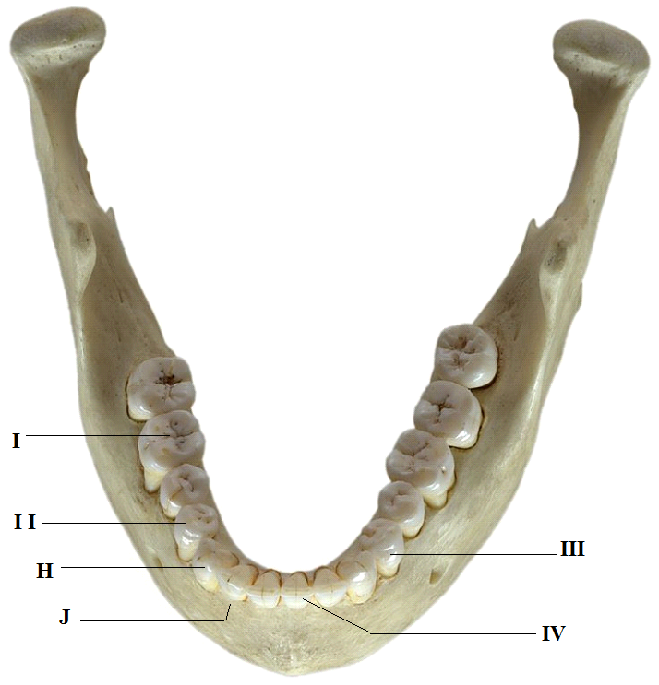
- Below is a photograph of an adult human jaw with teeth. Study the diagram and answer the questions that follow.

      - State the mode of nutrition in man. (1mk)
………………………………………..............................................................……………………………………………………......................................................................................................…

      - Name the type of teeth labeled I and III. (2mks)
I:………………………………………………………………………………............……………
III:…………………………………………………………………………………….........………

      - Name the parts of teeth labeled H and J. (2mks)
H:………………………………………………………………………………........………..…….
J:…………………………………………………………………………………….........……..….
      - Identify one distinguishing feature between teeth labeled II and IV. (1mk)
………………………………………..............................................................……………………………………………………......................................................................................................…

      - State one function of tooth IV. (1mk)
………………………………………..............................................................……………………………………………………......................................................................................................…

      - Write the dental formula from the jaw shown in the photograph. (1mk)
………………………………………..............................................................……………………………………………………......................................................................................................…………………………………………..............................................................……………………

      - Explain why tooth I would be more prone to dental carries than tooth III, (2mks)
………………………………………..............................................................……………………………………………………......................................................................................................…………………………………………..............................................................……………………………………………………......................................................................................................…

- Use the hand lens provided to observe specimen K and answer the questions that follow.
      - (i) In the space below draw a fully labeled diagram of representative part of the specimen. (5mks)

(ii) Calculate the magnification of your drawing. (2mks)

      - Identify:
        - The Kingdom (1mk)
………………………………………..............................................................……………………………………………………......................................................................................................…

        - The Division, to which the specimen belongs. (1mk)
………………………………………..............................................................……………………………………………………......................................................................................................…

        - Give a reason for your answer in b (ii) above. (1mk)
………………………………………..............................................................……………………………………………………......................................................................................................…

      - State the functions of any two parts labeled in your diagram. (2mks)
………………………………………..............................................................……………………………………………………………..............................................................……………………………………………………......................................................................................................…
………………………………......................................................................................................…

      - What is the mode of reproduction in the specimen? (1mk)
………………………………………..............................................................……………………………………………………......................................................................................................…

      - Explain the significance of colour observed in the specimen M. (2mks)
………………………………………..............................................................……………………………………………………......................................................................................................…………………………………………..............................................................……………………

- You are provided with solutions labeled L₁, L2 and L₃. Note that L₃ is the same as L2 except that L₃ has been boiled.

Label three test- tubes A, B and C.
Into the test- tube labeled A add 1ml of solution L_{1.}
Into the test- tube labeled B add 1ml of L₁ and 1ml of L_{2.}
Into the test- tube labeled C add 1ml of L₁ and 1ml of L_{3.}

- Withdraw a drop from test – tube A and place it on a white tile. To the drop add one drop of iodine solution. Record your observation in the table below. (3 mks)

Test - tube | observation | conclusion
A

B

C

Repeat the procedure with contents in test – tubes B and C. Record your observations in the table.
Place the three test –tubes labeled A, B and C into a water bath at 37⁰C.

NB. Ensure that the temperature of the water bath does not fall below 35⁰C or exceed 38⁰C
- After 30 minutes, test the contents of each of the test – tubes labeled A, B and C following the procedure in (a) above. Record your observations in the table below. (6 mks)

Test - tube | observation | conclusion
A

B

C

- Why was test – tube labeled A included in the experiment? (1mk)
………………………………………..............................................................……………………………………………………......................................................................................................…

- (i) suggest the identity of solution L₂ (1mk)
…………………………………………………………………………………………………………………………………………………………………………………………………………
(ii) Give a reason for your answer in (d) i above. (1 mk)
………………………………………..............................................................……………………………………………………......................................................................................................…
………………………………………………………..............................................................……

- Suggest a part of the alimentary canal in the body of a mammal where the process being investigated in the experiment would take place. (1mk)
………………………………………………………………………………………………………………………………………………………………………………………………………………………………………………………………………………………………………………

- Account for the results at the end of the experiment in the test – tube labeled.
- B (1mk)
……………………………………………………………………………………………………………………………………………………………………………………………………………………………………………………………………………………………………………………………................................................................................................................................…

- C (1mk)
……………………………………………………………………………………………………………………………………………………………………………………………………………………………………………………………………………………………………………………………….................................................................................................................................

