Name: …………………………………………………...............…… Adm no ……..….......... Class.................
231/2
BIOLOGY FORM THREE
END OF TERM TWO
TIME: 2 HOURS
JOINT EXAMINATION
INSTRUCTIONS TO CANDIDATES:
- Answer ALL the questions
- Answers should be written in the spaces provided

1. A student observed feeding relationship while on a tour in a coastal Island.
Eagles feed on small fish, Small fish feed on sea grass, Insect larvae and molluscs feed on sea grass, Insect larvae fed on by small fish, while crabs feed on insect larvae and molluscs.

a) From the above information, construct a food web. (3mks)

b) In which trophic level is small fish found. (1mk)
……………………………………………………………………………………………………..
……………………………………………………………………………………………………..

c) Extract a food chain where the Eagle is a tertiary consumer. (1mk)

d) Suppose all the crabs were poisoned, what would be the immediate effect in the ecosystem. Give a reason. (1mk)
……………………………………………………………………………………………………..
……………………………………………………………………………………………………..
(e) Give a reason why pyramid of biomass is a better representation of energy flow in an
eco system than pyramid of numbers. (1mk)
……………………………………………………………………………………………………..
……………………………………………………………………………………………………..
2. An experiment was set up as shown below.
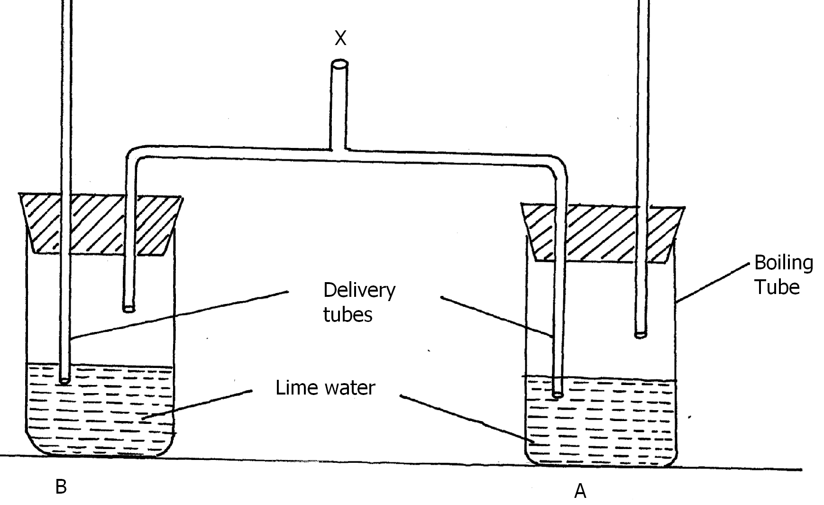
a) A student blew air in and out through point X. Using arrows indicate on the diagram how
air gets in and out of the set up. (2mks)

b) (i) In which of the test tube would lime water turn milky first. (1mk)
……………………………………………………………………………………………………..
……………………………………………………………………………………………………..

(ii) Give a reason. (1mk)
……………………………………………………………………………………………………..
……………………………………………………………………………………………………..

(c) What is the effect of lactic acid in the thigh muscles of an athlete after a short fast race.
(2mks)
……………………………………………………………………………………………………..
……………………………………………………………………………………………………..

(d) Identify the type of muscle in human being where formation and effect of lactic acid is
not felt. (1mk)
……………………………………………………………………………………………………..
……………………………………………………………………………………………………..

(e) What is the biological significance of boiling milk /ultra heat treated milk. (1mk)
……………………………………………………………………………………………………..
……………………………………………………………………………………………………..
3. The diagram below is a longitudinal section of an organ in mammals
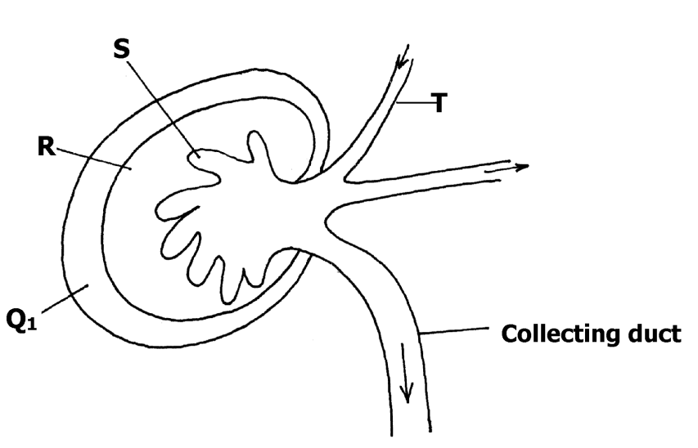
a) Name the organ (1mk)
……………………………………………………………………………………………………..
……………………………………………………………………………………………………..

b) Identify the parts R and S (2mks) ……………………………………………………………………………………………………..
……………………………………………………………………………………………………..
……………………………………………………………………………………………………..
……………………………………………………………………………………………………..

c) i) State two differences in the structure above found in the deserted- rat and fish (3mks)
……………………………………………………………………………………………………..
……………………………………………………………………………………………………..
……………………………………………………………………………………………………..
……………………………………………………………………………………………………..

ii) Account for the difference stated above. (2mks)
……………………………………………………………………………………………………..
……………………………………………………………………………………………………..
……………………………………………………………………………………………………..
……………………………………………………………………………………………………..

d) Name the gland associated with the secretion of aldorsterone hormone. (1mk)
……………………………………………………………………………………………….
……………………………………………………………………………………………….
4. The diagram below represents a circulatory system found in a certain class of chordates.
- Identify the type of circulatory system shown above. (1mk)
……………………………………………………………………………………………………..
……………………………………………………………………………………………………..

- Name one class of animals having this type of circulatory system. (1mk)
……………………………………………………………………………………………………..
……………………………………………………………………………………………………..

c) Identify parts labelled M, N and P. (3mks)
M…………………………………………………………………………………………………
N…………………………………………………………………………………………………
P…………………………………………………………………………………………………..

d) What disadvantages is faced by having the types of circulatory system shown above? (2mks)
……………………………………………………………………………………………………..
……………………………………………………………………………………………………..
……………………………………………………………………………………………………..
……………………………………………………………………………………………………..

e) Between blood vessels Q and T, which one carries oxygenated blood? (1mk)
……………………………………………………………………………………………………..
……………………………………………………………………………………………………..
5. In an experiment to investigate the rate of reaction indicated by the equation.
C₁₂H₂₂O₁₁ C₆H₁₂O₆ + C₆H₁₂O₆
Sucrose Fructose Glucose
It was found out that for products fructose and glucose to form, substance “K” was needed. Temperature was maintained at 37ºC.When substance “L” was added, reaction slowed and then
stopped.
a) Suggest identity of the substances (2mks)
K………….....………………………………………………………………………………
L…………….………………………………………………………………………………
- Other than temperature, state three factures that increase the rate of reaction. (3mks)
………………………………………………………………………………………………………………………………………………………………………………………………………………............................................................................................................................................………………………………………………………………………………………………………
d) Explain how substance “L” slowed the rate of reaction. (2mks)
…………………………………………………………………………………………………………................................................................................................................................................
e) What type of reaction is represented by the equation above? (1mk)
..……………………………………………………………………………………………………........................................................................................................................................................…

SECTION B (40 MARKS)
Answer questions 6 (compulsory) and either questions 7 or 8 in the spaces provided questions

6. The glucose level in mg per 100cm³ of blood was determined in two person Y and Z. Both had stayed for six hours without taking food. They were fed on equal amount of glucose at the start of the experiment .The amount of glucose in their blood was determined at intervals .The results are shown in the table below.
Times in minutes | Glucose level in blood in mg /100cm³
 | Y | Z
0 | 85 | 78
20 | 105 | 110
30 | 105 | 110
45 | 130 | 170
60 | 100 | 195
80 | 93 | 190
100 | 90 | 140
120 | 90 | 130
140 | 88 | 120

a) On the grid provided, plot graphs of glucose levels in blood against time on the same axes. (7mks)

b) What was the concentration of glucose in the blood of Y and Z at the 50th minute? (2mks)
Y.............................................................................................................................................
Z.............................................................................................................................................
c) Account for the level of glucose in present Y
i) During the first 45 minutes. (2mks)
..................................................................................................................................................................................................................................................................................................................................................................................................................................................................................................................
ii) After 45th minute to the end. (4mks)
..........................................................................................................................................................................................................................................................................................................................................................................................................................................................................................................................................................................................................................................................................................................................................................................................................................................................................................................................................................................................................................................................................................................................................................................................................

d) Account for the decrease in glucose level person Z after 60 minutes. (2mks)
..............................................................................................................................................................................................................................................................................................................................................................................................................................................................................................................................................................................................................................................................................................................................................................................................................................................................

e) Low blood sugar level in harmful to the body .Explain. (3mks)
..............................................................................................................................................................................................................................................................................................................................................................................................................................................................................................................................................................................................................................................................................................................................................................................................................................................................

7. Discuss the adaptations of seeds and fruits to dispersal. (20mks)
8 Describe the structure and functions of various organelles in a mature animal cell. (20mks)
.............................................................................................................................................................................................................................................................................................................................................................................................................................................................................................................................................................................................................................................................................................................................................................................................................................................................. .............................................................................................................................................................................................................................................................................................................................................................................................................................................................................................................................................................................................................................................................................................................................................................................................................................................................. .............................................................................................................................................................................................................................................................................................................................................................................................................................................................................................................................................................................................................................................................................................................................................................................................................................................................. .............................................................................................................................................................................................................................................................................................................................................................................................................................................................................................................................................................................................................................................................................................................................................................................................................................................................. ............................................................................................................................................................................................................................................................................................................................................ .............................................................................................................................................................................................................................................................................................................................................................................................................................................................................................................................................................................................................................................................................................................................................................................................................................................................. .................................................................................................................................................................................................................................................................................................................................................................................................................................................................................................................. ..........................................................................................................................................................................................................................................................................................................................................................................................................................................................................................................................................................................................................................................................................................................................................................................................................................................................................................................................................................................................................................................................................................................................................................................................................
..................................................................................................................................................................................................................................................................................................................................................................................................................................................................................................................

