231/2
BIOLOGY FORM THREE END OF TERM TWO
Marking scheme

Question 1
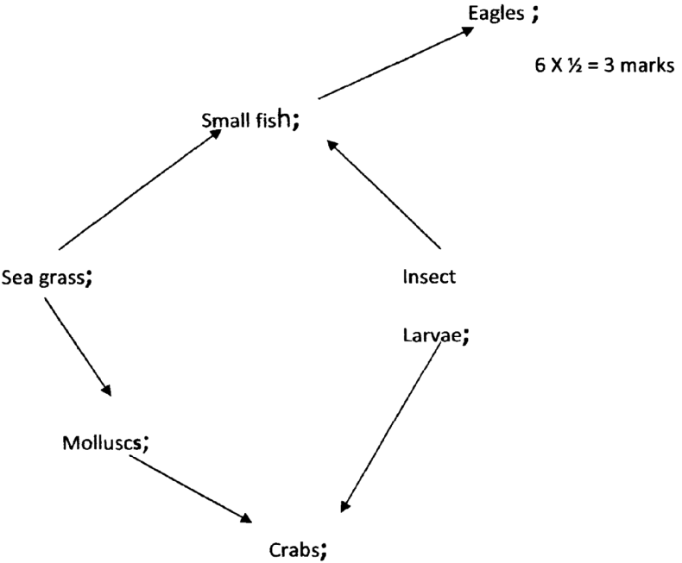
(a)

(b) Second / Third (1mk)

(c) Sea grass insect small Eagle Larvae Fish

(d) The population of molluscs / insect larvae would increase; due to decreased predation; (2mks)

(e) Shows the actual amount of energy flow of a food chain; (1mark)

Question 2
(a) (2mks)
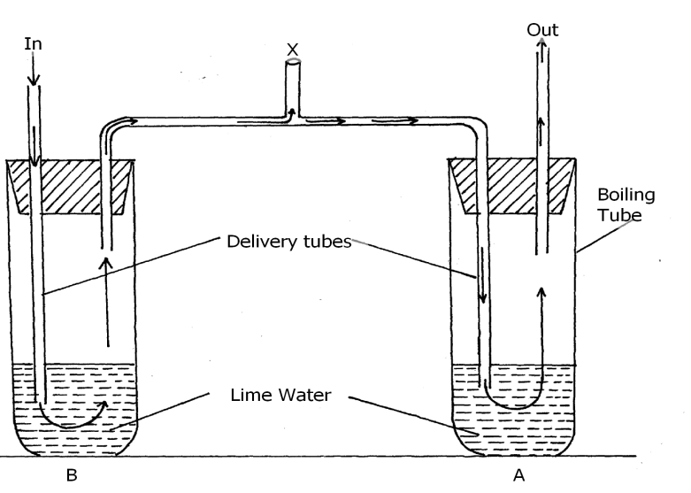
(b) (i) A; (1 mark)
(ii) Exhaled air has more carbon (iv) dioxide; (than B); (1 mark)

(c) - Poisonous if it accumulates;
- Muscle clump;
- Fatigue Mark any two correct

(d) Cardiac muscles; (1 mark)

(e) - Kill microorganisms (lactobacillus) bacteria R; germs;

(e) - High temperature denature bacteria enzymes / stops anaerobic respiration; Rj Respiration alone or aerobic respiration; Rj germs (1 mark)

Question 3
- Kidneys rej any other

b) R –Medulla ; rej any other
S – Pelvis ; rej pyramids

c) i) Desert rat Fish
Large medulla | Small medulla surface
Long loop of henles | Short loop of Henles
Small cortex surface | Large cortex surface

ii) Large medulla ----- surface for maximum reabsorption of water ; due to extensive/ long loop of Henles

Small medulla -------surface smaller ; surface for reabsorption due to short loop of Henles;

Question 4
a) single circulatory system

b) Pisces

c) M-gills
N- auricle/atrium
P – Ventricle
d) Blood passes through two capillary networks before returning back to the heart hence its under low pressure. This makes the animals less active (sluggish)

e) Q

Question 5
- K – Enzyme
L – Enzyme inhibitor

(b) - Optimum P^{H} rej P^{H} alone

- Increases enzyme concentration rej amount of enzyme alone.

- It occupied active sites of substances ; No competition with enzymes ; enzyme could not catalyse the reaction.

(d) Hydrolysis.

Question 6
S – ½ x 2 = 1
C – 1 x 2 = 2
A – ½ x 2 = 1
P – 1 x 2 = 2
Total = 6mks

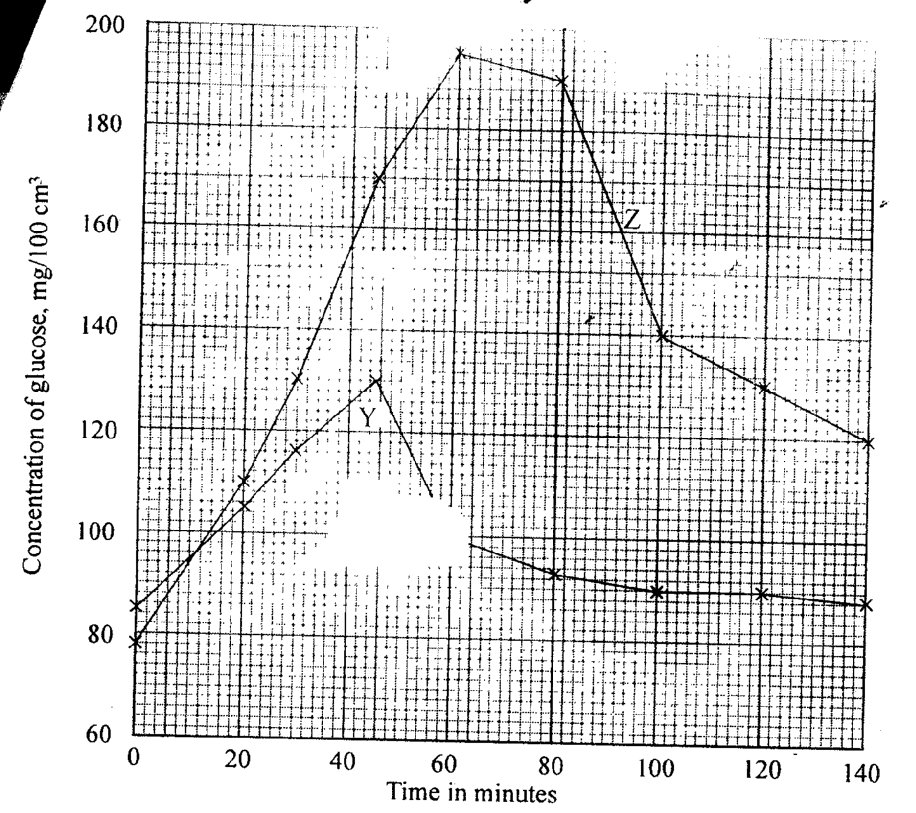

b) Y – 120mg / 100cm³ ± 1;
Z – 178mg / 100cm³ ± 1; (2mks)

c) i) Blood sugar level increased to 130 mg / 100cm³; glucose is being absorbed from the intestines;

- Some of it by – passes the liner without entering the cells thus raising blood glucose level;
ii) Glucose concentration declined to normal 90mg / 100cm³ high blood glucose stimulates the pancreas to produce insulin ; which stimulates the liver cells to take up glucose ; and consists it to glycogen; (4mks)

d) Some of the glucose is used in respiration to generate energy; some is lost in urine; (2mks)

7. Animal dispersal
Presence of hooks on ovary walls/ calvx e.g. in Bidens pilosa for attachment on animals hair! fur or clothes of human beings;
Succulent fruits; brightly coloured and scented fruits that attract animals; Some fruits are eaten together with seeds. The seeds have coats which are resistant to digestive enzyme; hence pass through the gut undigested and passed out through faeces far from the parent plant; e.g. passion, tomato, guava, lantana

Water dispersal
Fruits and seeds dispersed by water are light; hence float on water. Their seed coats are waterproof; This avoids soaking;
In some fruits e.g. coconut, mesocarp is fibrous and spongy; Air is trapped making the fruit light. Some water plants e.g. the water lily have seeds whose coats trap out bubbles. The bubbles make the seeds float on water; and can be carried away from the parent plant. The pericarp and the testa are waterproof; hence seeds remain afloat without soaking and sinking;

Wind dispersal
Fruits and seeds should be light; and small; to be carried away by air currents.
Some fruits and seeds have hairy; and feather- like projections; that increase the surface area; for them to be carried away by air currents and dropped far from the parent e.g. sonchus sp and cotton
Some fruits and seeds have wing-like structures; e.g. jacaranda, sycamore, tridax and nandi flame. Extensions increase the surface area; so that they are easily carried away by air currents;

Censor mechanism
Some fruits are capsule- shaped; Some have pores at the top; e.g. tobacco split along lines of weakness. The capsule is attached to a long stalk; hence when swayed by the wind. The seeds are released and scattered away from the parent plant;
Self dispersal
This method occurs in legumes. When the pod dries up; the seeds break off from the placenta;
The pod opens along the lines of weakness throwing seeds away from the parent; e.g. beans,
castor oil, peas, crotalaria
Any 1 point with explanation 2 mks i.e. 1 point 1 mark. Explanation 1 mark.
(10 x 2 = 20 mks)

8). Mitochondria;
Has a double membrane surrounding it and inner membrane folded to form cristae which increases the surface area for attachment of respiratory golgi body/apparatus, are stack of membrane bound like sac/is a system of membranes sacs/hollow spaces; that transports glycoproteins/carbohydrates and proteins; They package glycoproteins; secrete mucus/enzymes/synthesized proteins.

Lysosomes
Are spherical in shape and enclosed by a single membrane; contain hydrolytic enzyme which destroy worn out organelles, micro-organism/ingest food/breakdown large molecules.

Endoplasmic reticulum
Are membrane bound cavities in cytoplasm; smooth endoplasmic reticulum site for lipid/sterot transport. Rough endoplasmic reticulum ahs ribosome on its surface; and transport proteins.

Centrioles
Rod shaped; located outside the nuclear membrane, for formation of fibs and cilia

Cytoplasm;
It’s a fluid medium; where chemical reaction occurs, contains organelles and inclusions (e.g. glycogen granules, fat droplets and dissolved substances).

Cell membrane
Encloses all cell organelles; has phospholipid layer between two protein layers/it’s a lipoprotein layer has pores that selectively allows substances to pass in and out of the cell/its semipermeable.

Nucleus
Has a double membrane/nuclear membrane around it, which has pores to allow substances in and out of the nucleus; Has nucleoplasm, which contain nucleolus/chromatin, nucleus controls all cell activities, Nucleolus manufactures ribosomes and centrioles.

Ribosomes
Are spherical in shape and suspended in cytoplasm and attached on endoplasmic reticulum; synthesis proteins.

