END OF TERM 2 EXAMS
BIOLOGY
FORM 2

NAME: .............................................................CLASS:...........ADM:....................

- (i) What is respiration? (1mk)
…………………………………………………………………………………………………............................................................................................................................................
(ii) State any two importance of respiration. (2mks)
……………………………………………………………………………………………
………………………………………………………………………………………………….

- (a) (i) Name the blood vessel that supplies the cardiac muscles with its requirements.(1mk)
………………………………………………………………………………………………
………………………………………………………………………………………………
- State the corgenical defect of the above blood vessel resulting from prolonged large intake of cholesterol in the blood. (1mk)
………………………………………………………………………………………
………………………………………………………………………………………

(b) What is the importance of the thicker muscular wall of the left ventricle of a mammalian heart? (2mks)
…………………………………………………………………………………………………...................................................................................................................................................................

- (a) (i) Name the respiratory surface in insects. (1mk)
………………………………………………………………………………………………

(ii)State any one feature that adapts the structured named in a (i) above to its functions. (1mk)
………………………………………………………………………………………………….
- Why are the fish gills highly vascularized? (1mk)
………………………………………………………………………………………
…………………………………………………………………………………………
- a) (i) what would happen if a person secreted less A.D.H? (1mk)
………………………………………………………………………………………………….…………………………………………………………………………………………
(ii) Name the condition described in a(i) above. (1mk)
…………………………………………………………………………………………….

(b)What is the role of the loop of Henle in homeostasis? (1mk)
……………………………………………………………………………………………….
- (a) Name the products of anaerobic respiration in plants. (1mk)
………………………………………………………………………………………………
…………………………………………………………………………………………………..........................................................................................................................................
(b)Give any two economic importance of the products named in (a) above. (2mks)
………………………………………………………………………………………………
…………………………………………………………………………………………….
- The diagram below illustrates part of phloem tissue.
X

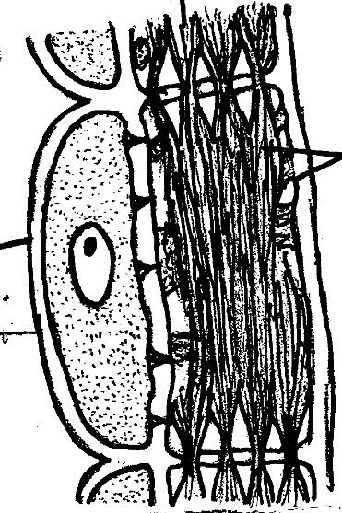

Y

Z

- Name the parts labeled. (2mks)
X………………………………………………
Y………………………………………………

(b)State the function of the part labeled Z (1mk)

………………………………………………………………………………
- Name the monosaccharides that make up the disaccharides below
(a) Sucrose (1mk)
………………………………………………………………………………………………
(b) Lactose (1mk)
……………………………………………………………………………………………
(c) Maltose (1mk)
………………………………………………………………………………………………
- State one use of the following excretory products of plants (2mks)
(i) Latex
……………………………………………………………………………………………
(ii) Colchicine

- (a) Define respiratory quotient (1mk)
……………………………………………………………………………………………
………………………………………………………………………………………………
(b) Given the equation below, calculate the respiratory quotient (RQ) (2mks)

C₆H₁₂O₆+6O₂ 6H₂O+6CO₂+2880kJ

- State the importance of the following
(i) Reversed stomatal rhythm to desert plants (1mk)
………………………………………………………………………………………………........................................................................................................................................................
(ii) Closing of stomata on a hot dry sunny day (1mk)
…………………………………………………………………………………………………….................................................................................................................................................
(iii) How does wind affect transpiration rate? (1mk)
……………………………………………………………………………………………………....................................................................................................................................................

- The diagram below represents the pathway of water from soil into the plant.
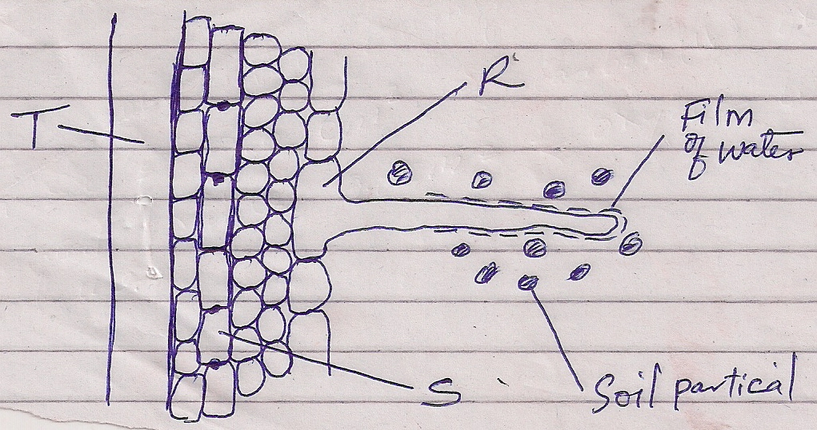
    - Name the structures labeled T and S.
T:……………………………………………………………………………………(1mk)
S:……………………………………………………………………………………(1mk)
    - State two ways in which the structure labeled R is adapted to its functions.
(2mks)
…………………………………………………………………………………………………………………………………………………………………………………………
- A student added equal amounts of blood to equal volumes of salt of different concentrations. She observed and counted the red blood cells at the beginning of the experiment and at end of the experiment. The results were as shown:-
Set up | Concentration of salt | Beginning | After 30 mins
A | 0.1mol | 500 | 500
B | 0.01mol | 500 | 250
Account for the results in:
- Set up A (2mks)
………………………………………………………………………………………………………………………………………………………………………………………………

- Set up B (2mks)
………………………………………………………………………………………………………………………………………………………………………………………………
- Below is a dental formula of certain organisms. Use it to answer the questions that follow.
I ⁰/₃, C ⁰/₁, PM ³/₂, M ³/₃
- Calculate the total number of teeth in the mouth of the organisms. (2mks)

- Name the organisms. (1mk)
……………………………………………………………………………………………
- Identify the mode of nutrition of the organisms. (1mk)
…………………………………………………………………………………………
- (a) Give a reason why glucose does not normally appear in urine even though it is filtered in mammalian Bowman’s capsule. (2mks)
…………………………………………………………………………………………………
…………………………………………………………………………………………………
(b) Which hormones are involved in the salt-water balance in human body? (2mks)
……………………………………………………………………………………………… ……………………………………………………………………………………………

- a) State two functions of the blood other than transport. (2mks)
…………………………………………………………………………………………………
…………………………………………………………………………………………………
(b) Name one defect of the circulatory system in humans. (1mk)
…………………………………………………………………………………………………

- (a) State two ways in which human body is naturally protected against harmful
bacteria. (2mks)
………………………………………………………………………………………………………………………………………………………………………………………………
(b) State one way in which the composition of blood in the pulmonary artery and that
of pulmonary vein differ. (1mk)
……………………………………………………………………………………………….
- Describe the path taken by Carbon (IV) Oxide released from the tissues of a cockroach into the atmosphere. (2mks)
………………………………………………………………………………………………………………………………………………………………………………………………………………………………………………………………………………………………………
- Form One student set up an experiment shown below to investigate a certain physiological process. The set up was left for 30 minutes.
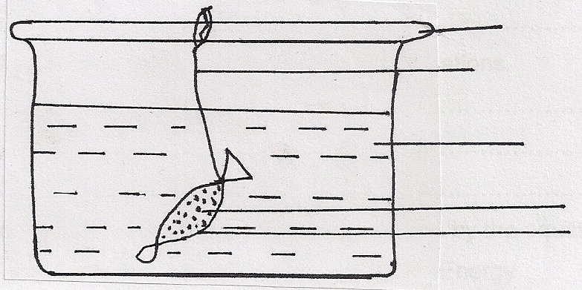
Glass rod
Thread

Distilled water
Sucrose solution
Visking Tubing

- Name the process under study. (1mk)
………………………………………………………………………………………………
- State the expected results after 30 minutes. (1mk)
………………………………………………………………………………………………
- Explain your answer in (b) above. (3mks)
………………………………………………………………………………………………………………………………………………………………………………………………………………………………………………………………………………………………

- Explain why it is important to stain specimen to be observed under a light microscope. (2mks)
………………………………………………………………………………………
…………..……………………………………………………………………………
- What is wilting? (2mks)
……………………………………………………………………………………………………………………...................................................................................................................................

- State the significance of the following steps while testing for disaccharides in food sample. (2mks)
(a) Addition of dilute hydrochloric acid
……………………………………………………………………………………………………………………...................................................................................................................................
(b) Addition of sodium bicarbonate.
…………………………………………………………………………………………………………………….......................................................................................................................................
- a) (i) Name the fluid produced by sebaceous gland. (1mk)
…………………………………………………………………………………………………………………….......................................................................................................................................
(ii) State two function of the fluid named in 5 a) (i) above. (2mks)
………………………………………………………………………………………………………
……………………..………………………………………………………………………………
b) Explain malpighian layer of the skin is adapted to perform its function. (1mk)
………………………………………………………………………………………………………
……………………..………………………………………………………………………………

- Outline three functions of colon. (3mks)
……………………………………………………………………………………………………………………....................................................................................................................................................................................................................................................................................................

- Explain four reasons why the study of biology is important ( 4mks)

- Define the term physiology (1mk)

