NAME: …………………………………………………………….CLASS: ………….ADM. NO……

AGRICULTURE EXAM
END OF TERM 2 - 2021
FORM TWO
TIME:

Answer ALL Questions.
- State four systems of farming. (2mks)

- State two effects of HIV/AIDS on agricultural production. (2mks)

- List four physical agents of weathering. (2mks)

- List four factors influencing soil formation. (2mks)

- Name two types of water pumps. (2mks)

- Mention two tertiary operations carried out during land preparation. (1mk)

- Outline four characteristics of a fertile soil. (2mks)

- Give two characteristics of plant used for preparing green manure. (2mks)

- Differentiate between a root stock and a scion as used in grafting. (2mks)

- Name two forms in which nitrogen is absorbed by plants. (2mks)

- State two deficiency symptoms of Nitrogen. (2mks)

- List four examples of phosphatic fertilizers. (2mks)

- A farmer was asked to apply fertilizers as follow: 200 kg/ha of DSP (40% P₂O₅), 150kg/ha of sulphate of ammonia 20% Nitrogen and 150kg/ha of Muriate of Potash 60% K₂O)
- How much P₂O₅ did the farmer apply per ha. (2mks)

- How much K₂O did the farmer apply per ha. (2mks)

- How much nitrogen did the farmer apply per/ha. (2mks)

- State two methods of pH testing. (2mks)

- Outline four disadvantages of mulching in crop production. (2mks)

- List 3 factors that determine the time of harvesting farm produce. (3mks)

- State four post harvesting practices. (2mks)

- The diagram below shows a type of storage facility. Use it to answer question that follow.
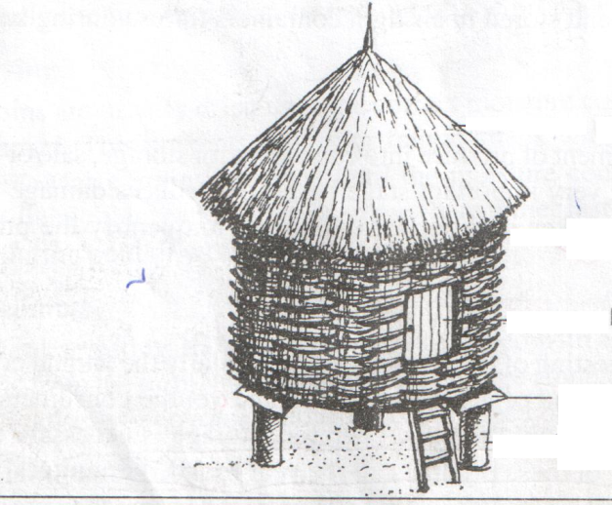
L

- Name the structure. (1mk)

- Name part L and state its function. (2mks)

- Name the roofing material the structure is made of: (1mk)

- List three limitations of the above structure. (3mks)

- Give two preparations that the farmer should make on the above structure before the crop produce is brought in. (2mks)

- Give four categories of vegetables. (2mks)

- The diagram below represents a pest that attacks tomatoes.
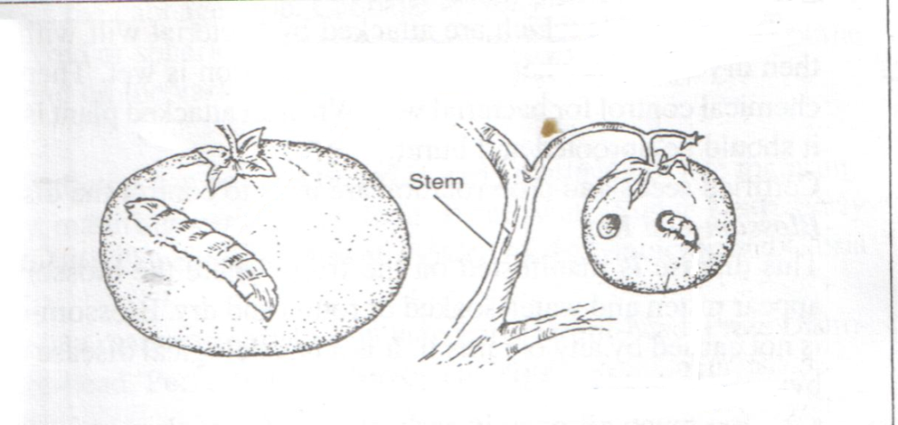
- Identify the pest. (1mk)

- State two control measures of the above pest. (2mks)

- (a) Differentiate between health and disease as used in livestock health. (2mks)

(b) State four factors that predispose livestock to diseases. (4mks)

(c) Outline 3 routine management practices of disease control. (3mks)

(d) State three activities in livestock health that necessitate handling of animals. (3mks)

- (a) List two harmful effects of tsetsefly infestation to livestock. (2mks)

(b) Name:
- Intermediate host for tapeworm. (1mk)

- Intermediate host for liverfluke. (1mk)

(c) Give two examples of one host tick. (2mks)

